Please note: It should be noted that the methods are not unique for some questions. The answering steps are necessary.

Question 1 The closed loop transfer function of a system is Gc(s)=$\frac{ω_{n}^{2}}{s^{2}+2{\text{ξω}}_{n}s+ω_{n}^{2}}$, Find the maximum overshoot $σ_{p}$=9.6%, damping ration $ξ$, and $ω_{n}$ when the peak time $t_{p}$=0.2 second.
[15]

Answer:
∵$σ_{p}$=$e^{−\frac{ξπ}{\sqrt{1−ξ^{2}}}}$×100%=9.6%
∴ξ=0.6
∵$t_{p}$=$\frac{π}{ω_{n}\sqrt{1−ξ^{2}}}$
∴$ω_{n}$=$\frac{π}{t_{p}\sqrt{1−ξ^{2}}}=\frac{3\text{.}\text{14}}{0\text{.}2\sqrt{1−0\text{.}6^{2}}}=$19.6rad/s

Question 2 Find transfer function (2) [20]
2.1The differential equation of a system is $\overset{¨}{y}$+2$\overset{˙}{y}$+3y=$\overset{˙}{u}$ +u, find the transfer function $\frac{Y\left(s\right)}{U(s)}$. Assume all initial states are zero. (5)

Answer:
Laplace transform:
Because the initial states are zero, we have
$$\begin{aligned}L\left\{\overset{¨}{y}\right\}=s^{2}Y(s) \\ L\left\{\overset{˙}{y}\right\}=\text{sY}(s) \\ L\left\{y\right\}=Y(s) \\ L\left\{\overset{˙}{u}\right\}=\text{sU}(s) \\ L\left\{u\right\}=U(s)\end{aligned}$$

$$(s^{2}+2s+3)Y(s)=(s+1)U(s)$$
$$\frac{Y\left(s\right)}{U(s)}=\frac{s+1}{(s^{2}+2s+3)}$$

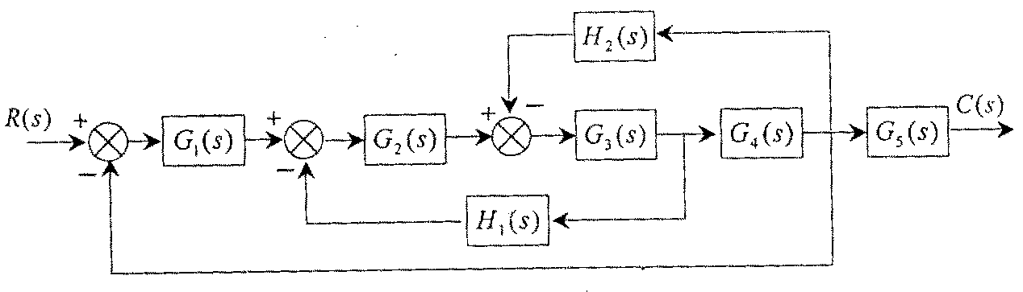
2.2 A system is given in Figure 1. Sketch the signal flow chart and find the transfer function $\frac{C\left(s\right)}{R(s)}$. (15)

Figure 1.

Answer:

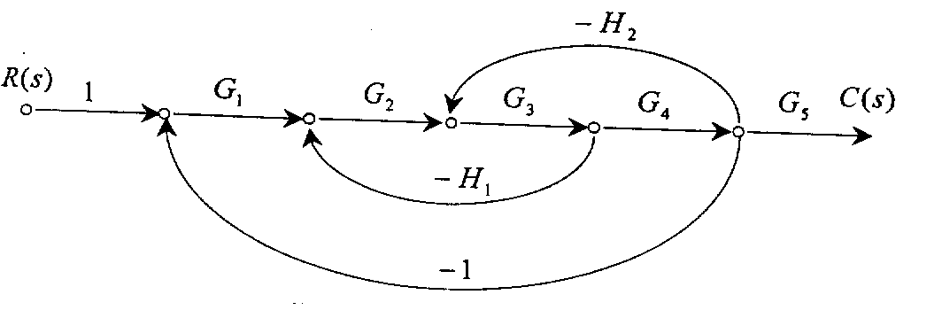

P₁=G₁G₂G₃G₄G₅,
L₁=-G₁G₂G₃G₄,
L₂=-G₂G₃H₁,
L₃=-G₃G₄H₂
$\frac{C(s)}{R(s)}=\frac{G_{1}G_{2}G_{3}G_{4}G_{5}}{1+G_{1}G_{2}G_{3}G_{4}+G_{2}G_{3}H_{1}+G_{3}G_{4}H_{2}}$

Question 3 The open loop transfer function of a unit negative feedback system is $G(s)=\frac{\text{10}}{s(s+1)}$.
Find
(a) $ω_{n}$ (2)
(b) $ξ$ (2)
(c) $δ\text{\%}$(Maximum overshoot) (2)
(d) $t_{p}$ (2)
(e) $t_{s}$ (2)

[10]
answer:
$$\begin{aligned}∵ξ=\frac{1}{2\sqrt{\text{10}}}=0\text{.}\text{158} \\ ω_{n}=\sqrt{\text{10}}=3\text{.}\text{16} \\ ∴σ\text{\%}=e^{−\text{πξ}\sqrt{1−ξ^{2}}}∗\text{100}\text{\%}=\text{60}\text{.}5\text{\%} \\ t_{s}=\frac{3}{{\text{ξω}}_{n}}=6\end{aligned}$$
$t_{p}=\frac{π}{ω_{d}}=\sqrt{1−ξ^{2}}ω_{n}=1\text{.}\text{94}$s

Question 4 The open loop transfer function of a unit negative feedback system is $G(s)=\frac{k}{(s+2)(s+4)(s^{2}+6s+\text{25})}$. Find K for system oscillation using Routh stability criterion.
[20]
answer:
The characteristic equation of the system is
$$(s+2)(s+4)(s^{2}+6s+\text{25})+k=0$$
i.e.
$$s^{4}+\text{12}s^{3}+\text{69}s^{2}+\text{198}s+\text{200}+k=0$$
$s^{4}$: $\begin{matrix}1 & \text{69} & \text{200}+k\end{matrix}$
$s^{3}$: $\begin{matrix}\text{12} & \text{198} & \end{matrix}$
$s^{2}$: $\begin{matrix}\text{52}\text{.}5 & \text{200}+k & \end{matrix}$
$s^{1}$: $\begin{matrix}\frac{\text{52}\text{.}5∗\text{198}−\text{12}∗(\text{200}+k)}{\text{52}\text{.}5} & & \end{matrix}$
$s^{0}$: $\begin{matrix}\text{200}+k & & \end{matrix}$
The system oscillates means
$$\begin{matrix}\frac{\text{52}\text{.}5∗\text{198}−\text{12}∗(\text{200}+k)}{\text{52}\text{.}5}=0 & & \end{matrix}$$
Or
$$\begin{matrix}\text{200}+k & & \end{matrix}$$
i.e.
$$\begin{matrix}\text{52}\text{.}5∗\text{198}−\text{12}∗(\text{200}+k)=0 & & \end{matrix}$$
$k=$666.25
Or
$k=$-200

Question 5: The open loop transfer function of a system is G(s)=$\frac{K}{s(s+2)(s+4)}$.
Sketch the root locus and find the range of K for stability. [15]

answer:
- The root loci have 3 branches
Origin from s1=0,s2=-2,s3=-4
Terminate at infinity.

- Root locus on the real axis
[0, -2] and [-4, -∞]

- Asymptotes ：
±60°,180°
σa=$\frac{−2−4}{3}$ =-2

- Points of departure
Since $\frac{\text{dK}}{\text{ds}}$ =0, we have s₁=-0.85,s₂=-3.15. Because it must lie on [ 0, -2],
so s₁=-0.85 is the departure point.

- The point cross the imagery axis.
ω₁=0, K=0;
ω_{2,3}=±2$\sqrt{2}$, K=48

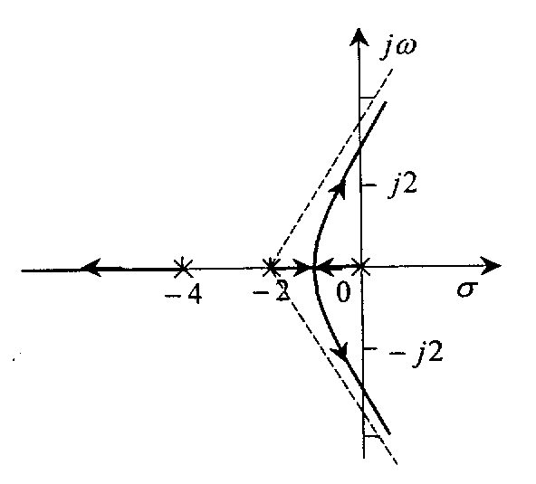
The range of K for stability: 0<K<48.

Question 6: The Bode diagram of a minimum phase system is given in Figure 3.
6.1Find the open loop transfer function of the system; (8)
6.2Find the static step error constant $k_{p,}$, the static velocity error constant $k_{v}$, and the static acceleration error constant $k_{a}$. (12)

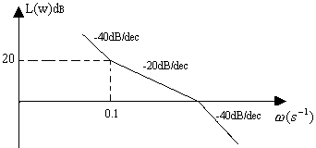
1

Figure 3.
[20]

answer:

$$(1)$$
II-type sytem;
Open loop zero: s=-0.1;
Open loop pole: s=-1.
Must have the form of $G(s)H(s)=\frac{K(\text{10}s+1)}{s^{2}(s+1)}$
$$\begin{aligned}\text{20}\text{log}{\left|G(jω)H(jω)\right|}_{ω=0\text{.}1}=\text{20} \\ \text{20}\text{log}({\left|\frac{K(jω\text{10}+1)}{−ω^{2}(jω+1)}\right|}_{ω=0\text{.}1})=\text{20}\end{aligned}$$
$${\left|\frac{K(jω\text{10}+1)}{−ω^{2}(jω+1)}\right|}_{ω=0\text{.}1}≈{\left|\frac{K}{−ω^{2}}\right|}_{ω=0\text{.}1}=\frac{K}{0\text{.}\text{01}}=\text{10}$$
$$K=0\text{.}1$$
So $G(s)H(s)=\frac{0\text{.}1(\text{10}s+1)}{s^{2}(s+1)}$
(2)$k_{p}=∞,k_{v}=\text{100},k_{a}=0\text{.}1$

[total: 100]

Annexure A
Laplace transform table:
f(t) | F(s)
 | 1
1(t)
t

