CHAPTER 3: DEMAND ELASTICITIES

OVERVIEW

This chapter introduces students to the concept of elasticity of demand. A demand elasticity measures how consumer demand responds to changes in a variable in the demand function. The price elasticity of demand is the key elasticity measure discussed in this chapter. It measures the sensitivity of the consumer’s behavior to changes in the price of the product by dividing the percentage change in the quantity demanded by the percentage change in the price that induced the change in the quantity demanded

OUTLINE OF TEXT MATERIAL

- Introduction

  - With the exception of perfectly competitive price-taking firms, all firms with market power face downward sloping demand curves. These firms must lower prices to sell more units of the product.

  - For firms that have varying degrees of market power, product price is a strategic variable that managers must understand and manipulate.

  - Demand (Price) Elasticity: Quantitative measure that shows how responsive consumers are to changes in price.

  - The chapter also discusses the relationship between price elasticity and revenue, and its relevance to the decisions of managers.

- Demand Elasticity: Quantitative measurement showing the percentage change in the quantity demanded of a particular product relative to the percentage change in any one of the variables included in the demand function for that product.

  - Elasticity measures the responsiveness of consumers in terms of percentage changes in both variables.

\

- Price Elasticity of Demand (e_{P}): Percentage change in the quantity demanded of a given good, X, relative to a percentage change in its price, all other factors constant.

  - Equation 3.1: e_{P} = %∆Q_{X} / %∆P_{X}
where:

e_{P} = price elasticity of demand
∆ = the absolute change in the variable: (Q₂ – Q₁) or (P₂ – P₁)

    - Price elasticity of demand is illustrated by the change in quantity demanded from Q₁ to Q₂ as the price changes from P₁ to P₂.

    - This is shown as the movement along the demand curve from A to B in Figure 3.1.

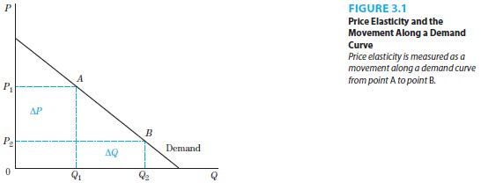
  - The price elasticity of demand affects managerial decisions on pricing strategies through the total revenue.

    - Total Revenue: The amount of money received by a producer for the sale of its product calculated as the price per unit times the quantity sold.

  - Price elasticities for downward sloping demand curves are negative because of the inverse relationship between price and quantity demanded. However, to determine the size of the price elasticity, absolute values are taken for the coefficients.

    - Unitary Elasticity: |e_{P}| = 1, when the magnitude of the percentage change in quantity demanded is equal to the magnitude of the percentage change in price.

    - Elastic Demand: |e_{P}| > 1, when the magnitude of the percentage change in quantity demanded is greater than the magnitude of the percentage change in price.

    - Inelastic Demand: |e_{P}| < 1, when the magnitude of the percentage change in quantity demanded is less than the magnitude of the percentage change in price.

  - Price elasticity of demand and total revenue are related in the following ways.

    - When demand is elastic, a higher price will decrease total revenue while a lower price will increase total revenue. This is illustrated in Figure 3.2.

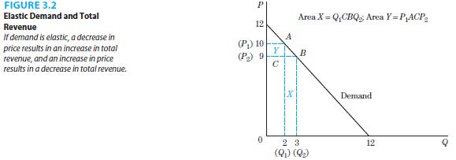

    - When demand is inelastic, a higher price will increase total revue while a lower price will decrease total revenue. This is illustrated in Figure 3.3.

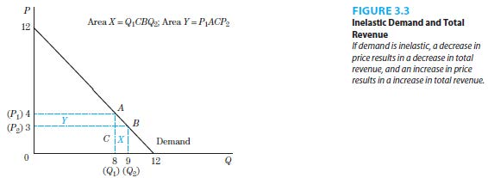

    - When demand is unit elastic, there is no change in the total revenue.

    - Two polar cases of demand curves, vertical and horizontal demand curves are important.

Perfectly Inelastic Demand: Zero elasticity of demand, illustrated by a vertical demand curve, where there is no change in quantity demanded for any change in price.

An example is the demand for insulin by a diabetic, who is completely unresponsive to changes in price ( necessity)

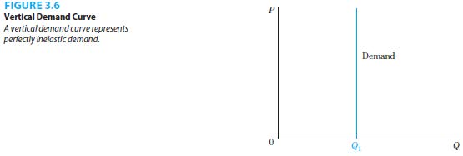
Perfectly Elastic Demand: Infinite elasticity of demand, illustrated by a horizontal demand curve, where there the quantity demanded would vary tremendously if there were any changes in price.

There is no exact application of a perfectly elastic demand in reality. Examples that illustrate this idea are the demand for common fruits and vegetables.

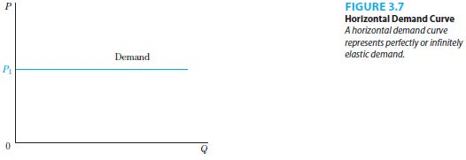

- Determinants of Price Elasticity of Demand

  - Number of Substitute Goods

    - Demand is more inelastic when there are fewer substitutes available, all else constant.

    - An example of inelastic demand is airline travel by business passengers due to the lack of available substitute modes of transportation.

  - Percent of Consumer’s Income Spent on the Product

    - Demand is more inelastic when a smaller fraction of a consumer’s income is spent on the product, all else constant.

    - An example of inelastic demand is the local newspaper since it makes up a very tiny fraction of a consumer’s income.

  - Time Period

    - Demand is more inelastic when the time period under consideration is short, all else constant.

    - It takes time for substitute products to be made available.

- Numerical Example of Elasticity, Prices and Revenues

  - Calculating Price Elasticities

    - Arc Price Elasticity of Demand: A measurement of the price elasticity of demand where the base quantity or price is calculated as the average value of the starting and ending quantities or prices.

.
      - Equation 3.3:

    - Point Price Elasticity of Demand: A measurement of the price elasticity of demand calculated as a point on the demand curve

Practice Questions

- Provide a simple definition of the price elasticity of demand and explain why knowing the price elasticity for her product is useful to the firm's manager.
- Summarize the relationship between elasticity, price changes, and changes in total revenue.
- Assume that, over time, engineers develop new residential furnaces that can run on different types of fuels, e.g., natural gas, electricity, propane, and fuel oil, simply by flipping a switch on the furnace. How would this technological change affect the price elasticity of demand for natural gas? Why?
- Assume that, for a particular demand curve, when price rises from $50 to $60, total revenue falls from $8,750 to $7800.
a. Based on this information, what is the quantity demanded at each price.
b. Without calculating the coefficient of elasticity, is demand over this range elastic or inelastic? How do you know?
- Calculate the arc price elasticity of demand for wheat in the two situations below:
The Wheat Market Farmer Brown's Wheat
Old price; $3.40/bu Old price; $3.40/bu
Old quantity; 2.5 billion bu Old quantity; 28,000 bu
New price; $3.20/bu New price; $3.20/bu
New quantity; 2.525 billion bu New quantity; 35,000 bu

- Assume that when the price of good X is $12, quantity demanded is 32. When price is decreased to $9, quantity demanded increases to 45. Calculate arc elasticity of demand over this range. What type of elasticity did you find?

