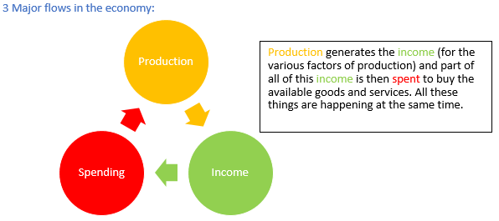
Stock variable: has no time dimension and can only be measured at a specific moment (wealth, assets, liabilities, capital, population, balance in a savings account, unemployment)
Flow variable: has a time dimension and can only be measured over a period (income, profit, loss, investment, and demand for labour)
Goods market: a market in which goods and services are traded; producers sell their products here, and households buy them.
Factor market: the market on which factors of productions= are sold. Factor markets include the labour market and the markets for capital goods
