SU 4

Interaction between households & firms = Supply and Demand

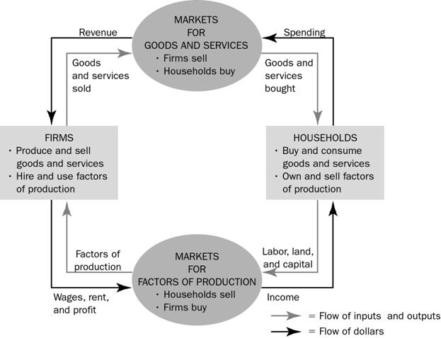

Demand

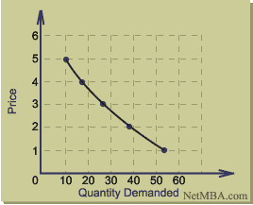

Demand = the quantity of a good demanded by an individual (or household) in a particular period is a function of the price of the good, prices of related goods, the income of individual (or household), taste, the number of people in the household and any other possible influence.
Demand Schedule and Demand Curve
Qd = f(Px, Pg, Y, T, N….)
- Qd = Quantity Demanded
- Px = Price of Good/Product
- Pg = Price of related goods
- Y = Household’s income during period
- T = Taste of consumer
- N = Number of people in specific household
- …. = Allowance for other influences
Ceteris Paribus = All other things being equal
Demand curve illustrates the quantities demanded at different prices.
The inverse relationship is called the law of demand
Market demand is obtained by horizontal summation of individual demands.

Movement in Demand Curve

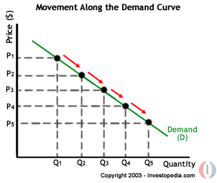

Movement along demand curve = Change in quantity demanded
If the price of the product changes there is a change in the quantity demanded which is called a change in the quantity demanded.

Shift in Demand Curve
Happens when a change in any of the determinants of demands change OTHER THAN PRICE.

Increase in Demand – Move to the Right
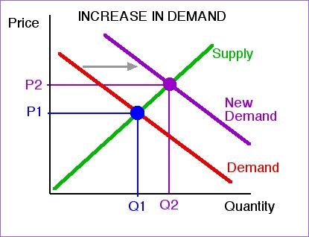
Demand can increase (moving the demand curve to the right) if
- incomes of buyers are increased (normally, although this is not true for "inferior goods")
- substitutes become more expensive or less available
- complements become less expensive or more available
- number of consumers increases (due to population, demographics)
- fads, fashions, tastes and attitudes (emotion) make the good more popular
- information about the good (including advertising) increases desire for the good
- changes in the buyers' environment (weather, time of year, laws) makes the good more desirable to buyers
- buyers have an expectation of higher FUTURE price for the good
Decrease in Demand – Move to the Left
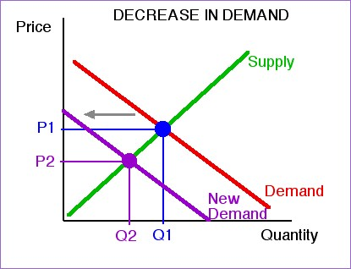
Demand can decrease (moving the demand curve to the left) if
- incomes of buyers are decreased (normally, although this is not true for "inferior goods")
- substitutes become less expensive or more available
- complements become more expensive or less available
- number of consumers decreases (due to population, demographics)
- fads, fashions, tastes and attitudes (emotion) make the good less popular
- information about the good (including advertising) decreases desire for the good
- changes in the buyers' environment (weather, time of year, laws) makes the good less desirable to buyers
- buyers have an expectation of lower FUTURE price for the good
Table 7-3 The Market Demand Curve – Summary

Supply

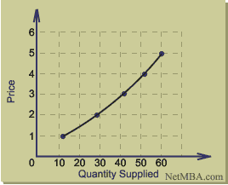

Supply = the quantities of a good of service that producers plan to sell at each possible price during a certain period.
Supply is determined by:
- Price of good – The higher the price, the more the producer wishes to sell
- Prices of alternatives – Producers must consider the prices of alternatives that they can produce with the same resources for more revenue.
- Prices of factors of production and other inputs – To make a profit costs need to be covered. If costs increase, fewer products will be supplied at the same cost as before. It will cost more to product each quantity.
- Expected future prices – The higher the expected future price of the product, the more the producer will plan to produce.
- State of technology – New technologies that enable producers to produce at lower cost will increase the quantity supplied at each price.

Qs = f(Px, Pg, Pf, Pe, Ty)
- Qs = Quantity Supplied
- Px = Price of good
- Pg = Prices of alternative outputs
- Pf = Price of Factors of Production (FoP)
- Pe = Price of expected future prices
- Ty = Technology

Movement in Supply Curve

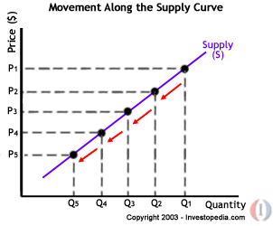

Movement along supply curve = Change in quantity supplied
The Supply Curve shows that the quantity supplied will increase if the price increases, ceteris paribus.

Market Equilibrium
The market is in equilibrium when the quantity demanded is equal to the quantity supplied. When the plans of households (buyers, demanders) coincide with the plans of firms (sellers, suppliers).

Shift in Supply Curve
Increase in Supply – Move to the right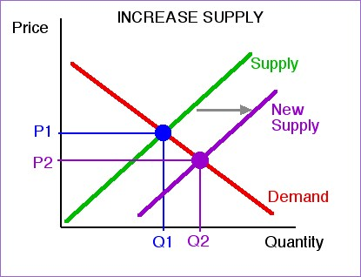
You may remember that supply can increase (moving the supply curve to the right) if
- COSTS ARE LOWER due to
- lower resource prices
- new technology for producing is used
- larger number of sellers
- favorable environment for producing or selling
- lower taxes
Decrease in Supply – Move to the left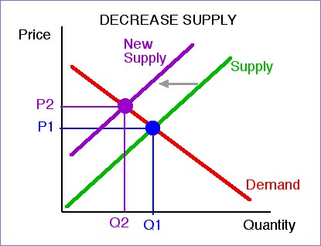
Supply can decrease (moving the supply curve to the left) if
- COSTS ARE HIGHER due to
- higher resource prices
- smaller number of sellers
- unfavourable environment for producing or selling
- higher taxes
Demand, Supply and Market Equilibrium

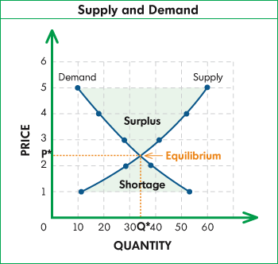

The demand curve intersects the supply curve – This is equilibrium price. The equilibrium quantity is “Q”.
At a price of 1, the quantity demanded is 53, and the quantity supplied is 10. The excess demand is the “Shortage” or in this instance 43.
At a price of 5, the quantity demanded is 10, and the quantity supplied is 60. The excess supply is the “Surplus” or in this instance 50.

SU 5

- Simultaneous Changes in Demand and Supply

When ONLY demand or ONLY supply changes, it is possible to predict what will happen to equilibrium prices and quantities in the market.
If demand AND supply change simultaneously, the precise outcome cannot be predicted.

Changes in Demand Curve
Table 7-3 (Page 120)

Changes in Supply Curve
Table 7-5 (Page 126)

Increase in demand = increase in equilibrium price
Decrease in supply = increase in equilibrium price
THEREFORE
An increase in demand AND decrease in supply = increase in equilibrium price
We CANNOT predict what will happen to the equilibrium quantity exchanged in the market.

Simultaneous changes in demand and supply. Table 8-1 (Page 139)

- Interaction between related markets

Fish and Meat - Substitutes

A decrease in the demand for fish is illustrated by a leftward (downward) shift of the demand curve. The equilibrium price and weekly traded quantity decreases. The increase in demand for meat is illustrated by a rightward (upward) shift of the demand curve. The equilibrium price and quantity traded increases.

Motorcars and tyres - Complements

An increase in in the cost of a motorcar is illustrated by a leftward (upward) shift in the supply curve. The equilibrium price of motorcars will increase and the equilibrium quantity will decrease. With fewer motorcars being produced, the demand for new tyres (complimentary good) will decrease. This is illustrated by a leftward (downward) shift in the demand curve. As a result the equilibrium price and equilibrium quantity of tyres will decrease.

- Government Intervention

When consumers, trade unions, farmers, businesses and politicians are not satisfied with prices and quantities determined by supply and demand, government may intervene through any of the following:
- Setting maximum prices (price ceilings)
- Setting minimum prices (price floors)
- Subsidizing certain products or activities
- Taxing certain products or activities

  - Maximum prices (price ceilings, price control)

Reasons for maximum prices:
- To keep prices of basic foodstuffs low to assist the poor
- To avoid exploitation of consumers by producers (“unfair” prices)
- To combat inflation
- To limit the production of certain goods or services in wartime

IF Maximum Price > Equilibrium (market-clearing) price, it will have no effect on price or quantity exchanged

IF Maximum Price < Equilibrium (market-clearing) price, quantity demanded will increase (higher than equilibrium), but suppliers will supply substantially less creating a market shortage (or excess demand). Managing this shortage is as follows:
- Consumers served on a “first come, first served” basis causing queues and waiting lists
- Suppliers may set up informal rationing systems (limits to each customer, or selling only to regular customers)
- Government may introduce and official rationing system (tickets, coupons etc.)

    - Black Markets

Consumers are willing to pay a certain price for a quantity of a good. If a consumer can purchase the good at a lower price there is a potential for a profit between the price willing to pay and actual purchase price by selling it to someone who wants the good (concert tickets is a good example).

Fixing prices below equilibrium price thus:
- Creates shortages (excess demand)
- Prevents market mechanism from allocating available quantity
- Stimulates black market activity by providing an incentive for people to obtain a good and resell it at a higher price to consumers who are willing to pay a higher price.

  - Agricultural prices

Agricultural prices fluctuate much more than prices of manufactured goods. Supply varies from season to season and is dependent on weather, alternative crops etc.

  - Minimum prices

Because demand for agricultural products is relatively stable and supply is subject to large fluctuations, prices tend to fluctuate causing unstable and uncertain income to farmers. Governments often introduce minimum prices (price floors), which serve as guarantees to producers.

IF Minimum Price < Equilibrium price, the operation of market forces in not disturbed.

IF Minimum Price > Equilibrium price, it creates a surplus (excess supply).

When government fixes prices above the equilibrium price, the following intervention is required:
- Government purchases the surplus and export it
- Government purchases the surplus and stores it (non-perishable)
- Government introduces production quotas to limit quantity supplied
- Government purchases and destroys the surplus
- Producers destroy the surplus

SU 6 – Elasticity

Elasticity is the measure of responsiveness or sensitivity. When variables are related, we often want to know how sensitive or responsive the dependent variable is to changes in the independent variable.

4 types of elasticity:
- Price elasticity of demand
- Income elasticity of demand
- Cross elasticity of demand
- Price elasticity of supply

- Price Elasticity of Demand

Price elasticity of demand = the percentage change in the quantity demanded if the price of the product changes by 1%.

Percentage change in the quantity
Demanded of a product
Price Elasticity of Demand = ---------------------------------------------
Percentage change in the price
Of the product

EXAMPLE: If the price of a product changes by 5% and this results in a 10% change in the quantity demanded, then Price Elasticity = 10% / 5% = 2. This implies that a 1% change in the price of the product will lead to a 2% change in the quantity demanded.

Price elasticity is the ratio of the percentage change in the quantity to the percentage change in the price. This ratio is called elasticity coefficient.
Elasticity coefficients enable us to compare how consumers react to changes in the prices of different goods and services.

Calculations

Calculate percentage change in quantity demanded

Percentage change in the quantity demanded | = | Change in Quantity | X 100
Percentage change in the quantity demanded | = | Quantity | X 100

Calculate percentage change in price of product

Percentage change in the price of the product | = | Change in Price | X 100
Percentage change in the price of the product | = | price | X 100

Price elasticity of demand is calculated as follows:

Price elasticity of demand | = | Change in Quantity | X | Price
Price elasticity of demand | = | Change in Price | X | Quantity

NB: Between two price points we can get two separate answers, it is thus important to use the average of the two points as the basis of the calculation, so if price moves from 36 to 48, we use the average as a calculation i.e. (36 +48) / 2 = 42. Same goes for quantity calculation.

Arc Elasticity of Demand between 2 points

Arc elasticity of demand | = | (Q2 – Q1) / (Q1 + Q2)
Arc elasticity of demand | = | (P2 – P1) / (P1 + P2)

Categories of price elasticity of demand
Perfectly Inelastic Demand (ep = 0)
Inelastic Demand (ep lies between 0 and 1)
Unit Elastic Demand (ep = 1)
Elastic Demand (ep lies between 1 and infinity)
Perfectly Elastic Demand (ep = infinity)
NB: Price Elasticity of Demand = Elasticity Coefficient

Table 9-2 (Page 163) Price Elasticity of Demand: a Summary

Inelastic demand (ep < 1): Salt, matches, toothpicks, cigarettes, bread, milk, petrol, electricity, water, eggs, potatoes, meat, postage stamps, medical care, legal service, car tyres etc.

Elastic demand (ep > 1): Motor vehicles, mutton, furniture, entertainment, restaurant meals, overseas holidays, butter, chicken, veal, apples, peaches etc.

- Income Elasticity of Demand

Income elasticity of demand measures the responsiveness of the quantity demanded to changes in income.

Percentage change in the quantity
Demanded of a product
Income Elasticity of Demand = ---------------------------------------------
Percentage change in consumer’s
Income

Goods with a positive income elasticity of demand are called normal goods
Goods with a negative income elasticity of demand are called inferior goods
Income elasticity of demand > 1 THEN good is Luxury Good
Income elasticity of demand >0 AND <1 good is essential good

- Cross Elasticity of Demand

Cross elasticity of demand measures the responsiveness of the quantity demanded of a particular good to the changes in the price of a related good.

Percentage change in the quantity
Demanded of product A
Cross Elasticity of Demand = ---------------------------------------------
Percentage change in the Price
Of Product B

In the case of substitutes (butter vs margarine) the cross elasticity of demand is positive. A change in the price of the product (butter) will lead to a change in the same direction in the quantity demanded of the substitute product.

In the case of complements the cross elasticity of demand is negative. A change in the price of one product (motorcars) will lead to a change in the opposite direction in the quantity demanded of the complimentary product (tyres).

- Price elasticity of supply

Percentage change in the quantity
supplied of a product
Price Elasticity of Supply = ---------------------------------------------
Percentage change in the Price
Of the Product

SU 7

The Indifference Approach

To explain indifference curves we assume a consumer consumes only two products, bread and meat. To the consumer it does not matter whether he gets one portion of meat and six loaves of bread per week or two portions of meat and three loaves of bread.

The combinations of satisfaction are drawn using an indifference curve.
This illustrates the law of substitution: The scarcer the good becomes, the greater its substitution value will be.

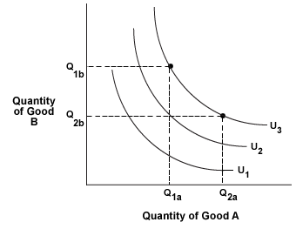
The slope of the indifference curve indicates the rate at which the consumer is prepared to sacrifice a small quantity of product A for a little more of product B. This rate is called marginal rate of substitution (MRS)

Perfect Complements = Goods that can only be used together eg. A two legged person with one left shoe will gain no additional satisfaction from more than 1 right shoe, and more than 1 left shoes will not increase his or her total utility. Indifference curve will be L shaped

Perfect Substitutes = Consumer regards Sasol as a perfect substitute for Caltex. Indifference curve is a straight line from left down to right.

Budget line

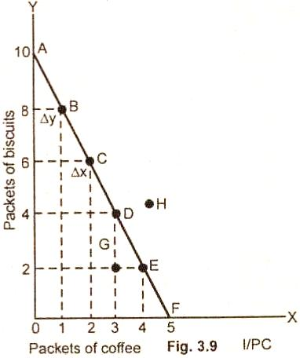

The budget line indicates all combinations of the two products that a consumer can afford to purchase with the income at his disposal.

Budget line = consumption possibilities curve = expenditure line = budget constraint.

When a consumer’s income changes, the equilibrium quantities of the goods concerned do not always change in the same direction. In the case of a Normal good, an increase in income will result in an increase in the quantity demanded. When an increase in income causes a decrease in the quantity demanded, the good is called an inferior good.

Consumer equilibrium

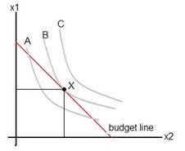

The consumer is in equilibrium (ie obtains highest affordable level of satisfaction) where the highest indifference curve just touches the budget line

SU 8

Costs, profit and revenue

Total Revenue (TR) = Price (P) x Quantity (Q) or simply PQ
Average Revenue (AR) = PQ/Q
Marginal Revenue (MR) = Additional Revenue / Additional unit of product

Total (Accounting) Profit = Total Revenue – Total Explicit Costs

Economic Profit = Total Revenue – Total Costs (explicit and implicit), including normal profit

Production in the Short Run

Short run = A period in which at least one of the inputs is fixed. A fixed input is an input whose quantity cannot be altered in the short run.

In the short run, a firm can expand output only by increasing the quantity of its variable inputs.

There is a relationship between the quantity of the inputs and the maximum output that can be obtained from these inputs.

Costs in the Short Run

Fixed cost is formally defined as cost that remains constant irrespective of output produced.

Although the price of a unit if labour is given, the quantity of the labour is variable and therefore the cost of labour is also variable. Variable Cost is formally defined as cost that changes when total product changes.

Variable costs = direct costs = prime costs = avoidable costs

Cost Calculations

Marginal Cost
Marginal Cost is the cost a company incurs when producing one more good. Suppose we're producing two goods, and we would like to know how much costs would increase if we increase production to three goods. This difference is the marginal cost of going from two to three. It can be calculated by:

Marginal Cost (Unit 2 to 3) = Total Cost of Producing 3 – Total Cost of Producing 2.

MC = TC(3) – TC (2)

Total Cost
The total cost is simply all the costs incurred in producing a certain number of goods. If you're given marginal cost data instead of total cost data, you can compute the total by the example given in the marginal cost section.

TC(3) = TC(2) + MC(3)

Fixed Cost
Fixed costs are the costs that are independent of the number of goods you produce, or more simply the costs you incur when you do not produce any goods. Usually the value at 0 units.

FC = TC value @ 0 units

Total Variable Costs
These are just the opposite of fixed costs; these are the costs that do change when we produce more. We calculate the total variable cost of producing 4 units by:

Total Variable Cost of Producing 4 units = Total Cost of Producing 4 Units – Total Cost of Producing 0 units.

TVC(4) = TC(4) – FC

Average Total Costs
Our average total cost is our fixed costs over the number of units we produce. So if we produce five units our formula is:

Average Total Cost of Producing 5 = Total Cost of Producing 5 units / Number of Units

ATC = TC/Qty

Average Fixed Costs
Our average fixed cost is our fixed costs over the number of units we produce, given by the formula:

Average Fixed Cost = Fixed Costs / Number of Units

AFC = FC/Qty

Average Variable Costs
The formula for average variable costs is:

Average Variable Cost = Total Variable Costs / Number of Units

AVC = TVC/Qty

Perfect Competition

Perfect competition occurs when none of the individual market participants (buyers or sellers) can influence the price of the product.

Requirements for perfect competition:
- Large number of buyers and sellers of the product
- No collusion between sellers – each must act independently
- All goods sold must be identical
- Buyers and sellers must be completely free to enter or leave the market
- All buyers and sellers must have perfect knowledge of market conditions
- There must be no government intervention
- All factors of production must be perfectly mobile

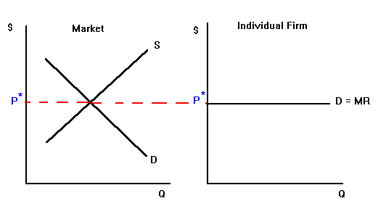

Graph on left shows that price of product is determined by demand and supply. The firm can sell its whole output at that price.

Graph on the right is the demand curve (which is perfectly elastic) for the product. Demand = Average Revenue = Marginal Revenue

Supply curve of the firm

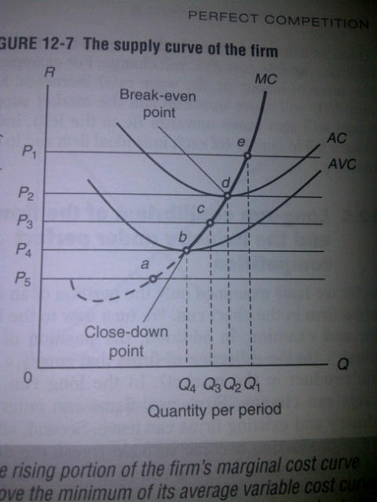

Close down point = MC curve below AVC intersection
Break-even point = MC curve intersection with AC (ATC)

Economic profit = Section between AC (ATC) and D=AR @ MR Intersection

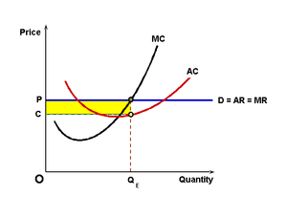

Monopoly

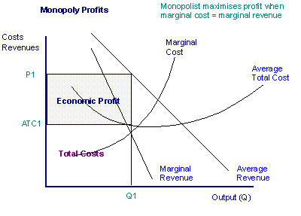

To maximize profits, the monopolist has to produce where MR = MC

Features of monopolistic competition
- Each firm produces a distinctive, differentiated product
- Each firm faces a downward-sloping demand curve for its products
- Large numbers of firms operate in the industry
- There are no barriers for entry or exit.

Difference between monopolistic competition and monopoly lies in the barriers t entry. Entry is not restricted in monopolistic competition whereas it’s blocked in the case of monopoly.

Difference between monopolistic competition and perfect competition is found in the nature of the product. Monopolistic competitors produce differentiated (heterogeneous) products. Perfectly competitive firms produce identical products.

SU 11

Labour Market

Labour Market versus the goods market

Most important differences include:
- Workers have to be physically present when their services are used. Non-Monetary factors, such as location and working conditions, are more important in labour markets.
- Labour services are embodied in the person and are therefore not transferable
- Labour is always rented and not sold unlike goods market.
- Relationship between suppliers and demanders involves considerations such as humanity, loyalty, fairness etc.
- Labour markets are usually characterized by trade unions, associations, collective bargaining and government intervention.
- Labour is intrinsically heterogeneous and unlike goods cannot be classified or standardized
- There are a variety of labour markets/segments. There could therefore be a shortage of labour in a certain segment.
- Remuneration of labour does not only consist of price, but may include non-wage benefits such as housing, medical etc.
- Remuneration of labour is affected by many factors not directly related to labour market i.e. taxation.

Money wages = nominal wages = the amount of money ACTUALLY received by a worker per hour, day, week, month or year.

Real wages = The quantity of goods and services that can be purchased with the nominal or money wage. Real wages are the purchasing power of money wages.

Example: Money wage increase by 5%, consumer goods/services increase by 10% THEN the real wage actually declined by 5%.

Calculation of marginal revenue product of labour

# workers | Total Physical Product | Marginal Physical product | Price per product | Marginal revenue product
0 | 0 | 0 | 50 | 0
1 | 10 | 10 | 50 | 500
2 | 18 | 8 | 50 | 400

The market demand of labour

A shift in the market demand for labour could be as a result of:
- Number of firms (employers) change
- Price of a product changes – Change in price = change in demand
- Marginal Physical Product MPP (or productivity) of labour changes since this will change marginal revenue product (MRP)
- A new substitute for labour becomes available – Example automation
- Price of a substitute factor of production changes. Example price of machine decrease, employers may wish to replace labour workers with machines.
- Price of complimentary factors of production changes. Example price of trucks decrease which results in an increase in trucks and the requirement to increase the number of drivers.

Trade Unions

There are two categories of trade union:

Craft Union
Consists of workers with a common set of skills (plumbers, electricians, printers) who are joined together in a common association, irrespective of where, or for whom, they work.

Craft unions control the supply of skilled labour in particular trades or professions. Supply control include: restricting membership, controlling the length of training or apprenticeship or raising the standards for entry.

If the union succeeds in reducing supply, the supply curve of skills shift leftward, the wage rate increases and the employment level reduces.

Industrial union
Tries to organize all workers (skilled and unskilled) in a particular industry in a single bargaining unit.

The ultimate aim of the industrial union is to achieve complete control over the labour supply in a particular industry. It can now force firms in the industry to bargain exclusively with the union over wages and other conditions of employment.

In contrast to craft unions, industrial unions use their bargaining power directly to increase wage rates.

Minimum Wages

If minimum wage rate is fixed above the equilibrium price, and excess supply of labour will develop (unemployment).

