1) Cohesion
- A text is made up of grammatical and lexical elements, and cohesive features are those that link one part of it with another.
- These linkages provide a sense of wholeness and internal unity, and allow a text to be read and understood easily.
- Thus, cohesion plays a vital role in achieving coherence
Lexical cohesions
- Related words or phrases belonging to the same semantic field.
- This related vocabulary enables us to recognise the context, thus aiding coherence
Examples:
- Repetition-of words or phrases
- synonymy-words that are similar in meaning
- antonymy-words that are opposite in meaning
- collocation-words that belong to the same semantic field
- time markers-relating to time (early, late, dates)
- sense relations-(human-man, woman, girl, boy, he, she, people)
Grammatical cohesion
- Grammatical elements that tie a text together
Examples:
- reference
- substitution
- ellipsis
- conjunctive
2) Genre and register
Types of Genre:
Expository
- letters/articles/reports
- contain facts and information
- aim to explain, clarify, define, instruct
Persuasive
- Debates
- one sided or single minded goal
- subjective and uses emotive language
- a personal conviction that a particular way of thinking is the only sensible way to think
- aims to convince the reader to adopt an opinion

Narrative
- fiction
- tells a story
- has a character/plot
Technical
- brochures/adverts
- contains specific terminology/inside language (jargon)
- usually short sentences
Types of register:
- Formal
- Consultative
- Frozen
- Intimate
- Causal
- Informal
3) Textual/Visual Analysis
What to look out for in a Visual text
Words/written features
- title
- headline
- captions
Images
- if it’s a close up shot-less details
- if it’s long shot-more details
- the connotative/denotative meaning
Layout
- Elements on the top-attention grabber
- elements below-new information
Typographical/fonts
- capitals-emphasis
What to look for in a textual analysis?
- Context-time period/place/situation
- Purpose-to instruct/inform/persuade/entertain/sell/complain
- audience-level of education/age/gender
- word choice-
- does it contain jargon
- slang/colloquial-creates a jarring effect
- emotive language
- standard English
- Structure/style
- construction of sentences (long and compound create a slower pace/formal)
and (short, truncated or simple create urgency/haste)
- format-paragraph/point form/Question and answer format
- Personal/Active voice-(I believe/I think)
- Formal/Passive voice-more persuasive and authoritative
- Language features (lots more can be added)
- processes
- linking words
- tense
- figurative language
- rhetorical devices
- mood
- modality
More Language features

Verbs to indicate actions and feelings
present tense for most of the argument e.g. Smoking is …, I hate…
past tense for some evidence or past happenings e.g. For years, people smoked …
future tense for suggesting solutions to problems, predictions for the future or calls for action e.g. We will be a healthier society if …, Society can change…

Adjectives and phrases – descriptive, emphatic, feeling words that appeal to the emotions
Wonderful, beneficial, amazing, excellent, terrible, horrible, cruel, unjust, endangered, unwise, attractive, frightening, perfect, highly recommended, practical, only course of action, sensible, the best way, useful, the only path, the obvious solution …

Personal /Active voice (first, second person) with action verbs –connects emotionally to the reader
I like, I think, I believe, I do not believe, I urge you, you should, shouldn’t, we should, could, must, must not, we need to, we will …

Formal/ Passive voice (more authoritative, more power of persuasion) creates distance but is more subtle
Progress writing from I think computer games are good … to Computer games are good …

Nominalise information – turn verbs, adverbs or clauses into nouns for more authority
Instead of You should not pollute… write Pollution should be stopped … It…
Greedy to greed; violent to violence; cruel to cruelty

Rhetorical questions and thought-provoking questions for effect
Where do we go from here? What is the point of …?

Emphatic language, hyperbole or exaggeration for effect
We need to…, Society has no other choice, it must…, There are a countless ways to…

Alliteration or rhyme, especially in the title or the last statement or sentence
Exercise is exhilarating. Plastic will never ever go away.

Figurative language, metaphor and simile to enhance your argument
… is driving me up the wall, Littering is a sickness, Eating junk food is like jumping off a cliff.

Repetition of words, phrases and concepts to push your point of view
We can stop the use of illegal drugs. We will stop the use of illegal drugs.

Quotes or humour that pack a punch and help your case
‘Tomorrow is the first day of the rest of our lives’ so let’s begin right now!

Anecdotes, examples, facts and statistics as evidence to enhance your argument
Last year…, An example of this can be seen… 70% of young smokers …

The antithesis or opposing points of view by contrasting the opposites
Smokers might say that smoking is relaxing but …, Love it or hate it …, Right this wrong…

Ethical language calls for fairness, ideas of right and wrong, morality and justice
The only fair thing to do is… We have a moral obligation to…

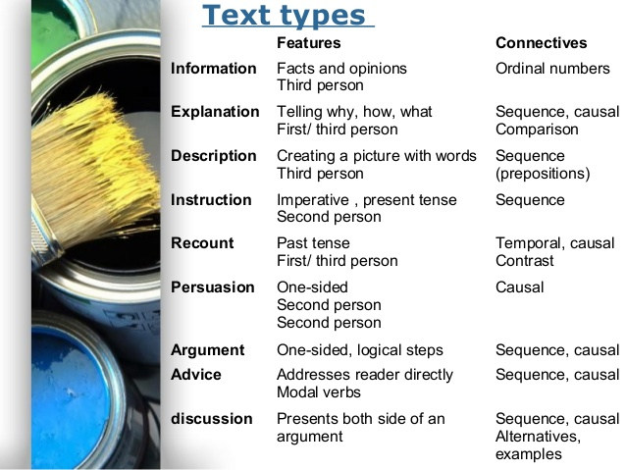
4) Essay Writing
In your introduction you need to:
- make the topic and purpose of the essay clear;
- address the question directly from the outset;
- outline the essay’s main argument and its structure/organisation;
- make sure that your introduction was not long and rambling.

In the main body you need to:
- use ‘signposting’ (e.g. topic sentences, discourse markers, comparative markers) to help the reader follow the sequence and logic of your argument;
- present information in a clear, logical order, and synthesise your ideas;
- provide evidence to support your points.

In your conclusion you need to:
- highlight the main/key points by drawing from the essay as whole;
- outline the implications of your main/key points in relation to the assignment title;
- make an overall concluding statement

