How to Write an A+ Comparison Essay on any Topic
(Published 3/10/2013 http://www.scoolwork.com/EssayWritingGuide/How_to_write_an_a_plus_comparison_essay.aspx)

What is a Comparison Essay?
A comparison essay (or a Compare and Contrast essay) is a commonly used type of writing assignment in various classes of high school and college, from art to science. In a comparison essay you should critically analyze any two subjects, finding and pointing out their similarities and/or differences.
Depending on your assignment, such essays can be comparative only (looking only at similarities), contrasting only (pointing out the differences) or both comparative and contrasting.

Choosing a Topic for Comparison Essay
In order to write a good essay, first you need to have a good topic for it, i.e. a topic that lets you easily demonstrate your writing skills and get a high grade easily.
What does that mean specifically regarding the comparison essay? Very simple: the subjects must be easy comparable, so you don’t need to work too hard to point out their similarities or differences. For example:
A big college campus and a small college campus
World War I and World War II
Two perspectives on the same place: morning and night
William Shakespeare with William Wordsworth
Windows vs. Linux

Comparison Essay Structure
Considering the right structure for your essay is one of the key points of success. Sticking to a recommended essay structure is the only way to properly outline and write it, paragraph by paragraph from the introduction to conclusion, without mistakes.
There are two recommended patterns for a comparison essay: point-by-point (or "alternating") pattern and subject-by-subject (or "block") pattern.

Alternating pattern
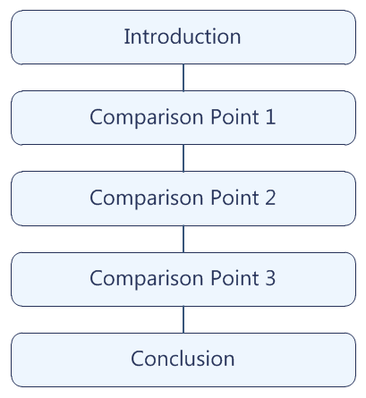
Alternating pattern is also known as "point-by-point comparison". This mode of comparison will result in your essay having 5 paragraphs. Alternating pattern is also known as "point-by-point comparison". This mode of comparison will result in your essay having 5 paragraphs.
In it, you will need to consecutively compare and contrast each of the similarities and differences in the given subjects:
- In the introduction you state your thesis.
- Then you discuss both of your subjects together for each point of comparison and contrast.
- In the conclusion you restate the thesis and shortly summarize your essay.

Block pattern
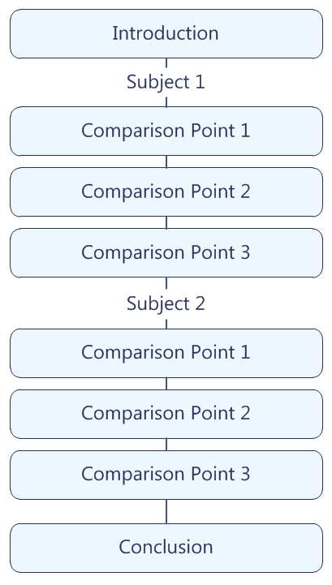
Block pattern is also known as "subject-by-subject comparison". According to this pattern, you will be required to separate the body of your compare and contrast essay in two parts.
The first part of the body will be dedicated to the first subject, while the other half will be centered around the second subject:
- In the introduction you state your thesis.
- First you discuss the first subject.
- Then you discuss the second subject.
- In the conclusion you restate the thesis and shortly summarize your essay.

Writing an A+ Comparison Essay

Introduction
The introduction of an essay is very important. It gives the reader his/her first impression of the comparison essay’s text. Remember: first impression counts!
Grab the reader’s attention
There are a lot of tips and techniques to help you in capturing a reader’s interest. You can find some pretty good information in the following articles:
How to Grab the Reader's Attention
A Proper Introduction
Essay Introductions
The most common five methods to grab your reader's attention, commonly used by professionals, are the following:
- Give a brief historical review of your topic for help reader to better understand it
- Start from a little story or an anecdote, which leads the reader into your topic
- Try to use a surprising statement – something disgusting, joyful or even shocking
- "Dropping" the name of a well-known person (celebrity) usually gets the reader's attention
- State straight out what your essay is going to be about, simply and clearly
Start from a short background
High school students often find it difficult to view their teachers as anything but "the enemy." However, after the first few months of a school year, students learn to appreciate their teachers as individuals with different approaches. Some teachers are "cool," while others are "tough."
State the thesis
Although Sally Strict & Larry Lax are both respected teachers at our school, their teaching styles and expectations for students differ significantly. While Ms. Strict maintains a highly structured classroom atmosphere to keep her pupils disciplined and motivated, Mr. Lax downplays structure in order to allow his students to push themselves.

Point paragraph
State the point
Finally, Ms. Strict enforces high standards for her students' written work.
Provide supporting details
She collects homework every day at the beginning of class; to turn it in five minutes late is to turn it in a whole day late. Every piece of writing, whether it is a journal entry or a formal essay, must be typed and stapled. Last but not least, all homework must display a sophisticated level of thinking and writing.
Use appropriate transitions
Transitions are important in comparison / contrast writing to avoid confusion. Without transitions, the points you are comparing / contrasting may blur into one another. Also, a variety of transitions prevent monotony.
For comparison:
Like, compared to, similar to, similarly, by analogy, likewise, in the same way, as well, both, too
For contrast:
Unlike, conversely, on the other hand, however, nevertheless, still, although, while, but, even though, although, despite, yet, regardless, on the one hand … one the other hand

Conclusion
The conclusion of a comparison essay is just as important as the introduction. The conclusion seals the comparison essay and tries to close the issue. Conclusion is the last part of the essay that your reader will experience.
Summarize the similarities and / or difference of the subjects
Thus, Ms. Strict and Mr. Lax both accomplish their goals of motivating their students to do excellent work, though they do so in very different ways: while Ms. Strict emphasizes the high standards she expects everyone can meet, Mr. Lax uses a more personal approach.
Emphasize the thesis and say why this topic is important
Their success demonstrates the importance of diversity in a school community: different students respond to different teaching styles. So rather than viewing their instructors as a monolithic "enemy" intent on making them suffer, students should recognize how they benefit from the variety of ways their teachers inspire them.

Finalizing your Work
Pay attention that even though your essay is fully written, it still isn’t ready to submission.
There are some common and annoying mistakes which may significantly harm your grade. However, you can avoid those grade lowering mistakes by completing the following checklist:
- Check spelling and grammar
- Ensure that your essay is fully compliant with the required formatting standard
- Properly organize all the citations and the References / Works Cited page
- Ensure that your title page is done as required
- Take a final look at your paper to be certain that everything is indeed fine

