STUDY UNIT 1: AN OVERVIEW OF THE SOUTH AFRICAN MACROECONOMIC ENVIRONMENT

MACROECONOMICS
ECONOMIC GROWTH
Economic growth takes place when the total production of goods and services in an economy increases.
It is traditionally defined as the annual rate of increase in total production or income in the economy under 2 conditions namely production, or income should be measured in real terms, (effects of inflation should be eliminated). Secondly, the figures should also be adjusted for population growth.
GROSS DOMESTIC PRODUCT
GDP (Gross Domestic Product) is an official measure of the FINAL goods and services produced inside the borders of a country by both the citizens and foreigners during a specified time period (usually one year). It is also the broadest, best-known and most used measure of economic activity.
GDP measures the production of new goods and services known as current production during a specified period and is a flow which reflects the level of economic activity that is taking place in the country.
NOMINAL AND REAL GROSS DOMESTIC PRODUCT
Nominal GDP or GDP at current prices is the sum of the quantities of final goods and services produced multiplied by their current price.
An increase in nominal GDP might increase over time due to an increase in the quantity or prices of goods and services produced.
Real GDP or GDP at constant prices is a measure of GDP in which the quantities produced are valued at the prices in a base year rather than at current prices.
Real GDP therefore measures the actual physical volume of production, and thus over comes the problem of price changes.
REAL PER CAPITA GDP
Positive economic growth occurs when the total production or income is growing at a faster rate than the population. Real GDP per capita is used as the measure of the economic wellbeing of the residents of a country.
A rise in the real GDP per capita implies that people are better off.
However there are factors that could give rise to an increase in the real GDP per capita without people becoming better off.
An example is where the increase in real GDP results from an increase in government spending on defense.
INFLATION
Inflation is defined as a continuous and considerable rise in prices in general. Note that this is a neutral definition of inflation since it does not tell us what the causes of inflation are.
The most commonly used indicator of changes in the general price level (inflation) is the consumer price index (CPI).
UNEMPLOYMENT
Unemployment occurs when economically active people who are willing and able to work, does not have paid employment.
The strict definition of unemployment used by Stats SA regards unemployed people as being 15 years and older, who,
• are not in paid employment or self employed,
• were available for paid employment or self employment during the seven days preceding the interview, and,
• took specific steps during the four weeks preceding the interview to find paid employment or self employment.
BALANCE OF PAYMENTS
The balance of payments is a systematic statistical record of all economic transactions between residents in the reporting country (e.g. South Africa) and the rest of the world during a particular period (quarter or year).
The South African balance of payments summarizes the transactions between South African households, firms and government and foreign households, firms and government.
The balance of payments consists of the following five sub accounts:
• Current account (Exports versus Imports): A surplus indicates that the value of the country’s exports exceeded the value of its imports during the period under review,
• Financial account: A surplus indicates that more funds flowed into the country than flowed out during the period under review. A net inflow of foreign capital thus occurred.
• Capital transfer account
• Unrecorded transactions
• Official reserve account
In principle the balancing item in the balance of payments is the change in the country’s gold and other foreign reserves.
Stability in the balance of payments exists where there is some balance between exports and imports.
When a country has to repay foreign debt and cannot borrow funds on the international financial markets, it has o maintain a surplus of exports over imports to offset the outflow of capital.
DISTRIBUTION OF INCOME
Distribution of income refers to the way in which income is distributed between a country’s residents (women, men and races).
Who earns the most Money? South Africa has a highly skewed distribution of personal or household income. Income distributions are difficult to measure and are therefore not estimated regularly.
Moreover, the estimates are subject to a significant margin of error.
In some countries the distribution of income among individuals or households has never been estimated, while in other countries such estimates are made only infrequently.
The Gini coefficient is used as a measurement to determine the distribution of income in a country.

Study Unit 2 – Goods Market
Goods Market
THE COMPOSITION OF GDP
• Consumption = C goods and services purchased by consumers.
• Investment = I sometimes called fixed investment
• Government Spending = G
• Foreign Trade: Exports>Imports (trade surplus); Export<Imports (trade deficit)
o Imports = IM
o Exports = X
THE DEMAND FOR GOODS AND SERVICES
‘Z’ represents the demand for goods and services where:
Z Ξ C + I + G + X – IM

GOODS MARKET
The Goods Market is the combined market for all goods and services, consisting of all producers and consumers including the Public sector (government), and the Foreign sector. It is in the goods market where producers decide how much to produce and consumers decide how much to purchase.

TOTAL DEMAND FOR GOODS, (Z) (TOTAL = AGGREGATE)
The total amount of goods and services demanded in the goods market. This total demand for goods and services determines the level of income and output in the economy.

TOTAL AMOUNT OF GOODS: (TOTAL = AGGREGATE)
All goods and services produced even if they replace depreciated or worn out products.
GROSS DOMESTIC EXPENDITURE (GDE)
The total value of spending within the borders of a country including imports but excluding exports, since spending on exports takes place outside the borders of the country.
Consumption
The usage and purchases (demand) for goods and services by consumers, firms, the government and foreign sectors. Households are the biggest consumption sector. Consumption C is a function of disposable income YD, as the disposable income YD increases the ability to consume C increases (Induced Consumption). Therefore:
C = C(YD),
But, there are other types of consumption, namely Induced consumption (cYD) and Autonomous consumption (c0). Therefore:

C = c0 + c(YD),
Autonomous Consumption, (c0):
This type of consumption indicates what people would consume if their income (YD) was zero.
Autonomous consumption is financed by means other than income such as inheritance, credit, past savings and gifts.
Induced Consumption, c(YD):
Induced income causes a change in consumption as the result of a change in disposable income.

Marginal propensity to consume, (c)
The marginal propensity to consume (c) is always less than 1 because people are likely to consume only part of any increase in disposable income and save the rest.
If a consumers’ disposable income increases, consumers’ will increase their consumption (spending) but not as much as their increased income level

Higher income increases consumption (less than one), and higher taxes decreases consumption (also less than one).

Financial investment, (I):
Investment in bonds, stocks etc. This type of investment produces a return by means of interest, dividends.

Endogenous variables: Variables that are explained, and which depend on other variables.
Exogenous variables: Variables that are not explained, but taken as a given.

Consumption is an example of an endogenous variable; Investment, Government spending and taxes are examples of exogenous variables.

I = Ī
Placing a bar above the ‘I’ in investment, refers to the investment as a given, and does not respond to changes.

Real investment:
Spending on capital such as machinery, buildings, inventories etc with the hope of a making a future profit. This increases the production capacity.
Government spending, (G)
Money spent by the government to stimulate the economy – like books for schools, personnel costs, bridges, roads etc.
The combination of Government spending (G) and Taxes (T) forms the fiscal policy.
The reason for assuming G and T to be exogenous variables is different to the reasons for I. The reasons for treating Government and Taxes as exogenous variables is based on two distinct arguments:
1. Governments do not behave with the same consistency as consumers or firms, so there is no reliable rule for G and T to which a formula can be written as was done with consumption. However there are certain predictable behavioral concepts in G and T.
2. One of the tasks of the most important tasks in macroeconomics is to think about the implications of alternative spending (G) and tax (T) decisions, and what implications these decisions would have.
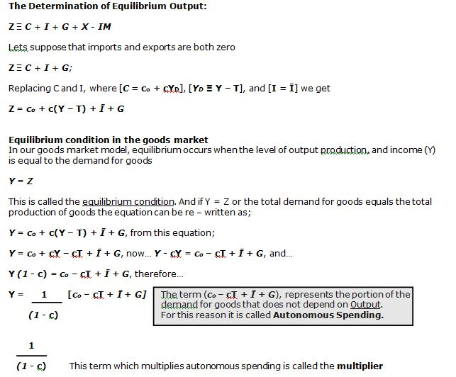

THE MULTIPLIER
The multiplier effect results from the behavior of households, who increase their consumer spending whenever their income increases.
Demand increases and firms produce more and income increases which causes consumer spending to increase. The amount by which they increase their consumer spending depends on the marginal propensity to consume and this will be less than the increase in income.
This increase in consumer spending means a further increase in the demand for goods and consequently a further increase in output and income take place, which in return increases consumer spending. The multiplier effect is thus in operation.
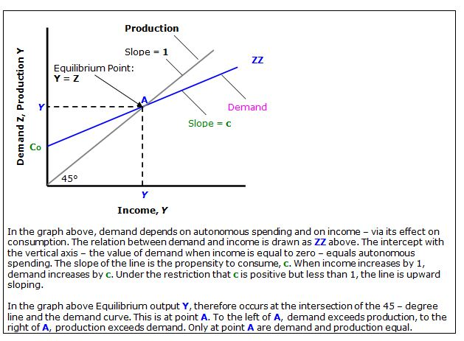
Equilibrium output
The equilibrium level of output is the level of output/production of goods and services is equal to the demand for the goods/output at that price point.
Autonomous spending
Autonomous spending consist of variables that are independent of the level of output, such as Investment, Government spending and consumer spending
Induced spending
Induced spending are those variables that are dependent on the level of income like consumer output.

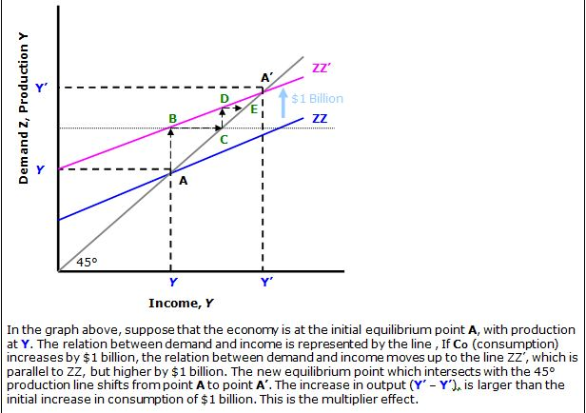
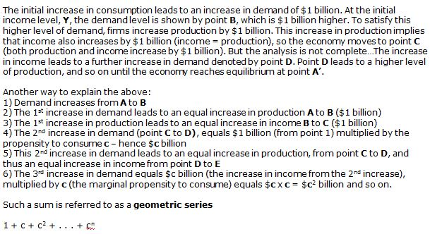
From the theoretical model of the goods market, the solution to unemployment seems to be as easy as increasing the demand for goods through increases in autonomous spending until full employment is reached.

But…it is not that easy…Full employment can be described as a situation where all available resources (labor, capital, land and entrepreneurship) are used to produce goods and services, and this is one of the objectives of macroeconomics.

If unemployment is caused mainly by a deficiency in the demand for goods, an increase in the demand for goods may be used to address it. However, a large part of the unemployment experienced in South Africa is of a structural nature.

Structural unemployment occurs when there is a mismatch between workers’ qualifications and job requirements, or when jobs disappear because of structural changes in the economy. Structural unemployment is usually confined to certain industries, sectors or categories of workers and is caused by factors such as a lack of education, training and skills, changes in production methods and techniques, changing consumer preferences, foreign competition, structural decline in certain industries and discrimination.

It would take more than an increase in the demand for goods to solve structural unemployment. Whilst an increase in the demand for goods might create more job opportunities, we might find ourselves in the ironic situation that, while there are more job opportunities, the unemployed are not able to fill these jobs owing to a lack of skills and training.

Jobless growth is another issue. While the increase in demand for goods increases the level of production, it does not necessarily follow that an increase in the level of output will create more jobs. Capital intensive firms require less labor than labor intensive firms, and the less labor that is required, the fewer the job opportunities.

Even if unemployment is caused by a deficiency in the demand for goods, the way in which the labor market reacts in the event of an increase in the demand for goods will determine whether demand policies are suitable. If an increase in the demand for goods leads to an increase in wages which causes an increase in prices and inflation, this might require the use of expenditure reducing policies (i.e. a decrease in the demand for goods) to keep inflation in check.

Conventional wisdom today requires that a limit be placed on the budget deficit, about 3% of GDP, in order to limit the impact of the budget deficit on interest rates, inflation and the balance of payments. With a goal to reduce a budget deficit and the ration of taxation on GDP, there is little scope for using government spending and taxation to pump up the demand for goods.

Increased government spending also impacts on the financial market, where the interest rate is determined, and under certain circumstances crowding out may occur. “Crowding out” is the term used to describe the situation where the rise is interest rates owing to increased government spending decreases investment spending by the private sector.

Exogenous variables
The variables that we can control. Government has two instruments it can use to influence the level of output, namely government spending (G) and taxes (T), both of which are policy variables of fiscal policy. In the goods market model, both are regarded as exogenous variables.

Endogenous variables
Variables that can not be controlled for example the value of investment is not determined by a variable such as the level of production
Fiscal policy
The government’s policy in respect of the level and composition of government spending, taxation and borrowing. The main instrument of fiscal policy is the budget and the main policy variables are government spending and taxation.
Budget deficit
The governments expenditure is more than its revenue – (G+R)-T (goods and transfer payments) – Taxes
Budget surplus
Governments’ spending is less than its revenue T-(G+R) Taxes – (goods +transfer payments)
Balanced budget
If the budget is balanced then G = T, (government spending will equal taxes collected)
Contractionary fiscal policy
“cool down” economy – used to decrease economic activity by decreasing the demand for goods. Government spending is decreased and taxes increased.
Expansionary fiscal policy
Used to stimulate the economy by increasing Government spending and/or reducing Taxes
Full employment
The situation where all available resources (labor, capital, land and entrepreneurship) are used to produce goods and services

STUDY UNIT 3 – FINANCIAL MARKET
FINANCIAL MARKET
Financial market
The financial market is where the interest rate is determined.
Wealth
Wealth consists of assets that have been accumulated over time such as fixed property, money, shares, oriental carpets or paintings.
Income
Income is the amount of funds, goods or services received by an individual, corporation or economy in a given time period. The main sources of income for households are: wages and salaries, interest, rent and profits. This income is received from firms who use the factors of production owned by households to produce goods and services.
Money
Money is anything that is generally accepted as a payment for goods and services or that is accepted in the settlement of debt – includes coins, notes and checking and savings account balances. Money pays no interest.
Bonds
Pay a positive interest rate (i), but can not be used for transactions
Money and Bond relations
Money is very convenient, but earns no interest. Bonds on the other hand earn interest. If all your wealth is held up in bonds, you will earn interest on the full amount, but you will need to constantly call your broker whenever you need cash for day to day living. An optimum balance must be used where wealth consists of both money and bonds, but in what proportions? This depends on two variables:
• Your level of transactions – Keep enough money on hand to prevent having to sell bonds too often. Hold twice your monthly expenses on hand. The rest of your disposable income should then be held in interest bearing investments or bonds.
• The interest rate on bonds – The only reason to hold wealth in investments or bonds is because they pay interest. When interest rates are high, you may decide to hold more wealth in investment than in cash and visa versa.
Demand for money
Demand for active balances
• The demand for active balances is influenced by peoples’ need to do transactions and the more transactions there are, the higher the demand for money.
• The level of transactions – and therefore the demand for active balances – is determined by the level of output and income in the economy.
• The higher the level of output and income in the economy, the more transactions there will be.
• As the level of output increases, the income of households also increases and they will want to do more transactions.
• They will therefore need more active balances and their demand for money will rise. As producers produce more output they will need more money to finance their transactions as well.
• Using the symbol Md for money, we can therefore, in terms of an events chain, state that:
Y↑ ⇒ active transactions↑ ⇒ Md↑
Y↓ ⇒ active transactions↓ ⇒ Md↓
• As the level of output and income (Y) rises in the economy the level of transactions increases and the demand for money (Md) rises – and vice versa.
Demand for passive balances
• The demand for passive balances, also referred to as the speculative demand for money, is related to the need by financial participants to keep wealth in the form of money – in this sense, money is viewed as a financial asset.
• Sometimes financial market participants wish to hold money not because they want to do active transactions, but because they have a need to keep their wealth in the most liquid asset there is – money.
• In our model, financial market participants have the choice between keeping money and bonds (treasury bills).
• The opportunity cost of holding money is the interest rate that is given up. The higher this interest rate, the higher the opportunity cost of holding money since keeping money earns no interest.
• A negative relationship exists between the interest rate (i) and the quantity of money demanded (Md).
• In other words, an increase in the interest rate reduces the quantity of money demanded and a decrease in the interest rate increases the quantity of money demanded.
• In terms of an events chain, this is represented as follows:
i↑ ⇒ passive demand for money↓ ⇒ Md↓
i↓ ⇒ passive demand for money↑ ⇒ Md↑
• There is, however, another important reason why money is held in passive balances and that has to do with the expected change in the price of treasury bills.
• If financial market participants expect the price of treasury bills to fall in the future they will be more inclined to hold money instead of treasury bills and vice versa
Deriving the Demand for money
The demand for money is represented by; Md, where d stands for demand. The demand for money depends on the overall level of transactions in the economy and on the interest rate. The overall level of transactions in the economy is likely to be roughly proportional to the nominal income.
Initially the demand for money is represented as;
Md = Y where an increase in income (Y) results in an increase in the demand for money (Md), and visa versa.
The relation between the demand for money, nominal income and the interest rate can be written as;
Md = YL(i) where Y; denotes nominal income, and the function of the interest rate (i)
(-) indicated by L(i), Md, denotes the demand for money. The minus sign
(-) indicates that the interest rate has a negative effect on the demand
for money i.e. an increase in the interest rate decreases the demand for
money, as people put more wealth into investments or bonds.
At a given level of income, the demand for money and the interest rate is represented by the Md curve. The curve is a downward sloping; the lower the interest rate (i), the higher the amount of money people want to hold (Md)
At a given interest rate, an increase in nominal income increases the demand for money. In other words, an increase in nominal income shifts the demand for money to the right from Md to Md’ So at interest rate (i), an increase in nominal income from Y to Y’ increases the demand for money from M to M’.
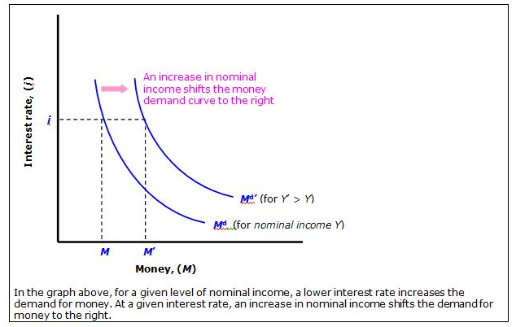

Demand for money
Money is required for transactions and the demand of money is the money needed for these transactions/ consumption
Exogenously determined money supply
An exogenously determined money supply implies that the money supply is determined by the central bank and is independent from the interest rate.
A change in the interest rate from i1 to i2 does not affect the money supply and this is depicted by a vertical line which is entirely inelastic with regards to the interest rate.
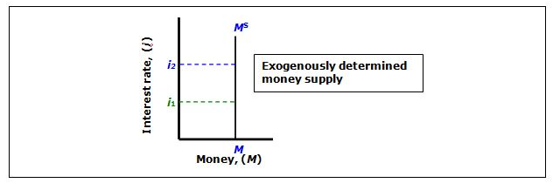
Demand determined money supply
A demand-determined money supply implies that the supply of money depends on the demand for money and the interest rate.
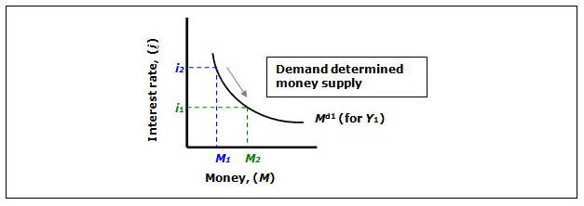

An increase and a decrease in the money supply
A demand-determined money supply implies that the supply of money depends on the demand for money and the interest rate.
Increase: If the central bank wishes to increase the money supply, it buys Treasury bills on the open market from a broker, commercial bank or individuals. The sellers of these bills receive money from the central bank, and thus the money supply increases. (Ms to Ms2)
Decrease: If the central bank wishes to decrease the money supply, it sells Treasury bills on the open market to a broker, commercial bank or individuals. The buyers of these bills pay the central bank with money, and thus the money supply decreases. (Ms to Ms1)
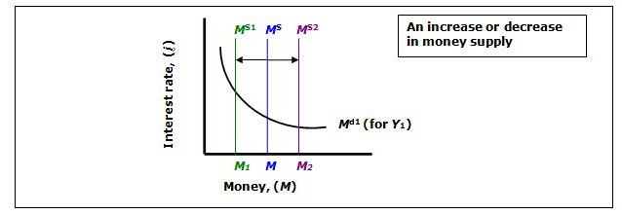
Determining the Interest rate
Equilibrium in financial markets requires that money supply be equal to money demand, or
Ms = Md where s denotes the supply, and d the demand.
Money supply = Money demand, so
M = YL(i)
This equation tells us that the interest rate, (i), must be such that, given their income (Y), people are willing to hold an amount of money equal to the existing money supply M.
This equilibrium relation is called the LM relation
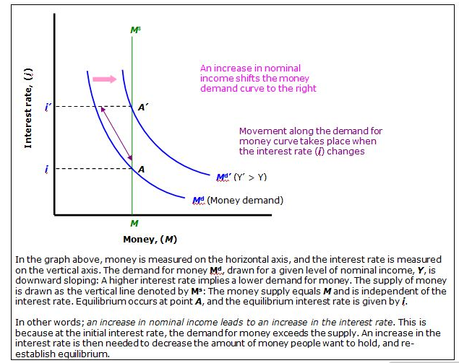

Equilibrium condition in the financial market
Equilibrium in the financial market is established at the point where the demand for money equals the supply of money
Ms = M d where s denotes the supply, and d the demand.
Interest rate
The interest rate is the price of borrowed money or the return that is earned on invested funds. The rate is expressed as a % per annum.
Monetary policy
Monetary policy can be defined as measures taken by the monetary authorities to influence the quantity of money or the rate of interest with a view to achieving stable prices, full employment and economic growth.
An increase in the level of income and output (Y ↑ ) increases the demand for money (Md ↑ ) for transaction purposes.
On the bonds market the supply of bonds increases and the price of bonds falls (Pb ↓ ) and the interest rate rises (I ↑ )
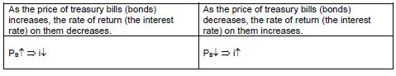

Expansionary monetary policy: If the central bank wishes to adopt an expansionary monetary policy, the central bank buys Treasury bills on the open market.
The purchase of these bonds causes the money in circulation to increase, and the price of bonds then increases, the result of this open market operation causes the interest rate to decrease. (Ms to Ms2) Pb↑ to i↓)
Contractionary monetary policy: If the central bank wishes to adopt a contractionary monetary policy, the central bank sells Treasury bills on the open market.
The sale of these bonds causes the money in circulation to decrease, and the price of bonds then fall, the result of this open market operation causes the interest rate to increases. (Ms to Ms1) Pb↓ to i ↑)
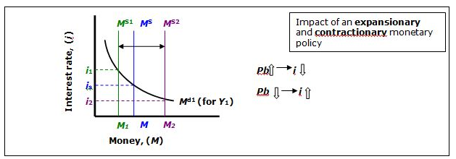

Open market operations
Open-market operations only, which consists of the sale or purchase of domestic financial assets such as Treasury bills by the central bank in order to exert a specific influence on the quantity of money in circulation and the interest rate. If the central bank wants to increase the amount of money in the economy, it buys binds and pays for them by creating money.
If the central bank wants to decrease the amount of money in the economy, it sells bonds and removes money from circulation by paying for the bonds. These operations are called open market operations.
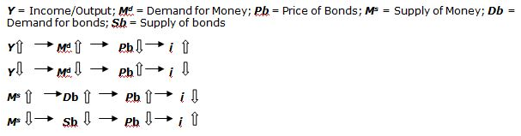
Treasury bills
Treasury bills, also called TBs, are short-term financial market instruments which are issued by government when it borrows from the public in order to finance its budget deficit. They are fully secured and guaranteed by the government.
Contractionary monetary policy
If the central bank wishes to decrease the money supply in order to increase the interest rate in the financial market, it must convince financial market participants to switch from money to Treasury bills. This requires a lower price for Treasury bills which implies a higher interest rate.
Expansionary monetary policy
If the central bank wishes to increase the money supply in order to change the interest rate, it needs to convince financial market participants to sell their Treasury bills to the central bank at a higher price than paid and the interest rate will be decreased.
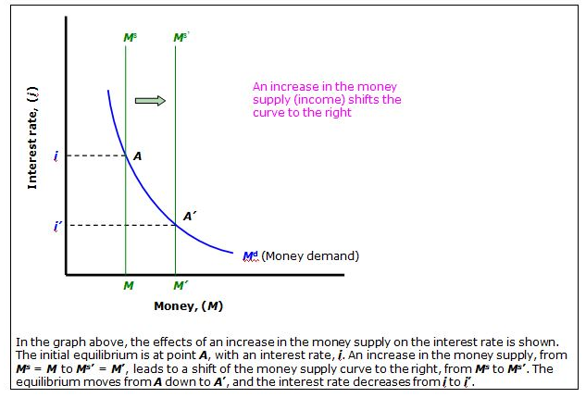

STUDY UNIT 4 – IS AND LM CURVES
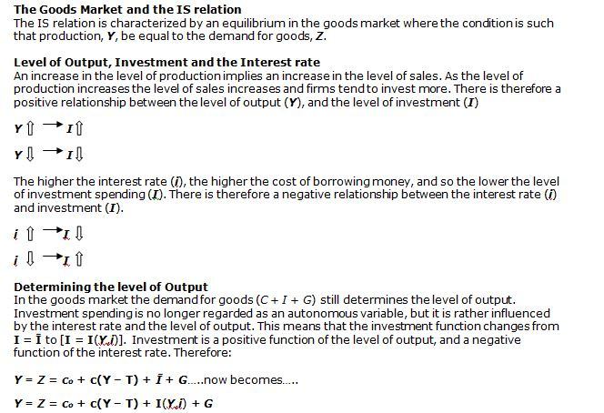

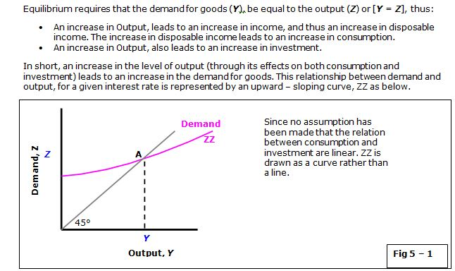

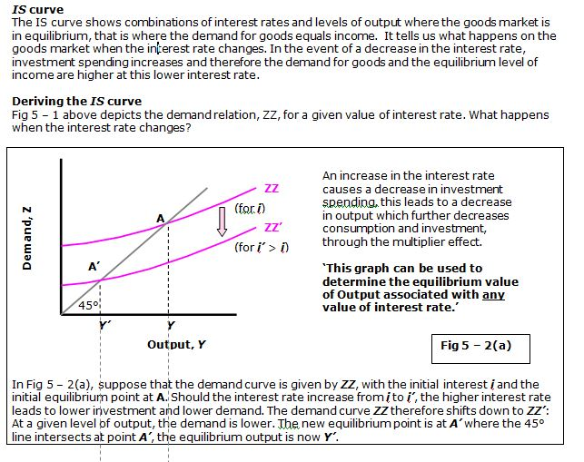
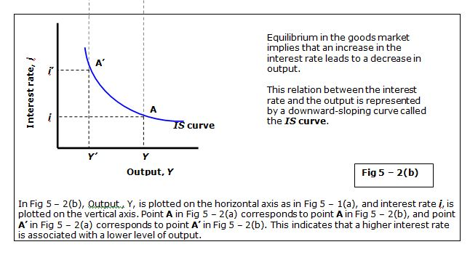
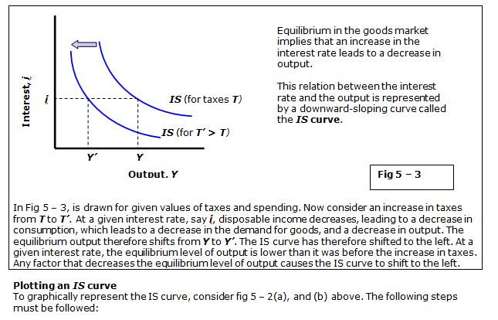
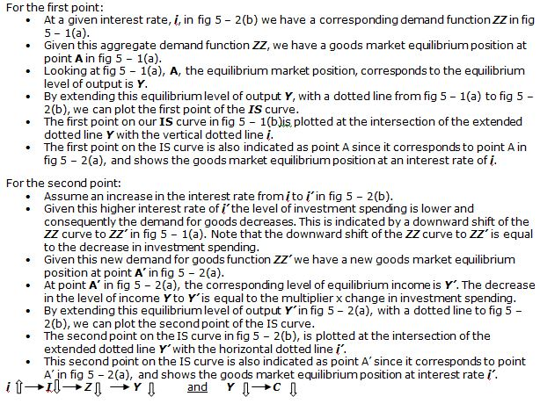
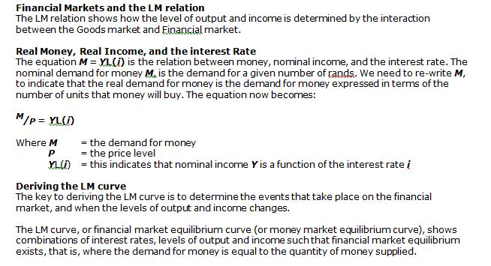
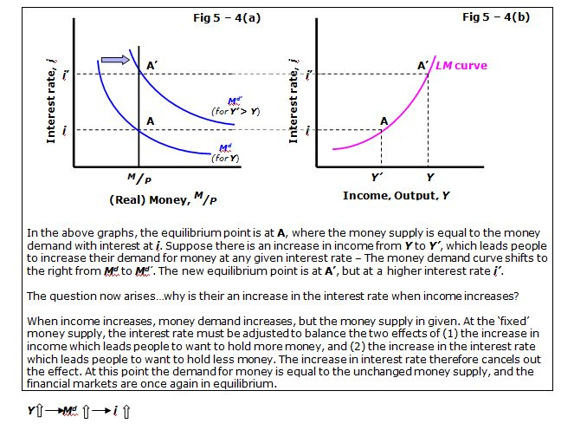
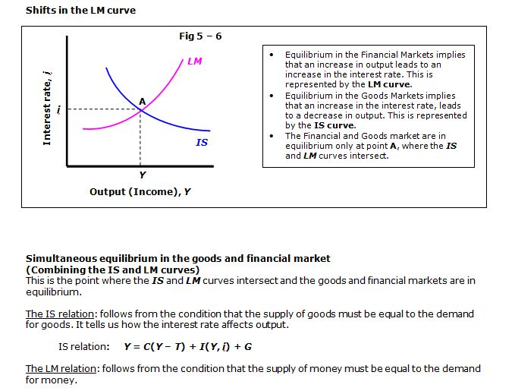
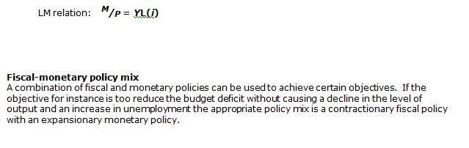
Study unit 5 Openness in goods and financial markets
Learning outcomes
• explain the concept of openness in the goods market
• define the nominal exchange rate
• distinguish between changes (appreciation and depreciation) of the nominal exchange rate
• define the real exchange rate
• distinguish between changes (appreciation and depreciation) of the real exchange rate
• explain the relationship between the nominal exchange rate and the real exchange rate
• explain the impact of changes in the domestic price level and foreign price level on the real exchange rate
• explain the concept of openness in the goods market
Openness in the goods market refers to the ability of consumers and firms to choose between domestic and foreign goods. While there are different ways of measuring the openness of the goods market, the most popular is to express imports and exports as a percentage of GDP. In South Africa, exports for 2013 were 24.63% of GDP and imports 32.14% of GDP, indicating that South Africa can be regarded as an open economy.
The choice between domestic goods and foreign goods
When goods markets are open, economic participants (households, firms and government) have a choice between buying domestic goods or foreign goods. A key factor that influences this decision is the price of domestic goods relative to foreign goods. In other words, the real exchange rate plays a vital role in this decision. The factors that impact on the real exchange rate are the nominal exchange rate, the domestic price level and foreign price level. It is therefore essential that you understand how these factors determine the real exchange rate. We will start with the nominal exchange rate.
• define the nominal exchange rate
Nominal exchange rate (E)
Note that there are two ways in which the nominal exchange rate can be defined.
Price of foreign currency in terms of the domestic currency ($1 = R)
One way is to express the price of foreign currency in terms of the domestic currency (e.g. $1 = R), and this is the common practice in South Africa – for instance, $1 = R8.6734. This is the rate you see on the television news, hear on the radio and read about in the newspapers. The convention of four decimal places is adopted because of the massive size of many transactions on the foreign exchange markets, which means that even small changes in exchange rates can give rise to substantial absolute changes in the value of such transactions.
Price of the domestic currency in terms of foreign currency (R1 = $)
The other way is to express it as the price of the domestic currency in terms of foreign currency (e.g. R1 = $). In the case of South Africa, this means that the price of the rand (the domestic currency) is expressed in terms of dollars, pounds, euros, and so forth. For instance, R1 = $0.20 means that the price of a rand in terms of dollars is 0.20 dollars. With R1, South Africans can buy 20 US cents and Americans can buy R1 with 20 US cents.( If the nominal exchange rate is defined as the price of foreign currency (dollars) in terms of the domestic currency (rand), the exchange rate is $1 = R5.)
• distinguish between changes (appreciation and depreciation) of the nominal exchange rate
An appreciation
An appreciation in the nominal exchange rate occurs when the price of the domestic currency in terms of the foreign currency increases. A change from R1 = $0.20 to R1 = $0.25 implies an increase in the nominal exchange rate (E) because the rand is worth more in terms of dollars than before. With R1, South Africans can now buy 25 US cents, while Americans must pay 25 US cents to buy R1. The domestic currency, in this case the rand, appreciates. For R1, more dollars can be obtained than before. [Expressing the nominal exchange rate in terms of the price of the dollar, it changes from $1 = R5 to $1 = R4 (fewer rands are needed to buy a dollar).]
In other words, if the exchange rate, expressed as R1=$, increases (E↑), then the domestic currency appreciates.
Depreciation
A depreciation in the nominal exchange rate occurs when the price of the domestic currency in terms of the foreign currency decreases. A change from R1 = $0.20 to R1 = $0.15 implies a decrease in the nominal exchange rate. The domestic currency, in this case the rand, depreciates because for R1, one obtains fewer dollars. [In terms of the price of foreign currency, it changes from $1 = R5 to $1 = R6.66 (more rands are now needed to buy a dollar).]
In other words, if the exchange rate expressed as R1 = $, decreases (E↓), then the domestic currency depreciates.
Note that the terms “appreciation” and “depreciation” are used when a flexible (floating) exchange rate system is in operation; under a fixed exchange rate system, the terms used would be “revaluation” (in the place of an appreciation) and “devaluation” (in the case of a depreciation).
• define the real exchange rate
From nominal (E) to real exchange rates (ε)
While the nominal exchange rate between the rand and the dollar tells us how much a dollar will cost us, the real exchange rate tells us what happens to the relative price of domestic goods in terms of foreign goods. It gives us some indication of the affordability of domestic goods compared with foreign goods and it is this relative price that influences economic participants’ choice between domestic and foreign goods.
• distinguish between changes (appreciation and depreciation) of the real exchange rate
The following example demonstrates the impact of a change in the nominal exchange rate on the real exchange rate:
Assume the following:
Year 1
GDP deflator for South Africa: 110
GDP deflator for the USA: 110
The nominal exchange rate: R1 = $0.20
Given this information, the real exchange rate is
ε = 0.20 x 110/110 = 0.2 x 1 = 0.2
This real exchange rate of 0.2 is an index number and does not tell us much. What is important is what happens to the value over time.
Year 2
GDP deflator for South Africa: 110
GDP deflator for the USA: 110
The nominal exchange rate: R1 = $0.10
Given this information, the real exchange rate is
ε = 0.10 x 120/110 = 0.1 x 1.1 = 0.11119 ECS2602/001
• explain the relationship between the nominal exchange rate and the real exchange rate
From nominal (E) to real exchange rates (ε)
While the nominal exchange rate between the rand and the dollar tells us how much a dollar will cost us, the real exchange rate tells us what happens to the relative price of domestic goods in terms of foreign goods. It gives us some indication of the affordability of domestic goods compared with foreign goods and it is this relative price that influences economic participants’ choice between domestic and foreign goods.
• explain the impact of changes in the domestic price level and foreign price level on the real exchange rate
Impact of interest rate and exchange rate
In assessing whether to invest in foreign or domestic bonds, the interest rate, exchange rate and expectations about the future exchange rate play an important role.
The following example illustrates this:
Suppose you are a South African and lucky enough to have a R100 000 available that you will not need for transactions. After doing some research on different financial investment opportunities you ended up with having to choose between buying one-year South African bonds or one-year USA bonds. What would you do based on the following information?
Interest rate on a one year South African bond = 4%
Interest rate on a one year USA bond = 3.8%
Current exchange rate: R1 = $0.10
Expected exchange rate: R1 = $0.11
Using formula 18.7 in the textbook, the calculations are as follows:
Return on South African bond
R100 000 (1 + 0.04) = R104 000
Return on USA bond:
At an exchange rate of R1 = $0.10 your investment in USA bonds, in dollars, is equal to R100 000 x $0.10 = $10 000.
Your investment after one year, in dollars, is worth:
$100 000 (1 + 0.038) = $10 380.
Converting $10 380 back into rands at the expected exchange rate of R1 = $0.11 gives you $10 380/0.11 = R94 363.64
From the calculations it is clear that you should be buying South African bonds.
But what if the expected exchange rate turned out to be R1 = $0.09. Was it still the best decision? The answer is “no” since, at an exchange rate of R1 = $0.09, you would get back $10 380/0.09 = R115 333.30. You should rather buy USA bonds.
OPENNESS IN THE FINANCIAL MARKETS Study Unit 5.1
Learning outcomes
-openness in financial markets
-The South African balance of payments
-Interest parity condition
-Choice between domestic and foreign bonds
-Interest rates and exchange rates
openness in financial markets
Openness in financial markets refers to the ability of financial investors not only to choose between money and domestic financial assets, but also to include foreign financial assets in their portfolio. See the prescribed book page for a discussion of why openness in the financial market allows a country to have a trade deficit or trade surplus
The South African balance of payments
Trade balance and balance on current account
The trade balance is the difference between trade exports and imports. It is, however, not always clear whether services are included or excluded in this figure. To indicate that it excludes services, one could make use of the concept merchandise trade balance. This will then be the difference between merchandise exports (including net gold exports) and merchandise imports.
The balance on the current account is the difference between all the sales of goods and services to the rest of the world and all the primary income receipt minus all the purchases of goods and services from the rest of the world and primary payments.
Interest parity condition
If financial investors’ only concern is the expected rate of return, they will hold only the assets with the highest expected rate of return. Combining this behavior with the free flow of financial capital, the arbitrage process will ensure that the expected rate of return between financial assets in the world will ultimately be the same.
One way to look at the arbitrage process is to assume that the expected exchange rate will be the same as the current exchange rate. If country A offers a higher return than country B, then capital will flow to country A where the demand for financial assets will increase. This will lead to an increase in the price of these assets and therefore a decline in the return on these assets. This process of arbitrage continues until the rate of return is the same in both countries.
Choice between domestic and foreign bonds
The choice between SA bonds and US bonds
Suppose the one-year nominal interest rate is as follows:
Domestic interest rate in South Africa (i): 5%
Interest rate in the USA (i*): 2%
Should you hold SA bonds or US bonds?
• It depends whether you expect the rand to depreciate versus the dollar over the coming year by more or less than the difference between the SA interest rate and the US interest rate, in this case 3% (5%–2% = 3%).
• If you expect the rand to depreciate by more than 3%, then, despite the fact that the interest rate is higher in SA than in USA, investing in SA bonds would be less attractive than investing in US bonds. By holding SA bonds, you will receive higher interest payments, but the rand will be worth less in terms of dollars, making investing in SA bonds less attractive than investing in US bonds.
• If you expect the rand to depreciate by less than 3%, or even to appreciate, then the reverse holds, and SA bonds are more attractive than US bonds.
Impact of interest rate and exchange rate
In assessing whether to invest in foreign or domestic bonds, the interest rate, exchange rate and expectations about the future exchange rate play an important role.
The following example illustrates this:
Suppose you are a South African and lucky enough to have a R100 000 available that you will not need for transactions. After doing some research on different financial investment opportunities you ended up with having to choose between buying one-year South African bonds or one-year USA bonds. What would you do based on the following information?
Interest rate on a one year South African bond = 4%
Interest rate on a one year USA bond = 3.8%
Current exchange rate: R1 = $0.10
Expected exchange rate: R1 = $0.11
Using formula 18.7 in the textbook, the calculations are as follows:
Return on South African bond
R100 000 (1 + 0.04) = R104 000
Return on USA bond:
At an exchange rate of R1 = $0.10 your investment in USA bonds, in dollars, is equal to R100 000 x $0.10 = $10 000.
Your investment after one year, in dollars, is worth:
$100 000 (1 + 0.038) = $10 380.
Converting $10 380 back into rands at the expected exchange rate of R1 = $0.11 gives you $10 380/0.11 = R94 363.64
From the calculations it is clear that you should be buying South African bonds.
But what if the expected exchange rate turned out to be R1 = $0.09. Was it still the best decision? The answer is “no” since, at an exchange rate of R1 = $0.09, you would get back $10 380/0.09 = R115 333.30. You should rather buy USA bonds

Study Unit 8: MORE MACROECONOMIC THEORY AND POLICY:
The aggregate demand-aggregate supply model:
• The AD (aggregate-demand)-AS (aggregate-supply) serves as a guide to policy-making.
• Deals with the general level of prices in the economy (eg: consumer price index), instead of the price of a particular good or service, and the total production of goods and services (eg: gross domestic product).
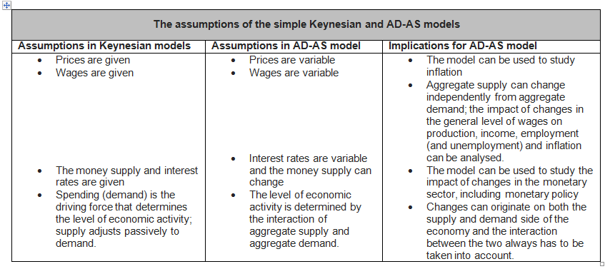
• The decrease in the price level will be accompanied by an increase in total real expenditure (or the total quantity demanded) and that an increase in the price level will give rise to a decrease in total real expenditure (or the aggregate quantity demanded), ceteris paribus.

• The increase in the price level will give rise to an increase in real production supplied (or the aggregate quantity supplied) and a decrease in the price level will lead to a fall in real production (or the total quality supplied).

What determines the position:
• Changes in any of these non-price determinants or aggregate demand and aggregate supply will give rise to shifts of the curves.

The aggregate demand curve:
Determined by everything that influences total expenditure (A) in the economy.
Include: C, I, G, T, X, Z. As well as all factors which influence these.
Most important factor = Interest rate (i) – which influences consumption and investment spending.

Along with government spending and taxes (the basic instruments of fiscal policy) the interest rate (the basic instrument of monetary policy) is an important policy variable which influences aggregate demand in the economy.

An expansionary fiscal policy
• (an increase in government spending G and/or a decrease in taxes T) will increase aggregate demand in the economy at each price level and this can be illustrated by rightward shift of the AD curve.
Contractionary fiscal policy
• (a decrease in G and/or an increase in T) can be illustrated by a leftward shift of the AD curve – increase in the repo rate is illustrated by a leftward shift of the AD curve.
• Decrease in the repo rate (expansionary monetary policy) by a rightward shift of the AD curve.
Study unit 9: The AS-AD model

Learning outcomes

The aggregate supply relationship
The derivation of the aggregate supply curve
The aggregate demand curve
The derivation of the aggregate demand curve
Equilibrium in the short run
The adjustment from the short to the medium run
The impact of monetary policy
The neutrality of money
The impact of fiscal policy
The impact of an increase in the price of oil (supply shock)

The aggregate supply relationship
Note that when the AD curve is derived it is done by assuming a change in the price level.
Fig (a)
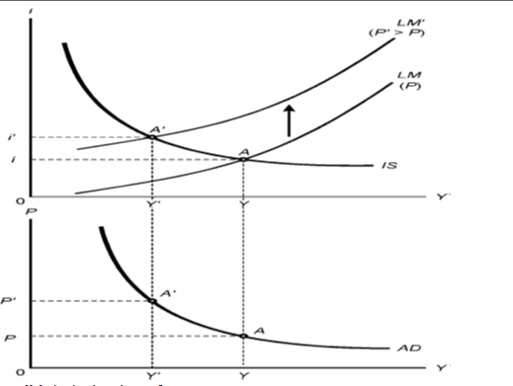

Fig (b) derivation of an AD curve
Plotting the first point A of the AD curve

Step 1: At a given price level of P in figure b, there are corresponding IS and LM curves in figure a. The IS curve is drawn for a given level of G and T and the LM curve is drawn for a given value of M/P.

Step 2: In figure a, at a price level of P, equilibrium in the goods and financial markets occurs at point A. At this equilibrium position, the equilibrium level of output and income is Y and the equilibrium interest rate i.173 ECS2602/001

Step 3: To plot the first point of the AD curve, the equilibrium level of output and income in figure a is extended as a dotted vertical line to figure b. The first point of the AD curve is plotted at the intersection of the dotted vertical Y-line with the dotted horizontal P-line, and this is called point A. This point A indicates that at a price level of P the goods and financial markets are in equilibrium at an output and income level of Y. This point A in figure b corresponds to point A in figure a.

Plotting the second point A’.
Step 4: Assume an increase in the price level from P to P’ in figure b.
Step 5: This increase in the price level implies that the real money supply (M/P) is lower. A lower real money supply shifts the LM curve to the left in figure a. As the real money supply decreases, the interest rate rises. As the interest rate rises, investment spending and the demand for goods decreases and the level of output and income declines. There is an upward movement along the IS curve.

Step 6: This increase in the interest rate, which causes a decrease in investment spending, the demand for goods and the level of output and income, continues until a new equilibrium is reached at point A’. At this new equilibrium position, the interest rate is i’ and the equilibrium level of output and income is Y’.

Step 7: To plot the second point of the AD curve, the new equilibrium level of output and income Y’ in figure a is extended as a dotted vertical line to figure b. The second point of the AD curve is then plotted at the intersection of the dotted vertical Y’-line with the broken horizontal P’-line, and is called point A’. This point A’ indicates that at a price level of P’ the goods and financial markets are in equilibrium at an output and income level of Y’. This point A’ in figure b corresponds to point A’ in figure a.

The AD curve shows a negative relationship between the price level and the level of output and represents combinations of the price level and the level of output and income where the goods and financial markets are in equilibrium.
The derivation of the aggregate supply curve

Shifts of the AD curve
It is essential for you to be able to distinguish clearly between a movement along the AD curve and a shift of the AD curve. A movement along the AD curve is caused by a change in the price level, while a shift in the AD curve is caused by a change in any of the autonomous (or exogenous) variables, such as taxes, government spending or the nominal money supply. Remember that exogenous variables include factors such as autonomous consumption and autonomous investment.
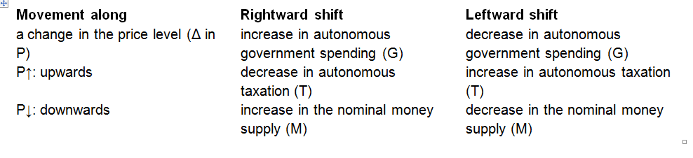
The aggregate demand curve
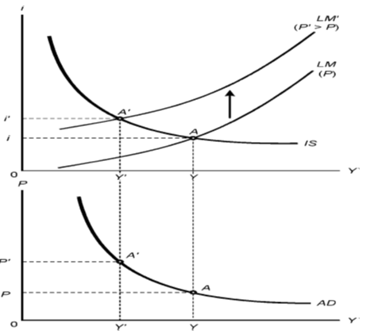
Fig c (AD, Aggregate demand curve dimensions)
The AD curve shows a negative relationship between the price level and the level of output and represents combinations of the price level and the level of output and income where the goods and financial markets are in equilibrium.

The derivation of the aggregate demand curve

In terms of the AS-AD model, the increase in the expected price level is represented by a shift of the AS curve to the left. The impact on the financial and goods market is represented by an upward movement along the AD curve.
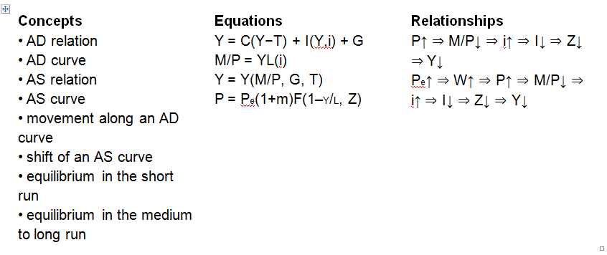

Equilibrium in the short run
A distinction is made between the short and medium run. In the short run, it is possible to be at a position away from the natural level of production and employment. In the medium run, however, the economy returns to the natural level of output and employment.
Also note that the short run will last for as long as the expected price level remains unchanged. Once the expected price level changes, the medium run starts.

A position away from the natural level of production and employment implies that the actual price level and the expected price level differ. At a position such as point A in figure 7-5 in the prescribed book, the expected price level is lower than the actual price level (Pe < P). It is this upward revision of the expected price level and the impact of this on nominal wages that eventually moves the economy back to the natural level of production and employment in the medium to long run.

The adjustment from the short to the medium run

From the short to the medium to long run
As workers revise their price expectations upwards, they increase their nominal wage demands. Firms react to this rise in the nominal wages by increasing the prices of goods and services. This increase in the price level, however, affects the financial market, where an increase in the price level reduces the real money supply, which in turn causes an increase in the interest rate and a decrease in investment spending, which lowers the demand for goods and the level of output declines.

In terms of a chain of events, this can be represented as follows:
Pe↑ ⇒ W↑ ⇒ P↑ ⇒ M/P↓ ⇒ i↑ ⇒ I↓ ⇒ Z↓ ⇒ Y↓
This process continues until the natural level of output and employment is reached, where the expected price level (Pe) = the actual price level (P). This then is the long run position. Note that the prescribed book does not specify the long run – it only refers to the medium run.

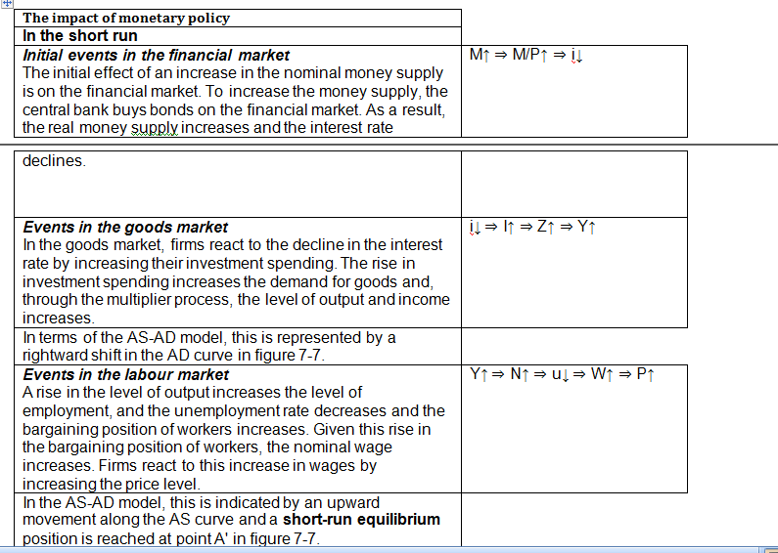
The neutrality of money

The interesting thing about the impact of an expansionary monetary policy is that in the medium run to long run, it is neutral, which means that it only changes nominal variables and not the real variables in the model. Comparing point A” (the long run position) with point A (the initial position), it is clear that not only are the level of output and income, the level of employment and the unemployment rate what they were before the increase in the nominal money supply, but the real money supply, the interest rate, investment spending, government spending and the real wage are also equal to their original values. What has changed? In this case, the nominal variables namely the nominal money supply, the nominal wage and the price level, are higher.

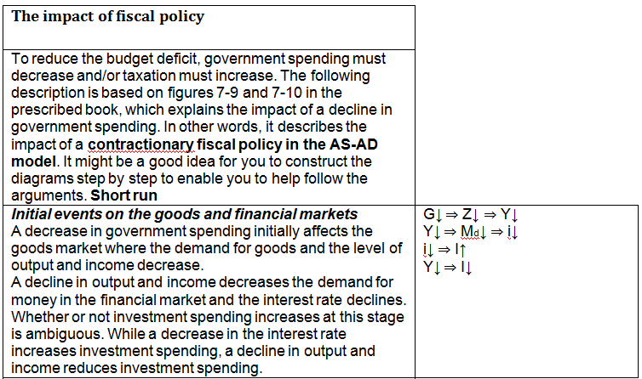
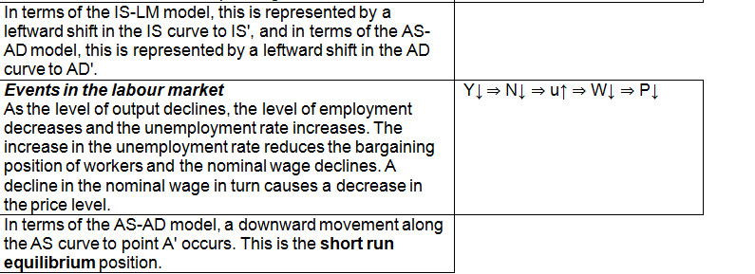

The impact of an increase in the price of oil (supply shock)
Impact on the supply curve and the labour market
When the properties of the AS curve were discussed, the assumption was made that the only cost of production is labour cost. To incorporate the impact of an increase in the price of oil, without changing this assumption, an increase in the markup over labour cost is used to take this increase in cost of production into account.
This increase in the markup has two significant effects:
▪ It increases the price level, and at every level of output, the price level is now higher. The result is that the AS curve shifts to the left.
▪ It increases the natural rate of unemployment. In the labour market the real wage implied by price setting is now lower – the PS curve shifts downwards. It is at a higher unemployment rate that the bargained real wage (targeted real wage) is equal to the real wage implied by price setting (feasible real wage).

Question bank

Question 1

Which of the following statements is/are correct?
a) In this module we only study the demand side of the economy which includes the goods market and the financial market. The labour market form part of the supply side analysis and are therefore excluded from this module.
b) The two most important accounts of the balance of payments are the current account and the financial account.
c) If total output decreases with 2% during a specific year and the general price level increases with 4% the real GDP will decrease and the nominal GDP will increase.
1) a, b and c

2) Only a and b
3) Only a and c
4) Only b and c. (Correct option is 4.)
5) None of the options 1 t o 4

Explanation
The two important accounts of the balance of payments are the current account and the financial account. If the rise in the general price level is more that the rise in nominal production then the real production (GDP) declines while the nominal production (GDP) increases.

Question 2
Consider the consumption functions of country A and country B.
Country A: C = 2 000 + 0.7Y D
Country B: C = 1 000 + 0.9Y D
Which of the follow ing state ments is/are correct?
a) In country A autonomous consumption is higher than in country B.

b) In country B induced consumption is definitely higher than in country A.
c) In country B total consumption is definitely higher than in country A.

1) Not a, b or c

2) Only a. (Correct option is 2.)
3) Only b
4) Only c
5) None of the options 1 t o 4

Explanation

In country A autonomous consumption is 2 000 while in country B it is 1 000. It is therefore higher in country A.
Induced consumption is that part of consumption that depends on income. To know what the induced consumption is we need not only to know what the marginal propensity to consume is but also what the income is. We can therefore not conclude that it is definitely higher in country B.
What total consumption is, depends on what the level of income is. Since we do not know what the level of income is, we do not know what the total consumption is.

Question 3
Which of the following statements with regards to the following consumption function? C = c0 + cYD is/are correct?

a. A change in the marginal propensity to consume will result in a change in income.

b. If autonomous consumption should be zero consumption will be equal to cYD.

c. A change in autonomous consumption will cause a change in marginal propensity to consume.

1) a, b and c

2) Only a and b
3) Only a and c
4) Only b and c
5) None of the options 1 to 4 (correct option is 5.)

Explanation
A change in the marginal propensity to consume implies that a higher proportion of income is spent and this will then result in a change in consumption spending and not in income.
If autonomous consumption is zero the part that is left is cYD.
A change in autonomous consumption does not cause a change in the marginal propensity to consume.

Question 4
In the goods market model a decrease in taxes will result in …
a) an increase in autonomous consumption.

b) an increase in disposable income.
c) an increase in income.
d) a decrease in induced consumption.

1) a, b and c

2) a, b and d

3) b, c and d
4) a, c and d
5) None of the options 1 to 4 (correct option is 5.)

Explanation
A decrease in taxes increases disposable income and consequently induced consumption spending increases. As consumption spending increases producers increase production and consequently income increases. The multiplier effect is in operation.
A decrease in taxes does not impact on autonomous consumption.
Only alternatives b and c are correct and therefore the correct option is 5.

Question 5
Which of the following are correct in terms of the goods market model?
a) G↑ → Z↑ → Y↑ → YD↑ → C↑

b) I↑ → Z↑ → Y↑ → YD↑ → C↑

c) T↓ → Z↑ → Y↑ → YD↑ → C↑

d) c0↑ → Z↑ → Y↑ → YD↑ → C↑

1) Only a, b and c

2) Only a, b and d (The correct option is therefore 2.)
3) Only b, c and d
4) Only a, c and d
5) a, b, c and d

Explanation
All the chain of events except c is correct. For c to be correct is should have been as follows:
T↓ → YD↑ → C↑ → Z↑ → Y↑

Question 6
Which of the following is/are correct in terms of the goods market model?
a) Autonomous consumption is represented by c0 + Ī + G – cT.

b) Induced consumption is presented by cYD.

c) The demand for goods determines the amount of goods that producers produce and they will only change their production if the demand for goods changes.
d) Equilibrium is presented by Y = c0 + c(Y−T) + Ī + G.

1) a, b, c and d
2) Only a, b and d
3) Only a, c and d
4) Only a, b and c
5) Only b, c and d (The correct option is therefore 5.)

Explanation
All the statements except statement a is correct. Autonomous consumption is only c0.

Questions 7 to 13 are based on the following data for the country PORTHOS for 2011.
Marginal propensity to consume = 0.5
Autonomous consumption = R600 million
Investment = R40 million
Government spending = R280 million
Taxes = R30 0 million

Question 7
Which of the following statements is/are correct?
a) The value of the multiplier is equal to 2.

b) The budget surplus is R20 million.
c) The equilibrium level of output and income is R1 540 million.
d) Total consumption is R1 220 million.

1) Only a, b and c

2) Only a, b and d

3) Only b, c and d
4) Only a, c and d
5) a, b, c and d (correct option is 5.)

Explanation
To answer this question correctly you must do the following:
Calculate the multiplier. The formula for the multiplier is 1/1-c. Given a marginal propensity to consume of 0.5 the value of the multiplier is 2.
Calculate the equilibrium level of output and income. The formula for the equilibrium level of output and income is
Given the information in the question the equilibrium level of income is 2 x (600 million + 40 million + 280 million –
0.5(300 million)) = 2 x R770 million = R1 540 million. Note that you must subtract cT.
Calculate the budget balance. The budget of government is the difference between tax revenue and government
spending (T – G) or (G – T). In this case there is a budget surplus of R20 million since T = R300 million and G = R280
million.
Calculate consumption spending at the equilibrium level of output and income. The consumption spending in this
model is C = co + cYD. Given a value of R600 million for c0 and YD
= Y – T = (R1540 million – R300 million) = R1 240 million, consumption spending at the equilibrium level of income =
600 + 0.5(1 240) = R600 million + R620 million = R1 220 million.
All the statements are correct and therefore the correct option is 5.

Question 8
An economist Dr B right Spa k calculated that the gap between the current level of output and income and the full
employment level of income is R110 million.
Which of the following will en sure that full employment is re ached?
a) An increase in government spending of R8 0 million which will result in a budget deficit of R10 million.
b) A decrease i n taxation of R160 million which will result in a bud get deficit of R90 million.
c) An increase in government spending of R4 0 million and a decrease in taxation of R80 million which will
result in a budget deficit o R50 million.
1) a, b and c
2) Only a and b
3) Only a and c
4) Only b and c
5) None of the options 1 t o 4 (correct option is 5.)

Explanation
The following diagram shows the economy of PORTHOS.
The vertical intercept is 770: c0 + Ī + G – cT = 600 + 40 + 280 – 0.5(300) = R920 million – R150 million = R770 million.
The equilibrium level of income is R1 540 million and the level of full employment R1 650 million, that is R1540
million + R110 million (the output and income gap)
Question 9 The President of the country Mr Cold Water is not interested in full employment. He is only interested to win the general elections during the current fiscal year and decide d to cut taxes with R1 50 million. By how much will the level of output and income increases if taxes are cut by R150 million?
- 1) R150 million. (The correct alternative is therefore 1.)
- 2) R300 million.
- 3) R75 million.
- 4) R50 million

Explanation If taxes are cut by R150 million the output and income increases by c(T) x the multiplier = 0.5(150 million) x 2 = R75 x 2 =R150 million.

Question 10 Mr Cold Water then realised that the country cannot afford an increase in the budget deficit due to its inability to raise loans to finance the budget deficit. He decided to keep the tax cuts at a R150 million and a budget surplus of R20 million.
To ensure a budget surplus of R20 million the government will have to ...
- 1) cut government spending with R80 million.
- 2) cut government spending with R75 million.
- 3) cut government spending with R150 million. (The correct alternative is therefore 3.)
- 4) increase government spending by R100 million.

Explanation To ensure that the budget surplus is unchanged at R20 million government spending must decrease by R150 million to compensate for the decrease of R150 million in tax revenue. Taxes is now R300 million – R150 million = R150 million. To keep the budget surplus unchanged at R20 million (as calculated in question 7) government spending must be equal to R130 million because T – G = R150 million – R130 million = R20 million. Government spending must therefore decreased by R150 million since R280 million – R150 million = R130 million.

Question 11 The end result of the actions by Mr Cold Water is that the level of output and income will …
- 1) increase by R150 million.
- 2) increase by R300 million
- 3) be unchanged.
- 4) decrease by R150 million. (The correct option is therefore 4.)
- 5) decrease by R300 million.

Explanation To be able to answer this question you must understand the balanced budget multiplier. The balanced budget multiplier indicates that an equal change in government spending and taxes, while leaving the budget unchanged, still have an impact on the level of output and income.
In the case of an equal increase in government spending and taxes it will have a stimulatory impact on the level of output and income while for an equal decrease in government spending and taxation it will have a contractionary impact. In this case study taxes decreased by R150 million (given in question 9) while government spending also decreased by a R150 million (calculated in question 10). The end result is that the economy contracts with R150 million. The reasoning for this as follows: The impact of a decrease in taxation: When dealing with taxation you have to remember that, unlike government spending, taxation influence the demand indirectly through the consumption function (which captures the behaviour of households). According to this function households will increase their consumption spending as their income increase but the increase in consumption is less than the increase in income. This effect is captured by the marginal propensity to consume. Therefore, in this model the decrease in taxation of R150 million causes an increase in disposable income (YD) of R150 million. This increase in disposable income causes consumption spending to increase not by R150 million but by c x YD = 0.5 x R150 million = R75 million. So, the injection in the economic system is R75 million and it is from this basis that the multiplier operates. The increase in output and income is therefore equal to the multiplier x c(T) = 2 x 0.5(150) = 2 x 75 = R150 million. The decrease in government spending of a R150 million causes autonomous spending (this is the leakage) to decrease by R150 million. It is from this basis that the multiplier starts to operate and the decrease in output and income is equal to the multiplier times the change in government spending = multiplier x G = 2 x R150 million = R300 million. Thus, the decrease in taxes leads to an increase of R150 million in the level of output and income while the decrease in government spending leads to a decrease of R300 million in the level of output and income. The end result is therefore: Increase in income due to the decrease in taxes – decrease in income due to decrease in government spending = R150 million – R300 million = –R150 million. Note: In your goods market diagram the demand for goods curve shifts upwards with 75 million and then downwards with 150 million leading to a lower level of income and output.

Question 12 After these actions the gap between the equilibrium level of output and income and the full employment level of income (as calculated by Dr Bright Spark) will be …
- 1. R280 million.
- 2. R110 million.
- 3. R0.
- 4. R260 million. (The correct option is therefore 4.)

Explanation To answer this question you must first calculate the equilibrium level of income after the policy actions that consist of the decrease in taxation of R150 million and a decrease in government spending of R150 million.
One way of doing it is as follows: ( ( )) ( ) Remember G = R130 million (calculated in question 10). The gap between full employment and the current level of output and income is: R1 650 million – R1 390 million = R260 million. The economy is now further away from full employment. The correct option is therefore 4.

Question 13 Mr Cold Water …
- 1) lost the election because unemployment has increased.
- 2) won the election because taxpayers were better off.
- 3) won the election because the level of output and income has increased.
- 4) winning or losing has nothing to do with the economy

Explanation Whether Mister Cold Water wins or lose the election depends on whether the voters care about the economy when choosing their government. If they care about the economy it then depends on how well informed they are about the impact of the actions of Mr Cold Water. If they have a very short time horizon they will only consider the impact of the decrease in the tax rate. The decrease in the tax rate has an immediate impact on their disposable income while the decrease in government spending will probably only take effect after the election. A rational voter will however take this into account and will not be fooled by Mister Cold Water. There is therefore no correct answer and the question was not marked.

Question 14 If an increase in the budget deficit is unacceptable in a country where the marginal propensity to consume is 0.8, which of the following policy actions will increase the level of output and income without increasing the budget deficit?
- An increase in government spending of R10 million and an increase in taxation of R10 million.
- b) An increase in government spending of R20 million and an increase taxation of R20 million.
- c) An increase in government spending of R40 million and an increase in taxation of R40 million
  - 1) a, b and c (The correct option is therefore 1.)
  - 2) Only a and b
  - 3) Only a and c
  - 4) Only b and c
  - 5) None of the options 1 to 4

Explanation This question also deals with the balanced budget multiplier. All of these actions will increase the level output and income since an equal increase in government spending and taxes will have a stimulatory impact on the level of output and income.
Questions 15 to 25 are based on the following approximate figures for the South African economy in 2010: Investment expenditure = R358 0 00 million Government expenditure = R383 000 million Re al GDP = R1 835 00 0 million Estimated population = 50 million Labour force = 20 million Unemployment rate = 25% Budget deficit = R142 000 million Government debt = R82 2 400 million Marginal propensity to consume = 0.33 Multiplier = 1.5

Question 15 Given the structural constraints of the South African economy the South African Reserve Bank and the World Bank estimated that the potential growth rate for South Africa is 3.5%. Given a real GDP for South Africa of R1 835 0 00 million in 2010 by how much should real GDP have to increase to achieve an economic growth rate of 3.5%?
- 1) R64 225 000 million.
- 2) R1 835 000 million.
- 3) R1 899 225 million.
- 4) R524 285 million
- 5) R64 225 million. (The correct option is therefore 5.)

Explanation Given the current level of output and income as measured by the real GDP of R1 835 000 million a 3.5% economic growth rate implies the real GDP must increase by 3.5%. By how much real GDP should increase is calculated as follows: 3.5/100 x R1 835 000 million = R64 225 million.

Question 16 Assuming a multiplier of 1.5 by how much should autonomous spending in the South African economy increase to achieve a growth rate of 3. 5%?
- 1. R64 225 million.
- 2. R42 817 million. (The correct option is therefore 2.)
- 3. R1 223 333 million.
- 4. R524 285 million.
- 5. R1 835 000 million.
Explanation
A multiplier of 1.5 indicates that for every R1 increase in autonomous spending the level of output and income increases with R1.50. If the increases needed in output and income is R64 225 million then the increase in autonomous spending must be R64 225 million/1.5 = R42 817 million.

Question 17 If this growth rate of 3.5% is to be achieved through an increase in government spending by how much should government spending increase?
- 1) R64 225 million.
- 2) R42 817 million. (The correct alternative is therefore 2.)
- 3) R1 223 333 million.
- 4) R524 285 million.
- 5) R1 835 000 million
Explanation Remember that government spending is one of the autonomous spending components. The increase in government spending should be equal to the increase in the needed autonomous spending of R42 817 million.

Questions 18 to 21 are based on the following additional information:
Assuming that the tax revenue stays the same and government spending increases to achieve a 3.5% growth rate.

Question 18
What impact will it have on the budget deficit?
1) It will increase the budget deficit by R64 225 million.
2) It will increase the budget deficit by R42 817 million. (The correct alternative is therefore 2.)
3) It will increase the budget deficit by R524 285 million.
4) It will decrease the budget deficit by R64 225 million.
5) It will decrease the budget deficit by R42 817 million.
Explanation
The budget deficit will increase with the amount of the increase in government spending of
R42 817 million.

Question 19
What is the percentage change in the budget deficit?
1) It will increase the budget deficit by 45%.
2) It will increase the budget deficit by 30%. (The correct alternative is therefore 2.)
3) It will increase the budget deficit by 36%
4) It will decrease the budget deficit by 45%.
5) It will decrease the budget deficit by 30%.
Explanation
The percentage change in the budget deficit is R42 817 million/R142 000 million x 100 = 30%.

Question 20
The government debt will...
1) be unchanged at R822 400 million.
2) increase to R865 217 million. (The correct option is therefore 2.)
3) decline with R42 817 million.
4) increase to R886 625 million
Explanation
The government debt will increase by R42 817 million to R865 217 million. [R822 400 million + R42 817 million =
R865 217 million].

Question 21
If the 3.5% growth rate is to be achieved by a change in taxation what should happen to taxation?
1) Taxes should be cut by R64 225 million.
2) Taxes should be cut by R42 817 million.
3) Taxes should be cut by R129 747 million. (The correct option is therefore 3.)
4) Taxes should be increased by R64 225 million.
5) Taxes should be increased by R42 817 million.
Explanation
To get the necessary increase of R42 817 million spending through a decrease in taxes the c(T)part need to be R42
817 and consequently taxes must decrease by R42 817/0.33 = R129 749. The closest alternative is 3 and therefore
the correct one. Note that this will have a huge impact on the budget deficit which will increase by 91%. [R129
749/R142 000 x 100% = 91%].

Question 22
If the change in the budget deficit is unacceptable which other component of expenditure might cause an increase in
output and income?
a) Autonomous consumption expenditure.
b) Investment expenditure.
c) Imports.
1) a, b and c
2) Only a and b (The correct option is therefore 2.)
3) Only a and c
4) Only b and c
5) None of the options 1 to 4
Explanation
Any increase in autonomous spending or investment spending will increase the demand for goods and the level of
output and income. More spending on imports will decrease the demand for goods produced in South Africa.

Question 23
How many people were unemployed in South Africa in 2010?
1) 30 million.
2) 12 .5 million.
3) 5 million. (The correct option is therefore 3.)
4) 20 million
Explanation
Given an unemployment rate of 25% and a labour force of 20 million, the number of unemployed people are 25/100
x 20 million = 0.25 x 20 million = 5 million.

Question 24
Assuming that the output per worker is R122 00 0 and for every additional worker employed output will increase
with R12 2 000 (in other word s, constant returns apply). By how much will employment increase if the economy grows at 3.5%?
1) 950 555
2) 350 787
3) 250 643
4) 526 434 (The correct option is therefore 4.)
Explanation
For every R122 000 increase in output an additional job is created. If output increases by R64 225 million (as
calculated in question 15) then the number of jobs created are R64 225 million/R122 000 = 526 434 jobs. This
illustrated that an increase of 3.5% will not be sufficient to deal with unemployment in South Africa.

Question 25
Which of the following statements is/are correct?
a) It i s possible to solve the unemployment problem in South Africa through an increase in government
spending and/or a decrease in taxation.
b) An increase in the growth rate of 3.5% is sufficient to decrease the number of employed people by 50%.
c) The only way to achieve a growth rate of 3.5% is through the fiscal policy actions.
1) a, b and c
2) Only a and b
3) Only a and c
4) Only b and c
5) Not statement a, b or c (the correct option is therefore 5.)
Explanation
As indicated in the answer to question 24, a 3.5% growth rate will not solve the unemployment problem and neither
can it be solved through an increase in government spending and/or a decrease in taxation. It is also possible to
achieve an increase in output and income through an increase in investment spending.
None of the statements is correct and the correct option is therefore 5.

Question 26
Which of the following statements is/are correct?
a) An increase in government spending and/o r a decrease in taxes can decrease cyclical unemployment.
b) A decrease in taxes in order to decrease unemployment will be as effective in a capital- intensive economy
as in a labour-intensive economy.
c) An expansionary fiscal policy is a mean to increase production, income and employment. However,
high imp orts, crowding out of private investment and a too high budget deficit are all constraints to the
effectiveness of this expansionary fiscal policy.
1) a, b and c
2) Only a and b
3) Only a and c (the correct option is 3.)
4) Only b and c
5) None of the options 1 t o 4
Explanation
Cyclical unemployment is also known as demand deficient unemployment and is due to a too low demand for goods.
The solution to this kind of unemployment is an increase in the demand for goods that can be brought about by an
increase in government spending and/or a decrease in taxation.
The more capital intensive an economy the less the number of jobs created for a given increase in production. A
decrease in taxation that stimulates production will therefore be more efficient in decreasing unemployment the
more labour intensive the economy.
A high import propensity, crowding out of private investment and budget deficits are all constraints on using fiscal
policy to deal with unemployment.
Only statements a and c are correct and therefore the correct option is 3.

Question 27
Which of the following statements is/are correct?
a) The liquidity preference theory of money refers to the demand for active and passive balances which are
determined by the need to do transactions and the need to keep wealth in the form of money.
b) If bonds were to pay a high interest, market participants would want to hold as little money as possible.
c) If the interest rate drops from 20% to 2% market participants will tend to sell their bonds and to keep more of
their wealth in the form of money.
1) a, b and c (the correct option is therefore 1.)
2) Only a and b
3) Only a and c
4) Only b and c
5) None of the options 1 to 4
Explanation
The demand for money consists of the demand for active balances – the need to do transactions – and the demand
for passive balances – the need to keep wealth in the form of money. The interest rate is the opportunity cost of
keeping wealth in the form of money and the lower the interest rate the lower the opportunity cost to keep money
and people are therefore willing to hold more money and less bonds if the interest rate is low.
All the statements are correct and the correct option is therefore 1.

Question 28
Which of the following statements is/are correct?
a) On the financial market an increase in income will increase the interest rate.
b) Expansionary monetary policy will increase the supply of bonds and the price of bonds will decrease.
c) Exogenously determined money supply implies that as the money supply increases the interest rate will also
increase.
1) Not a, b or c
2) Only a the (correct option is therefore 2.)
3) Only b
4) Only c
5) None of the options 1 to 4
Explanation
An increase in income increases the number of transactions and the demand for money increases which causes an
increase in the interest rate on the financial market.
An expansionary monetary policy implies the buying of bonds in order to increase the money supply in the economy.
As more bonds are demanded the price of bonds will increase and the interest rate decline.
As the money supply increases in the economy the interest rate will decrease. Only statement a is correct and the correct option is therefore 2.

Question 29
Which of the following statements is/are correct?
a) An increase in income shifts the demand for money curve to the right.
b) An increase in the interest rate is represented by an upward movement along the demand for money curve.
c) The money supply is determined by the central bank and is represented by a horizontal line, because it is not a
function of the interest rate.
1) a, b and c
2) Only a and b (the correct option is therefore 2.)
3) Only a and c
4) Only b and c
5) None of the options 1 to 4
Explanation
An increase in income increases the number of transaction and the demand for money increases. This is represented
by a rightward shift of the demand for money curve.
An increase in the interest rate is represented by an upward movement along the demand for money curve.
The supply of money is determined by the central bank and is independent of the interest rate and is therefore a
vertical line.
Statements a and b are correct and the correct option is therefore 2.

Question 30
Which of the following is/are correct regarding th e financial market?
a) If the equilibrium interest rate is 6% then there will be an excess supply of money at 10 % and an excess demand
for money at 3 %.
b) An increase in income will cause an excess demand for money which will cause the interest rate to increase.
c) An increase in the money supply will shift the demand for money curve to the right.
1) a, b and c
2) Only a and b (the correct option is therefore 2.)
3) Only a and c
4) Only b and c
5) None of the options 1 t o 4
Explanation
At a higher interest rate than the equilibrium interest rate there is an excess supply of money while at a lower
interest rate there is an excess demand for money.
As income increase the demand for money increases which initially causes an excess demand for money on the
financial market. This excess demand for money puts upward pressure on the interest rate and the increase in the
interest rate continues until equilibrium is reached again.
An increase in the money supply shifts the supply of money curve to the right.
Only statements a and b are correct and the correct option is therefore 2.

Question 31
Which of the following is/are correct regarding the financial market?
a) There is a negative relationship between the price of a treasury bill and the interest rate.
b) There is an inverse relationship between the price of a treasury bill and the interest rate.
c) If the price of a treasury bill is R9 700 and the rate of return is 3%, the rate of return will be lower than 3% if
the price if the price of the treasury bill increases to R9 800.
1) a, b and c (the correct option is 1.)
2) Only a and b
3) Only a and
4) Only b and c
5) None of the options 1 t o 4
Explanation
A negative relationship between the price of treasury bills and the interest rate indicates that as the price of treasury
bills increases the interest rate declines and vice versa.
An inverse relationship indicates a negative relationship.
If the price of a treasury bill increases the rate of return on it decreases. If the rate of return on a treasury bill with a
price of R9 700 is 3% it follows that if the price increase to R9 800 the rate of return will be less than 3%
All the statements are correct and therefore the correct option is 1.

Question 32
Which of the following is/are correct regarding the financial market?
a) A rising interest rate can be offset by an increase in the money supply.
b) A rising interest rate can be offset by contractionary monetary policy.
c) A rising interest rate can be offset by an increase in the supply of treasury bills by the central bank.
d) The rate of return in the market determines the price paid for treasury bills.
1) Only a (the correct option is therefore 1.)
2) Only b
3) Only c
4) Only d
5) None of the options 1 t o 4
Explanation
An increase in the money supply causes a decrease in the interest and a rising interest rate can be offset by an
increase in the money supply.
A contractionary monetary policy implies a decrease in the money supply and an increase in the interest rate. A
contractionary monetary policy can therefore not be used to offset an increase in the interest rate.
An increase in the supply of treasury bills implies a contractionary monetary policy. To offset a rising interest rate an
expansionary monetary policy is needed which implies the buying of bonds.
In this financial market model it is the price of a treasury bill that determines the rate of return.
Only statement a is correct and the correct option is therefore 1.

Question 33
Which of the following are correct in terms of the events chain: DB↑ → PB↑ → i↓ ?
- The events chain applies to the financial market.
- b) The events chain illustrates expansionary monetary policy.
- c) The events chain illustrates expansionary open market operations.
- d) The events chain shows what happens if the central bank buys treasury bills.
    - 1) Only a, b and c
    - 2) Only a, b and d
    - 3) Only b, c and d
    - 4) Only a, c and d
    - 5) a, b, c and d (the correct option is 5.)
Explanation
The events chain indeed applies to the financial market and indicates that the central bank demand treasury bills which cause an increase in the price of treasury bills and a decrease in the interest rate. This is part of an expansionary monetary policy where open market operations are used to bring about an increase in the money supply. All the statements are correct and therefore the correct option is 5.

Question 34
Which of the following is/are correct in terms of the events chain: Y↓ → Md↓ → PB↑ → i↓ ?
a) The events chain applies to the financial market.
b) The events chain illustrates the impact of a decrease in income on the goods market.
c) The events chain illustrates what happens to the interest rate if market participants sell more bonds.
1) Not a, b or c
2) Only a (the correct option is 2.)
3) Only b
4) Only c
5) None of the options 1 to 4
Explanation
The events chain shows what happens on the financial market if there is a decrease in output and income which
decreases the demand for money for transaction purposes. As the demand for money decreases the demand for
bonds increases, the price of bonds increases and the interest rate decreases.
Only statement a is correct and therefore the correct option is 2.

Question 35
Assuming that the face value of the treasury bill is R250 000 and the date to maturity is one year. Which of the
following statements is/are correct?
(The rate of return is rounded off to one decimal point.)
a) If the price paid for the treasury bill is R245 000 the rate of return is 2.0%.
b) If the price paid for the treasury bill is R243 000 the rate of return is 2.9%.
c) If the price paid for the treasury bill is R242 750 the rate of return is 3.0%.
d) If the price paid for the treasury bill is R210 000 the rate of return is 19.0%.
1) Only a, b and c
2) Only a, b and d
3) Only b, c and d
4) Only a, c and d
5) a, b, c and d (the correct option is 5.)
Explanation
To calculate the rate of return on a treasury bill you need to do the following:
Nominal return/Price paid x 100
The nominal return is calculated as follows: Face value minus price paid.
If the price paid is R245 000 the nominal return is R5 000 and the rate of return is 2%.
If the price paid is R243 000 the nominal return is R7 000 and the rate of return is 2.9%.
If the price paid is R242 750 the nominal return is R7 250 and the rate of return is 3%.
If the price paid is R210 000 the nominal return is R40 000 and the rate of return is 19%.
All the statements are correct and therefore the correct option is 5.

Question 36
Which of the following statements is/are correct?
a) A decrease in income with a simultaneous increase in the money supply shifts the demand for money curve to
the left and the money supply curve to the right. T he equilibrium interest rate is lower.
b) An increase in income with a simultaneous selling of treasury bills by the central bank shifts the demand for
money curve to the right and the money supply curve to the left. The equilibrium interest rate is higher.
c) An increase in income with simultaneous expansionary open market operations by the central bank shifts the
demand for money curve to the right and the money supply curve to the left. The equilibrium interest rate is
definitely higher.
1) a, b and c
2) Only a and b (the correct option is 2.)
3) Only a and c
4) Only b and c
5) None of the options 1 to 4
Explanation
A decrease in income shifts the money demand curve to the left and an increase in the money supply shifts the
supply of money curve to the right and the interest rate is definitely lower.
An increase in income increases the demand for money and the demand curve shifts to the right. If the central bank
sells treasury bills the money supply decreases and the money supply curve shift to the left and the interest rate
definitely increases.
An expansionary monetary policy implies an increase in the money supply which shifts the money supply curve to
the right.
Statements a and b are correct and therefore the correct option is 2.

Question 1
Which of the following statements is/are correct?
a) If the unemployment rate in South Africa is 25.3% it means that 25.3% of the total population do not work.
b) If the unemployment rate is 25%, and the estimated labour force is 20 million, then 5 million people are
unemployed.
c) The two most important accounts of the balance of payments are the current account and the capital transfer
account.
d) Compared with other developing countries the income distribution in South Africa is relative equal. e. A deficit
on the current account indicates that more financial investment funds flow out of the country during a certain
period.
1) a, b and e
2) a, c and d
3) Only b and e
4) Only a and b
5) Only b (The correct option is 5.)
Explanation
Only statement b is correct. Statement a is incorrect because the unemployment rate is measured in terms of the
economically active population and not the total population. Statement b is correct: 25% x 20 million = 25/100 x 20
000 000 = 5 000 000. Statement c is incorrect. The two most important accounts of the balance of payments are the
current account and the financial account. Statement d is incorrect. Compared with other developing countries the
income distribution in South Africa is unequal. In fact South Africa has a highly skewed income distribution. Some
studies estimated is as high as 0.68. Statement e is incorrect. A deficit on the current account indicates that the
value of the country's imports exceeds the value of the exports during a certain period.

Question 2
Which of the following statements is/are correct?
a) Real GDP is an official measure of the output and income (Y) during a specified time period in a country and it is
measured on the horizontal axis.
b) Real GDP is a measurement of GDP in which the quantities produced are valued at the prices in a base year, in
other words, it excludes the impact of inflation.
c) An increase in the prices of goods and services produced might increase the nominal GDP over time.
d) GDP at current prices does not take the continuous and considerable rise in the prices of goods and services into
consideration.
e) Real per capita GDP is a measure of the economic welfare of residents of a country.
1) a, b, c, d and e
2) Only b, c and d
3) Only a, d and e
4) Only a, b, c and e (The correct option is 4.)
5) None of the options 1 to 4
Explanation
Only statement d is incorrect. GDP at constant prices takes the continuous and considerable rise in the prices of
goods and services into consideration, in other words the impact of inflation is not excluded.

Question 3
Which of the following statements is/are correct?
a) GDP = C + I + G + (X – IM).
b) GDE = C + I + G.
c) Excluded from the final consumption expenditure by government are transfer payments and interest on debt.
d) Spending by households, private firms and government on residential and non-residential capital goods is
termed gross capital formation.
e) The biggest contributor to gross fixed capital formation in South Africa is the general government.
1) a, b, c, d and e
2) Only a, b, c and d (The correct option is 2.)
3) Only a, d and e
4) Only a, b, c and e
5) None of the options 1 to 4
Explanation
Statements c and d are also correct. Only statement e is incorrect. The biggest contributor to gross fixed capital
formation in South Africa is private business enterprises.

Question 4
Which of the following statements with regards to the following consumption function C = c0 + cY are correct?
a) A change in the marginal propensity to consume will result in a change in consumption.
b) A change in income will change the marginal propensity to consume.
c) A change in consumption will cause a change in income.
d) c0 and c are the exogenous variables in the consumption function.
e) Y is the endogenous variable in the consumption function.
1) Only a, d and e (The correct option is 1.)
2) Only b, d and e
3) Only a, b, d and e
4) Only a and d
5) a, b, c, d and e
Explanation
Statement a is correct. The marginal propensity to consume determines by how much consumption increases (or
decreases) for a given increase (or decrease) in income. Statement b is incorrect. The marginal propensity to
consume is given and exogenous in this model. Statement c is incorrect. The causality is from a change in income to
a change in consumption and not the other way around. If income increases, consumption will increase.

Question 5
In our goods market model an increase in the demand for goods implies …
a) an increase in output.
b) an increase in income.
c) an increase in the level of employment.
d) a decrease in unemployment.
1) Only a, c and d
2) Only b, c and d
3) a, b, c and d (The correct option is 3.)
4) Only a
5) Only b
Explanation
Remember that what firms pay out to the factors of production as income (Y) is equal to the value of total
production (TP) – hence income and output (production) are two sides of the same coin and will always be equal. If
the demand for goods increases, output and income will increase. Therefore to produce more, more people will be
employed and hence the unemployment decreases.

Question 6
In our goods market model an increase in taxes will result in …
a) a decrease in autonomous consumption.
b) a decrease in disposable income.
c) an increase in income.
d) a decrease in savings.
1) a, b and c
2) b, c and d
3) Only b and d (The correct option is 3.)
4) Only c and d
5) None of the options 1 to 4
Explanation
Statement a is incorrect and statement b is correct. Autonomous consumption will not be affected by taxation.
Taxation impact the cYd part. An increase in taxes will result in lower income. Statement c is therefore incorrect.
Statement d is correct since an increase in taxes lowers disposable income and savings is a positive function of
disposable income.

Question 7
Which of the following statements are correct?
a) If the income of households increases by R200 million, we can expect that consumer spending to increase
but the increase will be less than R200 million. This is due to the marginal propensity to consume.
b) Consumption spending has two parts: induced consumption and autonomous consumption.
c) If the government decides to lower taxes, for example by R10 million, consumer spending will increase by
the same amount namely R10 million.
d) If c = 0.8 and the government decides to lower taxes by R20 million, consumer spending will initially
increase only by cT = R16 million.
1) a, b and c
2) b, c and d
3) Only b and d
4) Only c and d
5) a, b and d (The correct option is 5.)
Explanation
Statement a is correct. Remember that households do not spend all their income on consumption. The part that is
not consumed is saved: c + s = 1. Statement b is correct.

Question 8
Which of the following are regarded as an increase in real investment?
a) Buying existing shares on a stock exchange.
b) The building of the Gautrain infrastructure.
c) The sinking of a new shaft for a gold mine.
d) An increase in savings.
1) Only a and d
2) Only b and c (The correct option is 2.)
3) a, b and c
4) Only b
5) Only d
Explanation
Make sure that you know the difference between real and financial investment. Statements a and d are examples of
financial investment and statements b and c are examples of real investment

Question 9
Which of the following statements is/are correct?
a) Financial investment directly creates production capacity.
b) Real investment is investment in capital goods.
c) The aim of real investment is to make a profit in the future.
d) In the goods market model investment is regarded as an autonomous variable, meaning that the value of
investment is not determined by the level of output and income.
1) a, b, c and d
2) Only a, b and c
3) Only b, c and d
4) Only b and d (The correct option is 3.)
5) Only c and d
Explanation
Statement a is incorrect. Real investment directly creates production capacity. Statements b and c are correct. In the
goods market model investment is regarded as autonomous (I = Ī) but in the IS-LM model this assumption changes.
Statement d is therefore also correct.

Questions 10 to 15 are based on the following data for the country SCOREMORE for 2010.
Marginal propensity to consume = 0.8
Government spending = R360 billion
Government revenue = R241 billion

Question 10
The value of the multiplier is equal to...
1) 1.25
2) 8
3) 0.2
4) 5 (The correct option is 4.)
Explanation
The formula to calculate the multiplier is 1/1–c. Therefore 1/1-0.8 = 1/0.2 = 5.

Question 11
During 2010 the country experienced a _____of _____.
1) budget surplus; R119 billion
2) budget surplus; R241 billion
3) budget deficit; R360 billion
4) budget deficit; R119 billion (The correct option is 4.)
5) During 2010 the country experienced a balanced budget.
Explanation
Government spending (G = R360 billion) is more than government revenue (T = R241 billion) and therefore a budget
deficit of R119 billion occurs.

Question 12
Economist calculated that the gap between the current level of output and income and the full employment level of
output and income is R100 billion.
Which of the following will ensure that full employment is reached?
1) An increase in government spending of R100 billion.
2) An increase in taxation of R100 billion.
3) An increase in government spending of R20 billion. (The correct option is 3.)
4) An increase in taxation of R20 billion.
5) An increase in government spending of R50 billion and a decrease in taxation of R50 billion.
Explanation
To ensure full employment you must also take the multiplier of 5 (as already calculated) into consideration: Given a
gap of a R100 billion autonomous spending must increase by R100 billion/5 = R20 billion.
An increase in autonomous spending of R100 billion will increase output and income by R100 billion x 5 = R500
billion. Statement 1 is therefore incorrect. An increase in taxation will decrease the level of output and therefore
statement 2 is incorrect. An increase of R20 billion in government spending increase autonomous spending by R20
billion and the level of output and income by R20 billion x 5 = R100 billion and the income gap is closed. Statement 3
is therefore correct. An increase in taxation will decrease the level of output and therefore statement 4 is incorrect.
Statement 4 is incorrect since an increase in government spending of R50 billion increases income and output by R50
billion x 5 = R250 billion while a decrease in taxation increases output and income by 5 x 0.8(R50 billion) = R200
billion and thereby overshooting the level of full employment.

Question 13
If an increase in the budget deficit is unacceptable which one of the following policy actions will increase the level of
output and income without increasing the budget deficit?
1) A decrease in government spending of R20 billion and a decrease in taxation of R20 billion.
2) An increase in government spending of R10 billion and an increase in taxation of R20 billion.
3) An increase in government spending of R20 billion and an increase taxation of R20 billion. (The correctoption is 3.)
4) An increase in government spending of R20 billion and a decrease in taxation of R10 billion.
Explanation
To keep the budget deficit the same the increase in government spending must be matched by an increase in
taxation (which is the revenue of government). This happens when the increase in government spending of R20
billion is match by an increase in taxation of R20 billion. Will this actions increase the level of output and income?
Yes, because of the balanced budget multiplier. The net effect will still be positive.

Question 14
Which one of the following describes the impact of an increase in government spending of R10 billion on the
goods market diagram?
1) The vertical intercept increases by R10 billion and via the multiplier effect the demand for goods and
the level of output and income increase by R50 billion. (The correct option is 1.)
2) The vertical intercept increases by R10 billion and via the multiplier effect the demand for goods and the level of output and income increase by R10 billion.
3) The vertical intercept increases by R50 billion and via the multiplier effect the demand for goods and the level of output and income increase by R50 billion.
4) The vertical intercept decreases by R10 billion and via the multiplier effect the demand for goods and the level of output and income increase by R50 billion.
5) The vertical intercept decreases by R10 billion and via the multiplier effect the demand for goods and the level of output and income decrease by R50 billion.

Explanation
An increase in government spending (or any other autonomous spending component) will shift the ZZ curve parallel upwards. In this case the ZZ curve will shift with R10 billion and via the multiplier effect (5 x R10 billion = R50 billion) the demand for goods and the level of output and income will increase by R50 billion.

Question 15
Which one of the following describes the impact of an increase in taxation of R10 billion on the goods market
diagram?
1) The vertical intercept increases by R10 billion and via the multiplier effect the increase in demand for goods and the level of output and income is R50 billion.
2) The vertical intercept decreases by R8 billion and via the multiplier effect the decrease in demand for goods and the level of output and income is R40 billion. (The correct option is 2.)
3) The vertical intercept increases by R8 billion and via the multiplier effect the decrease in demand for goods and the level of output and income is R40 billion.
4) The vertical intercept decreases by R10 billion and via the multiplier effect the decrease in demand for goods and the level of output and income is R50 billion.
5) The vertical intercept decreases by R50 billion and via the multiplier effect the decrease in demand for goods and the level of output and income is R50 billion.
Explanation
In the case of taxes, you must remember to use the formula c(T). Note that c(T) = 0.8 (given) x R10 billion = R8 billion and R8 billion x 5 (multiplier) = R40 billion.

Question 16
An increase in expenditure (e.g. G increases) implies an increase in income and employment. The implication is that government spending can be increased to a point of full employment. Which of the following factors can prevent that full employment is reached?
a) A portion of the unemployed do not have the appropriate training and skills required by the labour market.
b) An unacceptable high level of inflation.
c) Crowding out of private investment.
d) Jobless growth.
e) Structural unemployment.
1) a, b, c, d and e (The correct option is 1.)
2) Only a, c, d and e
3) Only a, b, d and e
4) Only b, c and d
5) Only b and e
Explanation
Factors such as a budget deficit, wage increases and balance of payments problems can also prevent full employment from being reached.

Question 17
Which of the following statements are correct? If the marginal propensity to save increases in the goods market
model …
a) it implies that households save a larger proportion of a change (or increase) in their income.
b) it implies a decrease in the marginal propensity to consume. This decrease in the marginal propensity to
consume leads to a decline in consumption spending. A decline in consumption spending in return causes the
demand for goods to decrease and eventually output and income decline.
c) investment spending will increase.
d) investment spending will be unchanged since investment spending is not a function of savings. It is an exogenous
variable and is determined by factors such as the interest rate, expectations, access to credit and confidence and
is therefore unchanged.
1) a, b and c
2) b and d
3) Only b and c
4) a, b and d (The correct option is 4.)
5) Only a and d
Explanation
Statements a and b are correct. Remember that the marginal propensity to consume (c) + the marginal propensity to save (s) = 1. Statement c is incorrect while statement d is correct. In the goods market model investment spending is exogenous.

Question 18
Given the following information answer the question that follows:
Marginal propensity to consume = 0.8
Multiplier = 5
Which one of the following policy actions will increase the level of output and income (Y) by a R1 000.
a) An increase in government spending of R200.
b) A decrease in taxation of R200.
c) A decrease in taxation of R250. d. A decrease in government spending of R1 000.
1) a and c (The correct option is 1.)
2) b and d
3) Only a
4) Only b
5) Only c

Question 19
Which of the following statement is/are correct?
a) The multiplier is 1.25.
b) The equilibrium level of output and income is 9 900.
c) The equilibrium level of output and income is 13 500.
d) The equilibrium level of output and income is 9 500.
e) The income gap is 800.
f) The income gap is 1 200.
1) a, b and e
2) Only b and e (The correct option is 2.)
3) Only b
4) Only e
5) 5. None of the options 1 to 4
Explanation
Statement a is incorrect. The formula to calculate the multiplier is
=
=
= 5. Statement b is correct and
statements c and d are incorrect. The equilibrium level of output and income is equal to the multiplier times
autonomous spending or Y =
(c0 + Ī + G – cT)
The multiplier is 5 and autonomous spending = 500 + 1 000 + 800 − 0.8(400) = 1 980. The equilibrium level of output
and income = 5 x 1 980 = 9 900. The income gap is therefore: 10 700 – 9 900 = 800. Therefore statement e is correct
and statement f is incorrect.

Question 20
Which of the following statement is/are correct?
a) To reach full employment government spending must increase by R200.
b) To reach full employment government spending must increase by R160.
c) To reach full employment taxes must decrease by R200.
d) To reach full employment taxes must decrease by R250.
1) a and c
2) a and d
3) b and c (The correct option is 3.)
4) b and d
5) Only b

Explanation
The income gap is 800.
Government spending must therefore increase by 800÷5 = 160.
Taxation must decrease by c(T) = 160
0.8(T) = 160
T = 160/0.8
T = 200
Questions 21 and 22 are based on the following information:
The international financial crisis of 2007 had a negative impact on the goods market by undermining consumer and investment confidence. To soften this negative impact the government implemented an expansionary fiscal policy.

Question 21
What was the possible impact of the financial crisis on the goods market?
a) The financial crises caused a decline in consumer and investors’ confidence.
b) In the goods market model a decline in consumer and investors’ confidence will decrease autonomous spending.
c) In the goods market model the demand curve for goods shift downwards (in other words the vertical intercept is lower).
d) The lower autonomous spending will cause a decline in output and income.
1) a, b, c and d (The correct option is 1.)
2) Only a, c and d
3) Only a and d
4) Only a, b and d
5) Only b and d

Question 22
What was the possible impact of the expansionary fiscal policy on the goods market?
a) An increase the demand for goods by increasing government spending and/or decrease taxes.
b) An increase the demand for goods by decreasing government spending and/or increase taxes.
c) An increase in autonomous spending and the level of output and income increases.
d) A decrease in autonomous spending and the level of output and income decreases.
1) a and d
2) a and c (The correct option is 2.)
3) b and c
4) b and d
5) Only a
Explanation
Expansionary fiscal policy means that government spending must increase and/or taxes must decrease. Statement a
is correct and statement b is incorrect. Government spending (autonomous spending) will increase and the level of
output and income will therefore also increase. Statement c is correct and statement d is incorrect.
Questions 23 to 30 are based on the following figures for a hypothetical country:
Level of output (Y) as represented by real GDP = R200 million
Estimated population = 50 million
Estimated labour force = 20 million
Unemployment rate = 20%
Multiplier = 2
Government spending (G) = R70 million (35% of real GDP)

