UNIT 1: ENGLISH LANGUAGE SYSTEMS: PERSUASION AND NARRATION/RHETORICAL ANALYSIS

WHAT IS AN ARGUMENT? HOW IS IT DIFFERENT FROM PERSUASION?
- Argumentative piece of writing
- Reasoned logical way of positioning your view, opinion/ belief
- Argument can take place between 2 people= disagreement over something
- Argument with 2 or more people = parliamentary debate
- Argument with 1 person/ group position themselves on particular subject to win others to their viewpoint
PERSUASIVE WRITING | ARGUMENTATIVE WRITING
- Persuasive essay- aims at getting readers to agree with a point of view on a particular topic | - Argument aims at getting readers to see and acknowledge that a view is more valid than another
- Persuasion even based on fact, is driven by writer’s opinion and draw on emotion and passion, and is therefore subjective | - Argument based on fact, will offer reasoned and credible claims drawing on a wider range of evidence ( and not emotion) to validate claims
- Wants to convince and win support to its side | - Puts view out there for people to consider.  - Aims is to share reasoned views, and not so much to convince
- In persuasion, once a topic has been identified, a side is taken and then presented with supporting reasons | - In an argument, research is necessary before a writer can take position. i.e. the research influences the position

EXAMPLES OF PERSUASIVE/ ARGUMENTIVE TEXTS
- Academic essays
- Students trained on how to present an academic argument
- Common forms = given topic to argue for or against it

- Text from an advocacy group
Table 1: Persuasion- Language features
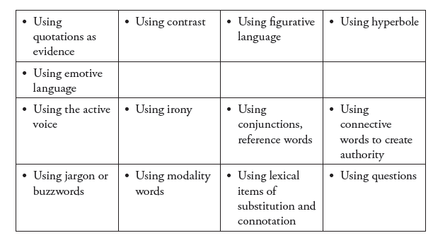

- Emotive language
- Modality words
- Questions

- Letters
- Websites
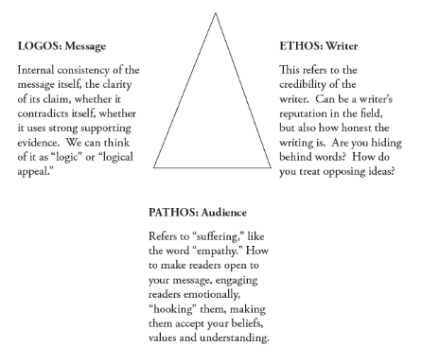
PERSUASION/ ARGUMENTIVE TECHNIQUES
Appeal
- Strategy used frequently in logical reasoning and critical thinking debates
- Appeal to person emotions – PATHOS
- Appeal to persons reasoning- LOGOS
- Appeal to person’s wisdom- ETHOS

Other techniques are:
TECHNIQUE | EXPLANATION
Analogy | Comparison using figures of speech e.g. metaphor, simile
Anaphora | Form of repetition of word/phrase to build up emotion
Anecdote | Using personal experiences/ specific details to support your point
Case study | Make reference to research/ facts to support your view- point
Repetition | Repeating words, phrases and sentences for emphasis
Rhetorical devices | Asking questions to which no answer is required, so as to tease readers to think
Word choice | Choose words that appeal to many senses, words with denotative and connotative meaning
Overgeneralisation | Use words such as “all”, “only”, “many”, to influence readers, create perceptions of what is being described

WHAT STRATEGIES DO WRITERS USE TO PERSUADE?
- Text arrangement
- Choosing an inviting title
- The thesis statement
- Give readers main/ central idea of piece of writing

- The main body of the text
2.1 use of transitions
2.2 Elements of styles
a) Tone
b) Sentence structure, word and phrases
c) Use of humour and organisation of ideas and points
d) Text development: use specific theoretical modes such as:
- Narration
- Description
- Examples and illustrations
- Process and analysis
- Definition
- Cause and effects
- Classification
- Comparison and contrast

- Rhetorical devices
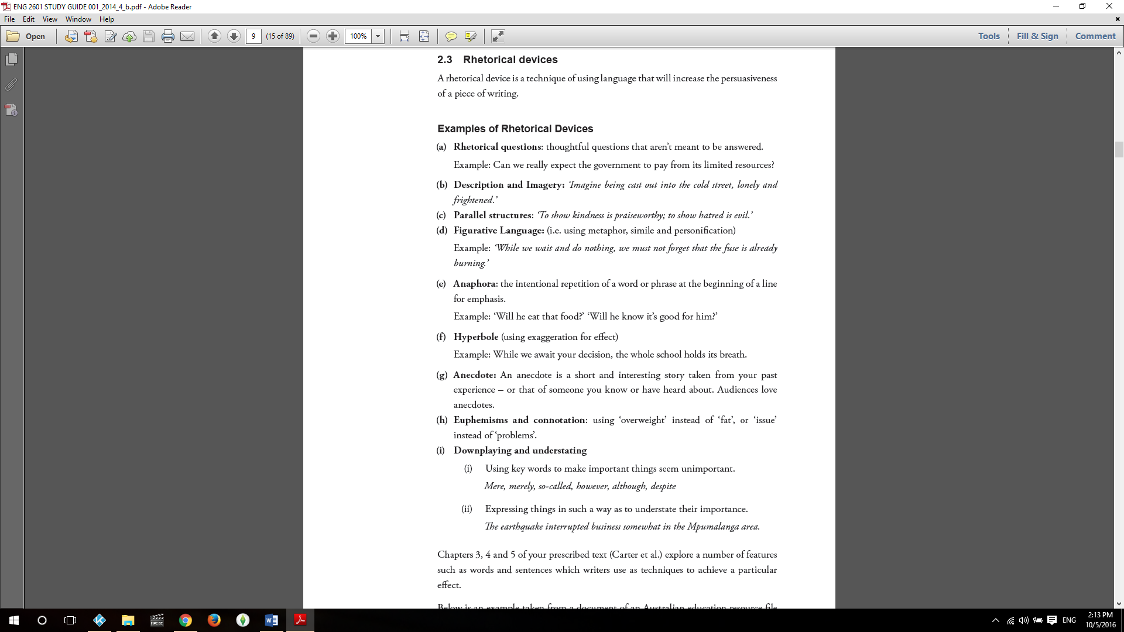
Techniques using language that will increase the persuasiveness of a piece of writing

SUMMARY OF NARRATIVE TEXT FEATURES
Purpose
- Entertain and capture readers interest in a story
- Can teach and inform the reader
- Can present fascinating themes and lesson
Types
- Typically imaginary but can be factual
- Include:
- Fairy stories
- Mysteries
- Science fiction
- Choose your own adventures
- Romances
- Horror stories
- Adventures stories
- Parables
- Fables and Moral tales
- Myths and legends
- Historical narratives
Text organisation
- Focus on sequence of events or actions
- Simple structure of narrative texts consists of:
- Orientation
- Complication
- Resolution
- Orientation gives indication of actions/ events that are forthcoming in the story
- Imaginary/factual “possible worlds” of the story is portrayed
- Introduce to main characters and possibly some minor ones

LANGUAGE FEATURES OF NARRATION
Summary of narrative features common in narratives:
- Main participant in a narrative are humans/ sometimes animals with human characteristics

- There are mainly action verbs [so called ‘material processes’] but also many verbs which refer to what the human participants said, or felt, or thought [verbal and mental processes] or language used to create an impact on the reader, e.g. adverbs, adjectives, and similes.
- Normally narratives are told or written in the past tense.
- There are many linking words to do with time, and order of events.
- Dialogue is often included, at which point the tense may change to the present or future.
- Descriptive language is used to enhance and develop the story by creating images in the reader’s mind.
- Narratives can be written in the first person (I, we) or third person (he, she, they).
- The events are narrated in chronological order, except when the plot has been twisted.
- Narratives typically use connectives that signal time (e.g. ‘early that morning’, ‘later on’, ‘once’.)
DIFFERENT TYPES OF PROCESSES
- Syntax

Syntax and Diction
Syntax and diction are closely related. Diction refers to the choice of words in a particular situation while syntax determines how the chosen words are used to form a sentence. Most often than not, adopting a complex diction means a complex syntactic structure of sentences and vice versa. In combination, syntax and diction help writers develop tone, mood and atmosphere in a text along with evoking interest of the readers.

Syntax Examples
Syntax in Poetry
The general word order of an English sentence is “Subject+Verb+Object”. In poetry, however, the word order may be shifted to achieve certain artistic effects such as producing rhythm or melody in the lines, achieving emphasis, heightening connection between two words etc. The unique syntax used in poetry makes it different from prose. Let us consider the following examples of syntax:

Example #1
In casual conversations, we can simply say, “I cannot go out” to convey our inability to go out. P J Kavanagh’s in his poem Beyond Decoration does not rely on merely stating a prosaic “I cannot go out”. Rather, he shifts the syntax and says “Go out I cannot”, which lays a much stronger emphasis on the inability to go out conveyed by the word “cannot”.

Example #2
Similarly, Milton shifts words in his poems frequently. Let us analyse lines from his poem Lycidas:
“Thee, Shepherd, thee the woods and desert caves,
With wild thyme and the gadding vine o’ergrown,
And all their echoes mourn”
The modified word order in the above lines is Object+Subject+Subject Complement+Verb.
Syntax in Prose
Syntax affects the nature of a prose text as well. It enhances its meanings and contributes toward its tone. Quickness, decisiveness and speed are added to a text by using short phrase, clauses and sentences. Whereas, in a text where the subject matter is serious that requires contemplation, long, convoluted sentence are used to slow down the pace of a prose text.

Example #1
“That night I sat on Tyan-yu’s bed and waited for him to touch me. But he didn’t. I was relieved.”
(The Joy Luck Club by Amy Tan)

Example #2
“They left me alone and I lay in bed and read the papers awhile, the news from the front, and the list of dead officers with their decorations and then reached down and brought up the bottle of Cinzano and held it straight up on my stomach, the cool glass against my stomach, and took little drinks making rings on my stomach from holding the bottle there between drinks, and watched it get dark outside over the roofs of the town.”
(A Farewell to Arms by Ernest Hemingway)
The two syntax examples above show a distinct use of syntax. Amy Tan uses short sentences to communicate in a powerful and concise manner. Ernest Hemingway, on the other hand, uses long and complex structures to emphasize the laziness of his character.
Syntax in Shakespeare
Writing all of his plays and sonnets in iambic pentameter, Shakespeare habitually reversed the general order of English sentences by placing verbs at the end of the sentences.

Example #1
In Romeo and Juliet, he writes,
“What light from yonder window breaks?” instead of using a common expression “What light breaks from yonder window?”

Example #2
In Richard III, he deliberately reverses the word order of a sentence,
“and all the clouds that lowered upon our house buried in the deep bosom of the ocean.” into “And all the clouds that lower’d upon our house in the deep bosom of the ocean buried.”

Function of Syntax
To convey meaning is one of the main functions of syntax. In literature, writers utilize syntax and diction to achieve certain artistic effects like mood, tone etc. Like diction, syntax aims to affect the readers as well as express the writer’s attitude.
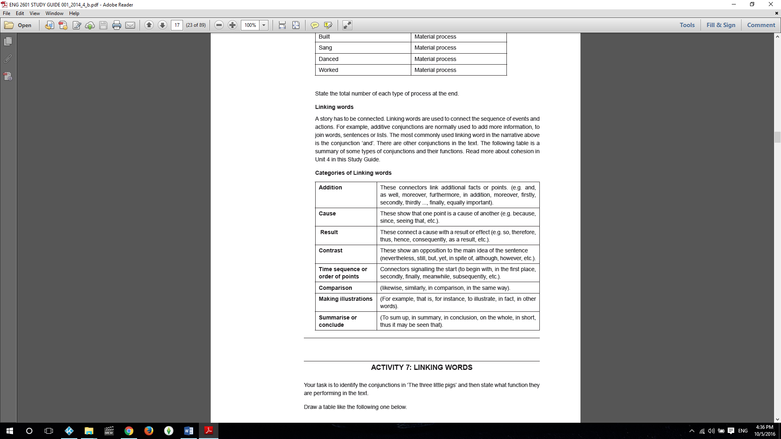
Linking words

Tense in narrative
- Finite verbs- are complete and can take inflections of tense
- A finite verb (sometimes called main verbs) is a verb that has a subject, this means that it can be the main verb in a sentence. It shows tense (past / present etc.) or number (singular / plural). For example:-
- I live in Germany. (I is the subject - live describes what the subject does - live is a finite verb).
- Non- finite verbs- do not take tenses
- A non-finite verb has no subject, tense or number. The only non-finite verb forms are the infinitive (indicated by to), the gerund or the participle.
For example:-
- I travelled to Germany to improve my German. (To improve is in the infinitive form).

- There are eight verb tense forms. For example, for the verb ‘eat’ (using ‘he’ as subject) we have the following possibilities:
- He eats (present simple)
- He has eaten (present perfect)
- He ate (past simple)
- He had eaten (past perfect)
- He is eating (present progressive)
- He has been eating (present perfect progressive)
- He was eating (past progressive)
- He had been eating (past perfect progressive)
- All the above are in the active voice.
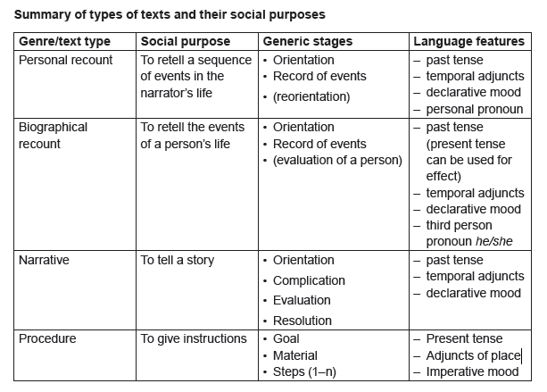
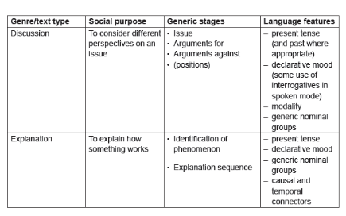
___________________________________________________________________________

UNIT 2: LANGUAGE AND MEANING

- Intonation – completely changes the meaning of a sentence or phrase
- Refers to the way in which voice rises when speaking(high pitch)
- Refers to the way in which voice falls when speaking ( low pitch)
- Intonation in speech is to stress and emphasise specific work, sentence or phrase in order to highlight an idea/ point of view
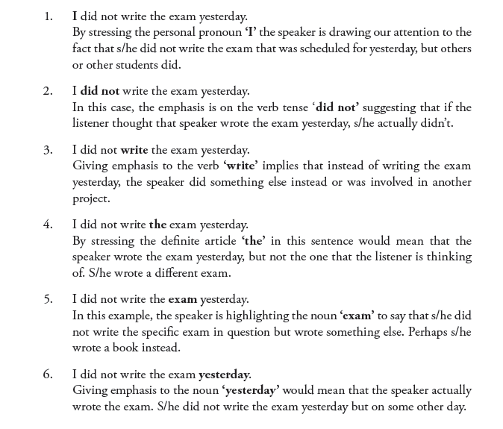

- Intonation is like a 'tune' or 'melody' in the voice, used to express different shades of meaning. Intonation patterns are the ways speakers adjust the pitch of their voice in order to convey meaning. Intonation is very important in communication as it gives information beyond just the basic meaning of the words.
LINGUISTIC MEANING AND SPEAKER’S MEANING
- Important as it distinguishes between what is said ( i.e. sentence meaning/ explicit meaning) and what is meant (i.e. what is implied, implicit/ proposed meaning)
- Difference between 2 concepts is that the former refers to the literal linguistic meaning of words sentences or phrases
- The latter has to do with the speaker’s intended meaning

Linguistic meaning
- Understood as context- independent phenomenon as meaning is often conventional, predictable and obvious.
- Direct link between word, sentence/ phase and its dentation or dictionary meaning

Speaker’s meaning
- Content dependent
- Comprehends what speaker means and intends to convey the listener would needs to know about the purpose and context in which something is said
- Process called implicature
- Implicature is mainly used in pragmatics to refer to that which is suggested or implied by an utterance.

- Two types of context:
Linguistic context
- has to do with the meaning of individual words in relation to other words within a sentence

Physical context
- Refers to the circumstances under which words are spoken or written.
- In other words, it is necessary to know who is speaking, to whom, as well as the situation in which that particular communication takes place.
SPEECH ACTS
- Aka communicative acts
- Refers to those actions that are performed when something special is said for the purpose of accomplishing some creative goal
- Include acts such as:
- Greetings
- Inviting
- Warning
- Requesting
- Promising
- Ordering
- Congratulating

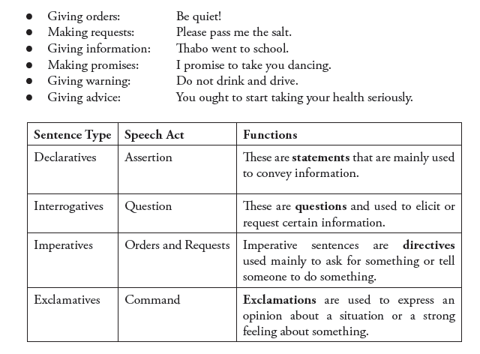

- Can be divided into:
Direct speech
- Direct speech repeats, or quotes, the exact words spoken. When we use direct speech in writing, we place the words spoken between quotation marks (" ") and there is no change in these words. We may be reporting something that's being said NOW (for example a telephone conversation), or telling someone later about a previous conversation.
Indirect speech
- Reported or indirect speech is usually used to talk about the past, so we normally change the tense of the words spoken. We use reporting verbs like 'say', 'tell', 'ask', and we may use the word 'that' to introduce the reported words. Inverted commas are not used.

SENSE AND REFERENCE
- Crucial components

