Activity 3.3
As we have mentioned in the section that we have just covered, the impact of missionaries was a global one.
Read the two case studies below, which relate to different mission stations in the 19th century.

1 Case study of Bechuanaland
Bechuanaland, which was largely the territory that is currently known as Botswana, was one of numerous areas across the African continent where a mission station was established. The London Missionary Society (LMS) decided to establish a mission station in 1800 to spread the Christian gospel. The LMS’s relationship with the local Tswana developed into a long-standing, if not initially an entirely successful, one. Notable missionaries such as James Read, Robert Moffat and David Livingstone were involved in the major mission stations in that region.
Read was initially welcomed by the Tlhaping chief Mothibi, as he was regarded as a supplier of firearms, tobacco, handkerchiefs and beads. However, Mothibi remained reserved. He was wary that Read could attempt to curb his authority. He was not entirely erroneous in making this assumption, as Read saw Mothibi’s power as an obstacle to his clerical undertakings. The invitations from the Tswana to missionaries who wished to settle in Bechuanaland were often rooted in the desire for political, military and economic advance.
Despite the inclusion of missionaries in these societies, very little success was initially enjoyed. One missionary, Robert Hamilton, recounted in 1822 that ‘I would be very glad if I could inform you that God’s work is going forward in this place, but I must write nothing but the truth. So far as I know, no one of these heathens are seeking after God’. By 1834, the Kuruman Mission in the area (which at that stage was part of British Bechuanaland) purportedly only converted five individuals out of the population of 3000.
Other problems arose, as local inhabitants were not eager to forfeit their traditional customs in exchange for a Christian, ‘civilised’ lifestyle. One chief, Sechele, allegedly only allowed Livingstone to baptise him as a means of political protection from the British against the Afrikaners. He also had trouble giving up his practices of polygamy and initiation.
Another reason for the missionaries’ failure in Bechuanaland related to their insistence on teaching local inhabitants how to read and write, instead of more practical skills. The parents of children were reluctant to remove their boys from their roles of practically contributing to the community by herding cattle. Subsequently, the majority of pupils who attended schools were young girls, who only attended the missionary institutions until their initiation.
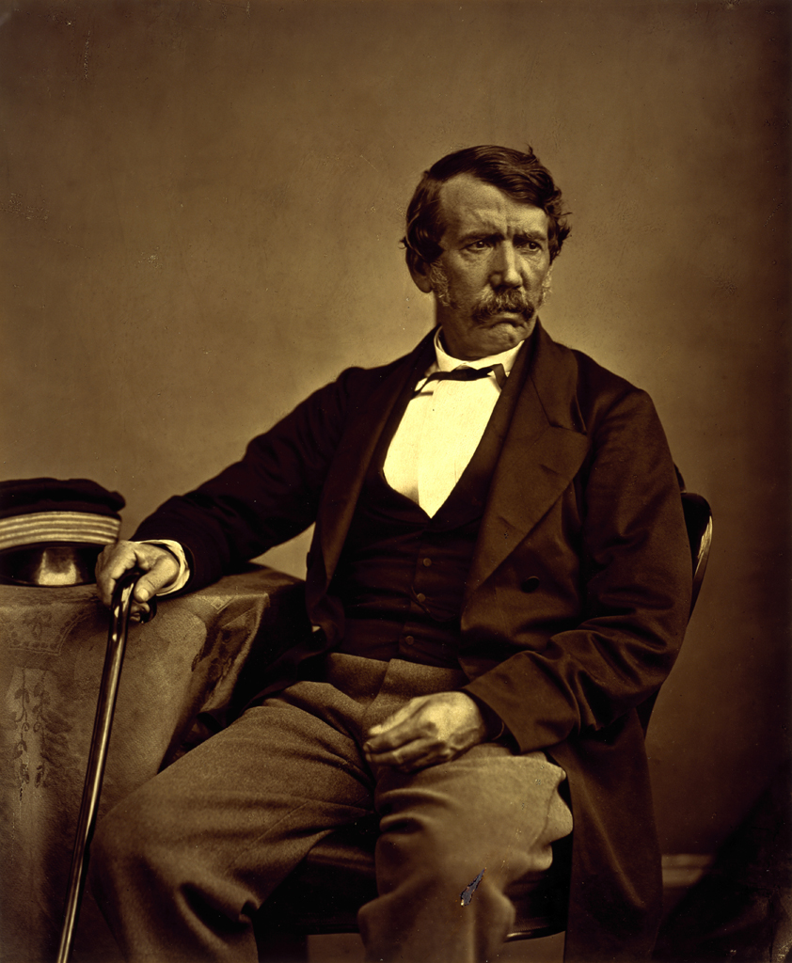
David Livingstone, as depicted by Thomas Annan in 1864.

Their differences in approach resulted in frequent tension, as chiefs struggled to appease both the missionaries and the traditional members of their communities. In 1833, a toiling Moffat wrote about teaching the Tswana’s: ‘Their intellectual faculties seem so benumbed that it is astonishing to see how destitute they are of the principle of curiosity. This, of course, is easily accounted for from their habits of indolence and sensuality’.
Eventually, the LMS realised that the practices they implemented largely failed. They reassessed the manner in which they approached their missionary endeavours. Thereafter, they enjoyed relative success in the area.

2 Case study of The Dakota Mission
The Dakota Mission was established in 1835 under the American Board of Commissioners for Foreign Missions in the northern part of America. Dakota was home to a Native American community of the same name. The missionaries decided to establish a post in the area under the guise of introducing civilisation. Although the interactions between the Native Americans and the missionaries were initially peaceful, the relationship eventually ended with bloodshed.
While the missionaries were concerned with matters of deliverance, their settlement also coincided with increasing encroachment on the land of the Native Americans. As with missionaries around the world, the Dakota Mission aimed to achieve its ‘civilising mission’ through education. The establishment of schools served as an important vehicle for achieving these goals.
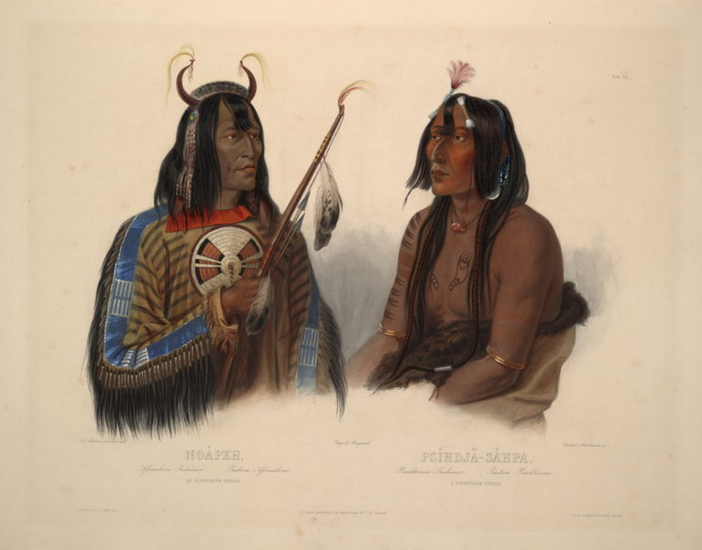
A depiction of Native Americans dressed in Dakota furs. It was painted by Karl Bodmer between 1840 and 1843.

The Native Americans, however, were not interested in conversion. They were only drawn to the missionaries because of their western knowledge, which benefited their community. This included providing medicine against smallpox, an epidemic which devastated the Native American population. However, they remained religiously sceptical. After 1842, for example, only two Native Americans joined the missionaries in the space of four years.
The missionaries were treated with increased suspicion and hostility as they continued their ‘civilising’ endeavours. The Native Americans labeled them as portents of bad luck after the region was struck by a drought. Disagreements between Native Americans and missionaries were also common. These disputes usually pertained to prescriptions made by the missionaries about attire, monogamy and worship. The Native Americans also did not appreciate the manner in which their belief system was labeled as ‘devil worship’. In addition, they were irked by the nature of superiority that the missionaries embodied in their quest to ‘civilise’. An example of this is the reaction of a missionary after witnessing a series of traditional practices that the Native Americans participated in. He described that the Native Americans possessed an ‘animal excitement’ during ceremonial events. This resonated with the missionaries’ perceptions of the ‘primitive’ local inhabitants of the region.
As hostilities increased, however, a handful of Native Americans converted to Christianity. Once they had done so, they cut their hair, dressed as the Europeans and practised the same agricultural methods as the missionaries. These converts were thus successfully westernised.
A series of ill-conceived bureaucratic decisions relating to land dispossession and the mismanagement of Native Americans’ annuities eventually led to significant discontent. In a violent attack by the Native Americans, an estimated 600 people were slaughtered in white settlements in the area. Almost 400 Native Americans were tried for the massacre, and 38 were ultimately sentenced to death.

* * *
Now answer the following questions:
- How can you deduce that the missionaries believed that the local inhabitants were ‘uncivilised’ and ‘primitive’?

- Why did the missionaries believe that they were ‘civilised’ and ‘modern’?

- Historical writing is hugely dependent on primary sources. Read through the two case studies again and identify extracts that could be regarded as primary sources. You can refresh your memory about primary sources by referring to Learning Unit 1.

- Bearing oral traditions and the availability of certain primary sources in mind (as illustrated in the two case studies), why is it that history is sometimes regarded as being ‘Eurocentric’?

- Although these two case studies take place on two different continents, there are similarities between them, specifically pertaining to the manner in which Europeans perceived and treated indigenous inhabitants. Similarly, there are also several differences. Write a paragraph where you highlight these similarities and differences.

J. Mutero Chirenje, ‘Church, State, and Education in Bechuanaland in the Nineteenth Century’, The International Journal of African Historical Studies, 9, 3 (1976), 406.
Source: https://www.flickr.com/photos/nationalgalleries/3094794021/in/album-72157607906844761/, accessed 04 May 2016, PD-US.
Mutero Chirenje, ‘Church, State and Education’, 414.
Source: Library of Congress, PD-US, accessed 4 May 2016.
A. Uchida, ‘The Protestant Mission and Native American Response: The Case of the Dakota Mission, 1835-1862’, The Japanese Journal of American Studies, 10 (1999), 159.

