THE EXAMINATION

1.1 Format of the examination

As previously mentioned, the examination will be a venue-based written examination. The exam paper will consist of five questions, questions 1 contains a compulsory case study that all students should answer. From the remaining four questions students should answer any two. Note, it is two of four questions. These questions will be subdivided into paragraph-type questions covering the full syllabus. Some of these questions may also be based on the case study in question 1 of the paper. You will only receive an examination paper and no examination script, as we have made provision for you to answer the questions on the examination paper. Write legibly and take note of the marks allocated to a question. Ensure that you provide enough facts.

1.2 Guidelines for the examination

On the module site and in the learning units and study guide, you will find links to articles and websites. You will NOT be examined on these unless we specifically state so. For example, in some chapters of the prescribed book you will find references to US-based legislation. We have provided the relevant South African legislation that you need to know. In your preparations you can also use the questions at the end of each chapter to revise, as well as the mind maps that you have compiled during the semester. Always look at the marks allocated to a question and ensure that you provide enough facts to earn the marks. Read the instructions in the examination paper carefully and complete all your personal particulars on the cover page of the examination script. Write legibly and write in pen.

Read all the questions in the examination paper, answer the compulsory question 1 and choose any two of the remaining questions answer. Indicate on the cover of the examination paper which questions you have completed by encircling the numbers of the questions you chose. For your convenience, we include an example of the examination cover page. (see next page for figure)

1.3 What should you study for the examination?
 | STUDY
You will be examined on learning units 01–12 and 14–17 and chapters 1–12 and 14–17 in the prescribed book. We have indicated in the learning units which sections you should study and there are only a few additional websites/documents that we referred you to that you will be examined on (e.g. the POPI Act).

You will thus NOT be examined on learning unit 13 (chapter 13) in the prescribed book. This learning unit, however, deals with important matters, but if you work in a large multinational there should be a lot of support and guidance provided along the way. Take note of the content, but we will not examine you on it. Learning unit 18 is a learning unit containing useful links and tools, you will not be examined on that either.

1.4 How do you prepare for the examination?

Use the mind maps that you have compiled after each learning unit, use the questions at the end of each chapter in the prescribed book, your assignments and also the activities in the learning units. Remember that you will be examined on the learning outcomes for the module. In Tutorial Letter HRMALL6/301/4/2018 we also provide guidelines for answering questions in the examination, assignments and also for answering case study-based questions. Remember to use the facts in the case study together with the theory that you have learnt to answer the questions. If you are linked to an e-Tutor, complete the self-assessments and engage with the e-Tutor online, we are in close contact with the e-Tutors for this module.

1.5 Previous examination papers

Previous examination papers are accessible via myUnisa, the examinations department will upload them under Official Study Material (at the bottom of the screen).

Figure 1 

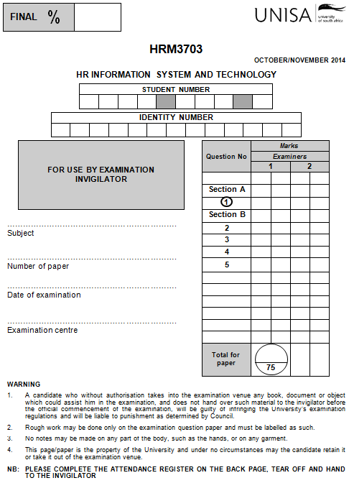
Encircle the numbers of the questions that you answer in the paper.
Complete this section.

Fill in the subject, number of paper, date of examination and examination centre.

