MNH203D – Labour Relations Management
Work is an inseparable part of human existence in many ways, everyone has to work in order to live, and Work is therefore a fundamental human activity.
Interaction with other people means that work is also a social activity - work gets done in the context of a group.
Employment relationship - it is a relationship which is based on an agreement between two parties: an employee (one party) who is in the service of another party, the employer.
``industrial relations''
``labour relations''
``labour relationships''
``work relations''
Defines these concepts as follows:
- labour: physical or mental work; exertion; toil
- industry: a branch of trade or manufacture
- industrial: of, or relating to industry or industries
- employee: a person employed for wages or a salary, especially at non-
- executive level
- employment: the act of employing or the state of being employed
- relations: what one person or thing has to do with one another

Dunlop – based on systems perspective, based on work from various sociologists. Dunlop says that certain people act (actors = managers, workers), in specific contexts (technological characteristics, the market and distribution power of society) guided by a body of rules.
The actors establish the “rules”
The people in the system share certain ideas – this holds the system together.

Flanders - defined Industrial relations as a study of the institutions of job regulation.
Hyman – focused on the processes of Industrial relations – the study of process control over work relations – which include job regulation - Job regulation means controlling the actions and activities of jobs, for example how a job is done and who may be employed in that job
Poole's definition that ``industrial relations is a discipline concerned with the systematic study of all aspects of the employment relationship''
Bain and Clegg state that the relationship may not necessarily be only formal, but may also be informal, and the context can be either structured or unstructured. They criticised the shared ideology by Dunlop. The traditional approach focused on managing conflicts and making rules in the employment context. This is broadened to include essentially all the interests involved in getting a job done and all aspects of people at work including doing the work and distributing the rewards. They defined industrial relations as all aspects of job regulations.

The Industrial Revolution changed virtually the entire socioeconomic system or order. Society was structured in such a way that most people worked in tiny communities at familiar handwork or agricultural activities. People worked in order to make a living, but also because the work itself provided them with a functional or traditional role.
Bendix explains:- The Industrial Revolution was a social and economic convulsion (fit , seizure) it changed the economic order. Mans his working life was closely aligned to his political and religious life. The idea of earning a living, if consciously formulated, was secondary to this fulfilment of this traditional or functional role. Until the eighteenth century, the striving for gain or excess profit, as we know it, was generally regarded as highly immoral. By the year 1700 society now began to accept that man was necessarily greedy for gain, that gain was the centre of commercial activity and that no law should exist against gain. Thus the industrial era was born. It brought with it the uprooting of workingman from his traditional way of life and the birth of a disorientated class of people known as the Proletariat. Large factories were established where a mass of workers performed relatively humdrum tasks to the dictates of a single employer or owner. It stands to reason that work lost much of its meaning and that the workingman had to search for a new identity. This he later found in the working class and in membership of workers' trade unions. New relationship patterns had to be established. The depersonalisation of work and the work situation caused a division between the employer and his employees, bringing about a further polarisation between those who laboured and those who owned or managed. Many saw capitalist activity as based on the principle of keeping the poor poor, since any increase in wages would signify a concomitant cut in profits. This is a perception which, sometimes unjustifiably so, is still held by many employees today. It greatly contributes to the negative attitude many workers hold towards their employment and to the basic conflict between employer and employee. Industrial Revolution had little positive results, such as greater progress and development in all spheres and, later, a general improvement in the standard of living of all people.
The greatest impact of the Industrial Revolution is,
- The removal of man's economic activity from his personal and social life
- The depersonalisation of work and, consequently, of the employment relationship
- The polarisation between the mass of employed on the one hand and the owners or managers on the other, resulting in the rise of a working class consciousness and providing the necessary impetus for the growth of trade unionism
- The negative attitudes engendered by the new dispensation
- The central role now played by economic activity, causing it to become the main aspect of man's life and one which impacts greatly on his personal, social and political life
- The predominance of capitalism, being the ownership by one per- son of the``tools''of production
- The consequential concept of ``selling labour'', leading to the disempowerment of the producers of such labour

LABOUR RELATIONS: AN INTER DISCIPLINARY AND MULTIDISCIPLINARY FIELD
Industrial relations developed into an independent field of study as a result of the Industrial Revolution.
Swanepoel, Slabbert, Erasmus and Brink (1999a) summarise industrial relations as a field of study by stating that it encompasses all aspects of people at work. The way the overall nature of this complex and interdisciplinary field is perceived will determine how specific issues and situations in the field are analysed and approached.
We refer to labour relations as an interdisciplinary field of study - Let us see what Boivin has to say about this: - We can consider industrial relations not as a basic science, but as a derived field of knowledge, where elements borrowed from many disciplines (economics, sociology, law, psychology, labour history, political science and administration) are used to study a particular series of work-related problems.

Figure 1.1 illustrates the interdisciplinary nature of labour relations as a discipline.

Figure 1.1 simply shows that labour relations can be studied as a separate discipline with clear boundaries, but also that it draws on information from other disciplines to explain phenomena which are interrelated to and arise from the employment relationship.

Then it also follows that labour relations is a multidisciplinary subject, as some aspects of labour relations can be studied from the perspective of many different disciplines.
Figure1.2 illustrates this point.

We can conclude that although labour relations must be studied as a separate field of study, using an interdisciplinary approach (in other words, by using knowledge derived from many other disciplines Hence we can actually say that labour relations can be regarded as an interdisciplinary field of study and as a multidisciplinary topic.

Q&A
Try to formulate a definition of Business Management as a field of study?
The science of business management covers functional fields such as financial management, human resource management, marketing management, purchasing and supply chain management, operations management and general management, to name but a few.

In what ways does management concern itself with aspects of the employment relationship?
Management includes activities such as planning, organising, leading and control. And all management functions and activities have one thing in common ö managers manage people. This means that the employment relationship permeates all management activities in any organisation. To put it simply, all managers must learn how to optimise the labour at their disposal and how to distribute the available rewards for labour supplied. This means that the employment relationship is indeed the cornerstone of all management activities.

Critically analyse and define the concepts ``industrial relations'', ``labour relations'' and ``employment relations''.
. explain that it is work in the context of an employment relationship that forms a central theme in all these concepts. Thus the root of industrial relations as field of study is the employment relationship.
. Industrial relations is the broad term denoting a specific field of study that is interdisciplinary (it draws on knowledge from many different disciplines such as sociology, psychology, law, etc).
. All this, however, can be linked to the employment relationship. The employment relationship comes into existence as soon as one person is employed by another. The employment relationship is not the same as employment relations. Employment relations is the new name for the field of study traditionally called industrial relations .We prefer the term ``employment relations'' because of its broader connotation, including nonindustrial employment settings and also the individual as well as collective aspects of employment.

``Labour relations is both an interdisciplinary field of study and a multidisciplinary subject.'' Discuss this statement, and indicate why you think it is right (or wrong).Use diagrammatical or visual representations to illustrate your arguments.
Labour relations can be seen as an interdisciplinary field of study. This means that labour relations is not considered as a basic science, but as a derived field of knowledge, in which elements borrowed from many disciplines (such as economics, sociology, law and psychology) are used to study a particular series of work-related problems. Labour relations can thus be viewed as a unique and separate field of study which concerns itself with a number of different but interdependent matters. This interdisciplinary nature of labour relations as a field of study is illustrated in figure 1.1 in the study guide. According to figure 1.1, labour relations can be studied as a separate and distinct discipline with boundaries, whilst borrowing knowledge from other disciplines in order to study all the phenomena that relate to and emanate from the employment relationship. Labour relations as an interdisciplinary field of study is therefore broader in scope than other disciplines or subjects such as sociology and law

LABOUR RELATIONS DYNAMICS: DIFFERENT PERSPECTIVES OR FRAMES OF REFERENCE

The pluralist perspective views the employing organisation as a coalition of individuals and groups with diverse objectives, values and interests. Management are responsible for efficiency, productivity and profitability. Workers concerns are higher pay better working conditions, job security and meaning full work. The competitive conflict between management and labour is seen as rational (sensible) and inevitable (expected). The key lies in the regulation of employment relationship.

The unitarist perspective views the organisation as an integrated group of people having a unified authority structure with common values, interest, and purpose. Management is seen to have the legitimate authority and right to manage – hence they are expected to provide appropriate leadership. Conflict is regarded as unnecessary as employees are expected to be loyal to management. A person working in the org is in basic harmony and conflict is the result of communication problems.

Radical perspective
This view of industrial relations looks at the nature of the capitalist society, where there is a fundamental division of interest between capital and labour, and sees workplace relations against this history. This perspective sees inequalities of power and economic wealth as having their roots in the nature of the capitalist economic system. Conflict is therefore seen as inevitable and trade unions are a natural response of workers to their exploitation by capital. Whilst there may be periods of acquiescence, the Marxist view would be that institutions of joint regulation would enhance rather than limit management's position as they presume the continuation of capitalism rather than challenge it

Social Corporatism - is a social democratic order where the state allows the other key interest groups to be full participants in the process of formulating certain state policies and in making certain key governance decisions.

State Corporatism - this is where the state imposes its will on labour movement. The emphasis shift form tripartite cooperation to paternalistic or authoritarian to demobilise trade unions and absorb them into government structures.

The tendency in South Africa at present seems to be a movement toward societal corporatism. Trade unions are treated as important interested parties, conflict is accepted, but it is also acknowledged that employers and employees have many interests in common. Note, however, that conditions in South Africa are not yet entirely favourable for successful societal corporatism according to the traditional Western European model. For example, we do not have a single, united and completely autonomous trade union movement; our democracy is still young; and employer organisations were traditionally fragmented. The key role-players (the state, labour and employers), however, have indicated that they are eager to accept that conflict can coexist with common interests.

THE MULTI DIMENSIONAL NATURE OF LABOUR RELATIONS
Studying the employment relationship from a management perspective has become a focal point in today's business environment, and this relationship can therefore be seen as the cornerstone of employment relations. This is so because, as soon as one person starts working for another, various employment relationships come into operation. There are four types of relationships: individual formal, individual informal, collective formal and collective informal. Although none of them can stand alone or exist in isolation, we will discuss them separately here to illustrate the point better.

The individual dimension. Every individual has an employment relationship with the organisation as an employing entity. Each worker interacts every day with and has a specific relationship with the organisation and with various individual managers at different levels, as well as with other workers as individuals. These are individual, interpersonal or human relations.
The collective dimension. Workers can organise themselves in groups which can enter into discussions as a group with management or with groups of employers. This is generally referred to as the labour management relationship, or the union-employer relationship. Labour usually organises workers in groups known as trade unions, which act as the representatives of their individual worker members. As a group, a union has a specific relationship with management, and in this regard we talk about intergroup relations. In practice, these two dimensions will occur together, with a formal dimension and/or an informal dimension.
The formal dimension. The parties have specific rights and duties which are based on official agreements between them, which may be individual or collective.
The formal dimension is characterised by certain agreements, rules, laws, regulations and formalities, which focus on the official control of the individual and/or the collective dimensions .Whether the (individual, formal) employment contract is written or verbal, it is an agreement which the parties have with each other.
The informal dimension. This is the fourth dimension of the employment relationship. It has to do with the dynamic aspects of human behaviour. This could include human behaviour in a group context (informal collective dimension), or in the context of the individual dimension. It includes those aspects and consequences which arise from the feelings and ideas that the various parties have about each other, their values, needs and outlook on life as well as their preferences and perceptions in respect of one another, and so on.

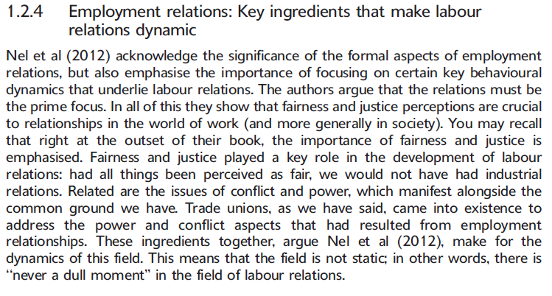

When we look at these dimensions, it is clear that the task of ensuring successful labour relations is not always easy. In practice, the four dimensions form an integrated whole which is usually referred to as labour relations. Successful labour relations can therefore be seen as the sum total of the quality of all these dimensions. All the dimensions must be maintained on a healthy level, separately and combined

THE MANAGEMENT PERSPECTIVE ON LABOUR RELATIONS

You will probably conclude that trade union officials are concerned about their members' interests to the extent to which these are related to the total employment relationship. As a result of this, and because the management of employment relationships is the most frequently occurring topic in human resource management and labour relations management, it is best to study them holistically. The management of employment relations should in fact be regarded as an integral part of the task of management; the same general management principles should therefore be applied to it.
Recent examples of trade union activity in the news clearly indicate how involved trade unions are in the human resource management activities of organisations. They are involved in wage negotiations, and address issues such as conditions of employment, health and safety, learnerships and skills development and retrenchments. In most organisations, union representatives are members of the job evaluation committee and selection committee and in some organisations may even represent employees' interests on the board of the company. All managers have to deal with employees, either individually or collectively, and should thus be equipped with the knowledge and skills to deal effectively with the human or people issues in the workplace. This includes a thorough knowledge of employment relations principle.

Management functions
Labour relations from a management perspective, we are basically concerned with the application of planning, organising, leadership/management and control in the management of people in their employment relationships. So, if you study labour relations from a business management perspective, your main aim is to understand how you should make decisions about the planning, organising, leadership and control of all aspects of employment relationships. Before we can do this, we need to know the context and the general theoretical principles. The module Labour Relations Management: Micro focuses on the planning, organising, leadership and control of labour relations, while this module prepares the way for it, lays the foundations and creates the context.Management is the planning,organising,leading and controlling of human & resources to achieve organizational goals effectively & efficiently ,from the process perspective of management , I has become rather common to accept that 4 four managerial tasks that constitute the process of managerial work reside in

Planning – about the future,thinking abt desired outcomes,setting goals and objectives & crafting ways of how to achieve these over time

Organising- essentially about getting the infrastructure in place that would enable work to be done to achieve what has been planned for.

Leading – activating and actively mobilising & working towards the execution of the plans,through the infrastructure that has been organised for that purpose

Controlling – monitoring & measuring the extent to which actual performance is aligned with the plans made & the results or outcomes desired.

Employment relations management

When human resource management and labour relations management are combined, the result is employment relations management. The employment relationship is the factor which links these two topics (personnel or human resource management and labour relations) which were traditionally studied separately in Business Management courses .We prefers to call this entire field of study employment relations management.
Although the collective dimension (labour-management-relationships) is the primary one in this module, bear in mind that the individual dimension can also be viewed as an integral part of labour relations management.

THE SYSTEMS APPROACH TO LABOUR RELATIONS
Bendix defines labour relations systems as the sum total of role-players, actions, processes, rules and regulations involved in or applicable to the employment relationship in a particular community. She emphasises that these components are common to all systems, but depend on the system in varying degrees and methods of interaction. This therefore emphasises that an integrated approach is necessary within this systems perspective on labour relations. Trade unions and their collective elements cannot be separated from the more individual aspects related to human resource management.

The three major components of the employment relations system of any organisation is inputs, throughputs and outputs.
The first component of an employment relations management system relates to the identification of these factors, variables and trends and the analysis of all of these in order to assess their potential implications (both inside and outside the organisation, but outside of the employment relations system such as the marketing, operational and financial subsystems of the organisation) for the management of employment relations within the organisation.

The second major component relates to the throughputs of the employment relations management system. This includes all the mechanisms (policies, procedures, practices, methods, etc) used to transform inputs into outputs and that actually add value to the organisation's pursuit of success. Hence there are numerous ``subcomponents’ ‘of this system because all the mechanisms that have to do with managing employment relationships (such as establishing employment relationships through recruitment and selection practices, processes and policies, eliciting superior employee performance and discipline, loyal and committed behaviour as well as all those policies, processes and practices that relate to rewarding and remunerating employees) have to be dealt with.

The important thing is to identify and analyse the potential influence of external factors on these throughput mechanisms. One example may be the increasing competition caused by the globalisation of the world economy. This may challenge the organisation to enhance the employee utilisation component by means of mechanisms such as more and better training and development, better work performance appraisal, management and reward, as well as efforts to improve the satisfaction levels of employees so that they remain productive and are not frequently absent or so that the organisation does not frequently lose competent employees as a result of resignations. It might also entail an improvement of the disciplinary and grievance handling mechanisms, and/or communication. These are merely some examples of how the competitiveness of organisations can be influenced.
The output component relates to measuring the extent to which the employment relations management outcomes actually add value to the organisation. As mentioned above, here the focus will be on measuring and monitoring factors like absenteeism, timekeeping, labour turnover, accident rates, industrial action occurrences, employee satisfaction levels, productivity and work performance level.

Distributive justice
Refer to the distribution of the conditions and the goods which affect individual well being - psychological , social and economic.
Justice and the perceptions that the parties to the employment relation- ship have of this concept, are central to employment relations. The pre- scribed book identifies three kinds of justice: distributive, procedural and individual. Distributive justice focuses on the perceived fairness of distributions or outcomes. A simple example of this kind of justice would be the way employees perceive their compensation when compared to that of others. In South Africa there is huge disparity between the compensation packages of the senior executives in organisations and employees on lower ranks, and this creates perceived distributive injustice.
Distribution decisions can be based on the following three criteria: -
Equality – everyone gets exactly the same distribution (family with 4 children - all will get the same amount of sweets)
Need – allocation is based on who need to goods most ( in a ER @ hospital , the worst affected will get urgent attention)
Equity - the reward are based on how much the person contribute (banks give better interest to those who have lots of money with them)

Procedural justice –is a perceived fairness of process and procedure following certain decisions or outcomes.
Procedural justice is about the process that is used to make decisions. When an organisation decides to retrench employees when no real economic need exists for the retrenchments, this can be perceived to be procedurally unjust (unmerited).
Six criteria to being fair to procedure:
Consistency –equal application of rules and procedures to all over time.
Bias suppression – prevention of self interest in the decision making process.
Accuracy - making decisions based on accurate information.
Correctability – modification or correction of decisions, if appropriate.
Representativeness – the representation of all stakeholders or parties concerned in the process
Ethicality – the reflection of current ethical and moral principles in the process

Interpersonal injustice is the manner in which outcomes are communicated to employees at interpersonal level - perceived fairness of treatment by decision makers.
This underpins perceptions of procedural and distributive justice.
Two aspects of Interpersonal injustice –
Interpersonal treatment – treatment received from decision maker – respect, courtesy, friendliness
Adequate fundamental accounts – the use of adequate explanations for the outcomes or decisions reached.

Three elements being central to interpersonal justice perceptions –
Neutrality – a function of the decision maker. Elimination of bias through the use of facts and accurate information.
Trust – the degree to which people believe the decision will be fair - treat people in a fair and compassionate manner.
Standing – the individuals concern with their status in the group. If they are treated rudely or with disrespect they will be aware that the authority they are dealing with view them as having a low standing in the group. If they are treated with respect and courtesy – they know their rights are respected.

Meaning, nature and causes of conflict

Conflict involves some form of competition, difference or tension.
In terms of conflict - the following must be clear:
Conflict in employment relations may be regarded as an in inherent (natural) part of the interaction between parties.
Conflict is a process
Conflict processes are dynamic and have to do with change
Conflict typically has some form of competitive nature
Conflict interactions often includes negative emotional qualities and may sometimes be associated with behavioural dimensions such as antagonism (hatred , dislike) , aggression, threats, hostility (resentment, unfriendliness) and lack of cooperation.

Perceived injustice leads to tension or conflict. Conflict can be good, leading to a higher level of creativity and change in an organisation, if it is constructively managed. Power is the dynamic that forms the basis of the interaction between the employer and employee. It is a medium for resolving different (divergent) aims and interests. Employers and employees draw on different bases of power and use the power dynamics to influence the processes of employment relations .For example, in a strike or lockout, the employees (or employer) use coercive power. Managers can use reward power, by providing incentive bonuses.
Sometimes, employees and their representatives, and employers and their representatives, may be involved in a situation where the needs of both parties can only be satisfied when there is cooperation and participation.
Dealing with HIV/AIDS in the workplace is one such example. In this instance, employers and employees adopt a joint problem-solving approach. This kind of approach requires high levels of trust between unions and employers.
Causes of conflict
Different values, attitudes or perceptions
Different objectives or methods of achieving them
Differences in information or communication blockages
Lack of resources (scarcity)
Skew distribution of resources (structural imbalance)
Personality differences

Power Dynamics

Legitimate power – this power emerges from the right to issue directives. Such power is accepted as part of the social structure and is obeyed because of organisational rank. Labour might have legitimate power through legislation.
Reward power – this power emanate from the group or individual to withhold rewards. Management hold this power by means of pay increases, incentives, bonuses, promotions. The reward power of Unions resides in their capacity to induce workers to increase productivity, improve quality, and work longer hours.
Coercive Power – refer to the capacity of the group to use force or coercion (intimidation) through the use of sanctions. Management can refuse to pay performance bonuses or threaten with retrenchment if productivity does not increase.
Knowledge Power – power is based on the possession of specialised knowledge or skill. Management may know more than employees about marketing, finance, general running of the business. Employees may have better knowledge on operating machines.
Referent Power – this power arises out of the “force” of an individual’s personality. Charismatic people can influence other people to want to be more like them. A charismatic manager can could encourage support for organisational goals and initiatives.

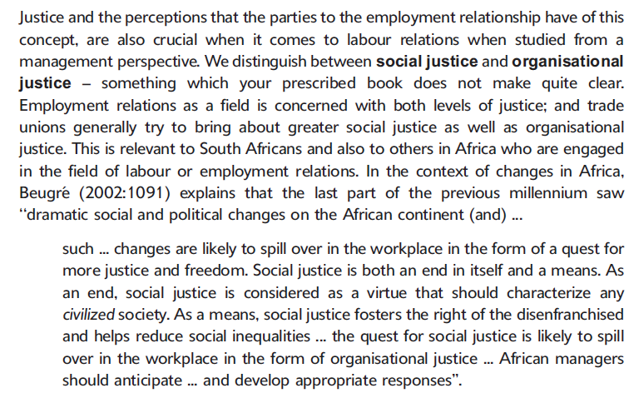

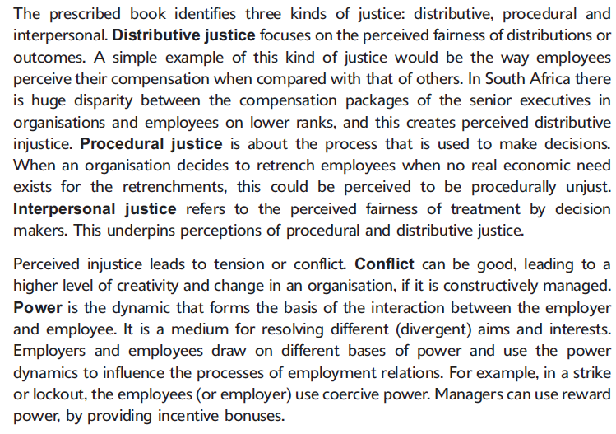

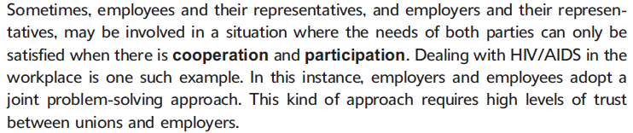

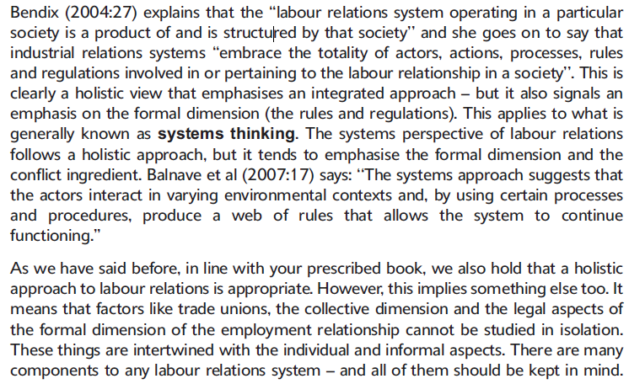

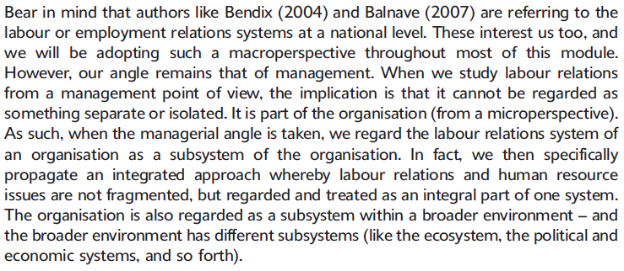

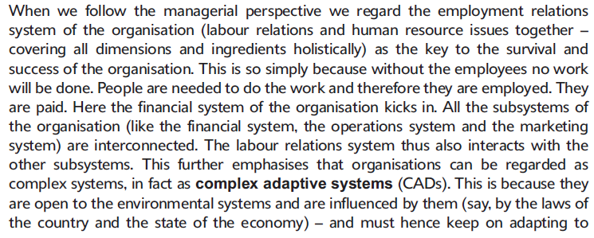
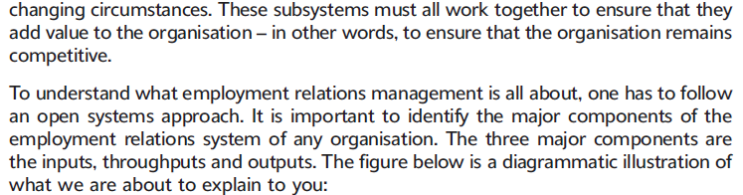

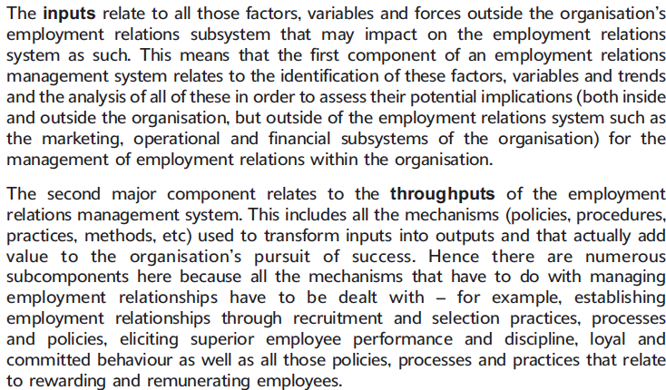

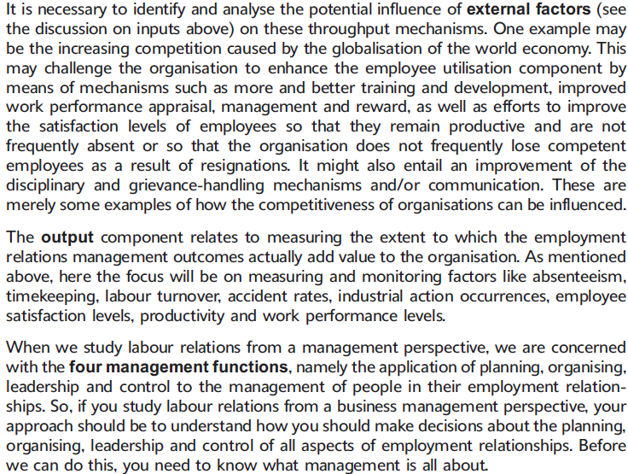

Cooperation and common ground dynamics
Coexistence, shared interests, and common ground are very important ingredients and dimensions.
The key underpinning of cooperation between role players, lies in the fact that human needs have to be satisfied. People need to work to earn money - organisations need people to work. Long term survival and continued existence is in all parties best interest.

Employees therefore willingly enter into the employment relationship, thereby participating in the productive process of the organisation, and contributing by means of expending energy in the form of mental and/or physical power. There is thus a general tendency in the individual employment to participate and cooperate.
Trade Unions exits because there are employees. If there are no employees -there are no trade unions – the trade unions thus have a interest in the continued existence of the organisation – as the employees belong to the trade union.

The most destructive method of interaction is warfare. There can be no cooperation whatsoever – parties interact as enemies. The objective is to defeat the other.
A purely unitarist ideology may underpin strategies and tactics.
In the case of adversarial interaction parties relate to each other in clear “us and them” , “we and they” terms. The parties are competitive and act as adversaries. The use of power to “capture territory” and “beat” or “outmanoeuvre” each other is common.
Win-lose bargaining is frequent and deadlocks, disputes and tactics of open confrontation (strikes) are part and parcel of everyday employment relation dynamics. Levels of thrust are very low.

If a pluralist perspective is employed the parties may start to experiment with more innovative and constructive interaction – as in the case of integrative accommodation. The parties accept one another yet they regularly engage in distributive bargaining. The win-lose mentality makes way for joint problem solving. The parties begin to express desire to build mutual trust and fully accept each other roles in employee relations. They will start to experiment with structures and processes whereby the Union will be able to influence certain personnel management issue that go beyond the traditional “bread and butter” concerns and the “rights” of the workers. The parties may process to joint problem solving.

In the case of partnership interactive model, levels of trust are very high and both Unions and management feel and think that “although we are different – we are together in this”
This type of relationship is simultaneous one of independence and interdependence. Each party still have a distinct role to play. The legal and contractual side of the relationship is thus downplayed.
Management and the Union, as partners, run the business and both look out for the workers.

The challenge in SA is to change and question the traditional perceptions, as well as those attitudes, values and ideologies that are rigidly clung to – the need is to move toward greater cooperative modes of interaction.
Unions must be seen as functioning parallel but independently with the employing organisation.
Parties must accept that unions exist to protect and furtherer workers rights and interests.
Employees , Unions and Organisations in SA need to acquire new knowledge , skills , attitudes and styles if success is to be achieved in this regard.

1.5 Marco External Factors

1.5.1.1 Socioeconomic Factors
1.5.1.2 Sociopolitical Dynamics (Textbook Page 23-29)

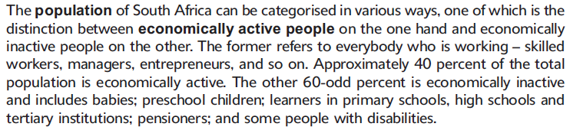
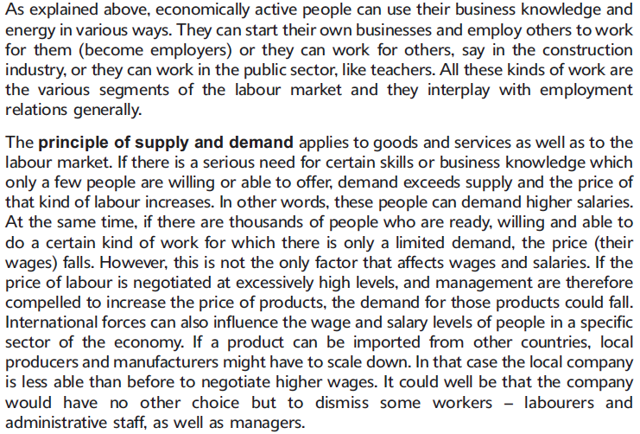

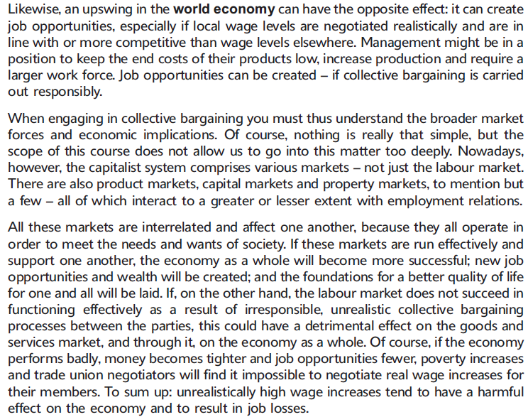
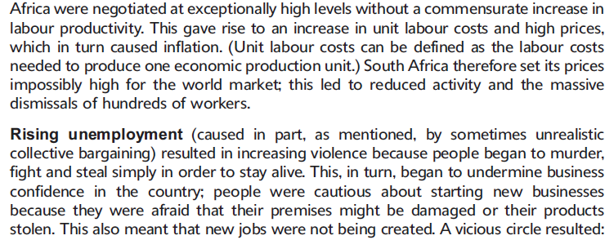

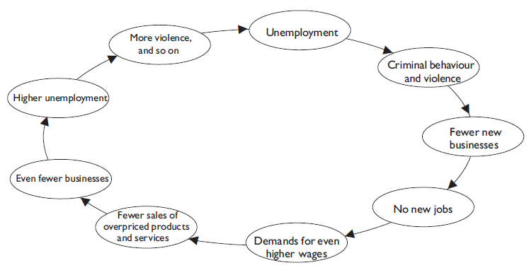

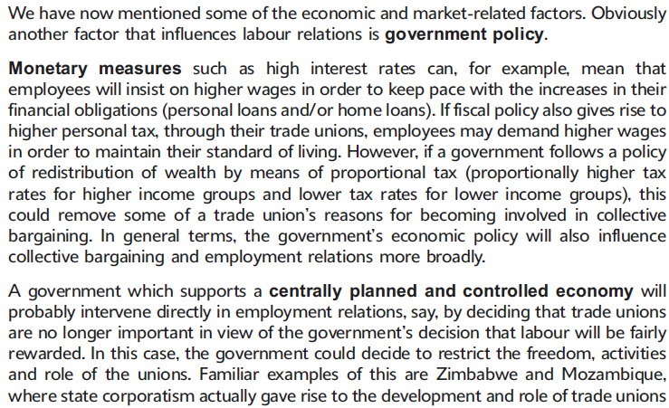

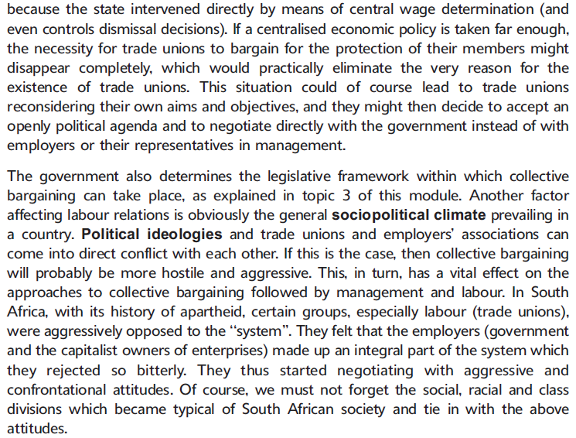

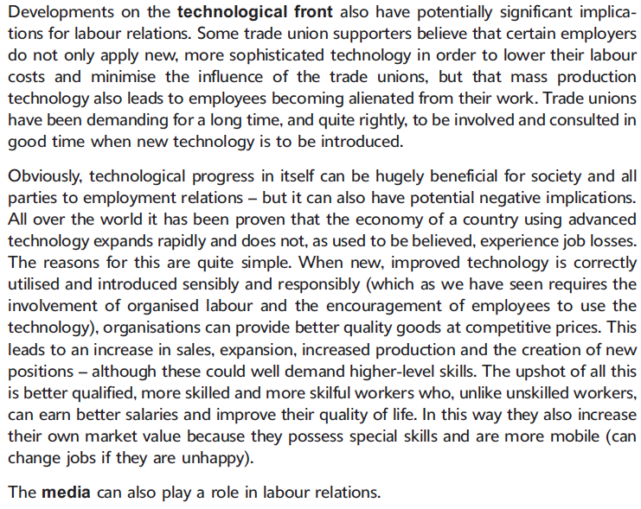

Organisational level Factors
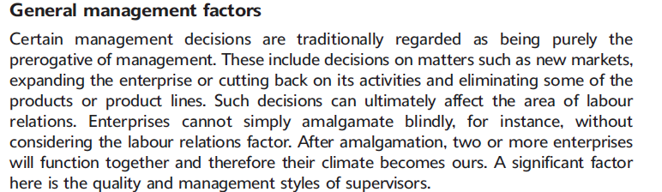
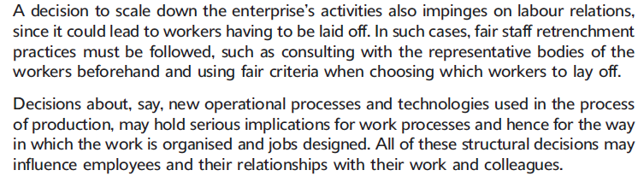

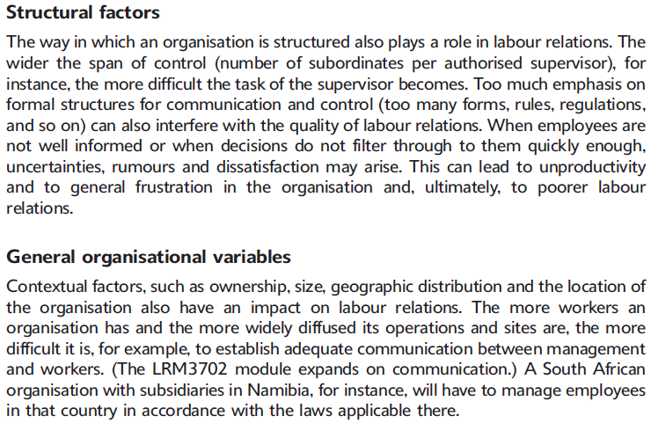
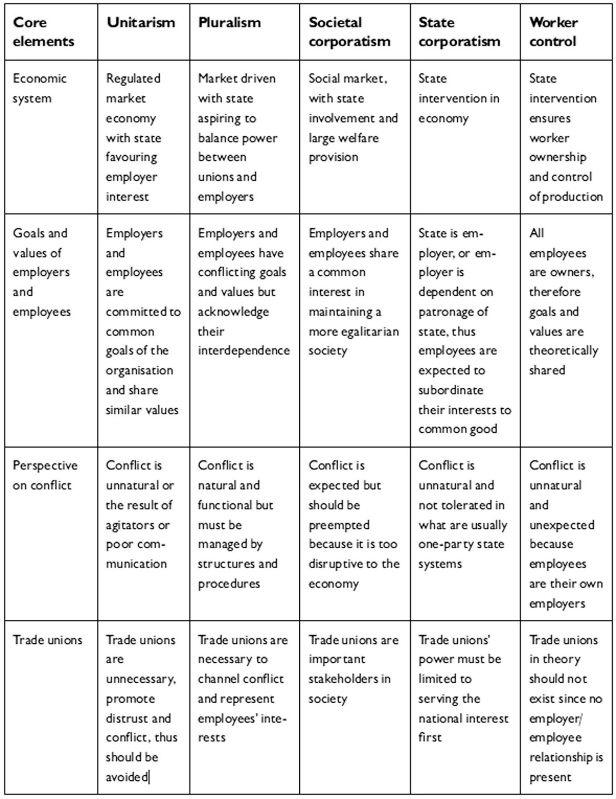

SELF-ASSESSMENT
Question1
Write a short essay on the following topic: The study of labour relations from a business management perspective.
Question 2
Distinguish between the different frames of reference concerned with the inherent nature of labour relations.
Question 3
Draw up a systems model for an integrated approach to the management of employment relations. Discuss this model, and explain how such an approach is aimed at enhancing the competitiveness of organisations.
Question 4
Explain how perceptions of procedural justice, distributive justice and interpersonal justice can contribute to conflict situations in the workplace.
How can these issues be resolved by focusing on common ground?

Question1
Here you could have used section 2.3 in the study guide as your point of departure.
In answering this question you were expected to start by explaining the task of management which is to determine how an organisation can achieve the highest possible output (profit) with the least possible input (labour, capital, land).
If you then view labour relations from a management perspective this means the management of all aspects and dimensions of employment relationships in such a way that its net effects result in more productive and successful organisations. The main concern for any labour relations man- ager would be to apply planning, organising, leading/directing and control to the management of people in their employment relationship (employment relations management). You can illustrate by means of practical examples how these four management functions form part of the management of labour relations.
Employment relationships need to be managed in such a way that their outcomes or outflows have a positive influence on the survival, continued existence and hence ultimate success of the organisation.

Question 2
Here you could have used section 2.1 in the study guide as well as section 1.2 (pp 6^10) in your prescribed book as your point of departure.
Even if we understand the importance of managing labour relations and try to link labour relations to the objectives of the undertaking, we still need to understand the approach we adopt to labour relations. e have to understand what approach to labour relations management will follow and, as a result, a number of approaches have been identified. In your answer you need to discuss and analyse the approaches as we briefly do below. At the outset, it is important to remember why we need to understand the various frames of reference: the frame of reference and the labour relations approach adopted by the organisation will influence labour relations decisions and the kind of labour relations (and the quality of the labour relations) that develop.
Now you have to discuss the characteristics of the following approaches and also give examples:
(a) The unitarist approach. Perhaps the most obvious examples in South
Africa are statements by management (which we still encounter all too often) that internal conflict in the organisation is the fault of out- side agitators and that trade unions aremerely disruptive and have no place in South African undertakings.
(b) The pluralist approach. The pluralist approach sees the organisation as consisting of individuals who form various groups, with their own goals and objectives, values, concerns and needs. Remember to also discuss the basic premises of pluralism!
(c) The radical perspective. This frame of reference for labour relations is influenced by Marxist thinking, with its emphasis on class and group conflict, economic power (and its distribution) in society and its view that social conflict merely reflects or expresses underlying economic conflict in society.
(d) Corporatism. Corporatism has been described as government bringing all the major role-players (organised labour, organised business and the state) into the processes of policy formulation and implementation. In South Africa, the best example of this is the National Economic Development and Labour Council (NEDLAC), a corporatist body that discusses, inter alia, new labour legislation. Note the distinction between state corporatism and social corporatism and the fact that the former may mean the gradual weakening of trade unions.
(e) Worker control. This approach is linked to democratic socialism, where the key decision-making structures of society, and in particular the processes of production of goods and services, were supposed to be under worker control.
The current trend in South Africa appears to be a gradual move towards societal corporatism. Trade unions are still regarded as important stake- holders and conflict is accepted, but there is also increasing acknowledgement of the common ground between employers and trade unions. The key role-players (the state, organised labour and organised business) have shown that they are willing and eager to accept the coexistence of both conflict and cooperation.
Question 3
Here you could have used study unit 2.4 in the study guide as your point of departure.
Figure1in the introductory section of this study guide is a visual presentation of a systems perspective on an integrated approach to the management of employment relations. According to this perspective, the organisation is seen as a subsystem of the wider environment in which it exists and functions and the management of employment relations as a subsystem of the organisation. In this question you have to discuss the inputs, throughputs and outputs of such an open system, with specific reference to the management of employment relations. Discuss this model, and explain how such an approach is aimed at enhancing organisations competitiveness.

Question 4
Here you could have proceeded from section 2.5 in the study guide.
Explain what distributive justice, procedural justice and interpersonal justice are and also how perceived injustices can lead to conflict. Use the criteria for distribution decisions and fair procedure, as well as the elements that are central to interpersonal justice perceptions in the prescribed book, to evaluate a situation, and explain how failure to heed these criteria can lead to conflict. Explain the causes of conflict and discuss how unions
And management can approach situations in order to cooperate instead of compete with each other.

Chapter 2

ROLE-PLAYERS IN LABOUR RELATIONS IN SOUTH-AFRICA

EMPLOYERS AND EMPLOYERS ORGANISATIONS

Management is a primary participant. An Entrepreneur is a person who risks their money to start an enterprise which provides goods and services to satisfy people’s needs.
The owner (Entrepreneur + Employer) cannot organise and manage all the aspects on his own – he employ people to assist him on management level – these managers (employees + manager) looks after certain function.

According to Barker and Holtzhausen , an employer is a ``person or organization who engaged one or more persons to work for him or her or it as employees or has allowed an employee to assist him or her or it in carrying on or conducting the business of the employer''.
This definition places the employer firmly in the context of the employment relationship the relationship between employee and employer. We can only say - that employers are people who enlist the services of somebody to promote their own interests. The concept ``employer'' only arises when there is an employee who is or will be employed (a prospective employer and (a) prospective employee(s)).The actual point in this study unit is that businesses (the subject of the study of Business Management) often become employers and join employers' organisations.

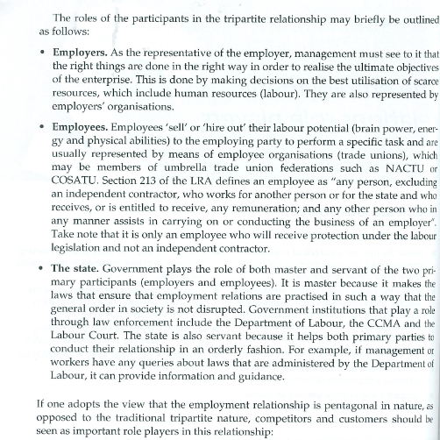

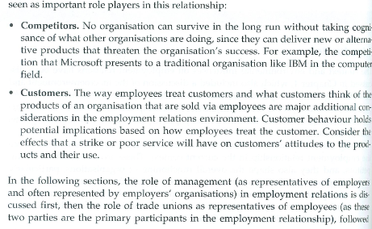

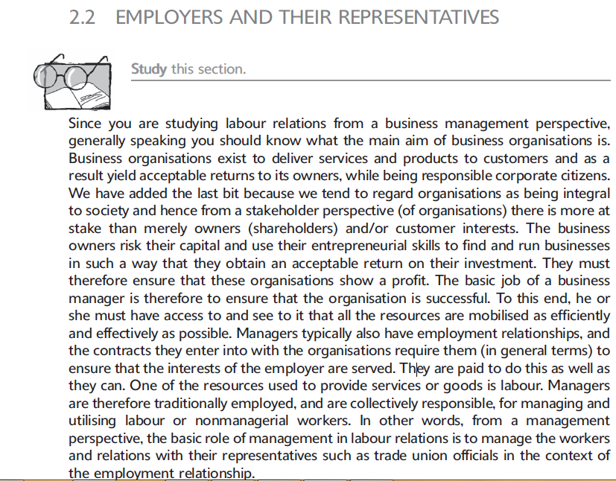

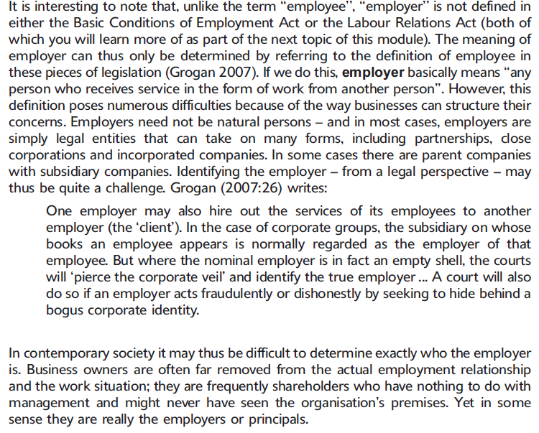

Employers' organisation

Barker and Holtzhausen define an employers' organisation as follows: ``An organization that voluntarily links together with any number of employers, often in a particular industry and/or region. One of the primary aims of such an organization is to regulate relations between employers and employee organizations.''

There are many different types of employer’s organisations. It is clear from the above that, just as employees can join trade unions, so too can employers join employers organisations such as the Chamber of Mines, or sectoral employers' organisations such as the Building Industries Federation of South Africa (BIFSA) and the Foundation for African Business and Consumer Services (FABCOS), and that these organisations, in turn, can affiliate with federations such as the National African Federated Chambers of Commerce (NAFCOC).The operation of these organisations is also subject to the provisions of the Labour Relations Act. Business South Africa (BSA) is an important umbrella organisation that provides its members with a collective voice on economic and social policy issues.

One primary aim of the Employers' organisations is to regulate the relations between employers and employee organisations.

Employers' organisations can also operate by sector or for the common interest –

Sectoral Employers organisations
This type of Employers organisations gained much more status – as this was previously nit the case. Some of these Employers organisations are: -
- Steel and Engineering Industries Federation of South Africa (Seifsa) – coordinate 41 Employers organisations.
- Sugar Manufacturers and Refiners Employers Association (SMREA) – established in 1947
- South African Petroleum Industry Association (SAPIA) established in 1994
- Chamber of Mines of South Africa (COM) – the oldest sectoral smployers organisations - established in 1894.
Employers' organisations may consist of any number of employers in any given enterprise, industry, trade or profession who associate in order to regulate relations between themselves and their employees in that sector. A significant consequence of membership of an employers' organisation is that once an employer has joined such an organisation, he or she is automatically bound by the terms of any agreement reached by the organisation. Employers' organisations usually form part of bargaining councils and in that way take part in collective bargaining with trade union representatives in order to achieve collective agreements. It goes without saying that the individual employer's views are also subject to the consensus view of the group.

Collective Interest Groups
The common factor of the entire Employers' organisations is that they represent the common and collective interest of their members, which leads to the fact that individual employers views are subject to the consensus view of the group. This is contentions as managers are sometimes employers - but are not the same as stakeholders or shareholders. This lead to tension in that the ability to make decisions is limited as management/employers are not always the owners.
There are English Speaking businesses – one example of a collective interest is the Blaawberg and West Coast Chamber of Business (SACOB)
Afrikaans Speaking businesses – one example of a collective interest is the Afrikaanse Handelskamers - operate under the collective umbrella Afrikaanse Handelsinstutuut (AHI)
Black businesses – one example of a collective interest is the National African Federated Chambers of Commerce (NAFCOC)
Although some integration had taken place between the various employers’ organisations – they still operate largely along separate lines.
Slabbert et al. State that employers’ organisations deal with issues that are economically and socially focused to help shape the business environment in SA.
The need existed for a joint national umbrella organisation which was then formed in 1994 – Business South Africa (BSA). Development has taken place and Business Unity South Africa (BUSA) was formed in 2003 to represent united employers organisations.

Business Unity South Africa (BUSA)

Business Unity South Africa (BUSA) was created in October 2003 through the merger of the Black Business Council and Business South Africa. It began operating in January 2004. The merger created the first truly unified organisation for business in South Africa.
BUSA represents South African business on macro-economic and high-level issues that affect it at the national and international levels. Our function is to ensure that business plays a constructive role in the country’s economic growth, development and transformation and to create an environment in which businesses of all sizes and in all sectors can thrive, expand and be competitive.

BUSA’s Vision - aims to be a unified and fully representative organisation that contributes to a vibrant, transforming and growing economy in South Africa
BUSA’s objectives are to:
- Act as the principal representative of business in South Africa in its national, sub-continental, continental and international spheres of activity so as to ensure a primary and consistent representation of the views of the South African business community
- Promote broad-based Black Economic Empowerment
- Advance and promote initiatives aimed at job creation and the alleviation of poverty
- Act for and represent the views of its members at national, sub-continental, continental and international levels
- Enable business to play a meaningful strategic role in South Africa's overall development
BUSA is a mechanism that enables one entity to speak on behalf of South African Businesses as a whole on appropriate issues and on a mandated basis.

Competitors
Nel et al (2008:39) refer to competitors as other organisations that may deliver new or alternative products and/or services that customers prefer.
This will impact on the employer and employee role players. This may happen at international and national levels .The dangers of competitors cannot be underestimated, because they can easily be the cause of a closure of an organisation if management do not respond positively to challenges and changes in the marketplace. Trade unions therefore also have a direct interest in competitors.

All managers need to be aware that employers' organisations fulfil a vital role in South Africa (Nel et al 2008:41). For example, they keep statistics on their members which they regularly update and represent their members on various councils such as bargaining councils and the councils of medical funds, pension funds and insurance companies. Managers should determine the position of their organisations in the industry, and then
Decide whether they wish to join an employers' organisation.

Question1
Write an essay outlining the role of employers' organisations in labour relations with specific reference to South Africa.
Question1
Here you could have used study unit 3 above and section 2.1in your prescribed book as your point of departure.
In answering this question you should first have defined an ``employers' organisation'' and indicated what the functions of such an organisation could include. An employers' organisation is a formal grouping of employers set up to defend, represent and/or advise affiliates and strengthen their position in society at large by looking after the collective interests of their members.
In South Africa there is no clear distinction between business/trade associations and employers' organisations and we can therefore say that employers' organisations in South Africa have a twofold function: firstly to establish economic policy, and secondly to be involved in employment relationships and policies, as well as the various labour functions of the state.
Secondly, you had to discuss the functions and activities of employers' organisations. These functions and activities are extremely varied. They could include (but are not limited to) the formulation of position papers and policies on issues of joint concern to members, the representation of employers in discussions with trade unions, government and the community, rendering of various specialised services such as the regulation of domestic
and foreign trade, advice to members, the establishment and administration of pension, provident and medical aid funds, the provision of services in labour relations and personnel administration, lobbying and influencing the introduction of legislation and acting as the collective spokesperson for their members. The main reasons for the existence of employers' organisations could be regarded as the facility offered to their members to exchange views and the formulation of policies on labour relations and related social matters.
Thirdly, you could have given some examples of South African employers' organisations and discussed their membership and functions. These could have included multispectral organisations such as the Afrikaanse Handelsinstituut (AHI) and the South African Chamber of Business (SACOB) and uni-sectoral organisations such as the Chamber of Mines of South Africa.
You should also have discussed the importance of employers' organisations such as Business Unity South Africa (BUSA).
Finally, you should have emphasised that although South African employers' organisations vary considerably in their membership, structures, scope and activities, they all have one common feature they all represent the collective interests of their members

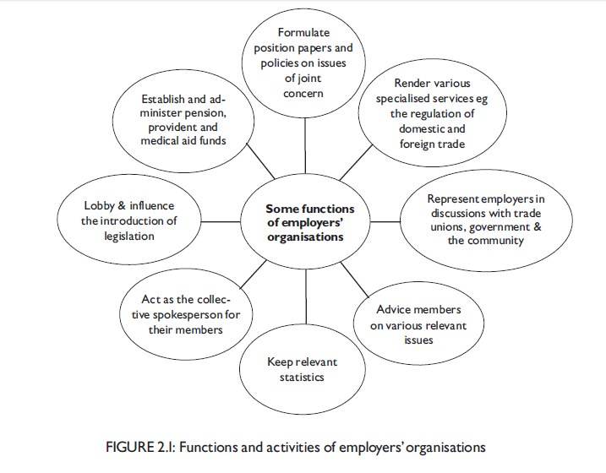

LABOUR AND TRADEUNIONS
The American College Dictionary defines labour as ``bodily toil for the sake of gain or economic production those engaged in such toil considered as class''.
To this it adds: ``a work or tasks to be done''.
Webster's College Dictionary defines labour as ``the service rendered or part played by the laborer, operative and functional, in the production of wealth, as distinguished from the service rendered by capitalists, or by those whose exertion is primarily or almost entirely mental'', or ``all mutual workers whose work is characterised largely by physical exertion: distinguished from all white collar or professional workers''.
These definitions distinguish between labourers and professional or office workers, and also imply the existence of inherent conflict between labour and capital. This would mean that labour organisations exclude office workers or professional people although we know that this sector can also be organised. The only valid portion of these definitions is their clear differentiation between labour and capital. In addition, it should be said that labour is done in an effort to acquire income. This means that labour includes all people who exert themselves for this purpose, that is, every employee in every sphere of human endeavour. The South African labour glossary (Barker & Holtzhausen1996:81) defines labour as ``Mental or physical effort that contributes to the output of goods or services. Alternatively workers or the work force''.
Clearly, such a definition may include managers and all other employee category. When we consider labour from the collective dimension of labour relations, and from the perspective of the tripartite nature of labour relations, however, for our purposes labour would then refer to non-managerial workers as a group and to their representatives.
What, then, is the ``work force''?
The South African Labour Glossary (Barker & Holtzhausen 1996:44) explains that ``the economically active population can be divided into the `usually active population', measured in relation to a long reference period such as a year and the` currently active population', measured in relation to a short reference period such as one day or one week ...The latter measure is the most widely used and is conceptually equated to the ‘labour force' or `work force'.''
Labour is therefore characterised by a willingness to exchange the worker's only negotiable commodity, which for want of a better term we can call ``energy''. This negotiable energy can take on various forms, such as physical labour, mental toil, knowledge or skills and creativity.
``Remuneration'' can include financial reward, long-term or short-term security (like group insurance and pension schemes), status, ego satisfaction or self-actualisation.
Although labour can therefore have an extremely broad meaning, the context in which it is used here is ``non-management employees and their representative bodies such as a trade union''. The specific focus is on trade unions and their role in labour relations.
Trade unions are key parties concerned with and role-players in the management of labour relations in South Africa. Trade unions not only played an important role in our transformation from apartheid to democracy, but they are vital parties concerned with role-players in the government of this country today. I
Note that, in terms of the LRA (the Labour Relations Act), an ``employee'' can be defined as ``any person, excluding an independent contractor, who works for another person or for the state and who receives, or is entitled to receive, any remuneration, and any other person who in any manner assists in carrying on or conducting the business of the employer''. In our definition, however, we are not referring to the statutory definition of an employee, in terms of which a manager would definitely be regarded as an employee, but to the tripartite relationship between employees/labour (represented by trade unions), employers (represented by management) and the state. In this context management acts as the representative of the employer and is therefore not regarded as ``labour''.

In its simplest - A Trade union can be seen as a voluntary organisation of workers.

The following definition of the International Confederation of Free Trade Unions:-
A trade union is regarded as continuing permanent organisation created by the workers to protect themselves at their work , to improve the conditions of their work through collective barraging , to seek to better the conditions of their lives , and to provide a means of expression for the workers’ view on matters of society.

Jose and Webster point out a couple of trends which may impact negatively on the union movement:-

Globalisation – this leads to competitive pressure in product markets, accelerating the mobility of capital and adding to the vulnerability of trade unions.
More insecure Employment - flexible labour market policies are gaining greater legitimacy and political support than before leading to an increased in practices such as subcontracting, outsourcing and the hiring of temporary and part time staff becoming more common.
Small Business – Technological changes make it possible to reshape production. This may lead to smaller companies undertaking more of the production normally undertaken by bigger ones. The large number of production units makes it difficult for unions to organise workers and to bargain collectively.
Geographic dispersion of production – the result of technological changes has been that production has been geographically dispersed outside the urban labour market, making it more difficult for unions to gain access to every work place.
Skills composition – the changing skill composition of the workforce – more skilled workers on the one end , better educated and less motivated by class and solidarity (shared aims))
Women Workers – women have a need for more flexi hours because of responsibilities after hours; tend to be less interested in union activities.
Increased Unemployment – the lack of formal employment in the economy in many developing countries place additional burdens on families. The unemployed may be so anxious to find work that they undermine union solidarity.

TYPES OF TRADE UNIONS
Trade unions can be grouped into different types according to their nature and character. Although different approaches can be followed to categorise types of trade unions
Craft Unions – their focus is on specific occupations i.e. carpenters, plumbers, painters, brick layers. Membership is gained by specific occupation, irrespective if the industry the member work in.
Industrial Trade Union – define their domain in terms of specific industries, members work in the industry, irrespective of their trade. Some of the best known are Mineworkers , Autoworkers and steel workers.

The following types of unions can be identified:
Occupational / Craft Union
The membership of occupational unions is restricted to specific occupations, regardless of the industry in which a member works. Craft unions were the first such unions to be established. An example of a craft union would be, say, a carpenters' union. Bendix (2004:152) states that ``the main characteristic of these unions is their concern for and protection of the skilled status of their membership.'' She goes on to say that their strength does not lie in their numbers, but rather in the strategic position they hold in organisations and the fact that they are not easily replaceable. These unions will fight for higher wages, prevent the erosion of wage differentials and endeavour to maintain the customs and standards of their craft.
They use the following methods to achieve this goal:
. restricted entry into trades by maintaining control over the number of apprentices in training
. setting high standards for the levels of qualification and training
. maintaining high standards for and the customs of the craft
. resisting changes in work practices
. disallowing the performance of any section of their work by members of other unions or workers with other skills (``job demarcation'')
By using the above methods they ensure the existence of relatively small numbers of well-paid and highly-trained persons in their trade.

promotion union
variation of the craft union is the promotion union. Promotion unions are confined in membership to workers with a certain skill, but who did not serve a recognised apprenticeship. Their members achieved their skilled position by being promoted through the ranks; they acquired their knowledge through practice on the job and reached their skilled status through promotion or merit, competence and leadership (Swanepoel et al 1999a:57). An example of a promotion union is the Footplate Workers' Association on the railways (Bendix 2004:152).
white-collar union
Bendix (2004:153) contends that with the shift to service industries in the economies of many developed countries there is a noticeable increase in the number of white-collar unions. These unions do not include manual workers in their membership. Members are drawn into trade unionism by bureaucracy, office automation and the eroding of differential

industrial union
According to Swanepoel et al (1999a:57), industrial unions organise workers in a single, well-defined industry regardless of the trade or profession that is actually being practiced (eg NUM, NUMSA). Their membership includes manual and white-collar workers. These unions operate according to the theory that workers have more in common with those who work in the same industry than with those who perform a similar skill because they work in similar conditions, with a common technology, and with the same/a similar employer(s). Bendix (2004: 153) argues that industrial unionism has definite advantages because it promotes stronger unions, helps to eliminate inter union competition, reduces the number of unions with which an employer has to bargain, improves communication between the trade union and the employers' organisation and results in improved industrial planning. The union's power base is also strongly enhanced through its ability to have an entire industry go on strike.

general union
A third grouping of trade unions is often referred to as general unions.
General unions organise all workers, regardless of the job or skill being performed and of the industry. According to Bendix (2004:153), general unions originated both from the politically inspired ideal of organising the entire work force into one body and from the need to represent non skilled workers without reference to industries. Swanepoel et al (1999a:58) maintain that these unions are based on the theory that workers feel an affinity with the working-class movement in general rather than with specific trades/industries
WHY DO TRADE UNIONS EXIST

At the heart of the trade Union lies the decision to join, take part in the process and support it. It seems like a good case for employees to join trade Unions. Drawing on Maslow’s theory – a vast range of unfulfilled needs of workers may influence them to join.
Factors that play an important role in the individual’s decision to unionise: -
- Perceived lack of job security
- management lack of respect for employees
- Anger that the employer
- The belief that union representation would be effective
- Favourable attitudes about trade unions in general.
Summarise the underlying reasons why you think people belong to unions.
The fact that 10 can do more easily what one may find difficult to do, and100 can do the same thing even more easily. There is strength in numbers and this is what a union usually provides. Unions provide employees with a formal and unified way of using their collective power to influence their situations in the workplace. Do you think your employer will take you seriously if you threaten to strike because of a change in your working conditions? Probably not (apart from the fact that the strike would be unprotected, who would miss only you in the entire organisation?) But, if you and your colleagues belong to a union and threaten to strike, the employer will probably stand up and take notice!

The trade union movement evolved from the Industrial Revolution (see sec 1.3 in study unit 1). The exploitation of the working class during the Industrial Revolution, for instance, led to the use of collective power to improve their working conditions within the system. Wages were low, working hours long and working conditions appalling. Management aimed at keeping costs low to increase profits and this meant reducing wages and a reluctance to spend money on safety precautions. Workers therefore saw trade unions as their only salvation.
There were, however, several other reasons for the creation of trade
unions, which included the following:
. the divorce of workers from owners
. poor wages and working conditions
. mass production and division of labour
. independence and discipline
. labour as a commodity: the development of a conflict-and-power relationship
. economic insecurity and dependence
. the class system: ``them and us''
. dehumanisation: hopelessness, helplessness and loss of dignity
. instruments of workers' direct control of industry and society (syndicalism)
. instrument of class war
. the institutional element of social conflict
. the defence mechanism of manual workers
. response to social stress
. the institutional component of democratic planning
. the collectivity principle

THE NATURE AND FUNCTION OF TRADE UNIONS
The role of trade unions in the employment relationship cannot be over- estimated. Bendix (2001:148) explains it as follows: ``... the collective with the highest profile is the union. Unions are both the reactive and the proactive participants in the relationship ... Any attempt to understand industrial relations processes, therefore, necessitates an understanding of unions ...''. Because trade unions are such an integral part of South African labour relations, it is important for you to have a good understanding of their role and functioning.
In general, the functions of a trade union can be summarised as follows:
A trade union
- represents its members by negotiating agreements with employers in the workers' general interest, regarding remuneration, service conditions, benefits and working conditions (wages, working hours, job security)
- brings workers' grievances to the attention of management and helps to resolve them
- ensures security of employment and income for its members (eg role in disciplinary hearings)
- improves the physical working environment through their efforts to improve safety
- continually monitors wage and service condition agreements which have been entered into with management
- participates in management decisions
- influences the government on social and economic policy matters
- ensures that government legislation is enforced in the workplace
- calls workers out on strike as a last resort in dealing with differences
- provides social services (to assist with difficulties such as illness, death, loan requirements)
- makes contributions to improved community services
- Federation serves on statutory bodies (egNEDLAC).

To sum up, it can be said that a trade union's overall role is to represent the sectoral needs and interests of its member

TRADE UNION GROUPINGS IN SOUTH AFRICA
Trade unions often affiliate as members of larger trade union federations. In
South Africa there are a few such federations, the main ones being Cosatu, Fedusa and Nactu.
The South African trade union federations COSATU, FEDUSA and NACTU, consist of a number of unions, each with its own constitution or policy. A fourth, smaller federation is the Confederation of South African Workers' Unions (CONSAWU). During the latter part of 2007, FEDUSA and NACTU also formed another confederation named The South African Confederation of Trade Unions (SACOTU). Second to COSATU, this is the biggest trade union confederation in South Africa. Many trade unions prefer not to affiliate with any of the existing federation’s .At present there are some 504 individual trade unions in South Africa with a total of about three million members. Knowledge of what these federations stand for and what unions are affiliated to them enables employers to have a better understanding of the feelings of the union members in their employ, and hence to deal with the more appropriately.
Write down these benefits, and compare them with what you have learnt so far about trade unions.
Trade unions provide collective power to their members, balancing the power between the employers and employees. This enables employees to use industrial action against employers if the need arises. They also provide benefits such as legal assistance, financial assistance, medical aid, funeral benefits and insurance benefits. Some unions even have retirement homes and subsidised holiday accommodation.

In the same way nations unite to combine forces – i.e. European Union – trade unions unite on national and international level. This is achieved by affiliating or confederations. Two examples are ICFTU - confederation of 215 national trade union centres and CTUC (Commonwealth Trade Union Council)
The power to influence lies in the ability and standing together.
Transnational trade unionism is thus clearly alive and well and stretches across the world.

The four largest trade unions in South Africa are all affiliated to Cosatu
NUM | National Union of Mine Workers | 299 000
Nehawu | National Education Health and Allied Workers Union | 234 000
Sadtu | South African Democratic Teachers Union | 214 000
Numsa | National Union of Metal Workers | 174 000

TRADEUNIONSTRUCTURES
Nel et al (2008:52) state that the policy-making function of a trade union is characterised by informal leadership in the person of the president, while the executive function provides the formal leadership performed by the secretary.
Policy Making Function
Each Branch appoints their respective branch committee, democratically. Each branch appoints a general committee. Technical and Administrative committees can be appointed as well. The general committee and general council make up the executive. The highest authority of a trade union is the congress made up of delegates from the branch committee.
Executive Function
In discussion the executive function – we enter the independent field of management. There are line functions and staff functions. Line functions = production, although a trade union is not a business – the recruitment of members and getting membership fees is it lifeblood. Staff functions are supportive role to the line function – i.e. administrative, technical , public relations.
THE SHOP STEWARD
The appointment of shop stewards in the workplace emphasises the change in ideology of the ``newer' 'unions as well as the movement towards greater worker participation. Shop stewards and their committees has become the centre of the union organisational structure. This indicates a total change of focus in organisational decision-making processes.
What does this mean in practice ?
One of the activities of the shop steward is to form and maintain shop steward committees and work- place forums. The purpose of these is to create a way for managers and workers to discuss common day-to-day problems in which the union does not, at that stage, have to become involved. In theory this should make it possible for employees to be more involved in decisions and issues that influence their daily lives at work.

A shop steward is defined as a representative person from within the workplace, elected to the position of shop steward and as such having the support of the general worker. Shop stewards can be involved with their tasks on a full-time or part-time basis. The Labour Relations Act (LRA) also supports the election of shop stewards.
It is important to know and understand the tasks and responsibilities of the shop steward, because he or she fulfils various roles. What is his or her role towards the union? Is it only to provide the union with information and to ensure that union subscriptions are handed over? What are the duties of the shop steward at management level? For instance, the shop steward often plays the role of negotiator, communicator, ``policeman'' and relationship-builder between employer and employee. Furthermore, his or her role in the handling of conflict, grievances and discipline should not be undervalued.
The complex role of the shop steward both as representative of the union (and, as such, of his or her co-employees) and as person expected to remain loyal to his or her employer, should be noted.

If a shop steward goes against the employer to support his or her co-worker, what effect do you think this would have on the shop steward's personal relationships in the organisation? Do you think this could have a negative effect on his or her role as an employee?
Individual shop stewards should be objective when approaching problem situations. They should not make promises or undertake to do something that cannot be done. The function is purely that of a liaison person. They give advice and assistance to members and see to it that the stipulations of the collective agreement are observed in all actions. They should promote good relations between employees and managers. When a shop steward provides assistance in a disciplinary hearing, for example, management should not see this as a breach of faith. Unfortunately, this is not always the case and individual shop stewards may find that their loyalty to the employer is suspect and that they are pressurised by the employer to conform. All the same, shop stewards are also protected by the LRA and the Basic Conditions of Employment Act (BCEA) and have the same rights and channels available as other employees in the case of victimisation or unfair treatment by employers.
Role and Functions of the shop steward
Ensure and maintain equilibrium in the relations between management and labour within the framework of existing rules.
The approach of the shop steward must always be objective. They must refrain from making empty promises and not delivering. The shop steward must also form workplace forums – a joint consultation between management and workers for discussing day –to-day problems which does not warrant the full intervention of the trade union i.e. parking, security, canteen facilities, changing room’s ventilation.
Further functions include –
- They carry out their duties as a member of the branch committee team. They are responsible for the effective organisation of their branch and must report to the branch committee on all problems that might arise between members or management and members.
- Enrol members to the trade union. And in case of any closed shop agreements – they must ensure members and management must adhere to these.
- Since they are au fait (familiar) with their Trade Unions constitution – particularly with regards to membership and benefits – they will inform and assist members when claiming for appropriate benefits.
- Encourage members to attend trade union meetings and to participate in discussions.
- Keep the trade union informed about the needs of their members and the general conditions in the trade , as to matters that can affect their members.
- In the work situation they guard the interests of members and see to it that -
  - Both sides observe all stipulations of the agreement
  - Activities comply with particular safety regulations
  - First aid cabinets are fully stocked
  - All aspects are covered in the case of injured on duty or trade illness – branch office must be notified after it was established if the worker is at home or in hospital – all must take place with the knowledge of management.
  - Workers consult the notice board periodically in order to keep abreast of new developments
  - Advise and assist members in matters concerning statutory (legal) and industrial (Trade) council benefits i.e. medial , unemployment , insurance.
  - Assist a member during a disciplinary hearing by management
- The liaison (relationship) functions performed by the shop steward –
  - Discuss valid complains with management through the right matters and obtain finality on the matters
  - Ensure that management use one of the official languages so that members can understand and be understood
  - Discuss particular resolutions of management with workers, and to test management’s feelings should the trade unions actions be unnecessary at this stage.

CUSTOMERS
Customers can be regarded as an important subset of employees in the employment relations context and form part of the pentagonal employment relationship.
Customers form an important part of the pentagonal employment relationship. Employees and their families also act as customers. Without customers – organisation will not exist – as they are the ones who buy the products or services. A customer that is unhappy with the product or service will switch to another product or service. This has a negative effect on the organisations, its operations, marketing strategy and processes. By changing the employees attitude toward their jobs can be a vital turnaround strategy – the employees attitude have a direct impact on customer satisfaction.

2.4 The state

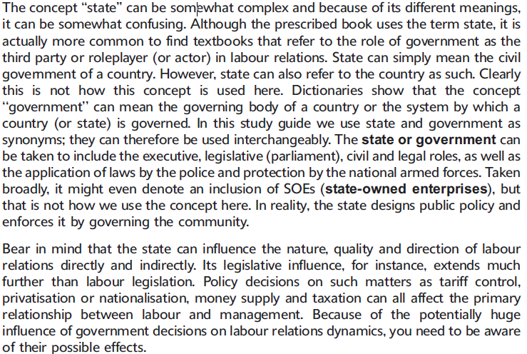

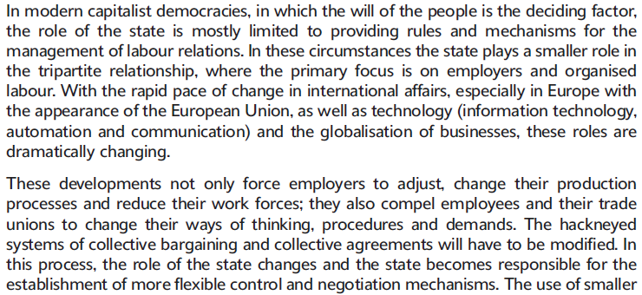

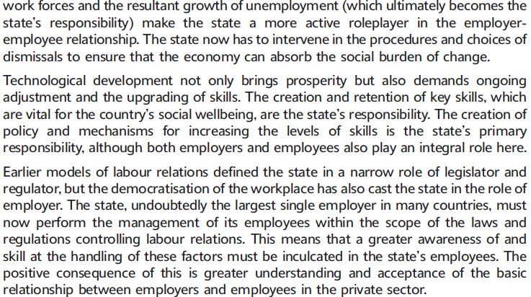

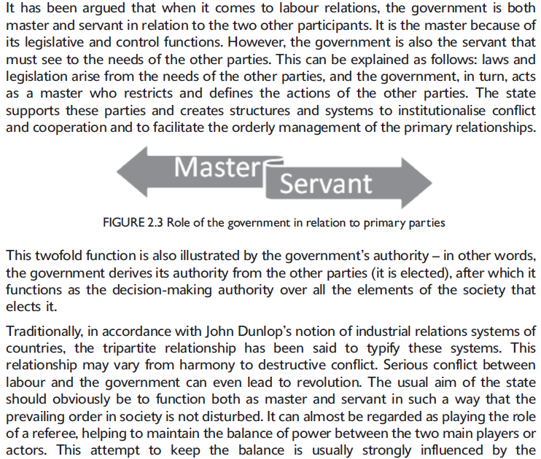

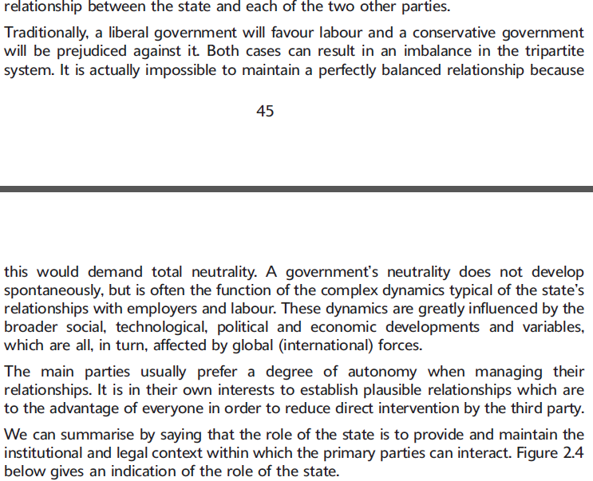

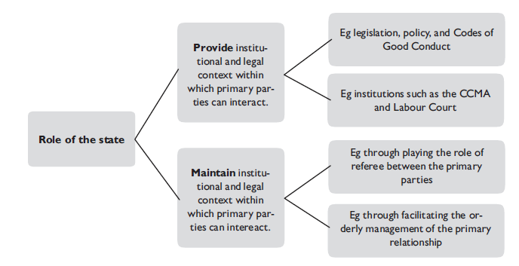

The role of the state in South Africa
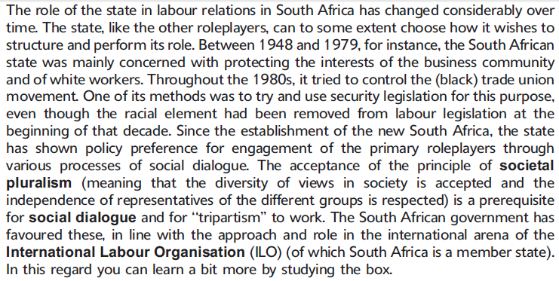

State Governance & processes (pg 64-66)
Labour relations in terms of the constitution ( pg 117-120)

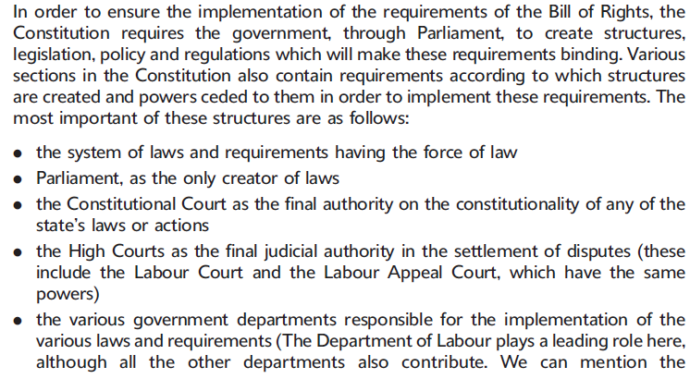

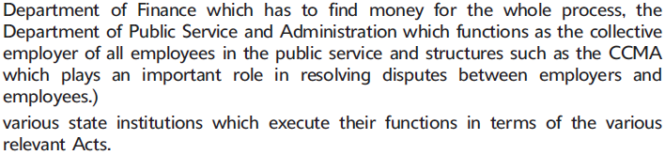

The South African Governments aims regarding labour relations

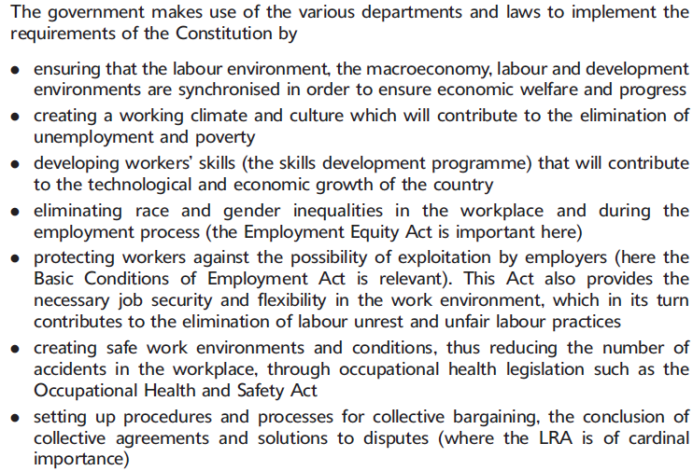

SELF-ASSESSMENT
Question1
Briefly discuss some of the fundamental reasons for the development of trade unions.
Question 2
Define a trade union and discuss the methods trade unions use to achieve their aims.
Question 3
Identify and discuss the different kinds of trade unions.
Question 4
``Shop stewards and their committees have ... become the centre of the organisational structure of ... new unions'' (Swanepoel et al 1999a:60^61).
With reference to this statement, discuss the role and responsibilities of the shop steward in the workplace.
Question 5
Briefly discuss the trade union groupings in South Africa, as well as some of the trends and dynamics of the trade union movement in South Africa.

Question1
The trade union movement evolved from the Industrial Revolution
There were, however, several other reasons for the creation of trade
unions, which included the following:
. the divorce of workers from owners
. poor wages and working conditions
. mass production and division of labour
. independence and discipline
. labour as a commodity: the development of a conflict-and-power relationship
. economic insecurity and dependence
. the class system: ``them and us''
. dehumanisation: hopelessness, helplessness and loss of dignity
. instruments of workers' direct control of industry and society (syndicalism)
. instrument of class war
. the institutional element of social conflict
. the defence mechanism of manual workers
. response to social stress
. the institutional component of democratic planning
. the collectivity principle

Question 2
A trade union is regarded as continuing permanent organisation created by the workers to protect themselves at their work , to improve the conditions of their work through collective barraging , to seek to better the conditions of their lives , and to provide a means of expression for the workers’ view on matters of society.
Trade unions use the following methods:
. administering a trade union fund
. representing their members in collective bargaining
. affiliation and representation on national and international bodies
. negotiating the closed-shop principle and the agency shop principle
. representing their members in grievance and disciplinary procedures
. representing their members in conciliation, mediation and arbitration
. mobilising strikes and picketing
. mobilising boycotts and socioeconomic protests
Question 3
You could also have included a discussion on who the members of the various groupings will be, as well as naming some examples of the various groupings in South Africa.
Trade unions can be grouped into different types according to their nature and character. Although different approaches can be followed to categorise types of trade unions
Craft Unions – their focus is on specific occupations i.e. carpenters, plumbers, painters, brick layers. Membership is gained by specific occupation, irrespective if the industry the member work in.
Industrial Trade Union – define their domain in terms of specific industries, members work in the industry, irrespective of their trade. Some of the best known are Mineworkers , Autoworkers and steel workers.

The following types of unions can be identified:
Occupational / Craft Union
The membership of occupational unions is restricted to specific occupations, regardless of the industry in which a member works. Craft unions were the first such unions to be established. An example of a craft union would be, say, a carpenters' union. Bendix (2004:152) states that ``the main characteristic of these unions is their concern for and protection of the skilled status of their membership.'' She goes on to say that their strength does not lie in their numbers, but rather in the strategic position they hold in organisations and the fact that they are not easily replaceable. These unions will fight for higher wages, prevent the erosion of wage differentials and endeavour to maintain the customs and standards of their craft.
They use the following methods to achieve this goal:
. restricted entry into trades by maintaining control over the number of apprentices in training
. setting high standards for the levels of qualification and training
. maintaining high standards for and the customs of the craft
. resisting changes in work practices
. disallowing the performance of any section of their work by members of other unions or workers with other skills (``job demarcation'')
By using the above methods they ensure the existence of relatively small numbers of well-paid and highly-trained persons in their trade.

promotion union
variation of the craft union is the promotion union. Promotion unions are confined in membership to workers with a certain skill, but who did not serve a recognised apprenticeship. Their members achieved their skilled position by being promoted through the ranks; they acquired their knowledge through practice on the job and reached their skilled status through promotion or merit, competence and leadership (Swanepoel et al 1999a:57). An example of a promotion union is the Footplate Workers' Association on the railways (Bendix 2004:152).
white-collar union
Bendix (2004:153) contends that with the shift to service industries in the economies of many developed countries there is a noticeable increase in the number of white-collar unions. These unions do not include manual workers in their membership. Members are drawn into trade unionism by bureaucracy, office automation and the eroding of differential

industrial union
According to Swanepoel et al (1999a:57), industrial unions organise workers in a single, well-defined industry regardless of the trade or profession that is actually being practiced (eg NUM, NUMSA). Their membership includes manual and white-collar workers. These unions operate according to the theory that workers have more in common with those who work in the same industry than with those who perform a similar skill because they work in similar conditions, with a common technology, and with the same/a similar employer(s). Bendix (2004: 153) argues that industrial unionism has definite advantages because it promotes stronger unions, helps to eliminate inter union competition, reduces the number of unions with which an employer has to bargain, improves communication between the trade union and the employers' organisation and results in improved industrial planning. The union's power base is also strongly enhanced through its ability to have an entire industry go on strike.

general union
A third grouping of trade unions is often referred to as general unions.
General unions organise all workers, regardless of the job or skill being performed and of the industry. According to Bendix (2004:153), general unions originated both from the politically inspired ideal of organising the entire work force into one body and from the need to represent non skilled workers without reference to industries. Swanepoel et al (1999a:58) maintain that these unions are based on the theory that workers feel an affinity with the working-class movement in general rather than with specific trades/industries
Question 4
The information you required as the basis of your answer to this question is contained in study unit 4.7 of the study guide, as well as in section 2.2.8 (pp 53^55) of your prescribed book. Your answer should have indicated that the appointment of shop stewards in the workplace emphasises the change in ideology of the``newer' 'unions as well as the movement towards greater worker participation. You could have defined a shop steward by explaining that he or she represents a person from inside the workplace, elected to the position of shop steward and as such having the support of the general worker. You could also have indicated that shop stewards can be involved with their tasks on either a full-time or a part-time basis. It would have been useful to indicate that the LRA supports the election of shop stewards. You had to discuss the functions of shop stewards in terms of the LRA.
You should also have outlined and discussed the policy-making and executive functions of the union, with specific reference to the role of the shop steward. Here you could have specifically referred to the various roles and functions of shop stewards. What is the shop steward's role in relation to the union? Is it only to provide the union with information and to ensure that union subscriptions are handed over? You should also have explained the duties of the shop steward at management level. For instance, do you think that the shop steward should have a good basic knowledge of the labour legislation that regulates the workplace? Give reasons for your answer. The complex role of the shop steward both as representing the union (and, as such, co-employees), and as being responsible for remaining loyal to his or her employer, could also have been highlighted. What effect do you think it has on the shop steward's interpersonal relationship as an employee in the organisation if he or she goes against the employer to support a co-worker? Do you think that it can negatively influence his or her role as an employee?

Question 5
You could have used section 2.2.9 in the prescribed book to answer this question.
There are five major trade union federations (briefly discuss each):
COSATU,FEDUSA and NACTU(who has formed SACOTUin 2007) and CONSAWU.
Many other, smaller trade union federations also exist.
Individually, each of these federations has basic principles which guide their actions, and a constitution, which serves as a code of conduct and good practice for their activities. Of the three, the best-known and most powerful is COSATU, mostly because of its involvement in political actions in the past. COSATU has many unions affiliated to it, representing at least 1,8 million workers. FEDUSA is known for its non sexist, gender-sensitive policies and foresees an increased role for tripartism. Twenty unions are affiliated to FEDUSA.NACTUhas17 affiliated unions and is known for its black consciousness leanings. FEDUSA and NACTU joined forces in 2007 to form the second biggest confederation of trade unions in South Africa, namely SACOTU.

THE STATE
The concept ``state'' can be somewhat complex. It includes the executive, legislative (parliament), civil and legal roles of the government, as well as the application of laws by the police and protection by the national armed forces. In practice, the state designs public policy and enforces it by governing the community. In the context of labour relations, it is important to note that the state can directly and indirectly influence the nature, quality and direction of labour relations. Its legislative influence, for instance, extends much further than labour legislation. Policy decisions on such matters as tariff control, privatisation or nationalisation, money supply and taxation can all affect the primary relationship between labour and management. Because of the potentially great influence of government decisions on the dynamics of labour relations dynamics, you need to be aware of their possible effects.
In modern capitalist democracies, in which the will of the people is the deciding factor, the role of the state is mostly limited to providing rules and mechanisms for the management of labour relations. In these circumstances the state plays a smaller, or secondary, role in the tripartite relationship, where the primary focus is on employers and organised labour.
With the rapid pace of change in international affairs, especially in Europe with the appearance of the European Union, as well as technology (information technology, automation and communication) and the globalisation of businesses, these roles are dramatically changing.
These developments not only force employers to adjust, change their production processes and reduce their work forces; they also compel employees and their trade unions to change their ways of thinking, procedures and demands. The hackneyed systems of collective bargaining and collective agreements will have to be modified. In this process, the role of the state changes and the state becomes responsible for the establishment of more flexible control and negotiation mechanisms. The use of smaller work forces and the resultant growth of unemployment (which ultimately becomes the state's responsibility) makes the state a more active role- player in the employer-employee relationship. The state now has to intervene in the procedures and choices of dismissals to ensure that the economy can absorb the social burden of change.
Technological development not only brings prosperity but also demands ongoing adjustment and the upgrading of skills. The creation and retention of key skills which are vital for the country's social wellbeing are the responsibility of the state. The creation of policy and mechanisms for increasing the levels of skills is the primary responsibility of the state, although both employers and employees also play an integral role here. Earlier models of labour relations defined the state in a narrow role of legislator and regulator, but the democratisation of the workplace has also cast the state in the role of employer. The state, undoubtedly the largest single employer in any economy, must now perform the management of its employees within the scope of the laws and regulations controlling labour relations. This means that a greater awareness of and skill at handling these aspects must be inculcated in the state's employees. The positive consequence of this is greater understanding and acceptance of the basic relationship which exists between employers and employees in the private sector.

The Role of the state
The role of the state in labour relations is generally to act as a parameter-setting body. Through the different Acts in labour legislation, the state sets the parameters and ground rules for the employment relationship. The state also sees to it that these Acts are observed by both employers and employees and that the rules are adhered to. For example, the LRA stipulates certain procedures that should be followed before workers can embark on protected industrial action. If these procedures are not followed, employers may dismiss employees, and employees may not be able to have this decision to dismiss reversed. The state can also be a conciliator, say, when a union and employer have reached a deadlock that cannot be resolved. Then the state can offer its services as mediator. The state may have different levels of involvement, depending on its policies and also the parties involved in the situation. For example, the state is more likely to become involved in a labour situation in a parastatal such as Escom or Iscor, than in a company such as De Beers, which is privately owned.
Master – servant
It has been argued that, when it comes to labour relations, the government is both master and servant in relation to the two other participants. It is the master because of its legislative and control functions. However, the government is also the servant which must see to the needs of the other parties. This can be explained as follows: laws and legislation arise from the needs of the other parties, and the government, in turn, acts as a master who restricts and defines the actions of the other parties. The state supports these parties and creates structures and systems to institutionalise conflict and cooperation and to facilitate the orderly management of the primary relationships. This twofold function is also illustrated by the government's authority in other words, the government derives its authority from the other parties (it is elected), after which it functions as the decision-making authority over all the elements of the society which elects it.

Tripartite relationship
The labour relationship system consists of a tripartite relationship which may vary from harmony to destructive conflict. Serious conflict between labour and the government can even lead to revolution. The usual aim of the state should obviously be to function both as master and as servant in such a way that the prevailing order in society is not disturbed. It can almost be regarded as playing the role of a referee, helping to maintain the balance of power between the two main players or teams. This attempt to keep the balance is usually strongly influenced by the relation- ship between the state and each of the two other parties.
Traditionally, a liberal government will favour labour and a conservative government will be prejudiced against it. Both cases can result in an imbalance in the tripartite system. It is actually impossible to maintain a perfectly balanced relationship, as this would demand total neutrality. A government's neutrality does not develop spontaneously, but is often the function of the complex dynamics typical of the state's relationships with employers and labour. These dynamics are greatly influenced by the broader social, technological, political and economic developments and variables, which are all, in turn, affected by global (international) forces.
The main parties usually prefer a degree of independence when managing their relationships. It is in their own interests to establish a plausible labour relationship system which is to the advantage of everyone in order to reduce direct intervention by the third party. We can summarise by saying that the role of the state is to provide and maintain the institutional and legal context within which the primary parties can interact.

THE ROLE OF THE STATE IN SOUTH AFRICA
The precise role of the state in labour relations in South Africa has changed considerably over time. The state, like the other role-players, can to some extent ``choose'' how it wants to structure and perform its role.
Between1948 and1979, for instance, the South African state was mainly concerned with protecting the interests of the business community and of white workers. Throughout the 1980s, it was trying to control the (black) trade union movement. One of its methods was to try and use security legislation for this purpose, even though the racial element had been removed from labour legislation at the beginning of that decade. Since the establishment of the ``new'' South Africa, the state has become more tolerant, which could be described as showing support for the principle of subsidiarity.
According to Douwes-Dekker (1998:56), the principle of subsidiarity is satisfied when a government
(1) permits nongovernmental organisations to perform functions and involve themselves in decision making, when the state itself will be responsible for implementing those decisions
(2) grants this responsibility to organisations which work as closely as possible with the people by definition, putting this principle of subsidiarity into practice means that the state has to become ``leaner'' from a public administration point of view, and more effective with regard to management, policy making and the allocation of resources. In such circumstances the state will concentrate mainly on redistributing wealth, while at the same time promoting an environment in which the main parties can continue to create wealth within the limits of law and order. In this context the other role-players
and other social groups are allowed to challenge the state and its agencies, and in that sense the labour market can achieve semi-government status.

(2) What can a government do to promote the following?
(a) unitarist employer strategies\
According to the unitarist perspective, unions are regarded as unnecessary and dysfunctional, because the organisation is a unified structure in which employees and employers work in harmony. Management can create a situation in which unions become ``unnecessary'' by taking full account of employee interests when making decisions.

(b) pluralism
The pluralist perspective adopts the opposite view of management and employees are seen as groups with diverse objectives and interests and thus in competition with each other. This creates perpetual dynamic tension in the organisation. This view (unitarist) also recognises the interdependence of management and employees, and parties may reach compromises on issues in which conflict exists. The role of the state is to provide ways to regulate the conflict, and to provide the machinery to institutionalise it. This is achieved through labour legislation, which provides guidelines and rules for specific situations.

(c) societal corporatism
Societal corporatism acknowledges that the state, labour and employers are interdependent and all parties participate in the formulation of certain policies and key decision making.

THE NATIONA LECONOMIC DEVELOPMENT AND LABOUR COUNCIL (NEDLAC)
The National Economic Development and Labour Council (NEDLAC) is a statutory body comprising representatives of organised labour, organised business and the government whose aim it is to deal with issues on the economy, labour and development. The three parties involved work together with organisations having community and development interests to promote economic growth, participation in economic decision making and social equality in South Africa. Figure 5.1 shows a graphic representation of the structure of NEDLAC.

Nedlac is made up of representatives from:

Organised Business
Business Unity SA (BUSA) represents this sector. The Overall Convenor of the Business Constituency is Raymond Parsons.

Organised Labour
Cosatu, Fedusa and Nactu represent the interests of Organised Labour. The Overall Convenor of the Labour Constituency is Bheki Ntshalintshali.

Government
Government delegates are drawn from the key economic departments, namely, Labour, Trade and Industry, Treasury and Public Works. Representatives from other Government departments participate on an ad hoc basis. The Overall Convenor of the Government Constituency is Jimmy Manyi.

Community Constituency
A number of organisations make up the Community representation, including the Women's National Coalition; the South African National Civics Organisation; the South African Youth Council; Disabled People of South Africa; the National Co-operatives Association of South Africa and the Financial Sector Campaign Coalition. The Overall Convenor of the Community Constituency is Lulama Nare.

The Four Chambers
Public Finance and Monetary Policy Chamber
Trade and Industry Chamber
Labour Market Chamber
Development Chamber.

Nedlac business is conducted under nine (9) distinct policy work streams; namely Annual Summit; Executive Council; Management Committee; Public Finance and Monetary Policy Chamber; Trade and Industry Chamber; Labour Market Chamber; Development Chamber, Section 77 and Special Projects.

Annual Summit
The Council convenes an annual summit each year and is Chaired by the President or Executive Deputy President or such equivalent person as the Constitution of the Republic of South Africa may provide for. While the summit does not form part of the Council itself, its function involves as many relevant groups and forums as possible in order to give feedback on Council activities to obtain inputs from organisations or persons not normally involved in the day to day activities of the Council. The summit brings together no more than 300 delegates.

Executive Council
The Executive Council is Nedlac's highest decisionmaking body. It consists of no more than 18 members of each of the four Nedlac Constituencies- Government, Business, Labour and Community. The Executive Council meets at least four times every financial year to receive report-backs Nedlac's four Chambers and Management Committee to review progress, reach consensus and ratify agreements.

Management Committee
Nedlac's Management Committee consists of 18 members made up as follows:

• 4 Overall Convenors

• 13 Chamber Convenors

• 1 Executive Director

The Management Committee oversees and coordinates all Nedlac's work, subject to the authority of the Executive Council.

Nedlac Chambers
Negotiations are conducted under four distinct policy work streams; namely Public Finance and Monetary Policy Chamber; Trade and Industry Chamber; Labour Market Chamber; and the Development Chamber.

STATE GOVERNANCE AND PROCESSES
Constitution of the Republic of South Africa

The South African Constitution (Constitution of the Republic of South Africa, Act108 of1996) is the highest law of the land. The introductory article ((a1) of the LRA 66 of 1995) states clearly that the aim of the LRA is ``to give effect to and regulate the fundamental rights conferred by section 27 of the Constitution'' (referring to s 27 of the interim Constitution which was changed to section 23 in the final Constitution).
Section 23 deals with labour-related fundamental rights as follows:

``Labour relations
(1) Everyone has the right to fair labour practices.
(2) Every worker has the right
a. to form and join a trade union;
b. to participate in the activities and programmes of a trade un-
ion; and
c. to strike.
(3) Every employer has the right
a. to form and join an employers' organisation; and
b. to participate in the activities and programmes of an employers' organisation.
(4) Every trade union and every employers' organisation has the right
a. to determine its own administration, programmes and activities;
b. to organise; and
c. to form and join a federation.
(5) Every trade union, employers' organisation and employer has the right to engage in collective bargaining. National legislation maybe enacted to regulate collective bargaining. To the extent that the legislation may limit a right in this Chapter, the limitation must comply with section 36(1).
(6) National legislation may recognise union security arrangements contained in collective agreements. To the extent that the legislation may limit a right in this Chapter, the limitation must comply with section 36(1).''

It is therefore vital for you to understand the effect of the Constitution on labour relations in South Africa
ACTIVITY 5.3
Imagine that you recently opened your own restaurant and sports bar. You appointed five kitchen workers, a receptionist who also does some administration, two bar workers, and seven waiters. The local soccer season is in full swing, and an important match has just started. The restaurant is full and extremely busy. You heard about this a short while ago and you are feeling good, because you are obviously doing excellent business.
You have just arrived at the restaurant, and your receptionist, Nandi Molekwa, comes running towards you: she is clearly very upset.``Sir'', she whispers,``Bongi Tsabadi, one of the waiters, has just told me that all seven of the waiters and the two bar workers are very unhappy; they are going to stop work within a quarter of an hour. They demand to know why they get paid less than the kitchen staff and me, and they say it is their constitutional right to know exactly what each of us earns.''
Do you think that the Constitution is applicable in this case? ``Yes'', or ``No''.
FEEDBACK
Every law in the country is subject to the Constitution, because it is the highest law in South Africa. This does not mean that employees can claim certain rights under the Constitution, but rather that labour legislation should not encroach on constitutional rights. As stated earlier, employees have rights that are enshrined in the Constitution, such as the right to form and join trade unions. This means that these rights may not be negated by the LRA and/or other labour legislation. Whether or not compensation is confidential, is usually a matter that is determined by organisational policy and not the Constitution.

GOVERNMENT STRUCTURES
In order to ensure the implementation of the requirements of the Bill of Rights, the Constitution requires the government, through Parliament, to create structures, legislation, policy and regulations which will make these requirements binding

Apart from the protection the Constitution affords to workers, various sections in it also contain requirements according to which structures are created and powers ceded to the min order to implement these requirements. The most important of these structures are as follows:
. The system of laws and requirements having the force of law Parliament, as the only creator of laws
. The Constitutional Court as the final authority on the constitutionality of any of the state's laws or actions
. The High Courts as the final judicial authority in the settlement of disputes (these include the Labour Court and the Labour Appeal Court, which have the same powers)
. The various government departments responsible for the implementation of the various laws and requirements (The Department of Labour plays a leading role here [see sec 5.7 below], although all the other departments also contribute. We can mention the Department of Finance which has to find money for the whole process, the Department of Public Service and Administration which functions as the collective employer of all employees in the public service, and structures like the Commission for Reconciliation, Mediation and Arbitration which plays a key role in settling disputes between employers and employees.)
. Various state institutions (e.g. the National Skills Authority), which execute their functions in terms of the various relevant Acts.

The states involvement in various labour related bodies
National Skills Authority – focuses on research and training of human resources, also inform the minister of matters and policy relating to training and relevant legislation.
Unemployment Insurance Board – focus on matters dealing with unemployment which requires the attention of the minister.
Compensation Board for Occupational Injuries and Diseases – focus on matters relating to compensation of injured employees. Includes minimum and maximum compensation for temporary and total disability.
Advisory Council for Occupational Health and Safety –give advice to the minister relating to Occupational (work related) Health and Safety
Mines Health and Safety Council – deals with safety, research, mining regulations and mining occupational health.
Commission for Employment Equity – provide info on Employment Equity and related issues for the minister.
Commission for Conciliation, Mediation and Arbitration (CCMA) – deals with issues pertaining to the landscape of work - Issues in terms of Labour Relations.

GOVERNMENT AIMS IN MANAGING LABOUR RELATIONS
The government makes use of the various departments and laws to implement the requirements of the constitution by
. Ensuring that the labour environment, the macro economy and development environment are synchronised in order to ensure economic welfare and progress
. Creating a working climate and culture which will contribute to the elimination of unemployment and poverty
. Developing workers' skills (the skills development programme) which will contribute to the technological and economic growth of the country
. Eliminating race and gender inequalities in the workplace and during the employment process (the Employment Equity Act is important here)
. Protecting workers against the possibility of exploitation by employers (here the Basic Conditions of Employment Act is relevant).This Act also provides the necessary job security and flexibility in the work environment, which in its turn contributes to the elimination of labour unrest and unfair labour practices.
. Creating safe work environments and conditions, thus reducing the number of accidents in the workplace, through occupational health legislation such as the Occupational Health and Safety Act
. Setting up procedures and processes for collective bargaining, the conclusion of collective agreements and solutions to disputes (where the LRA is of cardinal importance)

THE ROLE OF THE MINISTER OF LABOUR AND THE DEPARTMENT OF LABOUR
Main responsibilities of Department of Labour
Labour Policy – setting, planning, research, labour market in for and stats
Labour relations – registration of labour organisations, addition of bargaining council agreements, and regulation of basic conditions of employment act, employment equity
Human Resource Development and employment services – provide broad direction of training efforts in the country, responsible for special programs directed at unemployed persons, dealing with employment services such as career counselling, registration and placement of unemployed persons.
Occupational Health and Safety – promoting a safe work environment
The Compensation Fund – provide compensation for injury or death due to occupational accident or diseases
Unemployment insurance managed by department of labour.

ACTIVITY 5.4
(1) Which South African government department plays the primary role in labour relations?

The Department of Labour acts as the state's watchdog, to ensure that both employers and employees adhere to the requirements of the LRA, Basic Conditions of Employment
Act and other labour legislation. The Department also provides services such as employment services, career counselling and the infrastructure for the conciliation of disputes.

THE STATE AS EMPLOYER
The public sector provides some 22 percent of all job opportunities in South Africa (Finnemore & Van Rensburg 1999a:202), comprising jobs in government departments on the national and provincial levels, including administration, services such as health, welfare and education, security and statutory bodies and commissions, as well as jobs in local government, public enterprises like the SABC, Telkom and Transnet, universities and technikons. The state as an employer differs from employers in the private sector in the following respects:
. Organisations in the private sector exist mainly to make a profit for their shareholders, while the main aim of organisations in the public sector is to provide a public service.
. Employees in the private sector can try to increase their own remuneration at the expense of the shareholders.
. The right to strike is generally accepted and supported in the private sector, while strike actions in the public sector (especially such basic services as transport and health services) do not have much support.
Factors such as privatisation and commercialisation have meant, however, that there is no longer much difference between labour relations or employment relations in the private and public sectors. In terms of the LRA 66 of1995, workers in the public sector are entitled to rights and service conditions corresponding to those in the private sector.
Although the employees in the public service have the same rights and privileges as any other workers, in terms of the LRA and the Constitution, the collective bargaining process is handled differently in the public service.
The main difference is that the state does not only operate as the regulator of the process, but also as the employer. There are also differences in the negotiation process and the conclusion of collective agreements between the public and the private sectors. The public service is divided into a central council known as the Public Service Coordinating Bargaining Council, sectoral councils for the large public service sectors, and department councils for the larger government departments. There are therefore sectoral councils for education, health services and various other smaller groupings in the public service. The only exceptions are the councils for the uniformed members of the South African National Defence Force and the South African Police Service. Although these departments have their own councils, they do not form an integral part of the Public Service Coordinating Bargaining Council. The Department of Public Service and Administration, which represents the state as an employer in the Public Service Coordinating Bargaining Council, negotiates annually with all the recognised trade unions on matters concerning the entire public service such as salary increases, allowances, retrenchments and other conditions of service. Disputes which arise in this negotiation process can either result in strikes or follow the route of reconciliation and arbitration according to the nature of the dispute

Apart from the Public Service Coordinating Bargaining Council, most government departments also have a Departmental Bargaining Chamber.
They are not represented in the Public Service Coordinating Bargaining Council, and mostly deal with matters which fall within the jurisdiction of the relevant departmental head. Disputes which arise in these chambers are solved, like any other dispute between employer and employee, by means of reconciliation and arbitration

(2) Briefly describe the role and aim of each party in the pentagonal relationship. Do you think this approach is closer to reality than the tripartite relationship?

The employment relations system at its simplest is a tripartite system consisting of employers, employees and the state. However, the dynamics of customer satisfaction and competition also influence the employment relationship and should not be ignored. This means that the traditional triangular relationship changes to a pentagonal relationship, involving five parties. The role of the state is to provide a legislative framework within which the parties can conduct their relationship. Employers are the owners of an organisation. Their interests are represented by managers in the organisation, who must manage the organisation in such a way that the owners receive a good return on their investment. The representatives of employees (trade unions) further the interests of employees, protecting them in their place of work, improving conditions of work and often also playing a social role. Customers are the buyers of the company's products or services; the company exists because there are customers who need or want its products and are prepared to pay for it. Competitors are other potential suppliers of products or ser- vices and their actions influence the behaviour of the other parties in the pentagonal relationship.

SELF-ASSESSMENT
Question1
Discuss the role of the state in present-day labour relations.
Question1
A brief overview of the role of the state will include the following:
. The state is a secondary participant in the main tripartite relationship (note, however, that we now also refer to a pentagonal employment relationship which includes customers and competitors).
. The state can influence the nature, quality and direction of labour relations directly and indirectly.
. The state has a legislative influence through labour and other legislation.
. The state makes policy decisions on issues such as tariff controls, privatisation, nationalisation, the money supply and taxation. These influence the primary relationship between labour and management.
. The state can be regarded as master because of its legislative and control functions.
. The state is also a servant because it looks after the other parties' needs.
The four main roles of the state in labour relations are that the state
(1) is the largest employer. (Its employment practices have a pervasive in- fluence. In South Africa, the largest single employer remains the public service.)
(2) drafts and passes legislation that regulates labour relations. (Examples of this in South Africa include the LRA 66 of 1995 and the Basic Conditions of Employment Act 75 of1997.)
(3) providesmeans for the resolution of labour disputes between employers and employees or between employers and trade unions. (In South
Africa, the best example is the CCMA [Commission for Conciliation,
Mediation and Arbitration.])
(4) may intervene in the conduct of labour relationships in some way or another, and this intervention will probably relate to intervention in the collective bargaining system or actual negotiations. (Examples in this regard are harder to think of, but note that theMinister of Labour can determine minimum wages by means of a sectoral determination in terms of the Basic Conditions of Employment Act.)

Question 2
Discuss the role of the Minister of Labour and the Department of Labour in South African labour relations.
To answer this question, you should have consulted section 5.7 in the study guide and section 2.3.3 in your prescribed book.
The Department of Labour is responsible for the execution of labour policy. Its mission is to play a significant role in reducing unemployment, poverty and inequality through a set of policies and programmes which are aimed at improved economic efficiency, skills development and employment creation, eliminating inequality and discrimination in the workplace and creating sound labour relations. The Department is responsible for the registration of unions and employers' organisations, and should create the infrastructure to facilitate the conciliation of disputes and the implementation of the Employment Equity Act (all designated employers should submit EE plans to the Department). It is also involved in skills development (registration of learnerships), promoting a safework environment, providing compensation in cases of injury, disease or death because of occupational accidents or diseases, and it manages the Unemployment Insurance Fund.

Question 3
Briefly describe the evolution of the pentagonal employment relations system as opposed to the traditional tripartite relations system. In your answer you should address the role played by all the parties to the employment relations system.
Question 3
In the tripartite system, the parties involved in labour relations issues are the state, organised labour and employers. In the pentagonal system, the parties are organised labour, organised business, government and the community (competitors and customers).
Each of these parties has a different role to fulfil and aim to achieve.
. The state provides a framework for formulating the conflict between management (representatives of owners or employers) and employees.
This statutory framework balances the power between employers and employees and enables role-players to interact constructively.
. Employers want to maximise their profit, to achieve a good return on the investment they have made in the company.
. Employees want to be protected and work in improved conditions.
. Customers influence the relationship through their purchasing power, while the decisions and actions of competitors also impact on the relationship.
These parties are all represented in NEDLAC, where the parties seek to reach agreement through negotiation and discussion. The Minister of
Labour acts as the liaison between NEDLAC and government. NEDLAC's highest decision-making body is the executive council, which has to conclude and ratify all agreements negotiated in the NEDLAC chambers. The management committee oversees and coordinates NEDLAC's work, while its four chambers drive its works programme. Chambers are the labour market, public finance and monetary policy, trade and industry and development.

THE INTERPLAY BETWEEN EMPLOYMENTRELATIONS AND ITS BROADER ENVIRONMENT:
IMPLICATIONS FOR MANAGEMENTAND ORGANISATIONAL SUCCESS

MACROEXTERNALFACTORS
It has often been said that nowadays change is the only thing that remains constant. This is particularly true of the workplace, not only in South Africa, but all over the world, and change obviously has a potential impact on labour relations. The political transformation of South Africa, for instance, has created a fundamentally new context in which labour relations have to be managed.

Briefly write down the ways in which you think the following factors may affect labour relations in South Africa:
- changes in technology (eg information technology such as computers
- population growth
- inflation rates
- expectation levels of the population
- political developments (such as elections)

Changes in technology can lead to retrenchment of staff, because fewer staff may be able to do more work. More often, such changes create a need for retraining staff, who must be equipped with new skills to use the new technology. If the population grows and the economy does not, a high unemployment rate may result. This can lead to higher wage demands, because an employed person may be supporting an extended family. Political changes create expectations from the populace. For instance, recent demands for housing and job creation are examples of some of these expectations. Trade unions do not only intervene in the workplace, but also in social issues. Inflation rates affect organisations' profitability. When inflation rates rise (or the rand strengthens against the dollar), some organisations may lose money and jobs may be threatened. All these things may affect the relationship between employers and employees, not only because of the economic impact of the factors, but also because of the social impact.

If a business organisation is to remain prosperous, it must continually adapt to its external environment, which is constantly changing (Swanepoel et al 1999a:112). The external environment entails influences on or inputs from systems in the broader community, such as the political, economic, social, demographic, educational and technological systems.

Socioeconomic factors social and political dynamics
Economic growth rate, inflation, taxation and interest rate may have an effect on employment relations. A sluggish economy = less demand for products and services, may also lead to increased unemployment, few job opportunities.
People with no jobs don’t have money and are desperate to obtain resources to enable them to make a living – so it may lead to violence in the community. Workers lives may be threatened, worker feel anxious, unsafe and stressed - this can lead to health problems. It also negatively impact production / or output. Poor performance or absenteeism leads to warnings and ultimately dismissal. This has a direct impact on the organisations performance and competitiveness. Restructuring to cut costs may be needed to ensure the survival of the business.
Poor economic performance will have an influence on manager’s decisions, reluctance on wage increases. Industrial action may follow (strikes) as a result. Industrial action, although aimed at reaching economic goals, is a social process. Violence and intimidation normally goes hand in hand with this social process. Violence and intimidation normally force other workers to stay at home - this can cause conflict between management and workers.

Social and political dynamics
The socio-political environment is extremely important. Government promulgate (circulate) and enforce the relevant legislation that impacts directly on employment relations. Organised labour and organised business are engaged directly to take part in the process of drafting /amending labour related legislation. Nedlac is the primary structure through which this is done through.
Organised labour (Unions) is a important stake holder and role player in south African politics. The rights of the unions have been preserved in the Constitution of South Africa.
The role of the trade union in the workplace and in the broader society will depend on the socio-political dispensation (allowance) of the country.
The following trends may be relevant illustrative of this regard –
- As democracy more of a reality - workers tend to strive to be more involved in management decisions. Workers want to be more involved in organisational issues that affect their lives.
- Growing levels of expectations – expectations are normally created amongst the voters. Workers are looking to government and their organisations to “deliver” against transformation, job creation and workplace diversification.
- Pressure is being placed on the private sector to make considerable contributions towards combating poverty and to help raise living standards. Employers should ensure that all employees, irrespective of race or gender should share in the same housing scheme benefit – and those who have been deprived should be treated more favourably.
- Crime, frequently worsen by acts of violence as well as intimidation in the community spill over into the workplace. Banks in SA are frequently exposed to robberies, and the safety and security of their staff have become areas of prime concern. These require special measures instituted. Relevant agreements and codes of conduct therefore become essential for order, peace and stability.
- Another aspect is training and education. Today’s youth are tomorrow’s workforce. SA has an oversupply of unskilled workers. It is to the advantage of any business to be involved in education and development. Union are becoming increasingly interested in the extent in which employers invest money in the development of their employees. If employees is not developed it may not only lead to inferior (lower) productivity levels, but also capacity / competency related cases – and may even threaten the existence of the organisation.
- The changing value system is also having an impact on employment relations; it is becoming increasingly necessary to involve women in the business and professional world. Equal opportunity for woman is a prerequisite. However, woman may sometimes have conflicting personal needs, pregnancy , birth and caring for a newborn. Proactive management decisions to assist more generously with need such as maternity leave and paternity leave as well as child care – subsidy or facilities at work. Flexi times and Flexi place can also be alternatives.

ORGANISATIONAL LEVELFACTORS
Whereas the previous section emphasised the fact that the nature and quality of labour relations in organisations can be influenced by a host of factors outside the organisation, this section focuses on how variables and factors within the organisation can interact with the dynamics of labour relations in the organisation. In this internal environment, the focus is on the influence of factors within the business organisation, such as the mission, vision, leadership and management style (including the way employment relationships are managed), culture, philosophy, policies, strategies and objectives (Swanepoel et al1999a:111).

General management related factors
Certain management decisions are traditionally regarded as being purely the prerogative of management. These include decisions on matters such as new markets, expanding the enterprise or cutting back on its activities and eliminating some of the products or product lines. Such decisions can ultimately affect the area of labour relations. Enterprises cannot just blindly amalgamate, for instance, without considering the labour relations factor. After amalgamation two or more enterprises will function ``together'' and therefore ``their'' climate becomes ``ours''. An important factor here is the caliber and management styles of supervisors. A decision to scale down the enterprise's activities also impinges on labour relations, since it could lead to workers having to be laid off. In such cases fair staff retrenchment practices must be followed, such as consulting with
There presentative bodies of the workers beforehand and using fair criteria when choosing which workers to lay off.

Structural factors
Decisions about, for example, new operational processes and technologies used in the process of production, may hold serious implications for work processes and hence for how the work is organised and jobs designed. All these ``structural'' decisions may influence employees and their relationships with their work and colleagues. The way in which an organisation is structured thus also features in labour relations. The wider the span of control (number of subordinates per authorised supervisor), for instance, the more difficult the task of the supervisor becomes. Too much emphasis on formal structures for communication and control (too many forms, rules, regulations and so on) can also interfere with the quality of labour relations. When employees are not well informed or when decisions do not filter through to them quickly enough, uncertainties, rumours and dissatisfaction may arise. This can lead to unproductiveness and to general frustration in the organisation and, ultimately, to poorer labour relations.

The organisational context
Contextual factors, such as ownership, size, geographic distribution and location of the organisation also have an impact on labour relations. The more workers in an organisation and the more widely diffused its operations and sites, the more difficult it is, for example, to establish adequate communication between management and workers. A South African
Organisation with subsidiaries in Namibia, for instance, will have to manage employees in that country in accordance with the laws applicable there.

Question1
Identify the macro-external variables shaping the business environment.
Pay specific attention to their effect on labour relations.

Question1
In this question you have to identify and discuss various macro-external factors that may influence labour relations, such as socioeconomic factors and socio-political variables. It will not be enough to merely discuss these variables. You must also indicate what their effect will be on labour relations in the organisation. For instance, if you discuss economic variables, you can mention that economic growth rate, inflation, taxation and interest rates may have an effect on labour relations. You should then discuss how this may influence labour relations. For instance, if the economy is slow, it will give rise to even higher unemployment, leading to all sorts of community problems (eg violence).This, in turn, may affect the organisation's workers if their lives are, say, threatened.

Question 2
Write brief notes on the organisational factors influencing the nature and quality of labour relations within organisations.
Question 2
The same applies here. You have to indicate how general management, structural and organisational contextual factors may influence labour relations.

Chapter 3

THE HISTORICAL DEVELOPMENT OF LABOUR RELATIONS IN SOUTHAFRICA

Seven phases in the history of South African labour relations
The question is: Was this the actual start of labour relations in
South Africa? Is this where we should begin to study the history of south labour relations?
If we agree that the employment relationship is the essential cornerstone or foundation of labour relations (see topic 1), and that the nature of this employment relationship changed dramatically as a result of the Industrial Revolution, then we should actually focus on the development of labour relations in South Africa starting from the time when employment, as we know it today, began in this country.

By now your study of South African labour history should have shown you the impact of various environmental factors on the employment relationship itself and also on the legal framework which regulated this relationship. The South African labour relations system is still divided because of past events. In spite of the fact that discrimination on the basis of race, gender, language, and so on, is forbidden both in labour legislation and in general legislation, labour relations are still often characterised by racial and political divisions. The labour relations system has had to change considerably, and very quickly, in the last decade, and has been marked by problems in the political arena. Although problems from the past have been eliminated, new problems keep on appearing and employers, employees (trade unions) and the state are then expected to make adaptations. The labour relations system is therefore still a dynamic one, subject to constant changes necessitated by developments in labour, the economy and the socio-political arena.
Now that you are familiar with the historical development of labour relations in South Africa, we can focus on the present labour relations system.
In topic 4 we will look at the legal framework within which South African labour relations are regulated. It is vital for every manager to be familiar with this in order to manage labour relations effectively.

Question1
Write an essay briefly sketching the historical development of labour relations in South Africa over the seven-phase period.
Here you have to briefly describe the major economic activity and the kind of labour that was utilised. Also identify, if possible, the legislation that was to regulate the relationship between labour and managers. What were the effects of these Acts? What developments were there of trade unions and collective labour activities? What changes led to the next phase?
For instance, let us look at theperiod,1870 to1924. It was the time of the discovery of diamonds and gold. Skilled artisans were recruited abroad.
The establishment of a branch of the Amalgamated Society of Carpenters and Joiners of Great Britain took place ö Blacks and Afrikaans-speaking workers were excluded from this society. The South African Typographical Union was formed, the first truly South African union. Cultural heterogeneity was a problem, as was the fact that blacks were mostly unskilled and whites skilled labourers. For blacks the employment relationship was conducted mainly on an informal basis. The principal Acts of the time were the Industrial Disputes Prevention Act of 1909, and the Mines and Works Act of1911, which attempted to consolidate all other previous legislation and to introduce racially discriminatory legislation. The Masters and Servants Act of 1856 were also still applicable, with the Black Labour Regulations Act15 of 1911promulgated to regulate black matters. The power of white unions was growing, and various other Acts were promulgated. Black workers formed trade unions to protect their interests. The Rand Rebellion was the most critical turning point in employment relations.

THE FORMAL FRAMEWORK GOVERNING SOUTH AFRICAN LABOUR RELATIONS: STATUTORY
PERSPECTIVES

SOUTHAFRICA'S STATUTORY LABOUR RELATIONS SYSTEM
The legislation cited in this study unit is available on the following websites, should you require additional information:
www.acts.co.za
www.parliament.gov.za
www.gov.za

THE INDIVIDUAL CONTRACT OF EMPLOYMENT
As mentioned earlier in this module, our focus is mainly on the collective dimension of labour relations, while the individual dimension will be studied in the module, Labour Relations Management: Micro (MNH304H).
However, we do feel that, before you study the statutory framework of labour relations, you should study the individual agreement (the employment contract) which regulates the relationship between the individual employer and the employee.
As soon as a person offers his or her services (labour) to any other person (an employer) in exchange for compensation, a special contractual relationship comes into being. There need not be a formal, written contract. If an oral agreement is concluded between the two parties, they are expected to comply with its conditions.

Employment contract
The employment contract is really a bilateral agreement between an employer and a worker. The worker offers his or her potential to work to the employer, and in exchange the employer remunerates the worker for his or her labour. The contents of the employment contract are decided upon by the employer and the worker, but other Acts and agreements
Affecting minimum conditions must also be taken into account.
The parties may not accept conditions which are less favourable than those for which provision has been made in the Basic Conditions of Employment
Act 75 of 1997, in bargaining council agreements, or than conditions set by the Occupational Health and Safety Act85 of1993.
In terms of their employment contract, both employer and employee are understood to have specific duties. The employee sells labour to the employer, but the employer also has a lot to offer in the employment relationship.

Duties of the employer
the duties of the employer (Backer1999:4- 9) include the duty to
. Employ
. Provide work as agreed
. Pay a salary
. Provide safe working conditions
. Grant leave
. Contribute to the unemployment insurance fund
. Keep certain written records
. Provide the employee whose employment is terminating with a service certificate or testimonial

Duties of the employee
the employee, like the employer, also has specific duties relating to the employment contract. The following duties of the employee can be identified (Backer1999:9-12):
. To make his or her personal services available
. To be competent
. To act in good faith
. To give service in a subordinate capacity

Requirements for a valid contract
- Parties must have contractual capacity
- Performance of the contract must be possible - if a person claim he is a welder, he must be able to weld to a certain standard.
- The contract may not be contra bonos mores (against public moral values)
- The contract must comply with any formalities which may be prescribed – all apprenticeship contracts must be on place.
- The parties must intend to be bound

PURPOSE AND OBJECTIVES OF THE LABOURRELATIONS ACT 66OF1995 (LRA)
As mentioned previously, the aim of this study unit is to provide an over- view of the labour relations system as it exists in South Africa at present, with special reference to the Labour Relations Act 66 of1995 (the Act, or the LRA) and to the collective dimension of labour relations. The Act itself is extremely readable and user friendly. If there are any issues that you would like to study in greater detail than we can offer here, it would be helpful for you to read the relevant sections in the Act as well as the corresponding sections in chapter 6 of the prescribed book. You can obtain the Act from the Government Printer at a modest price. Also note that South African labour legislation is regularly revised. We will keep you up to date on further changes to the laws, once they have been enacted, in tutorial letters. We do recommend strongly that you also try to keep abreast of the latest developments by following the media. Remember that no manager or business person who wishes to get ahead can afford not to be completely aware of the latest developments in labour relations. You will recall what we said earlier about your work force being your single most valuable resource!
In July1994 the Cabinet announced that labour legislation had to be radically revised. The LRA 66 of 1995 was a product of negotiations between organised labour, business and other interested parties, and introduced a new era in South African labour relations. The hostile, pluralistic labour relations system moved closer to social corporatism. The new LRA was followed by the Basic Conditions of Employment Act, the Employment
Equity Act, the Skills Development Act and the Skills Development Levies
Act, If we look at current labour legislation, we must ask ourselves why South
Africa needed a completely new LRA. Why could the legislation which had lasted for almost 60 years, from 1924 to 1956 to 1980, not simply be amended?
To answer this question, think about what Rautenbach (1993:1) said a few years ago about labour relations in South Africa: ``South African labour laws have failed and must be repealed ... . Some fourteen years after the great dawn of the `new labour law' heralded by the famous Wiehahn Report into industrial laws, every object that laws were meant to serve remains unfulfilled.''
This is a mouthful. But let us look around: South African workers are regarded by some as the most unproductive industrial work force in the world; our strike rate compares favourably with the most strife-ridden industrial societies in the world; industrial violence and intimidation are commonplace; our unemployment is estimated to be at 40 percent of the active population ... .
When the Government of National Unity was elected in April1994, most
South African adults wanted something different, something new, and this included something new in the field of labour relations. The majority of educated South Africans (ie, those involved in business enterprises, labour, and so on) realised that what we had was just no longer good enough for the times in which we were living. Consider carefully the following quotation, which came from a Supreme Court judge as long ago as 1987 (Natal
Die Casting Co (Pty) Ltd v President, Industrial Court and others (1987) 8
ILJ 245 on 253^254 (per Kriek J):
I have on previous occasions, in relation to a variety of problems arising from the interpretation of various provisions in the (1956) Act, expressed dismay at the fact that the legislature, in 1979, saw fit to cut, trim, stretch, adapt and generally doctor the old Act in order to accommodate and give effect to the recommendations of the Wiehahn commission instead of scrapping the old Act and producing an intelligible piece of legislation which clearly and unequivocally expressed its intentions. What was the Court saying? That the numerous amendments made to the old Act meant that the 1956 Act had become clumsy and hard to work with. These remarks were made in 1987.The old Labour Relations Act 28 of 1956 was changed in 1988 (LRA 83 of 1988) and in 1991 (LRA 9 of 1991).
The LRA 28 of1956 had therefore become outdated. It was like a machine that was constantly breaking down, being repaired, having new parts added and old parts removed. But it was never completely rewritten from start to finish. Let us quickly sum up how this situation arose.
The Industrial Reconciliation Act 11 of 1924 was the direct result of the
Rand Rebellion in1922, when mine workers rose up against the mine owners.The1924 Act formed the basis of our labour legislation for a long time, but its effects were confined to white workers no provision was made for black employees in the 1924 Act. The Industrial Reconciliation Act 11of 1924 was amended in 1956 to become the LRA 28 of 1956; it still excluded black employees. A commission of enquiry (the Wiehahn Commission) was appointed in the late 1970s to investigate labour legislation, and its recommendation was that trade unions representing black employees should be allowed to make use of the arbitration mechanisms of the LRA. The Commission also recommended that these trade unions should also be allowed to register (provision was made in the LRA for the registration of trade unions and employers' organisations). At first, only a few unions registered but, in due course. Increasingly more unions registered and took part in the procedures and arbitration system provided for by the LRA 28 of
1956. The amendments (in 1979 and the early 1980s) introduced the concept of unfair labour practices, a vague concept of labour injustice, but one which would play a key role in South African labour law. These amendments also included the establishment of the Labour Court, another institution which was to play a vital part in the creation of South Africa's labour relations dispensation.
In April 1994 the interim Constitution (Constitution of the Republic of South Africa 200 of 1993) came into effect, completely changing the constitutional basis of the South African legal system. It was evident that the old LRA, which actually went back to 1924, did not easily fit into the new constitutional system of exactly 70 years later.
As you learnt in study unit 5, the constitution of South Africa has definite implications for labour relations. For example, the old LRA made no provision for the right to strike (although it did support the ``freedom'' to strike), the right to lock out or to organise. New legislation was necessary to meet these constitutional requirements and to solve some of the problems created under the old dispensation.

The main elements of the South African employment relations system.

- Everyone has the right to fair labour practice
- Every worker has the right –
  - To form or join a trade union
  - To participate in activities and programmes of a trade union
  - To strike
- Every employer has the right –
  - To form or join an employer’s organisation
  - To participate in activities and programmes of an employer’s organisation
- Every trade union and every employer’s organisation has the right
  - To determine its own administration , programmes and activities
  - To organize
  - To form and join a federation
- Every trade union, employer’s organisation and employer had the right to engage in collective bargaining. National legislation may be enacted to regulate collective bargaining. To the extent that legislation may limit a right in this chapter, the limitation must comply with section 36(1).
- National Legislation may recognise union security arrangements contained in collective agreements. To the extent that the legislation may limit a right in this chapter, the limitation must comply with section 36(1).

Section1of the LRA 66 of1995 outlines the purpose of the Act:
Purpose of this Act
The purpose of this Act is to advance economic development, social justice, labour peace and the democratisation of the workplace by fulfilling the primary objectives of this Act, which are -
(a) to give effect to and regulate the fundamental rights conferred by section 27 of the Constitution;
(b) to give effect to obligations incurred by the Republic as a member state of the International Labour Organisation;
(c) to provide a framework within which employees and their trade unions, employers and employers 'organisations can
(i) collectively bargain to determine wages, terms and conditions
of employment and other matters of mutual interest; and
(ii) formulate industrial policy; and
(d) to promote
(i) orderly collective bargaining;
(ii) collective bargaining at sectoral level;
(iii) employee participation in decision making in the workplace; and
(iv) the effective resolution of labour disputes.

Look carefully at these points, and note the following: the Act has a number of objectives (the promotion of economic development, social justice, and so on); and, it has four main objectives in terms of which its respective objectives of social justice, et cetera, can be achieved.
We can see that one of the declared objectives of the Act is to give effect to the requirements of the Constitution (see point (a)).Note also that the emphasis is now on the collective dimension (points (c) and (d)).
If you were asked what the overriding theme of the new LRA 66 of1995 is, you could look through this introductory section (and other sections which we will be dealing with) and say that it is mainly the promotion and regulation of the collective dimension of employment relations.

International Labour Organisation (ILO)
You may be wondering what the reference to the International Labour
Organisation means. It is another hidden reference to collective bargaining. In 1993 the Fact-finding and Conciliation Commission of the International Labour Organisation (ILO) visited South Africa with a view to establishing whether South Africa's labour relations system (in terms of the old LRA and how it was applied) met international standards. These international labour standards are contained mainly in two conventions, the ILO's Convention on Freedom of Association and Protection of the Right to Organise No. 87 (1948) and the ILO's Convention Concerning the Application of the Principles of the Right to Organise and to Bargain Collectively No. 98 (1949). Although other documents also contain international labour standards, these two are the most important.
The Fact-Finding and Conciliation Commission concluded that the South African system did not at that time satisfy international standards. The new legislation can also therefore be regarded as an attempt to bring South Africa more into line with ILO standards, especially with regard to the right to organise and to collective bargaining. You should also note that South Africa is once again a member of the ILO, its membership having been terminated in1964.

SCOPE OF APPLICATION OF THE LABOUR RELATIONS ACT 66 OF 1995 (LRA)
The LRA 66 of1995 is, with a few exceptions, applicable to all employment relationships, that is, all relationships between employers and employees (see topic 1). It does not matter whether these relations are in the private or public sector (where the state is the employer).The concept ``employee'' is defined as follows in section 213 of the LRA 66 of 1995

Employee means:-
(a) Any person, excluding an independent contractor, who works for another person or for the State and who receives, or is entitled to receive, any remuneration; and
(b) Any other person who in any manner assists in carrying on or conducting the business of an employer

The term ``employer'' is not defined in the Act.
Certain classes of employees, however, are not included in the new labour dispensation. Who are they?
Three categories of employees (and their employers) are excluded from the LRA. They are members of the
(1) National Defence Force
(2) National Intelligence Agency
(3) South African Secret Service
This indicates that certain people (even if they can be classified as workers in terms of the definition) are excluded from the new labour legislation on the basis of the kind of work they do (the ``unique functions'' involved in their work).Note that, although soldiers and spies may be excluded from the scope of the LRA, they are still protected by the Constitution. The
Constitutional Court has decided that members of the South African National Defence Force must be classified as ``workers'', and that they are entitled to found and join trade unions.

Essential services
There are also certain other categories of employees who are excluded from particular rights as contained in the LRA. Employees who are concerned with essential services may not strike, for instance, unless an agreement has been reached on how a minimum level of service can be maintained. The employees affected by this are those employed in a service sector declared to be an essential service by the Essential Services Committee, those employed by Parliament, and employees of the South African Police Service.
Subject to the exclusions mentioned above, the LRA is applicable to all employees, employers, trade unions, employers' organisations, federations, bargaining councils and statutory councils. It also applies to domestic workers and farm workers, who were previously excluded from the Act.

Independent contractors
Until the contrary is proved, a person who works for, or renders services to, any other person is presumed, regardless of the form of the contract, to be an employ, if any one or more of the following factors are present:
(a) the manner in which the person works is subject to the control or direction of another person;
(b) the person's hours of work are subject to the control or direction of another person;
(c) in the case of a person who works for an organisation, the person forms part of that organisation;
(d) the person has worked for that other person for an average of at least 40 hours per month over the last three months;
(e) the person is economically dependent on the other person for whom he or she works or renders services;
(f) the person is provided with tools of trade or work equipment by the other person; or
(g) the person only works for or renders services to one person.
(2) Subsection (1)does not apply to any person who earns in excess of the amount determined by the Minister in terms of section 6(3) of the Basic Conditions of Employment Act.
(3) If a proposed or existing work arrangement involves persons who earn amounts equal to or below the amounts determined by the
Minister in terms of section 6(3) of the Basic Conditions of Employment Act, any of the contracting parties may approach the commission for an advisory award on whether the persons involved in the arrangement are employees.
(4) NEDLAC must prepare and issue a Code of Good Practice that sets out guidelines for determining whether persons, including those who earn in excess of the amount determined in subsection are employees.''

Temporary employment service
The LRA contains important restrictions on employment by a temporary employment service. In this case the employee is provided to the client by the temporary employment service. In terms of the LRA, the temporary employment service is deemed to be the employer, and not the client for whom the work is done. In order to be classified as a temporary employment service, the agency must provide ``workers'' to a client, for a fee, in order to provide services to the client or to work for him or her. The ``worker'' is paid by the temporary employment service. The service contract is therefore between the temporary employment service and the employee.
This does not, however, absolve the client of all legal responsibility towards this employee, as the person is still employed on his or her premises. This means that the client can, for instance, be held responsible (or at least partly responsible) if the temporary employment service does not meet the minimum conditions set out in the Basic Conditions of Employment Act.

Temporary employee’s fixed-term employees
A distinction must be made between temporary employees and fixed-term employees. Fixed-term contracts of employment are entered into for a specific period of time. Temporary employees, however, are not necessarily appointed for a fixed period ö they might be appointed to complete a particular task or project. The contract of a temporary employee will automatically lapse if the reason for his or her appointment no longer applies; say the task or the project has been completed, for instance. If a person was appointed on a fixed-term contract of employment, that contract automatically lapses after the contract period.

Reasonable expectation
If the employee, however, has a reasonable expectation that the contract will continue on the same or a similar basis, then terminating that contract would be regarded as unfair dismissal. Temporary status can also change to permanent status if the employee has a reasonable expectation in that regard. However, this expectation cannot be simply time-related; other factors such as the nature of the employee's work and its importance to the organisation must also be taken into consideration.

FREEDOM OF ASSOCIATION AND GENERAL PROTECTION
We must remember here that one of the specific purposes of the LRA 66 of 1995 is to make the Constitution effective. One of the stipulations in section 23 of the Constitution is that workers have the right to establish trade unions and join them. (Similarly, employers have the right to establish and join employers' organisations.) This right forms the basis of freedom of association: workers are free to associate, form a group, found a union. In the same way, employers are also free to associate with other employers and found an employers' organisation. This freedom of association is also laid down in the ILO's international labour standards, and is an acknowledged freedom in the majority of labour relations systems. These stipulations therefore make up the basis of the collective aspect of employment relations.

Protection of employees and persons seeking employment
The LRA states as a general rule that nobody, especially a manager representing the employer, may punish, discriminate against or take any action against any employee simply because the employee exercises a right conferred by the LRA. Nobody can demand that the employee must sacrifice or give up his or her freedom of association. No employee can be disadvantaged (treated unjustly or punished) for exercising his or her rights to found, join or take part in the activities of a trade union.
Note too that protection of freedom of association is extended to people who are not yet employees the Act refers to a person seeking employment. This means in practice that an employer cannot refuse to appoint someone applying for work simply because that person is a member of a certain trade union or has taken part in trade union activities in the past.
Nobody is allowed to favour or promise to favour an employee or work seeker if he or she undertakes not to practise the right to freedom of association. A may not promise B a salary increase if B undertakes not to join a trade union, such an agreement would be invalid.

Chapter 2 of the LRA clearly states that no person may discriminate against an employee by means of the following actions
(b) prevent an employee or a person seeking employment from exercising any right conferred by this Act or from participating in any proceedings in terms of this Act; or
(c) prejudice an employee or a person seeking employment because of past, present or anticipated-
- Membership of a trade union or workplace forum;
- Participation in forming a trade union or federation of trade unions or establishing a workplace forum;
- Participation in the lawful activities of a trade union, federation of trade unions or workplace forum;
- Failure or refusal to do something that an employer may not lawfully permit or require an employee to do;
- Disclosure of information that the employee is lawfully entitled or required to give to another person;
- Exercise of any right conferred by this Act; or
Participation in any proceedings in terms of this Act.

Protection of employers' rights
The LRA grants employers a similar right to freedom of association. Every employer has the right to found, join or take part in the legal activities of an employer organisation. The right is protected by a general provision that nobody is allowed to discriminate against an employer for exercising any right granted by the Act.
There are other more specific provisions on employer protection which are similar to those that protect the freedom of association of employees: nobody is allowed to demand that an employer not practise his or her right to freedom of association, and nobody is allowed to prejudice an employer for practising his or her right to freedom of association. No benefit may be given or promised to any employer on condition that he or she will not exercise these rights.

(1) No person may discriminate against an employer for exercising any right conferred by this Act.
(2) Without limiting the general protection conferred by subsection (1), no person may do, or threaten to do, any of the following-
(a) require an employer-
(i) not to be a member of an employers' organisation;
(ii) not to become a member of an employers' organisation; or
(iii) to give up membership of an employers' organisation;
(b) prevent an employer from exercising any right conferred by this Act or from participating in any proceedings in terms of this Act; or
(c) prejudice an employer because of past, present or anticipated-
(i) membership of an employers' organisation;
(ii) participation in forming an employers' organisation or a federation of employers' organisations;
(iii) participation in the lawful activities of an employers' organisation or a federation of employers' organisations;
(iv) disclosure of information that the employer is lawfully entitled or required to give to another person;
(v) exercise of any right conferred by this Act; or
(vi) participation in any proceedings in terms of this Act.
(3) No person may advantage, or promise to advantage, an employer in exchange for that employer not exercising any right conferred by this Act or not participating in any proceedings in terms of this Act. However, nothing in this section precludes the parties to a dispute from concluding an agreement to settle that dispute.
Rights of trade unions and employer organisations
Chapter 6 of the LRA also sets out rights that are applicable to both trade unions and employer organisations, for instance, to determine its own constitution and rules.

Every trade union and employer’s organisation had the right to determine its own constitution and rules, to elect office-bearers, officials, and representative subject to the provision of the LRA.
Every trade union and employer’s organisation had the right to plan and organise its administration and lawful activities, to form a federation of unions or employer’s organisations, to join federation of unions or employer’s organisations, to participate in lawful activities.

Procedures for settling disputes connected with freedom of association
The first step is to refer the dispute on freedom of association to a bargaining council if there is one. If there is no bargaining council, the dispute should be referred to the Commission for Conciliation, Mediation and Arbitration (CCMA), which we will discuss in more detail later.
Note that the CCMA or a bargaining council must attempt to settle the dispute by means of reconciliation; there must be an attempt to get the parties to agree on a solution for the problem or dispute. Only if this attempt by a neutral third party fails to persuade the two parties to the dispute to reach agreement may the case be referred to the Labour Court for a final decision.

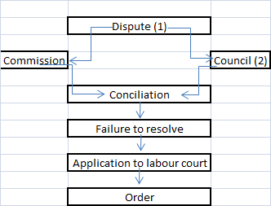
If there is a dispute about the interpretation or application of the provision concerning freedom of association and general protection, any party to the dispute may refer the dispute in writing to a bargaining council.
The party who refer the dispute must satisfy the council or the commission that a copy of the dispute was served on all parties. The council or the commission must try and solve the dispute through conciliation.

Relation to other rights
The right of freedom of association has a direct impact on the exercise of the rights to organise, bargain collectively and strike. The interdependence of these rights, that is, the acknowledgement of all four of them, forms the basis of the successful operation of the labour relations system. The South African labour relations system is, for instance, based on collective bargaining which, in turn, is possible only if there are collective bodies.
Hence, the right to freedom of association is the real core of our system of labour relations: if an employer could prevent employees from joining a trade union, collective bargaining would be impossible.

Trade unions and employers' organisations
Nel et al (2005:96^97) set out stipulations regarding the registration of trade unions and employers' organisations.
Trade unions and employers' organisations are not required to register with the Department of Labour. However, it is advisable to do so because registered trade unions have more rights than unregistered ones. Registration of trade unions and employer organisations ensures combating and control of corruption, unconstitutional practices and finance. Trade unions that wish to register must be independent, that is, free of the influence of employers or employers' organisations. Registered trade unions also have organisational rights, granted by the CCMA. Sections 95 to111of the LRA contain provisions relating to the registration of trade unions and of employers' organisations. In the majority of cases, these provisions are technical and administrative, and quite similar. As indicated previously in this study guide, there are certain administrative requirements which must be met before registration can take place, and the whole registration procedure is set out in great detail in the LRA. Other matters covered in this part of the Act include the keeping of records, auditing these records, and providing information to the Registrar.

Registrar of Labour Relations
The LRA also provides for the appointment of a Registrar of Labour Relations charged with registering trade unions and employers' organisations.
Procedures, including appeals against the registrar's decisions, are also contained in this part of the Act. The focus is on the registration of trade unions in terms of the Act, and is based on Bendix (2001:218^220). (Note that the provisions applicable to employers' organisations are similar.)
The LRA 66 of 1995 stipulates that only registered trade unions can claim all the rights granted to trade unions, such as the right to access, hold meetings on the employers' premises and elect shop stewards. The intention is to encourage trade unions to register. Unregistered trade unions have no statutory rights, although they can enter into agreements with employers.

List of the advantages of registration for trade unions -
Only registered trade unions have certain rights, such as the right to enter the premises of an employer to recruit members, communicate with members or
Hold meetings (outside working hours).Registered trade unions may elect representatives in the workplace and assist members in the workplace with grievance and disciplinary proceedings. Registered trade unions are also entitled to disclosure of relevant information needed for the effective performance of their functions.

The function of the registar for labour relations
- Register trade unions
- Register employer organisations
- Federations of trade unions with the names of the federations who’s constitutions have been submitted to the registar
- Federations of employer organisations with the names of the federations who’s constitutions have been submitted to the registar
- Councils

ORGANISATIONALRIGHTS
It would be senseless to allow workers to found or join a trade union if the trade union itself were not protected by the law.
The LRA grants specific organisational rights such as the right to access and the deduction of trade union subscriptions.
Organisational rights as part of the LRA –
- The right to access the workplace
- Deductions of trade union subscriptions
- The number of trade union representatives to be elected
- Leave for trade union representatives
- Disclosure of information
- Prohibition (exclusion) in the domestic sector
- Rights to establish thresholds of representativeness

Trade union access to the workplace
Before we consider the specific rights which the LRA grants to trade unions, you need to understand a few other matters such as the source of these rights and whether all registered trade unions have exactly the same rights.
Majority membership
If the trade union (or trade unions acting in concert) has majority membership (in other words, it represents the majority (50% + 1) of the employees of a given organisation), it is entitled to all the specific organisational rights for shop stewards. A trade union which is already acknowledged as the collective bargaining representative is also entitled to all these rights whether or not it has majority membership.
Sufficiently representative
A registered trade union which is sufficiently representative (with a significant membership but not a majority) can also apply for certain rights. The Act provides that a trade union has the right of access to the workplace. An office bearer or trade union official is entitled to enter the employers' premises to recruit or talk to members. A trade union can also hold meetings on the employers' premises, provided that these take place outside working hours. Ballots (in terms of the trade union's constitution) can also be held on the employers' premises. The employers' rights, however, are also protected, in that these trade unions' rights are subject to any conditions regarding time and place that are reasonable and necessary to safeguard life or property or prevent the undue disruption of work.

It is also possible for trade unions and employers to enter into collective agreements on trade union recognition and the exercise of organisational rights (at workplace or bargaining council level). In such cases no specific level of representation is demanded. Membership of a bargaining council or a statutory council also gives a trade union the automatic right of access to the workplace, as well as the right to debit order facilities, if the trade
union falls within the registered scope of the council, regardless of its representation in the particular workplace.

Deduction of trade union subscriptions or levies
Any employee who belongs to a trade union can authorise the employer in writing to deduct subscriptions or levies payable to that trade union from the employee's wages.
Note that the authorisation has to be written, except in the case of an agency shop agreement where the agency fee can be deducted from the employee's wages without permission. Membership fees must be paid in to the trade union concerned before the 15th of every month. The Act also provides that the employee may revoke this authorisation, and it also states that certain information must be provided by the employer to the trade union together with the monthly payments of membership fees.

Trade union representatives
The LRA contains detailed conditions for the election of shop stewards in the workplace. The number of shop stewards that can be elected depends on the number of trade union members employed in that particular work- place. For instance, if there are 10 trade union members, they may elect one representative.
The nomination, election, length of service and termination of service of shop stewards is regulated by the constitution of the trade union concerned.
Essential functions of shop stewards
The LRA provides for certain essential functions regarding workplace shop stewards
Subject to reasonable conditions, a shop steward is entitled to take a reasonable amount of time off during working hours with pay, in order to perform these functions and to be trained in any field of relevance to him or her.
Leave for trade union activities
A shop steward or trade union office bearer has the right to take ``reasonable leave'' during working hours.
Rights relating to the disclosure of information
In terms of the LRA 28 of 1956, employers were under no legal obligation to provide a trade union with information on profits, cash flow, and so on.
This often meant that the trade union was unaware of the exact financial condition of the organisation when it was negotiating. If the employer claimed that there was no money, the union often had no access to information which could help it decide whether the employer was really in dire financial straits, or whether the employer had lied about this in order to avoid granting large salary increases.

Disclosure of information
The Act now makes provision for the disclosure of information. The basic rule is that an employer has to provide the trade unions (or shop stewards) with all the relevant information necessary for them to do their job. If the trade union and the employer are engaged in collective bargaining, the employer must make available to the trade union all the relevant information that will allow the trade union to engage effectively in consultation or collective bargaining. What this ``relevant'' information might be will depend on the facts of the case a trade union which is negotiating about salary increases, for instance, would like to have access to the employers' financial statements.
However, certain types of information are excluded from this provision. The employer need not disclose information which is legally protected or privileged (professional, legal information for the purposes of legal processes); information which is confidential and which could cause considerable harm to an employee or the employer if it were to be made public
(such as trade secrets); or information which the employer cannot disclose without transgressing a limitation set by law or a court order. If there is a dispute about the disclosure of information, it can be referred in writing to the CCMA.

The domestic sector
The Act defines the domestic sector as ``the employment of employees engaged in domestic work in their employers' homes or on the property on which the home is situated'' (s 17(1)).
The LRA 66 of 1995 also applies to domestic workers. They have freedom of association and can also found, join and take part in the legal activities of trade unions. The Act does, however, acknowledge that the situation of domestic servants is somewhat different. The right to access which trade unions have (to enter the employers' premises) does not include the right to enter the homes of employers in the domestic sector, unless they agree, nor is the right to the disclosure of information applicable.
Right to establish a threshold of representativeness
A collective agreement may be concluded between the parties to establish a threshold of representativeness. A collective agreement is not unless the representativeness in the agreement applies equally to any registered trade union seeking organisational rights.
Certain organisational rights for trade unions party to a council
Registered trade unions in a council automatically have the right of access to the workplace and deduction of trade union subscriptions or levies in respect of all workplaces within the registered scope of the council.
Exercising organisational rights
Any registered trade union can inform an employer in writing that the union intends to exercise one or more of the organisational rights which the Act has granted it. A certified copy of the trade unions registration must accompany the notice and must specify
- The workplace where the trade union seek to exercise the rights
- The representativeness of the trade union in that workplace, and the facts that it is a representative trade union
- The rights that the trade union seek to exercise , and how they will be exercised
The employer must meet the trade union within 30 days of receiving the note and must attempt to conclude a collective agreement on how the trade union will exercise the rights in the work place.

ACTIVITY 8.7
Read the following case study and answer the questions that follow. Substantiate your answers with references to the LRA 66 of1995.

Until recently there was no trade union representation in the organisation. In the last three months, however, the Retail Workers' Union has been actively recruiting members mainly clerks, sales staff and other employees. The trade union has now approached management in Gauteng, claiming to represent 400 employees in Gauteng and the Western Cape.
The trade union is demanding the following rights:
. The right to access
. The right to hold trade union meetings
. The right to appoint shop stewards

- What must a trade union do before it can claim organisational rights?

Before a trade union can obtain organisational rights, it must inform the employer in writing of the rights it intends demanding. The trade union must also provide proof of registration and representation.

- Can the Retail Workers' Union claim these rights?

In terms of the LRA, the practice of organisational rights is subject to ``any conditions as to time and place that are reasonable and necessary to safeguard life or property or to prevent the undue disruption of work.'' The exercise of these rights is therefore subject to an agreement between the employer (Paywell) and the trade union (the Retail Workers' Union) stating how, when and in what circumstances these rights will be practised.

- Can the management of Pay well ignore the union's request?

After the management of Paywell have received a request from the Retail Workers' Union, they will have 30 days in which to answer the union and call a meeting. If management refuse to do this, or cast doubt on the representativeness of the union, the case can be referred to the Commission for Conciliation, Mediation and Arbitration (CCMA).This body will try to resolve the dispute through conciliation, and if that is unsuccessful, through arbitration.

- What would you advise the management of Pay well to do?

The management of Paywell will first have to determine the representativeness of the Retail Workers' Union. The LRA does not define ``representative'', and this could lead to a difference of opinion between management and the union about whether the union is sufficiently representative of the employees or not. In general, membership of 30 percent plus can be regarded as sufficiently representative, but all circumstances must be taken into account before a decision is taken. Another aspect to be considered is the definition of ``workplace''. The LRA defines it as ``the place or places where the employees of an employer work''. The Act further states that where such workplaces are independent as far as their size, function or organisation are concerned, they can be regarded as separate workplaces. Paywell is a retail business with five branches managed by the Head Office in
Gauteng. The branches will not therefore be regarded as separate workplaces, but Paywell will be considered to be one workplace in terms of the LRA. Since trade unions cannot be representative of only one section of the workplace if that workplace consists of more than one part, the total work force must be taken into account when the representativeness of the Retail Workers' Union is calculated. The trade union cannot be representative only in the Gauteng and Western Cape branches. On the basis of this information, you can advise management that the Retail Workers' Union can be regarded as sufficiently representative, and that it must accordingly be granted the right to enter the workplace and to hold trade union meetings there. Since the trade union does not represent a majority of the employees of Paywell (over 50%), it is not entitled to appoint shop stewards.

Handling disputes over organisational rights
Disputes over organisational rights are referred, in writing, to the CCMA. The CCMA must try to settle the dispute by conciliation, and if that does not work, by arbitration.

ACTIVITY 8.8
The Retail Workers' Union (see activity 8.7) has decided to declare a dispute regarding organisational rights because the employer will not allow the union to hold a meeting at
08:00 in the morning, half an hour after the employees have started working.
- Is this a valid dispute? Substantiate your answer.
The organisational rights of a registered trade union includes the right to hold meetings on the employer's premises, but only out of working hours, for example, during a tea or lunch break, before or after working hours. The request to hold a meeting during working hours is not valid - hence the dispute is not valid.
(2) How are disputes about organisational rights settled?
Disputes about organisational rights may be referred to the CCMA, which must try to resolve the dispute through conciliation. If the dispute remains unresolved any of the parties may request that it be referred to arbitration.

ACTIVITY 8.9
Your domestic servant has joined a trade union and the representative of the union demands access to her place of employment (your house) to hold a meeting. The representative also demands to know what you earn, so that a fair wage can be negotiated for your domestic servant. Do you have to agree to these requests? Substantiate your answer.

A representative of a trade union can only gain access to the house of the employer of a domestic servant if the employer agrees. The right to the disclosure of information does not apply to the domestic sector. You do not have to agree to these requests.

The LRA provides for two institutions which can promote centralised collective bargaining and serve as dispute resolution bodies: bargaining councils and statutory councils
A bargaining council is a body consisting of employer representatives (usually employers' organisations) and employee representatives (usually trade unions and/or trade union federations); its objective is to reach collective agreements, by means of centralised collective bargaining, which will be binding on all employers and employees in the specific sector and area where the council operates, and to settle disputes which might arise in this sector and area.
The Act contains a long list of the functions of bargaining councils. The principal functions are as follows:
Collective bargaining functions
. Reaching and enforcing collective agreements
. Promoting and introducing training and education schemes
. Establishing and administering pension, provident, medical aid and other funds
Dispute resolution functions
. Preventing and settling labour disputes
. Founding and administering a fund which can be used for the settlement of disputes

Powers and functions of bargaining council
(1) The powers and functions of a bargaining council in relation to its registered scope include the following-
(a) to conclude collective agreements;
(b) to enforce those collective agreements;
(c) to prevent and resolve labour disputes;
(d) to perform the dispute resolution functions referred to in section 51;
(e)to establish and administer a fund to be used for resolving disputes;
(f) to promote and establish training and education schemes;
(g) to establish and administer pension, provident, medical aid, sick pay, holiday, unemployment and training schemes or funds or any similar schemes or funds for the benefit of one or more of the parties to the bargaining council or their members;
(h) to develop proposals for submission to NEDLAC or any other appropriate forum on policy and legislation that may affect the sector and area;
(i) to determine by collective agreement the matters which may not be an issue in dispute for the purposes of a strike or a lock-out at the workplace; and
(j) to confer on workplace forums additional matters for consultation;
(k) to provide industrial support services within the sector; and
(l) to extend the services and functions of the bargaining council to workers in the informal sector and home workers.

Sector area
Note that a bargaining council is established for a sector and an area. A sector is defined as an industry or a service, and an area refers to any number of areas, contiguous or not (these definitions and others can be found in s 213 of the LRA). A bargaining council is therefore established for a particular industry or service and for a specific geographical area.

The constitution of bargaining councils
The Act provides details of the registration process as well as those matters which must be dealt with in the constitution of a bargaining council if it is to be registered. These include the appointment of representatives to the council (one half of the representatives to be appointed by the trade unions who are parties on the council, and the other half by the employers' organisations); the way in which the representatives must resign their seats; how decisions are to be taken; how office bearers and officials are to be appointed; the formation of committees; a procedure for the settlement of disputes; and other administrative matters such as the depositing of funds, amendments to the constitution and liquidation of the council.

Constitution of bargaining council
(1) The constitution of every bargaining council must at least provide for-
(a) the appointment of representatives of the parties to the bargaining council, of whom half must be appointed by the trade unions that are party to the bargaining council and the other half by the employers' organisations that are party to the bargaining council, and the appointment of alternates to the representatives;
(b) the representation of small and medium enterprises;
(c) the circumstances and manner in which representatives must vacate their seats' and the procedure for replacing them;
(d) rules for the convening and conducting of meetings of representatives, including the quorum required for, and the minutes to be kept of, those meetings;
(e) the manner in which decisions are to be made; the appointment or election of office-bearers and officials, their functions, and the circumstances and manner in which they may be removed from office;
(g) the establishment and functioning of committees;
(h) the determination through arbitration of any dispute arising between the parties to the bargaining council about the interpretation or application of the bargaining council's constitution;
(i) the procedure to be followed if a dispute arises between the parties to the bargaining council;
(j) the procedure to be followed if a dispute arises between a registered trade union that is a party to the bargaining council, or its members, or both, on the one hand, and employers who belong to a registered employers' organisation that is a party to the bargaining council, on the other hand;
(k) the procedure for exemption from collective agreements;
(l) the banking and investment of its funds;
(m) the purposes for which its funds may be used;
(n) the delegation of its powers and functions;
(o) the admission of additional registered trade unions and registered employers' organisations as parties to the bargaining council, subject to the provisions of section 56;7
(p) a procedure for changing its constitution; and
(q) a procedure by which it may resolve to wind up.

Enforcement of collective agreements concluded in bargaining councils
A collective agreement concluded in a bargaining council is only binding on those parties on the bargaining council who were party to the collective agreement.

Agents of bargaining councils
The Act also states that the Minister of Labour, at the request of a bargaining council, may appoint any person to be the designated agent of that council. The function of this agent is to help the council to enforce any collective agreement which it concluded. Once a certificate has been issued to this agent stating that he or she has been appointed in terms of the Act as a designated agent, the agent has the competences of a commissioner (a commissioner is appointed by the CCMA).

STATUTORY COUNCILS
Application and establishment of a statutory council
One of the problems which trade unions (especially the trade union federation COSATU) encountered with the first draft of the new legislation was that, as they saw it, centralised bargaining was not sufficiently promoted. The trade unions demanded that bargaining councils be established for each sector and that employers be obliged to join them.
This demand led to a stipulation in the Act, which refers to the institution of statutory councils. A statutory council can be appointed at the request of one or more trade unions (or employers' organisations) whose members comprise at least 30 percent of the employees (employers) in a sector or area. The formation of statutory councils may well lead to problems. Where unions and employer associations agree to the establishment of such a council, no difficulties should arise. Where, however, one or other party is reluctant to participate, the Act sets out a number of steps, culminating in a ministerial appointment process, in order to get a council off the ground (s 41). A council which has such an inauspicious beginning is unlikely to achieve anything meaningful in labour-management relations (Thompson1995).

Powers and functions of statutory councils
The functions of the statutory council are to settle disputes, to create and promote training and education schemes, and to administer various funds such as provident funds, medical funds, sick leave payments or unemployment funds.
The main difference between the usual bargaining council and the statutory council arises from the fact that the conclusion of collective agreements is not usually one of the functions of the statutory council.
However, statutory councils may serve as halfway houses on the way to bargaining councils, and provision is therefore made for their constitutions to be adapted to include any of the functions of a bargaining council, including the conclusion of collective agreements.

Are there any differences between bargaining councils and statutory council?
Statutory councils may perform dispute resolutions functions, promote and establish education and training schemes, pension, medical aid and unemployment schemes (to name but a few). They do not usually conclude collective agreements. They can be formed by trade unions that represent 30 percent of the employees, whereas a bargaining council can be formed by any registered trade union.

BARGAININGCOUNCILS INTHE PUBLIC
SECTOR
The LRA makes provision for the establishment of a bargaining council for the public service as a whole, the Public Service Coordinating Bargaining Council. The constitution of this council must provide for a procedure to be followed for the establishment of a bargaining council for a sector of the public service as indicated by the council. A bargaining council can be established for a particular sector within the public service, as indicated by the Public Service Coordinating Bargaining Council or by the President.
Bargaining councils for a sector in the public service have final jurisdiction over matters specific to that sector. These councils can also arrive at collective agreements and settle labour disputes in cases where the state as an employer is empowered to do so.

DISPUTE RESOLUTIONSTRUCTURES
We hope that you realise by now that the aim of collective bargaining is to reach agreements. You also know that provision is made in the LRA66 of 1995 for various structures which can help the parties to attempt to reach a collective agreement, and that we can distinguish between various kinds of collective agreements.
The legislator realised, however, that the parties will not always be able to reach agreement on certain issues. Problems also sometimes arise when agreements have to be implemented. The LRA therefore also makes specific provision for structures to help with disputes that might arise during the maintenance of employment relationships. Bargaining councils and statutory councils have already been considered as examples of these structures. The LRA also makes specific provision for other institutions that were designed to handle labour-related disputes: the CCMA, the Labour
Court and the Labour Appeal Court. Many of the conditions according to which these bodies were established are highly complicated and technical, and fall outside the scope of this course. We will therefore provide only an overview of these bodies and their operations. If you read through the Act, you will obviously find out more about these bodies and the ways in which they operate. We will now look briefly at the functioning of each of these structures.

The Commission for Conciliation, Mediation and Arbitration (CCMA)
The CCMA is a key dispute resolution body. The main function of the Com- mission is to attempt, through conciliation, to resolve any dispute referred to it in terms of the LRA. Please note that the CCMA is not a court. If the
Commission does not manage to resolve the dispute, it is then referred either for arbitration or to the Labour Court (which we will discuss below), depending on the nature of the dispute. Another function of the CCMA is to help with the institution of workplace forums. The CCMA also has a number of advisory functions.
The Commission is managed by a management body consisting of10members nominated by NEDLAC and appointed by the Minister of Labour.
The LRA contains detailed provisions for the appointment of commissioners (the people who actually bring about the resolution of disputes) and of the Director of the Commission. Other provisions relate to the institution of commission committees, the staff of the commission, and financial matters. Other complicated provisions relate to the resolution of disputes. Section 135 of the Act, called ``Resolution of disputes through conciliation'', sketches the actual procedures for the resolution of disputes.
The commissioner charged with resolving the dispute must, in terms of this section, determine a process according to which attempts can be made to settle the dispute. This process can include mediation, the execution of an investigation of the facts, and/or recommendations to the parties, which could take the form of advisory arbitration awards. As a general rule, the CCMA has 30 days in which to attempt to resolve a dispute.

The arbitration process (remember that the problem must in some instances be finally settled through arbitration) is also treated in more detail in the LRA. Many issues, like the arbitration of disputes affecting essential services or the arbitration of disputes concerning dismissals related to conduct or capacity, are regulated in detail by the LRA. Finally, the Act also contains provisions on the effect of arbitration resolutions (an arbitration resolution issued by a commissioner is final and binding unless it was an advisory arbitration award). Arbitration awards can be revised by the Labour Court. (Note that an arbitration award can only be revised on certain grounds, such as if the arbitrator is found guilty of misconduct, has committed a gross irregularity or has exceeded his or her powers.) In general, however, there are no grounds for appeal against an arbitration award.
In terms of section127 of the Act, any bargaining council or private agency can apply for accreditation by the governing body of the CCMA in order to
. settle disputes by means of conciliation or to
. arbitrate disputes which conciliation has not resolved in those cases where the Act demands that settlement must be obtained by arbitration.
This provision makes it possible for the CCMA to accredit organisations such as the Alternative Dispute Resolution Association of South Africa (ADRASA) with dispute resolution competence. When such a private organisation is accredited, this means that the private body can perform all the dispute resolution functions of the CCMA.

The commissions function is as follows
- Conciliate workplace disputes
- Arbitrate disputes that remain unresolved after conciliation
- Facilitate the establishment of workplace forums and statutory councils
- Compile and publish information and statistics about its activities
- Consider applications for accreditation and subsidy from bargaining councils and private agencies.
The CCMA may -
Supervise ballots for unions and employer organisations
Give training and advice on -
- the establishment of collective bargaining structures
- workplace restructuring
- consultation processes
- termination of employment
- employment equity programmes
- dispute prevention
Resolution of disputes through conciliation
When a dispute has been referred to the Commission, the Commission must appoint a commissioner to attempt to resolve it through conciliation. The appointed commissioner must attempt to resolve the dispute through conciliation within 30 days of the date the Commission received the referral: However the parties may agree to extend the 30-day period.
The commissioner must determine a process to attempt to resolve the dispute, which may include
(a) mediating the dispute;
(b) conducting a fact-finding exercise; and
(c) making a recommendation to the parties, which may be in the form of an advisory arbitration award.
When conciliation has failed, or at the end of the 30-day period or any further period agreed between the parties-
(a) the commissioner must issue a certificate stating whether or not the dispute has been resolved
(b) the Commission must serve a copy of that certificate on each party to the dispute or the person who represented a party in the conciliation proceedings; and
(c) the commissioner must file the original of that certificate with the Commission.
Arbitration of disputes
If the dispute being arbitrated is about the fairness of a dismissal and a party has alleged that the reason for the dismissal relates to the employee’s conduct or capacity, the parties, despite section 138(4), are not entitled to be represented by a legal practitioner in the arbitration proceedings unless—
(a) the commissioner and all the other parties consent; or
(b) the commissioner concludes that it is unreasonable to expect a party to deal with the dispute without legal representation, after considering—
(i) the nature of the questions of law raised by the dispute;
(ii) the complexity of the dispute;
(iii) the public interest; and
(iv) the comparative ability of the opposing parties or their representatives to deal with the arbitration of the dispute.
The Supreme Court of Appeal in its decision endorsed the following principles:
- The discretion to dismiss lies primarily with the employer:
- The decision must be exercised fairly;
- Interference should not lightly be contemplated;|
- Commissioners should use their powers with ‘caution’
- They must afford the sanction imposed by the employer ‘a measure of deference’.
WHEN THE CON ARB PROCESS MAY BE USED
In certain instances, the commissioner or council must arbitrate the dispute at the request of the employee immediately, if unresolved.
The types of disputes where this can occur are:
• when the dismissal of the employee is for any reason relating to probation;
• where it relates to any unfair labour practice relating to probation;
• when relating to any other dispute (conduct, capacity, continued employment intolerable, less favourable terms after a s197 or s197A transfer, reason for dismissal unknown, or an unfair labour practice) where neither party objects to the matter being proceeded with, on a con-arb basis.

The Labour Court
The Labour Court is a court of law. It is a high court with authority, inherent powers and status relating to matters within its jurisdiction, this status being equivalent to that of a provincial division of the Supreme Court of South Africa (s 151 of the Act). The Labour Court therefore has a much higher status than its predecessor, the old Industrial Court.
The Labour Court consists of a Judge President, a Deputy Judge President and as many judges as the President deems necessary. Note that judges are appointed on the recommendation of NEDLAC and in consultation with the Minister of Justice and the Judge President of the Labour Court. There are provisions detailing the appointment of judges to the Labour Court, the offices of these judges, their salaries and the conditions and provisions of their appointment to the Labour Court.
The LRA provides that specific disputes can be referred to the Labour
Court. This includes disputes about
. freedom of association
. automatic unfair dismissal (say, on the grounds of pregnancy or trade union membership)
. unfair conduct by the employer
. dismissal on the grounds of operational requirements
. unprotected strikes or protest actions
. rights connected with picket lines
. appeals against refusal of admission to a bargaining council
. payment and application of agency fees
Unfair discrimination can also be referred to the Labour Court in terms of the Equal Employment Act. The Labour Court will first decide whether an attempt has been made to settle the dispute by means of mediation. If no such attempt was made, the Labour Court can refuse to hear the case. In cases where the LRA determines that a dispute which cannot be resolved by mediation must be referred to arbitration, the Labour Court has no jurisdiction to pass judgement.
The Labour Court also has the following powers:
. issuing court orders (eg the provision of urgent interim legal aid; the granting of interdicts; the issuing of orders directing the performance of any particular act which, when implemented, will remedy a wrong and give effect to the primary objects of this Act; or of declaratory orders)
. ordering compliance with the Act
. settling disputes between a member of a trade union and the union itself about alleged non compliance with the trade union's constitution
. revision of any decision taken by the state or any act performed by the state in its capacity as employer, where this is legally permissible
The Labour Court also fulfils other technical functions, but the impression one has is that it is indeed a powerful institution.
Unlike the CCMA, the Labour Court is a superior court. Legal representation is allowed. A party can also be represented by a fellow worker or an office bearer or official of a trade union. A company can be represented by a director of the company or an employee (s 161of the LRA). The Labour Court has experienced a number of problems in the past 10 years of operation, to the extent that a task team has been formed with the responsibility of re-evaluating the system of adjudicating labour matters. The task team's proposals are contained in a Bill that was tabled in Parliament.

The Labour Appeal Court
The Labour Appeal Court is the final court of appeal against all judgements and orders passed and issued by the Labour Court. The Labour
Appeal Court is a superior court with inherent powers and standing equivalent to those of the Appellate Division of the Supreme Court. The Labour Appeal Court consists of the Judge President of the Labour Court, the deputy Judge President of the Labour Court and three other judges of the Supreme Court. The powers of the Labour Appeal Court relate largely to appeals and reviews. Only in exceptional cases can the Labour Appeal Court sit as a court of first instance.

DISPUTE RESOLUTIONPROCESSES
Disputes of right and disputes of interest
Earlier in this study unit we identified various possible disputes and the processes used to resolve them. A study of the LRA shows, however, that there are many more possible disputes than the ones we have already identified. We will first examine the difference between a dispute of right and a dispute of interest.
There are two types of disputes (Bendix 2004:552^553): those that arise when bargaining fails, and those that arise because one party has infringed a right of the other party.

Dispute of interest
If the parties to an attempt at collective bargaining cannot reach an agreement and talks are deadlocked, one or other party will declare a dispute.
This kind of dispute is called a dispute of interest, because there is no clear right on the side of one of the parties and the problem can eventually be solved by power play such as a strike or a lockout. Before either party resorts to industrial action, there is usually a cooling-off period during which efforts will be made to achieve conciliation or mediation. If these fail, industrial action may take place.

Dispute of right
When one party believes that a right which it has by law or by agreement has been violated, it will first try to negotiate with the other party. If the right is not restored, the party will declare a dispute. This dispute is known as a dispute about rights, and will eventually be settled by arbitration or a legal decision. Parties to a dispute of rights should not become involved in industrial action, since they can resort to arbitration to decide whether a Right has in fact been violated or not. An attempt can be made here to sort out the problem by conciliation or mediation before it is referred to the judgement of a third party.

Dispute resolution mechanisms
The following methods are usually employed to resolve disputes:
Conciliation. A third party brings the parties together but does not intervene.
Mediation. A third party actively attempts to bring about a resolution, but cannot take a final decision.
Arbitration. A third party takes a decision which both parties accept as binding.
Conciliation-arbitration. With the consent of the parties involved, a dispute may be directly referred to arbitration if not solved through conciliation.
Adjudication. A court of law decides the dispute.

The advantages of conciliation and mediation are that they do not take the decision out of the hands of the parties. It is always better if the parties themselves can come to a decision. Where parties agree to subject themselves to arbitration, they are bound by the decision of the arbiter. On the other hand, arbitration may well bring about a speedier resolution, and prevent the parties from building up more hostility towards each other.
No single form of intervention is really any better than another. Some disputes are more suited to conciliation, others to mediation, and others again to arbitration. Conciliation works when the parties have a fairly healthy relationship, when neither of them is seriously defensive or aggressive, and when conflict has not yet reached an extremely high level. Mediation is effective when both parties are serious about finding a mutually acceptable solution, where a series of positive resolutions exists, where conflict has escalated because one or both of the parties is inexperienced and has committed itself to too much, but where the conflict is not too serious. Both parties must also trust the mediator. Mediation does not work well when conflict is at an extremely high level and matters of principle are at issue. Arbitration should be considered when there are exceptional high levels of conflict, when one party wants to show that it is right as a matter of principle, when a settlement is needed rather quickly, and when the parties are strong enough to face accusations that they have allowed the matter to be taken out of their hands. The main problem with arbitration is that one party may be dissatisfied, which could lead to more conflict in the future. This danger also exists with conciliation and mediation, but the chances are smaller.
Before we explain the dispute resolution process further, you need to have a clear understanding of conciliation and arbitration as dispute resolution mechanisms. We will therefore first focus on these concepts.

Conciliation
According to Finne more and Van Rensburg (2002:306), conciliation can be
defined as a direct intervention process where a third party, the mediator, plays an active role as go-between and supports the parties to a dispute in an effort to help them overcome their differences and achieve their own mutually acceptable agreement.
At the micro level, conciliation can occur in a specific workplace or department. It can even take place between an individual employee and a manager, or between two employees. At the macro level, conciliation can be applied to resolve disputes on the organisational, industrial or national level. Atypical explanation of the conciliation parties in a collective dispute in an organisation with trade union representation is shown in figure 8.2.

Conciliation versus mediation
Note that people in South Africa often regard the words ``conciliation'' and ``mediation'' as synonyms. In terms of legislation, conciliation refers to a method of dispute resolution, while mediation is a sub-process of conciliation.
The conciliation process usually begins when a party voluntarily decides to refer an issue to conciliation. This usually happens when deadlock has been reached in the attempts by the parties to settle a dispute .Conciliation can be used to settle jurisdictional disputes and disputes about rights.

General functions of conciliation
The general functions of conciliation are to create an environment in which provision is made for
. clarification of and focusing on the cause of the dispute
. improved communication between the parties
. controlled relief of tension by affording the parties the opportunity to air their grievances to an impartial third party who can facilitate the interaction
. more objective fact finding
. establishing the parties' real interests
. creativity in the search for alternative solutions
. a more realistic view of the balance of power between the parties
. a nonbinding process which affords the parties an opportunity to test their suggestions on each other without committing to a final agreement
. mediating presentations and counter presentations by an intermediary with the necessary experience until an acceptable resolution is achieved
. access to advice on what a reasonable resolution of the dispute would involve legal advice
. help with setting up a clear, formal agreement reflecting the outcome of any resolution
. achieving a formal agreement (usually in writing) which both parties regard as valid
It is clear from the above that the mediator is a go-between for the parties to the dispute. The mediator must therefore be acceptable and must have no interest in the dispute, because this could be detrimental to the process. Effective mediators will be impartial, but will also introduce new values and interests into the process. A successful mediator will have the ability to reach agreements.
The mediator has no decision-making power in respect of the final agreement. The final decision is taken by the parties themselves. The mediator does, however, influence the decision through his or her management of the conciliation process and his or her insight and knowledge. The mediator might decide on a strategy in advance or follow a flexible approach, depending on the circumstances.
The mediator will often arrange a preliminary meeting with the parties in which they can agree on topics like documentation, place, participants and processes. Factors such as the venue can affect the final outcome. The mediator can have the parties meet in two different rooms and function as go-between, or the parties can hold a joint meeting with the mediator as facilitator. The mediator is in control of the flow of information and the communication between the parties. He or she must help the parties to resolve the conflict by seeing their own positions and demands in a realistic light, and encourage them to reach an agreement. When an agreement is reached, the mediator must ensure that the written agreement is clear and reflects the intentions of the parties, and that both parties sign it.

Skills and characteristics of mediators
It is clear from the above that a mediator must have specific skills and characteristics. For example, he or she must
. be able to listen empathetically
. be impartial and objective
. be reliable, credible and ethical in his or her handling of the process
. encourage creativity
. be assertive
. have legal knowledge and understand labour relations
. demonstrate the skills of a good chairperson
. be patient but determined
. have a sense of humour with which to defuse tense situations
Most importantly, a mediator must command the respect of both parties.
In South Africa, parties can make use of private dispute resolution bodies, in which case they must bear the costs. The state does, however, make provision for conciliation by a Commissioner of the CCMA (discussed above) in which case no costs are incurred.
Next, we will give you an example of a conciliation process which will illustrate how this process can be applied to find innovative solutions to problems.

In 1998, the CCMA issued a Good Practice Code with guidelines on conciliation processes (Government Gazette No 19836, 1998) in addition to the requirements in section115 of the LRA.

Arbitration
Arbitration can be defined as a process of direct intervention where a third party, the arbitrator, plays a decisive role in resolving a dispute between two parties by holding a fair hearing in which positions can be stated and witnesses heard, by evaluating these positions and witnesses, and by taking a final decision which the parties must adhere to (Finnemore &
Van Rensburg 2000:309). A typical arbitration process in an organisation with trade union representation is shown in figure 8.3.

The arbitration process usually begins when a party voluntarily decides to refer a matter to an arbitrator for a final decision. This usually happens if the dispute could not be resolved by means of conciliation. Arbitration can be applied to settle disputes of right and of interest, but it is usually more appropriate for the resolution of disputes of right. Disputes about unfair discipline or dismissal, organisational rights of trade unions and the interpretation of collective agreements are usually referred for arbitration.

Arbitration does not take place within a court of law, and an arbitrator does not necessarily have a legal background. Arbitration decisions are generally, final and binding. However, provision is made for revision by the Labour Court in certain circumstances.

General functions of arbitration
The general functions of arbitration are to create a structured process which provides for
. an opportunity for employees and employers to promote and defend their rights
. a fair hearing for a dispute by an independent, well-qualified person
. a set procedure for dispute resolution which has built-in time frames for the achievement of a final solution
. a binding dispute resolution mechanism when negotiation and conciliation have failed
. a means of avoiding unnecessary labour unrest
. the development of a corpus of legal knowledge about the interpretation of labour legislation
The arbitrator must first establish the origins of the dispute. He or she can ask the parties for opening arguments, and decide on that basis, what the specific issues are, on which decisions have to be taken. The arbitrator will then give both parties the opportunity to state their cases, provide documentary evidence and call witnesses. Cross-examination of witnesses must also be allowed, after which the parties can present their closing arguments.
The arbitrator's role is to ensure a fair hearing. During this process, he or she must get witnesses to take an oath, explain the procedure to participants, ensure that the parties do not interrupt each other, protect witnesses against unfair cross-examination, ask questions where clarification is needed, and sum up complicated evidence to ensure that it is understandable to all participants. Arbitrators can make use of interpreters when necessary, and may also carry out on-site inspections of places where incidents happened. A written record of proceedings must be kept.
The arbitrator analyses the evidence which has been presented, and weighs it up. He or she then takes a decision, and must give the reasons for it. A formal arbitration report, complete and unambiguous, containing this information is made available to the parties.

Characteristics and skills of arbitrators
Although arbitrators require the same sort of skills as mediators, they also need additional ones.
Arbitrators must
. be capable of controlling the arbitration process
. be able to listen attentively and pay attention to the fine details
. reveal knowledge of the legal process, labour law and jurisprudence
. demonstrate that they are capable of impartiality and of holding a fair hearing
. be independent and have no interest in the outcome of the dispute
. be reliable, credible and ethical in the execution of their duties
. not be prejudiced or stereotyped in their thinking
. be able to evaluate complex data and give a sound judgement
. have good writing skills
. complete reports and pass judgements in good time
In South Africa, arbitration usually takes place under the auspices of the CCMA.

Dispute resolution at plant level
In the majority of organisations where there is a solid relationship between employers (managers) and employee representatives, and where negotiations take place, some or other kind of dispute resolution procedure will exist. This procedure usually includes the following:
. details of how the dispute will be declared
. time limits within which the other party must respond
. a number of conciliation meetings
. the possibility of mediation or arbitration (some agreements stipulate that disputes of right must go straight to arbitration)
. in the event of a plant-level procedure, details on what should happen if the dispute is not resolved. (Does it go to arbitration? Will the parties use the statutory mechanisms? Will the parties have the right to strike or lockout?)
If a plant-level procedure ends without resolution, it will be taken further by the statutory mechanisms. Those dispute procedures which provide for arbitration in disputes of right, and for the right to strike or to lockout, need not make use of the statutory mechanisms. In such cases they are said to have contracted out of the LRA.

The statutory dispute resolution mechanism
Conciliation advisory arbitration
The LRA makes detailed provision for dispute resolution bodies and processes to handle disputes of rights and of interests. Although the processes for the two kinds of disputes differ in their course, both are first subject to conciliation. The Act makes use of the term ``conciliation'' to include mediation, fact finding and advisory arbitration. The person facilitating conciliation can therefore use any of these interventions in an attempt to persuade the parties to settle. (Advisory arbitration differs from normal arbitration in that the arbitrator advises the parties about the kind of decision which he or she would take, although they are not bound by this decision.)
The bodies involved in conciliation are the CCMA and the bargaining councils. If a bargaining council has jurisdiction in a specific industry or sector, any dispute which arises in that area or industry must be referred to that bargaining council for conciliation. A dispute can only be referred to the CCMA in sectors without bargaining councils. The parties usually have a period of 30 days in which to refer the dispute to the CCMA or the bar- gaining council. If the mediation process does not lead to a settlement, the commissioner or relevant official of the bargaining council will issue a certificate of non-resolution, after which the dispute can be submitted for arbitration or decision, if it is a dispute about rights. In the case of a dispute about interests, the parties can legally strike or lockout (see fig 8.6 below).
Note that in cases of disputes of interests, the parties need not refer the dispute for mediation if they have already followed a procedure contained in their collective agreement. In such cases, either of the two parties may strike or lockout when they have reached the end of their own procedure.
The bodies dealing with arbitration are once again the CCMA or the bar- gaining councils, while the Labour Court is responsible for deciding about certain rights. Certain disputes can be submitted to either the CCMA or the bargaining council for arbitration, depending on whether a bargaining council exists; other disputes must be submitted to the CCMA, and yet others to the Labour Court. The LRA lays down a specific procedure for each kind of dispute.

Arbitration by the bargaining council or the CCMA is regarded as final. If one of the parties can prove that the Commissioner was guilty of misconduct, committed a gross irregularity or exceeded his or her powers, or that an arbitration referral was obtained irregularly, then that party can request the Labour Court to set the referral aside and decide the dispute itself. In addition, section 158(1)(g) of the LRA gives the Labour Court the right to revise the execution of any function for which the Act makes provision, for reasons which the law allows. This would also apply to the conduct of the arbitrators appointed under the Act.
Appeals can be lodged against the decision of the Labour Court itself to the Labour Appeal Court, which functions as the final decision-making body in terms of the Act.
(The CCMA, Labour Court and Labour Appeal Court have been discussed in greater detail above. Refer back to the above section if you are not sure about the functioning of these bodies.

SELF-ASSESSMENT
Question1
Sketch the objective and the main aims of the LRA 66 of1995.
Question1
Here you could have used study unit 8, section 8.2 in the study guide and chapter 4, section 4.3 (pp 106^108) in your prescribed book as your point of departure.
Section1of the LRA 66 of1995 outlines the purpose of the Act. It can be summarised by saying that it is to advance economic development, social justice, labour peace and the democratisation of the workplace by fulfilling the primary objectives of this Act. You also need to discuss these objectives.
To sum up, the overriding theme of the new LRA 66 of1995 is the promotion and regulation of the collective dimension of employment relations.
The LRA 66 of1995, with a few exceptions, is applicable to all employment relationships, that is, all relationships between employers and employees (see topic1).
Three categories of employees (and their employers) are excluded from the LRA .They are members of the
(1) National Defence Force
(2) National Intelligence Agency
(3) South African Secret Service

Question 2
Explain what is meant by freedom of association. In your answer also address the issue of protection of employees and work seekers with regard to freedom of association.
Question 2
The notion of freedom of association means that every employee has the right to participate in forming a trade union or federation of trade unions and to join a trade union, subject to its constitution.
Important aspects of freedom of association are that
. employees may participate in the lawful activities of a trade union
. employees may take part in the union elections
. a worker may stand for election, and may hold office if elected (office bearer, official or trade union representative)
Employees exercising their right to freedom of association are protected in the following sense:
. No person may discriminate against an employee for exercising the right to freedom of association.
. An employee (or a person seeking employment)may not be required to undertake not to be or become a member of a union or workplace forum; nor may an employee or person seeking employment be required to give up membership of a trade union or workplace forum.
. Employees (or persons seeking employment) may not be prejudiced because of their union membership, their membership of a workplace forum, their participation in the formation of a trade union, their participation in the lawful activities of a trade union, or prejudiced because they disclosed information that they are lawfully entitled or required to give to another person. The right to freedom of association is not only an employee right. Every employer has the right to form, join, or participate in the lawful activities of an employers' organisation.

Question 3
Write concise notes on the organisational rights of trade unions, with specific reference to the difference in rights according to the registered status of the trade union.
Organisational rights refer to the basic rights of collective organisations (registered trade unions and employers' organisations) as outlined in the
LRA. These rights include the following:
. to determine their own constitutions and rules
. to hold elections for office bearers, officials and representatives
. to plan and organise their own administration and legal activities
. to participate in forming a federation of trade unions or a federation of
employers' organisations
. to affiliate with, and participate in the affairs of, an international workers' organisation or international employers' organisation or the ILO and contribute to or receive financial assistance from those organisations
Registered trade unions and employers' organisations are also entitled to
the following specific rights:
. trade union access to the workplace (majority and sufficiently representative trade unions)
. deduction of trade union subscriptions (majority and sufficiently representative trade unions)
. leave for trade union activities (majority and sufficiently representative
trade unions)
. trade unions representatives (majority representative trade unions only)
. disclosure of information (majority representative trade unions only)
Note that majority representative trade unions (ie trade unions representing 50% + 1employees in the workplace) may require recognition of all of
the above specific rights from their employees while trade unions with only sufficient representation (as agreed by the employer) may only require recognition of some of these rights.

Question 4
How does one deal with disputes about organisational rights? (Use a diagram to illustrate your answer to this question.)
Question 4
Disputes over organisational rights are referred, in writing, to the CCMA.
The CCMA must try to settle the dispute by conciliation, and if that does not work, by arbitration. Section 4.6.10 in your prescribed book deals with disputes about organisational rights. Figure 4.3 in your prescribed book gives a diagrammatical presentation on how to deal with such a dispute.

Question 5
Discuss bargaining councils as structures for collective bargaining and dispute resolution.
Question 5
Here you could have used study unit 8.6 in the study guide and 4.7 in the prescribed book as your point of departure.
In answering this question, you had to discuss and elaborate on the role and functions of bargaining councils for collective bargaining and dispute resolution.
Bargaining councils are centralised, sectoral level, bargaining and dispute resolution structures. A bargaining council is established for a certain sector (industry or service) in a specific geographical area.
The main functions of a bargaining council include the following:
- collective bargaining functions:
- concluding and enforcing collective agreements
- promoting and establishing training and education schemes
- establishing and administering pension, provident, medical and other funds
Dispute resolution functions:
- preventing and resolving labour disputes
- establishing and administering a fund to be used for resolving disputes

Question 6
Discuss briefly the nature, role and functions of the following dispute resolution bodies:
(a) the CCMA
(b) the Labour Court
(c) the Labour Appeal Court

Question 6
The following guidelines indicate what should be discussed when answering this question:
. CCMA
- itsmain function of dispute resolution
- the fact that it is not a court of law
- the secondary functions of the CCMA, namely to assist with the establishment of workplace forums, as well as certain advisory functions
- the governing body of the CCMA
- the process of resolution of disputes, namely
* mediation, fact finding, recommendations
* arbitration
* no general right of appeal
. Labour Court
- As a court of law
- as a superior court
- consisting of a Judge President, Deputy Judge President, a number of judges
- the powers of the Labour Court
- the technical functions of the Labour Court
- representation at the Labour Court
. Labour Appeal Court
- as a final court of appeal
- as a superior court
- consisting of a Judge President of the Labour Court, Deputy Judge President of the Labour Court and three judges of the Supreme
- Court of Appeal the powers of an appellate and review nature

OTHER RELEVANT LABOUR LEGISLATION

Acts which governs specific issues between employer and employee –
- Collective Bargaining - Labour Relations Act No 66 of 1995
- Employment Conditions and wages - The basic conditions of employment act 75 of 1997
- Safety of employees – The Occupational Health and Safety Act no 85 of 1993 and The Mine Health and Safety act no 29 of 1996
- Protection of employees – Compensation for Occupational Injuries and Diseases act no 130 of 1993
- Training – Skills Development act no 97 of 1998 and Skills Development levies act no 9 of 1999
- Equity in the workplace – Employment Equity Act no 55 of 1998

THE BASIC CONDITIONS OF EMPLOYMENT ACT 75 OF 1997 (BCEA)

Working Time
Ordinary hours of work
An employer may not require or permit an employee to work more than -
- 45 hours in any week; and
- nine hours in any day if the employee works for five days or fewer in a week; or
- eight hours in any day if the employee works on more than five days in a week

Overtime
An employer may not require or permit an employee to work -
- overtime except in accordance with an agreement;
- more than ten hours’ overtime a week
An employer must pay an employee at least one and one-half times the employee’s wage for overtime worked, or give paid time off equivalent to the value of the overtime.

Extended ordinary daily hours of work
By agreement an employee may work up to 12 hours in a day without receiving overtime pay , the weekly limit applies and the employee may not work more than five days in a week.. The bill provides that a collective agreement may permit hours of work to be averaged over a period of up to four months provided that the average hours per week does not exceed 45 ordinary hours and five hours of overtime. The Minister on the grounds of health and safety and (after consulting the Commission and the relevant health and safety authority) may determine by regulation, the maximum permitted hours of work, including overtime, for any employee.

Daily and weekly rest period
An employer must allow an employee -
- a daily rest period of at least twelve consecutive hours between ending and recommencing work; and
- a weekly rest period of at least 36 consecutive hours which, unless otherwise agreed, must include Sunday
- an agreement in writing may provide for - a rest period of at least 60 consecutive hours every two weeks
- An employer must pay an employee who works on a Sunday at double the employee’s wage for each hour worked unless the employee ordinarily works on a Sunday, in which case the employer must pay the employee at one and one-half times the employee’s wage for each hour worked , and by agreement , an employee can also be granted paid time off for Sunday work.

Night work
“Night work” means work performed after 18:00 and before 06:00 the next day.
- the employee is compensated by the payment of an allowance, which may be a shift allowance, or by a reduction of working hours; and
- Transportation is available between the employee’s place of residence and the workplace at the commencement and conclusion of the employee’s shift.
- Employer must inform the employee in writing of any health and safety hazards associated with the night work, and on request provide employees with free medical assessments.

Public holidays
(1) An employer may not require an employee to work on a public holiday except in accordance with an agreement.
(2) If a public holiday falls on a day on which an employee would ordinarily work, an employer must pay -
- an employee who does not work on the public holiday, at least the wage that the employee would ordinarily have received for work on that day;
- an employee who does work on the public holiday - at least double the amount of his ordinary pay.

Emergency work
The limits of ordinary and overtime working hours and the requirements for meal intervals and rest periods do not prevent the performance of emergency work

Application
The limit in hours of work and overtime do not apply to senior managerial employees, sales staff who travel to the premises of customers and who regulate their own hours of work, employees who work less than 24 hours a month for an employer.

Leave
An employer must grant an employee at least 21 (3 weeks) consecutive days’ annual leave on full remuneration in respect of each annual leave cycle (12 months)
Or
one day of annual leave on full remuneration for every 17 days (or 17 hours) on which the employee worked.
Annual leave accumulate at 1, 25 days per month for an employee who work a five day week and for employees who work a six day week 1, 5 days per month. Where annual leave is carried over from the previous cycle and the employee had not, within six months, taken leave, the employee can demand to take leave and the employer may not refuse permission. Employers may not force employees to take leave in their notice period. Employers may not pay instead of granting annual leave. However, en employee must be paid out the leave that they have not taken.

Sick Leave
An employee is entitled to six weeks (36 days) paid leave for every 36 months of continues employment. during the first six months of employment, an employee is entitled to one day’s paid sick leave for every 26 days worked. Before an employer pays sick leave, they may request a medical certificate form an employee who is regularly away from work, for more than two consecutive days. the employee’s entitlement to pay for any day’s sick leave is at least 75 per cent of the wage payable to the employee for the ordinary hours the employee would have worked on that day

Dealing with Medical certificates
A Valid Medical certificate should comprise the following:-
- Name and address of qualified practitioner
- Name of patient
- Employment number of patient
- Date and Time of examination
- Whether the certificate was issues as a result of the practitioners observation or as a result of information received from the patient
- Description of illness – patient may withhold consent (approval) to declare illness
- Capacity to which the patient is able to perform normal or less strenuous duties
- Exact period of sick leave and date of issuing certificate
- Clear identity of practitioner who issued the certificate , which must be personally and originally signed by him or her

Maternity leave
a pregnant employee is entitled to at least four consecutive months' maternity leave. An employee may commence maternity leave at any time from four weeks before the expected date of birth. The employer must be notified in writing on the date on which she intends to commence the leave and the date of return – this must be done at least four weeks before taking up the maternity leave. No employee may work for six weeks after the birth of her child - employer may not request this. During an employee's pregnancy, and for a period of six months after the birth of her child, her employer must offer her suitable alternative employment on terms and conditions that are no less favourable than her ordinary terms and conditions of employment, if the employee is required to perform night work, or her work poses a danger to her health or safety or that of her child.
Family responsibility leave
An employer must grant an employee, during each annual leave cycle, at the request of the employee, three days' paid leave – this only applies to employees who four or more days per week. The employer may request reasonable proof for the purpose of which the leave is taken before paying the employee.
Application
the provisions in respect of leave do not apply to leave granted by an employer in excess of the requirements of the act. These provisions do not apply to employees who work less than 24 hours a month.
Remuneration, deductions and notice of termination of service
Payment of remuneration
An employer must pay to an employee any remuneration that is paid in money-
(a) in South African currency;
(b) daily, weekly, fortnightly or monthly; and
(c) in cash, by cheque or by direct deposit into an account designated by the employee.
An employer may not make any deduction from an employee's remuneration unless-
the employee in writing agrees to the deduction in respect of a debt specified in the agreement; or
the deduction is required or permitted in terms of a law.
A deduction may be made to reimburse an employer for loss or damage only if-
the loss or damage occurred in the course of employment and was due to the fault of the employee
the employer has followed a fair procedure and has given the employee a reasonable opportunity to show why the deductions should not be made.
An employee may agree in writing to an employer for deducting a debt specified in the agreement.
TERMINATION OF EMPLOYMENT
During the first six months of employment, an employment contract may be terminated on one week notice. The notice period for the remainder of the year is two weeks and after the first year, four weeks. Notice must be given in writing. If the recipient cannot understand the notice, it must be explained to them in their language. The employer may not give termination of contract in any period of leave – annual leave, family responsibility leave or maternity leave. The employee may give notice in a leave period – as there is nothing in the act to prevent this. The employer may give notice if the employee is on sick leave. The employee may challenge the fairness or lawfulness of the dismissal.
Exclusions
The above requirements do not apply to employees who work less than 24 hours a month.
Administrative Obligations
the employer must provide the employee with written particulars of employment when he/she start employment – the particular must include:-
- ordinary hours of work
- wage
- Rate of pay for overtime
- Leave
The employer must keep these records for three years after the end of the contract
Give all employees information concerning remuneration, deductions and time worked with regards to their pay
Keep record of the time worked by each employee as well as remuneration involved
Display at the workplace a statement of employees rights under the Act.
On termination the employee is entitled to a certificate of service. Simplified provisions apply to employers who have fewer than 5 employees and employers of domestic workers.
Prohibition of the employment of children and of forced labour
Nobody is allowed to employ a child under 15 years of age, and the Minister of Labour is empowered to issue regulations prohibiting or setting out conditions for the employment of children over15 years of age.
Variations of basic conditions of service
Basic conditions of service can be modified by means of collective agreements (concluded inside or outside bargaining councils), individual agreements, determinations by the Minister or sectoral determinations. Agreements by bargaining councils take precedence over other collective agreements which, in turn, take precedence over individual agreements. A bargaining council agreement can amend any provision of the Act.
Sectoral determinations
The Minister of Labour can make sectoral determinations which set out basic conditions of employment for employees in unorganised sectors. The Employment Conditions Commission (the Commission) exists to advise the Minister of Labour on sectoral determinations, the effect of government policy directions on employment, and any other matters arising from the application of the Act
Monitoring, enforcement and legal proceedings
The Minister of Labour can appoint labour inspectors. Labour inspectors perform their duties subject to the direction and control of the Minister. Their function is to promote, monitor and enforce compliance with employment legislation. Labour inspectors must advise employees and employers about their rights and obligations under employment legislation.
Labour inspectors have the following powers: -
- May enter any workplace without notice or warrant to conduct inspection
- They may enter a home – only with permission of the owner – in terms of an authorisation by the labour court.
- They may question persons and inspect, copy and remove records , documents and other relevant items. Every person must cooperate with and answer any relevant questions put by a labour inspector.

They can also perform inspections, investigate complaints and ensure compliance with an employment Act.

THE SKILLS DEVELOPMENTACT 97 OF1998 (SDA) ANDTHE SKILLS DEVELOPMENT LEVIES ACT 9 OF1999 (SDLA)
Skills Development Act (SDA)
Skills Development Levies Act (SDLA)
Two Acts, the Skills Development Act 97 of 1998 (SDA) and the Skills
Development Levies Act 9 of 1999 (SDLA), play a vital role in the management of training in organisations. Organisations are now legally obliged to use the workplace as an active learning environment and to afford employees the opportunity to acquire new skills. Organisations therefore have no valid reasons for not training their employees. The SDLA also provides for the imposition of a skills development levy which the employer has to pay at a rate of one percent of an employee's total remuneration.
Provided an organisation meets the requirements of the Act as far as the training of its employees is concerned, it can claim back up to 80 percent of the levy. It is clearly to an organisation's advantage, therefore, to invest in the training of its employees, even if only in order to claim back part of the money which it had to pay out in terms of this levy.
Purpose of the SDA
- To develop the skills of SA’s workforce
- To increase the level of investment in education and training
- To use the workplace as an active learning environment and to provide employees the opportunity to acquire new skills
- To provide opportunities for new entrants to the labour market and gain work experience
- To employ persons who find it difficult to be employed
- To encourage workers to participate in leadership and other programmes
- To improve the employment prospects of persons previously disadvantaged - to redress those disadvantages by training and education
- To ensure the quality of education and training in and for the workplace
- To assist work seekers to find work, retrenched workers to re-enter the labour market and employers to find qualified employees.
Management implications of the South African Qualifications Authority Act, the SDA and the SDLA
The establishment of the South African Skills Authority, the SDA and the
SDLA has posed further challenges for employers in respect of the management, training and development of employees in organisations. Some of these challenges are
- to ensure that all the interested parties in the organisation are aware of
- the Acts and the employers' responsibilities under them
- to take part in the structures required by the South African Skills Authority, for example, standards which generate structures for controlling the quality of training to participate in the process of planning and launching a SETA
- to bring the organisation's human resources strategy, especially its education and training strategy, into line with the overall business strategy
- to make financial and personnel resources available so that the levies can be paid and actions taken in accordance with the National Skills Framework

Compensation for Occupational Injuries and Diseases Act (COIDA)
The Occupational Health and Safety Act (OHSA) (discussed below) lays down certain rules aimed at the prevention of accidents in the workplace, while the Compensation for Occupational Injuries and Diseases Act130 of 1993 (COIDA) arranges for the payment of compensation to people who are injured or become ill while working, or to their dependents if they die.
The current Act emphasises occupational illnesses according to international standards. The Act covers all employees, whatever their remuneration. Consequently, a large number of employees who were previously not protected by the law because of the nature of their work are now within the jurisdiction of the Act and subject to assessment and the payment of the assessed amount to the Compensation Commissioner.
COIDA provides typical, compulsory, state-controlled insurance coverage, but employers can still introduce their own schemes, with the Commissioner's approval, which means that they need not pay assessment rates to the Compensation Fund.

THE OCCUPATIONAL HEALTH AND SAFETY ACT 85 OF 1993 (OHSA)
The main aim of the Occupational Health and Safety Act 85 of 1993 (OHSA) is to protect the safety and health of workers. In order to do so, OHSA imposes certain obligations on employers and employees. These obligations must be seen as additional to the common law duty of the employer to provide safe working conditions.
The primary difference between this Act and its predecessor is that the old Machinery and Occupational Safety Act required inspectors from the Department of Labour to visit employers' premises regularly. As a result of the workload of the limited number of inspectors, however, inspections took place far too seldom. The task of the inspectorate of preventing accidents by eliminating dangerous work or dangerous situations was largely neglected in the process. The new Act solves this problem by requiring employers to provide and maintain a working environment which is safe and without health hazards to employees, as far as possible, and by granting extensive powers to health and safety representatives and committees to investigate and monitor working conditions.
Although the main aim of OHSA is to try to prevent occupational accidents, the manufacturers of machinery also have certain obligations.
Employers and employees whose work might affect the health and safety of the public also have certain duties. OHSA itself only lists broad, general obligations. Detailed rules on lighting in the workplace, the size of ladders and so on are contained in the regulations.
OHSA has a wide range of applications. It not only covers the civil service and the agricultural and domestic sectors, but also the users of machinery, and injuries to people who are not employees. For instance, an incident on an escalator in a shopping mall in which a member of the public is injured, or an incident in which a private person is injured by the private use of machinery, must be reported. The main exception is the mining industry, which is regulated by the Minerals Act and the Mine Health and Safety Act. OHSA does, however, become operational if something happens which is not covered by those Acts.
Functions of the Advisory Council
advise the Minister with regard to –
- matters of policy arising out of or in connection with the application of the provisions of this Act;
- any matter relating to occupational health and safety;
perform the functions assigned to it by this Act or referred to it by the Minister.
- do such research and conduct such investigations as it may deem necessary
- make rules relating to the calling of meetings of the Council, a technical committees established by the council
advise the Department concerning –
- the formulation and publication of standards, specifications or other forms of guidance
- the promotion of education and training in occupational health and safety; and
- the collection and dissemination of information on occupational health and safety.
General duties of employers regarding health and safety at work
Every employer shall provide and maintain, as far as is reasonably practicable, a working environment that is safe and without risk to the health of his employees. Without derogating from the generality of an employer's the matters to which those duties refer include in particular --
- the provision and maintenance of systems of work, plant and machinery that, as far as is reasonably practicable, are safe and without risks to health
- taking such steps - as reasonably practicable as possible - to eliminate or mitigate any hazard or potential hazard to the safety or health of employees, before resorting to personal protective equipment
- ensuring, as far as is reasonably practicable, the safety and absence of risks to health in connection with the production, processing, use, handling, storage or transport of articles or substances;
- establishing, as far as is reasonably practicable, what hazards are attached to any work which is performed, any article or substance which is produced, processed, used, handled, stored or transported establish what precautionary measures should be taken.
- Providing such information, instructions, training and supervision.
- taking all necessary measures to ensure that the requirements of this Act are complied with
- ensuring that work is performed and that plant or machinery is used under the general supervision of a person trained with authority to ensure that precautionary measures taken by the employer are implemented
- in the area of listed work , to ensure not only that all safety measures are taken , but also that occupational hygiene and biological monitoring programmes are undertaken
- Inform safety representatives of the steps taken to identify the hazards and evaluate the risks entailed in the listed work , and of the monitoring and occupational hygiene programmes and their results
- Inform all employees of the danger involved in their work
- Provide facilities , assistance and training to healthy and safety representatives
- Inform health and safety representatives beforehand of inspections , investigations , formal inquiries and application for exemption
- Inform health and safety representatives of any incidents which occurs at the workplace is defined. An incident is defined as an occurrence as a result of which a person dies , becomes unconscious , loses a limb or part of a limb become so ill that he or she is likely to die or become disabled or will not be able to work for a period of more than 14 days.
- Ensure the safety committee performs its functions.
General duties of employees at work
every employee shall at work --
- take reasonable care for the health and safety of himself and of other persons who may be affected by his acts or omissions
- as regards any duty or requirement imposed on his employer or any other person by this Act, co-operate with such employer or person to enable that duty or requirement to be performed or complied with;
- carry out any lawful order given to him, and obey the health and safety rules and procedures laid down by his employer or by anyone authorized thereto by his employer, in the interest of health or safety;
Penalties for offences
Nobody may tamper with, discourage, and deceive or unduly influence somebody who is to give evidence, no one may be prejudice (discriminate) or precipitate (rush) proceedings.
Tamper with or misuse safety equipment, wilfully or recklessly do anything which endangers health or safety.
Offences are subject to fines or R50 000-00 or one year’s imprisonment - or both.
Any person who omits or commits to do an act whereby another person is injured in such a way that the person would die , would have been guilty of culpable(in the wrong , guilty) homicide (murder , killing) – subject to up to R100 000-00or two years imprisonment – or both.
Victimisation
No employer shall dismiss an employee, or reduce the rate of his remuneration, or alter the terms or conditions of his employment to terms or conditions less favourable to him, or alter his position relative to other employees employed by that employer to his disadvantage, by reason of the fact, or because he suspects or believes, whether or not the suspicion or belief is justified or correct, that that employee has given information to the Minister or to any other person charged with the administration of a provision of this Act which in terms of this Act he is required to give or which relates to the terms, conditions or circumstances of his employment or to those of any other employee of his employer, or has complied with a lawful prohibition, requirement, request or direction of an inspector, or has given evidence before a court of law or the industrial court, or has done anything which he may or is required to do in terms of this Act or has refused to do anything which he is prohibited from doing in terms of this Act.
Employment Equity Act (EEA)
The Employment Equity Act 55 of1998 (EEA)was signed by the State President inOctober1998 and started coming into effect (in stages) in1999.
The overall aim of the Act is to bring about fairness in the workplace, mainly through the following:
. the ban on unfair discrimination which is applicable to all employers
. measures for affirmative action, which are applicable only to designated employers
The principal determinations for implementing the aims of the Act include the following:
. All employers are expected to take steps to end unfair discrimination in their employment policies and practices.
. Unfair discrimination against employees or prospective employees on the basis of race, gender, pregnancy, marital status, family responsibilities, ethnic or social origins, colour, sexual orientation, age, disability, HIV status, religion, conscience, belief, political opinion, culture, language and birth is forbidden.
. Medical and psychometric testing of employees is forbidden unless it is justified.
. Designated employers must prepare and implement employment equity plans after having carried out a workforce analysis and consulted trade unions and employees.
. Employment equity plans must contain specific affirmative action measures in order to promote the fair representation of people from designated groups in all occupational categories and levels in the work force.
. Designated employers must take steps to progressively reduce inequitable income differentials.
. Designated employers must report to the Department of Labour on the ways in which they are implementing employment equity.
. A Commission of Employment Equity must be appointed.
. The Labour Inspectorate and the Director General of the Department of Labour are responsible for the enforcement of equity obligations.
. An employer who intends entering into a contract with the state must meet his or her employment equity obligations.
. An employee is protected against victimisation for exercising his or her rights as granted by the Act. Unfair discrimination and is applicable to all employees and employers. Chapter 3, which deals with affirmative action, is only applicable to designated employers and people from designated groups.
A designated employer is
. an employer with 50 or more employees
. an employer with fewer than 50 employees, but with a total annual turnover which is equal to or more than the relevant annual turnover
for a small business in terms of Schedule 4 of the Act (see table below)
. a municipality
. a government body, excluding local government, the National Defence Force, the National Intelligence Agency and the South African Secret Service
. an employer who becomes a designated employer in terms of a collective agreement, to the extent that the collective agreement provides for these designated groups
Designated groups are:
. black people (a general term which includes blacks, coloureds and Indians)
. women
. disabled people
As can be expected, and as was already the case under the LRA, the EEA requires employers to eliminate direct and indirect discrimination. This is nothing new, and the same situation occurs in most other countries. In view of South Africa's history, however, employers must be extremely sensitive in their management of employment relations, especially since there are so many possible indirect discrimination traps they might fall into.
As far as affirmative action is concerned, the Act introduces a process in which there is movement towards employment equity, and expects employers to make reasonable efforts to progress in this regard. There is no support for tokenism, and reasonable provision is made for bone fide business considerations. In general therefore, employers do not have much to worry about, provided that they do their best to progress towards employment equity, and can prove it. In the author's view, however, the same cannot be said for the provisions relating to vertical income differentials, and it is unfortunate that the government and Parliament saw fit to include these provisions, which could turn out to be extremely problematic for employers.
The difference between formal and substantive equality
Formal Equality = sameness treatment = the law must treat individuals in the same manner, irrespective of their special circumstances.
Substantive Equality = take special circumstances into account.
Formal Equality requires that all people must be bearers of rights.
Substantive Equality takes into consideration and need to investigate the actual socio-economic conditions of a group and individuals.
Affirmative action measures
Affirmative action measures are measures designed to ensure that suitably qualified people from designated groups have equal employment opportunities and are equitably represented in all occupational categories and levels in the workforce of a designated employer.
2) Affirmative action measures implemented by a designated employer must include-
a)measures to identify and eliminate employment barriers, including unfair discrimination, which adversely affect people from designated groups;
b)measures designed to further diversity in the workplace based on equal dignity and respect of all people;
c)making reasonable accommodation for people from designated groups in order to ensure that they enjoy equal opportunities and are equitably represented in the workforce of a designated employer;
d)measures to-
i)ensure the equitable representation of suitably qualified people from designated groups in all occupational categories and levels in the workforce; and
ii)retain and develop people from designated groups and to implement appropriate training measures, including measures in terms of an Act of Parliament providing for skills development.
3) The measures include preferential treatment and numerical goals, but exclude quotas.
4) Nothing in this section requires a designated employer to take any decision concerning an employment policy or practice that would establish an absolute barrier to the prospective or continued employment or advancement of people who are not from designated groups.
Amendments to the Employment Equity Act 2006
1) Some of the more important amendments include an expanded definition of “Designated groups.”
This definition now states that " Designated groups” means Black people (i.e. Africans, Coloureds and Indians), women and people with disabilities who are natural persons, and:
Citizens of the Republic of South Africa by birth or descent, or
citizens of the Republic of South Africa by naturalisation before the commencement date of the Constitution of the Republic of South Africa act of 1993, or
became citizens of the Republic of South Africa after the commencement date of the Constitution of the Republic of South Africa act of 1993, but who, were it not for Apartheid policy that had been in place prior to that date, would have been entitled to acquire citizenship by naturalisation prior to do date
This makes it clear that citizens of other countries, who claim to be classed as members of the designated group because they are Black, can no longer make that claim.
2) The regulation states that a senior manager or managers who are assigned this responsibility, must be permanent employees, and must have their employment Equity duties or outcomes incorporated into their performance contracts. In addition such persons must be given the necessary executive authority and mandate to act and take action in terms of the employment Equity Act, they must be provided with an appropriate budget and be given access to other required resources, and very importantly, they must be provided with time off from other duties and commitments in order to perform their duties in terms of employment equity.
3) The duty of employers to report (usually annually) and the method of completing the necessary report forms are now incorporated in the regulations.
The reporting requirements requires considerable input and preparation from employers on completing the prescribed forms - Form EEA 2, which previously consisted of 12 pages, now consists of 23 pages, and the form EEA 4, previously 2 pages, now consists of 11 pages
4) The regulations now provide that the consultative Forum must be established or an existing forum, such as a Workplace Forum, must be utilised. The Forum must include employee representatives from both designated and non-designated groups, and the employer must be represented on the Forum by one or more members of senior management in the Forum.
5) The amendments include special forms to be completed by each employee in the process of combining a workplace profile, and provision is made for employees at any time to be able to add information to the form that is completed
THE UNEMPLOYMENT INSURANCE ACT 63 OF 2001 (UIA)
The Unemployment Insurance Act 63 of 2001provides for the payment of benefits for a limited period to people who are ready and willing to work, but are unable to obtain work for whatever reason. In terms of the UIA, some employees (those who qualify as contributors in terms of s 2 of the
UIA) contribute monthly to the Unemployment Insurance Fund, which is administered by the Department of Labour. Employers also pay in a certain amount for every contributor (employee) they employ. An employee who is out of work can claim benefits from the Fund. The UIA also provides for sickness benefits, benefits to dependents if an employee referred to as a contributor dies, and for maternity and adoption benefits.
With the exception of the following categories of people, most employees are covered by the Act. The following people are not covered:
. employees employed for less than 24 hours a month with a particular
employer, and their employers
. employees who receive remuneration under a learnership agreement registered in terms of the SDA 97 of1998, and their employers
. employers and employees in the national and provincial spheres of government
. persons who enter the Republic for the purpose of carrying out a contract of service, apprenticeship or learnership within the Republic if upon the termination thereof the employer is required by law or by the contract of service, apprenticeship or learnership, as the case may be, or by any other agreement or undertaking, to repatriate that person, or that person is so required to leave the Republic, and his or her employers

Scope of the Act
- This Act applies to all employers and employees, other than-
- employees employed for less than 24 hours a month with a particular employer, and their employers;
- employees who receive remuneration under a learnership agreement registered in terms of the Skills Development Act, 1998 (Act No. 97 of 1998), and their employers;
- employers and employees in the national and provincial spheres of government;
- persons who enter the Republic for the purpose of carrying out a contract of service, apprenticeship or learnership within the Republic if upon the termination thereof the employer is required by law or by the contract of service, apprenticeship or learnership, as the case may be, or by any other agreement or undertaking, to repatriate that person, or that person is so required to leave the Republic, and their employers.
In terms of the provisions, the following persons who might be contributors are however not entitled to benefits
Contributors who receive a monthly pension / disability grant from the state
Contributors who refused to accept appropriate available work
A person who has voluntary resigned from employment – an exemption exist where an employer and the working conditions so unbearable that the employee had to other choice but to resign , the dispute had been referred to the CCMA.

Duties of employers – when commences to be an employer
Provide the street address of the business and branches.
Provide the names, ID numbers and monthly remuneration of each employee, stating the address where each of the employees are employed.
To inform the commissioner before the seventh day of each month of any changes during the previous month with information previously provided.
To pay UIF the required amount from the employer and each of the employees, by the seventh day of the month.

Benefits and Allowances
Illness benefits
If an employee is unable to work, the prescribed requirements in respect of the illness must be complied with. The illness should be more than 14 days. All applications for illness benefit must be applied for within six months after the illness.
Maternity Leave
A contributor who is pregnant is entitled to the maternity benefits during the period of pregnancy and delivery. Application for maternity leave must be made at least eight weeks before the expected date of delivery.
Adoption Benefits
Only one contributor of the adopting parties is entitled to the adoption benefits, the adopted child must be below the age of two,
Dependants Benefits
The surviving spouse or a life partner of a deceased contributor is entitled to the dependant's benefits – must be claimed within six months of the death.
Unemployment benefit
an unemployed contributor is entitled to unemployment benefits contemplated in this Part for any period of unemployment lasting more than 14 days.
The reason for the unemployment is
- the termination of the contributor's contract of employment by the employer of that contributor or the ending of a fixed term contract,
- the dismissal of the contributor
- insolvency in terms of' the provisions of' the Insolvency
the benefit to which a contributor is entitled is calculated in one of two ways
contributors who earn less than a particular amount (known as the benefit transaction income level) , are entitled to a percentage of their previous pay
contributors who earn more than the benefit transaction income level are entitled to a flat benefit equal to the entitlement of a contributor who was previously paid at the benefit transaction income level.
BROAD-BASEDBLACK ECONOMIC EMPOWERMENTACT 53 of 2003 (BBBEEA)
“Black People” is a generic term which means Africans, Coloureds and Indians.
"broad-based black economic empowerment" means the economic empowerment of all black people including women, workers, youth, people with disabilities and people living in rural areas through diverse but integrated socio-economic strategies that include

Final code of good practice 9 February 2007
Nine final Codes / elements
Code 000 – Conceptual Framework BBBEE
Code 100 - Ownership
Code 200 – Management Control
Code 300 – Employment Equity
Code 400 – Skills Development
Code 500 – Preferential Procurement
Code 600 – Enterprise Development
Code 700 – Socio Economic Development
Code 800 – Qualifying Small Enterprises

All Enterprises need to establish their BBBEE status. Measurement depends on the classification – where it fits in and where it operates. The criteria for classifying a business is as follow
Exempted micro enterprises
Qualifying small enterprises
Specialised enterprises
Sector codes
All other enterprises – including multi nationals

The above will inform the enterprises of requirements (scorecards) for measuring their BBBEE compliance.

Question1
Name any seven labour laws (excluding the LRA 66 of 1995) that influence the way in which employment relationships are managed. Explain the rationale, scope of application and purpose of any two of these Acts. Also discuss some of the topics covered by these two Act

Question1
Here you could have used study unit 9 in the study guide and chapter 5 in your prescribed book as your point of departure.
Although the LRA can be viewed as the single most important piece of legislation regulating the collective dimension of employment relations in South Africa, there are many other statutes that affect both the individual and collective dimensions of employment relations in South Africa. These include:
. the Occupational Health and Safety Act 85 of1993
. the Compensation for Occupational Injuries and Diseases Act 130 of 1993
. the Unemployment Insurance Act 30 of1966
. the Basic Conditions of Employment Act 75 of1997
. the Employment Equity Act 55 of1998
. the Skills Development Act 97 of1998
. the Skills Development Levies Act 9 of1999
. the Broad-based Black Economic Empowerment Act 53 of 2003
You were required to start by identifying the above statutes and then to explain the rationale, scope of application and purpose of any two of these Acts. You also had to discuss some of the topics covered by these two Acts.
The following are examples of what you could have discussed:
The BCEA 75 of 1997
. introduction and application, including the objectives and overall purpose of the Act
. working time (ordinary hours of work, overtime, extended ordinary daily hours of work, meal intervals, daily and weekly rest periods and night work)
. leave (annual, sick, maternity and family responsibility)
. payment of remuneration and deductions and notice of termination of employment
. administrative obligations . prohibition of the employment of children and forced labour
. variation of basic conditions of employment
. sectoral determinations
. the functions and working of the Employment Conditions Commission
. monitoring, enforcement and legal proceedings
. general issues such as temporary employment services, deeming of persons as employees, duration of employment, codes of good practice, confidentiality, obstruction, undue influence and fraud, offences, penalties and maximum permissible fines and transitional arrangements
The EEA 55 of 1998
. the overall purpose and most important provisions of the Act
. scope of application
. prohibition of unfair discrimination
. affirmative action
. income differentials
. enforcement of the EEA including the reviewing of employment equity plans and imposing fines
. additional matters such as codes of practice and regulations, state contracts, independent contractors and the Commission for Employment Equity
You could have chosen any two of the listed Acts. The above merely serve as examples of what we expected of you. Since the perspective of this module is management and not legal studies, you only need a broad under- standing of these statutes. You should be able to describe each of the Acts in broad terms, by referring to its scope of application, objectives and the topics it covers.

Informal aspects of labour relations dynamics
PSYCHOLOGICAL (mental) CONTRACTS, SOCIAL CONTRACTS AND PSYCHOSOCIAL CONTRACTS
Social contracts are concluded at macro-centralised levels. Psychological contracts are concluded at organisational levels and at the level of every individual employment relationship. A major challenge in South Africa is not only to focus on these, more implicit, social and psychological contracts, but also to link them together and incorporate some or other intermediate kind of implicit contract: the psychosocial contract.

The psychosocial contract
Swanepoel et al (1999a:363) state that the employment relationship is often described as a social exchange relationship where the employer and the employee cooperate to achieve mutual benefits. A formal contract (as discussed in study unit 8) formalises this relationship. Even though these contracts lay down the obligations of the employer and the employee to each other, they still only partially reflect the obligated exchanges between employer and employee and do not address all aspects of the employment relationship (Spindler in Swanepoel et al,1999a:363). As such, this gives rise to the formation of informal contracts, which are unwritten, unexpressed representations of the employment relationship. According to Swanepoel et al (1999a:364), these informal contracts are aimed at reducing the individual's uncertainty about those unspecified elements of the employment relationship. The psychological contract encompasses the expectations of the employee in both the implied (and informal) and formal contracts of employment.
Two types of informal contracts can be distinguished, namely the social contract and the psychological contract. A social contract is an agreement in which all major role-players are socially contracted to operate within the defined parameters of an agreed policy framework. Social contracts are thus concluded at macro-centralised levels. Social democratic countries often entered into social contracts when there was a crisis that could only be resolved by the participation of all the major stakeholders. In South Africa, many such social contracts were entered into during the period of change from an apartheid regime to a democratic society. A psychological contract, on the other hand, refers to an individual's beliefs about the terms and conditions of a reciprocal exchange agreement between an individual and another party. This contract emerges when one party believes that a promise of future return has been made, a contribution has been given and thus an obligation has been created to provide future benefits. It is not limited to the employment relationship but can exist in any number of associations between an individual and other parties. Psychological contracts are ``non legal'' and informal. They refer to the needs, expectations, values and interests that shape interactional patterns and are aimed at constructive relationship building. These contracts are concluded at organisational and individual level. While the former two contracts are more implicit, the challenge in South Africa is also to align these and to build in some intermediate form of contract, namely the psychosocial contract. The foundation for this contract lies in the management of expectations and it can therefore be defined as an agreement encompassing the invisible and unwritten set of reciprocal expectations, evolving over time, between the various parties that have an interest in the organisation. It therefore outlines what and how each party should and must contribute to gain from the relationship and should focus on the reciprocal expectations of co-responsibility for organisational success by all the parties involved. The psychosocial contract is the primary source of security and legitimacy between the respective parties and imparts stability and predictability to their interactions over time. It is also multidimensional and multifaceted, consisting of two-way interactions between the demands placed by one party on the other, and simultaneously the resources offered by that party to the other party.
Table 10.1, adapted from Slabbert et al (2005:19^12), outlines the hybrid character of the psychosocial contract. This combination of characteristics of both the social and the psychological contracts together with its level of functioning (organisational), makes it the ideal link between the expectations originating from the social and the psychological contracts.
You may well ask why you need to know all this. An example of the value of psychosocial contracting would be the need for the reconstruction of existing psychosocial contracts in many South African organisations to overcome the inability to find common ground in negotiations between management and employees .Attributes such as respect for the dignity and uniqueness of each party and equitable sharing in benefits and rewards should be embraced. This, in turn, leads to an agreement on a mutual set of expectations regarding responsibility for organisational success by the respective stakeholders

According to Slabbert et al (2005:19^15), establishing partnership contracts in South African organisations should be the new basis for tackling the future successfully. Table 10.2 lists the core attributes of the foreseen partnership contract. Psychosocial contracting can also be used to facilitate the development of an integrated and shared value system for business organisations.
The basis of psychosocial contracting deals with the mutual expectations of employers and employees, and their representatives, relating to both the individual and the collective dimensions. Because the employment relationship is based on the concept of exchange, labour relations have developed to a considerable extent around these exchanges and around the associated psychosocial contracts and underlying expectations, values and interests of the parties concerned.
The following diagrammatical representation may further help to explain the dynamics of exchange:
Extracts from Douwes-Dekker (1998:55^56) illustrate the relevance of these informal exchanges at various levels, in the South African context.
He explains as follows:
The employment relationship refers to the conditions under which the employer decides to hire labour and the employee decides to sell labour to the employer. Minimum levels or degrees of these conditions are contained in legislation or bargaining council agree- ments ... .The actual conditions will be reflected in, usually, informal arrangements set by exchanges ... .The term exchange captures that dimension of informal flexibility ... .Central to the way the employment relationship is shaped is the notion of exchange ... done within the context of the labour market, the product market and how the industrial relationship has been patterned by the parties ... .The regulation of the exchange is conducted as a definite ``external aspect'' ... . In manufacturing industries regulation takes place at either industry or conglomerate level. What is critical is for the complementarily between the levels to be consciously promoted ... . In the packaging industry two COSATU unions and the Mineworkers Union responded to the drive for world-class manufacturing and
over a five-year period entered into a workplace change programme driven by the necessity to respond to considerable improvement in technology, reduction in staff and skills enhancement ... .The union and employers' association parties to an industry bargaining council can ensure the workplace does not become the arena for basic collective bargaining conflicts ...with time to achieve workplace innovations through conscious formulation of the employment relationship ... the power context of collective bargaining is fought for most industries at bargaining council level ... the level of trust so engendered between the leaders brings certainty that agreements will be honoured ... certainty that the agreement ``will stick'' is an essential guarantee for the manager to cope with the turbulence of the``global village'' ...The crisis of competition and WCM has resulted in the parties adapting to the specific peculiarities of their industry regarding the complementarily between levels of the industrial relations system.

VALUES, INTERESTS ANDETHICS
In the module, Labour Relations Management: Micro (MNH304H), you will learn about collective bargaining, and you will find that collective agreements contain a number of principles which are related to the values of the parties. Often agreements are concluded in order to formalise some issues at sectoral level, say, by making them more specific than general social agreements. These agreements are based on the interests, values and ethics of the parties.

Values ethics
Values can be regarded as those things which have value for or are important to an individual or a group, such as an organisation. Ethics can be viewed as the moral standards for right and wrong behaviour. From these descriptions it should be clear that they form an integral part of the informal dimension of the employment relationship dynamic if they are formalised by means of valid agreements, they become part of the formal dimension and take the form of rules, regulations, and so on. The role players in labour relations need to consider these informal aspects with the respect they deserve, simply because factors like unethical behaviour. and/or the insensitive imposition of one party's values on another, can result in unhappiness and inferior labour relations.
The main challenge for the parties is therefore to build their relationships with the understanding that most variables affecting aspects such as values, ethics and interests should be balanced out, exchanged and cultivated.
Before we continue, let us define the following concepts:
. Values are things that have worth or are important to an individual or group and that motivate behaviour.
. Culture is the body of knowledge and experience accumulated by society over many generations. Values are the system of beliefs that emanate primarily from culture.
. Ethics constitute the moral standard of right and wrong behaviour. This, in turn, emanates from our value (or belief) system and can be regarded as values in practice.
. Interests explain the activities of the market and the purposes of individual parties
All of the above form part of the informal dimension of employment relations.

Interests
Douwes-Dekker (1998:67^74) distinguishes clearly between values and interests, emphasising their importance in employment relations. A few extracts from his work will illustrate this point. The energy of structural tensions in the inherent conflict between workers and employers can be creatively resolved in societal values underlying these societal norms. At national level, the federations of the labour-market parties pursue different interests, namely the support for the RDP by COSATU,NACTU and FEDUSA and support for GEAR by BSA and NAFCOC. The distinction between public values and private interests identified by Provis (1996) provides a relevant diagnostic approach to assist in understanding the complexities of the phenomenon of consensus-seeking which the parties to the IR system are grappling with. The recent management theories on values and culture were used by Provis (1996) as an opportunity to examine their implications for unitarist and pluralist approaches to industrial relations. The ongoing development of South Afri-
ca's industrial relations system is currently based on pluralism. That is, unions and employers' associations, are regarded as critical to coping with competitiveness and identifying the nature of South Africa's ``localness''.
Pluralism provides the base for democratic corporatism ... Pluralism is implicit in the legislative base of NEDLAC but has not been fully incorporated or realised in the relationship expressions between the parties to NEDLAC ... As Provis (1996) points out, interests explain the activities of the market and the purposes of individuals or parties. Values emerge from joint structures, bosberaads or forums and lead to endorsed behaviour and action for their constituents, and even publicly for different but everwidening circles of constituents and related interest groups. That is, values conceptualise needs and desires that can be represented to other persons as valid claims on behaviour or performance, initially in a subsystem and then for the society as a whole. Values motivate behaviour ... ``The great significance of the concept of `values' is the way it identifies motives that are publicly endorsed but nevertheless have significant effects'' (Provis
1996:474).Thus an important question to ask when the government proposes a certainmodel of development is: Does it represent public values or private interest? and this is the basis of COSATU's anger against GEAR ...
The adoption of GEAR was seen as a rejection of the RDP. The intent of the GEAR focus on wealth creation could have been negotiated as complementary to the RDP focus on wealth distribution ... Interests focus on a narrower area of human activity than values. The following points from Provis' literature survey (1996) highlight the difference:
Interest cannot be classified as an idealised mode of behaviour or end-state of existence. It would be difficult to argue that an interest is a standard or that it has an ``ought'' character. It is the ``ought'' character of values that gives them the role in public debate. Interests, on the other hand, characteristically have to do with individual choices and private advancement: often, economic advancement. Values and interests have different effects.
Values, rights and obligations are public, moral concerns; interests are private, prudential concerns. Values have a part in construction of social identity which interests do not. Even though interests and values are different, can we discern relationships? Do people have an interest in promoting their values, for example? More contentious, do some sets of interests in society foster certain dominant values?'' (Provis1996:479, 480)
The distinction between the promotion of interests by independent organisations and the forging of values in their joint structures to gain a sufficient degree of endorsement of new societal norms, standards, codes of conduct, as well as monitoring of resulting outcome behaviours, has relevance for both the workplace and the national levels of interaction between different expressions of organised capital and labour ... . Regarding the nature of appropriate values in the workplace culture, who can best shape them? Organisational design consultants claim they promote value-sharing activities. It is significant that certain conglomerates in South Africa, once they realised the union was a presence in the workplace, introduced from the late1980s, at considerable costs, consultants to South Africa to run ``value-sharing workshops''. It was hoped that such activities would lead workers to identify with the company goals, endorse flexibility, and generate commitment and co-operation, and, implicitly, decrease the influence of the union in the workplace. This type of unitarism is not only manufacturing in 1995 is being adopted by other industries. Hence ``how'' workplace change programmes are introduced is critical to the sustainability of structures established. As Provis (1996:481) points out:
If ``managing values'' is done for the sake of control, there is a difficulty. Management cannot just choose values that will allow them to exercise control, because values cannot just be chosen to satisfy any particular need. Values are the things for the sake of which things are chosen: not the other way round. Managing values is then just new jargon for manipulation and deceit. Manipulation has been transcended only if management's strategy has been based on the same values that they seek to instil in others, and if management embrace those values ö for their own sake, and not because they are values that advantage management.
In this regard the best approach for engendering appropriate processes to establish missions and values is ... to be considered jointly by the chief executive of the company and the union concerned ... A joint approach is recommended because as Provis (1996) points out: Managing values is inherently likely to give rise to paradox and difficulty, because ``manage'' implies ``manage in order to achieve some end'', but values influence choice of ends. There may be ways to escape the paradoxes that arise but then there tend to be moral problems, because values are so fundamental to human life. It is possible that some values are more fundamental than others: for example, values like ``integrity'' or ``loyalty'' may be more basic than ``keeping within budget'' or ``working hard''.
Strains and tensions will still arise when finding consensus on the values but their creative resolution should lead to national endorsement of codes of conduct and best-practice goals imperative to competitiveness (Douwes-Dekker1998:68^72).
It is often said that core values in an organisation are those principles that guide the organisation's actions and behaviour. Lencioni in Slabbert et al
(2005:19^15^19^16) also says that these core values often serve as ``cultural cornerstones in companies''. Lencioni warns, however, that core value statements are often ``bland, toothless, or just plain dishonest''. Such value statements should not be seen as harmless, much rather should they be viewed and realised as potentially destructive. Empty value statements can ``create cynical, dispirited employees, alienate customers and undermine managerial credibility''. He stresses though that core values can set a company apart from its competition in the ``global village'' by clarifying its identity and serving as a rallying point for employees. counter-productive but contrary to the reality of the high-wage-high-skill nature and uniqueness of South Africa's manufacturing industry. The out-comes of collective bargaining agreements since 1995 reflect an increased willingness to accept inflation-linked increases, to productivity-linked performance programmes and more than one-year agreements. Thus moderation within world-class manufacturing requirements is an objective reflected in the output of collective bargaining. The trend set by motor manufacturing in 1995 is being adopted by other industries. Hence ``how'' workplace change programmes are introducedis critical to the sustainability of structures established. As Provis (1996:481) points out:
If ``managing values'' is done for the sake of control, there is a difficulty. Management cannot just choose values that will allow them to exercise control, because values cannot just be chosen to satisfy any particular need. Values are the things for the sake of which things are chosen: not the other way round. Managing values is then just new jargon for manipulation and deceit. Manipulation has been transcended only if management's strategy has been based on the same values that they seek to instil in others, and if management embrace those values ö for their own sake, and not because they are values that advantage management. In this regard the best approach for engendering appropriate processes to establish missions and values is ... to be considered jointly by the chief executive of the company and the union concerned ... A joint approach is recommended because as Provis (1996) points out: Managing values is inherently likely to give rise to paradox and difficulty, because ``manage'' implies ``manage in order to achieve some end'', but values influence choice of ends. There may be ways to escape the paradoxes that arise but then there tend to be moral problems, because values are so fundamental to human life. It is possible
that some values are more fundamental than others: for example, values like ``integrity'' or ``loyalty'' may be more basic than ``keeping within budget'' or ``working hard''.
Strains and tensions will still arise when finding consensus on the values but their creative resolution should lead to national endorsement of codes of conduct and best-practice goals imperative to competitiveness (Douwes-Dekker1998:68^72).
It is often said that core values in an organisation are those principles that guide the organisation's actions and behaviour. Lencioni in Slabbert et al
(2005:19^15^19^16) also says that these core values often serve as ``cultural cornerstones in companies''. Lencioni warns, however, that core value statements are often ``bland, toothless, or just plain dishonest''. Such value statements should not be seen as harmless, much rather should they be viewed and realised as potentially destructive. Empty value statements can ``create cynical, dispirited employees, alienate customers and undermine managerial credibility''. He stresses though that core values can set a company apart from its competition in the ``global village'' by clarifying its identity and serving as a rallying point for employees.

Lapin in Swanepoel et al (1999a:375^378) identified five objectives for the implementation of a value and ethics programme in South Africa:
(1) The need to improve productivity levels in South African business. South African business needs to become competitive internationally. For this to happen, organisations need highly committed employees with high productivity levels. An ethic of productivity needs to be instilled in workers.
(2) The need to reduce levels of economic crime. Unacceptably high levels of economic crime, ranging from petty theft to fraud, prevail in South Africa. An environment hostile to theft and crime must be created in our organisations.
(3) The need to address diversity meaningfully. Organisations in South Africa should strive towards celebrating the diversity in our businesses and should endeavour to use this to stimulate innovativeness and productivity.
(4) The need to address our declining standards of ethics. Socio-political changes in South Africa in the past10 years have overturned old paradigms of morality and ethics. A new moral framework for the South African population still seems to be eluding us.
(5) The need to move towards participative management. Political imperatives and new management practices are forcing organisations to move to more participative management styles .Organisations should strive to develop and sustain high levels of trust among diverse employees. The principle of ubuntu becomes especially important here. Sindane in Slabbert et al (2005:19^37) defines ubuntu as ``... a way of life that positively contributes to the sustenance of the wellbeing of people, a community or society. Ubuntu is a process that promotes the common good of people, a community or society.'' According to Mbigi in Slabbert et al (2005:19^37) ``Ubuntu is the essence of South African corporate renewal ... it is the vehicle that may place South African companies on the high road to achieving world-class status.''

Question1
Write an essay on the nature and significance of psychosocial contracting in South Africa.
Question1
Here you could have used study unit 10 in the study guide as your point of departure.
In answering this question you should have started by defining and differ- entiating between psychological, social and psychosocial contracts. Secondly, you had to explain the nature of the psychosocial contract. Table10.1in this study unit outlines the hybrid character of the psychosocial contract. This combination of characteristics of both the social and the psychological contracts together with its level of functioning (organisational), makes it the ideal link between the expectations originating from the social and the psychological contracts.
Your discussion on psychosocial contracting should, however, not merely be theoretical but you should also have given your views on its value. An example would be the need for the reconstruction of existing psychosocial contracts in many South African organisations to overcome the inability to find common ground in negotiations between management and employees. Attributes such as respect for the dignity and uniqueness of each party and equitable sharing in benefits and rewards should be embraced. This would, in turn, lead to agreement on a mutual set of expectations regarding responsibility for organisational success by the respective stakeholders

Question 2
Write brief notes on the nature, role and importance of interests, values and ethics in South African labour relations.
Your first step was to define the concepts ``interests'', ``values'' and ``ethics''.
Your definitions should have included the following:
. Values - Values are things that have worth or are important to an individual/group; they motivate behaviour.
. Culture -Culture is the body of knowledge and experience accumulated by society over many generations values form the system of beliefs that emanate primarily from culture.
. Ethics - Ethics sets the moral standard of right and wrong behaviour ethics emanates from value system.
. Interests - Interests explain the activities of the market and the purposes of individual parties.
. Interests, values and ethics form part of the informal dimension of employment relations
You should have then briefly discussed the objectives of the above, which are to:
- Improve the productivity levels of business in South Africa
- Reduce levels of economic crime
- Address diversity
address declining standards of national and business ethics
- Move from autocratic to participative management

