Family Business – MNE3704
TOPIC 1
Study Unit 1
Family business is all enterprises in which an entrepreneur or next-gen CEO and one or more family significantly influence the firm through their participation, ownership control and strategic preference and the culture and values they impart to the enterprise.
- 15% or more ownership control by two or more family or partnership with family
- Strategic influence on the management of the firm
- Concern with family relationship
- Continuity across generation
4 Characteristics that describe the distinctiveness of a family business
- Presence of a family
- Overlap between family, management and ownership with its zero-sum propensities.
- When family unity is high: Unique source of competitive advantage derived from the interaction between family, management and ownership
- Owner’s dream of keeping the business in the family
Succession planning contributes to the uniqueness of family business.
For family business to survive a balance have to be found between protecting the core of the business and adapting the changing business environment.
Family business management skill very important.
Theoretical perspective on family business
Five theoretical perspectives, namely:
- Systems theory perspective
  - Three overlapping and interactive subsystems: Ownership, Family, Management. If one subsystem is favored above the rest, significant sub-optimization.
  - Family-first business employment birthright
  - Family-first business tends to equalize compensation
  - Family-first business great difficulty providing for continuity
  - Management-first is based on responsibility and performance
  - No automatic commitment to the family business continuity
  - Ownership-first investment time horizons and perceived risk are the most significant
  - Patient capital significant source of competitive advantage
  - Vulnerable to blurred boundaries, alternative, joint optimization
  - Joint optimization by writing policies
  - Family and business continuity when focus on larger system: family business
- Agency Theory
  - Family business more costly organizational governance
  - Reduce by certain managerial and governance practices
- Strategic Perspective
  - Unique differences provided by family ownership and control are a source of competitive advantage
- Resource based perspective
  - 5 unique resources family business can call upon
    - Overlapping responsibilities between owners and managers
    - Concentrated ownership lead to higher overall corporate productivity
    - Focus on client and market niches result in higher returns
    - The desire the protect the family name and reputation translate into higher product/service
    - The nature of family-ownership-management interaction
- Stewardship perspective
  - Fact translate into the continuing health and well-being of the firm
  - Stewards ship refer to the commitment to the business
  - Individual responsibilities
  - Objective and commitment stance of independent board members
Ethics and social responsibility
Perception:
- Less social responsible
- Less ethical when it comes to tax
- Built-in desire to uphold family values
- Good ethics, good business
- Triple bottom line
Advantages of family business
Advantages | Disadvantages
Long-term orientation | Less access to capital markets may curtail growth
Greater independence of action  - Less or no pressure from stock market  - Less or no takeover risk | Confusing organization  - Messy structure  - No clear division of tasks
Family culture as a source of pride  - Stability  - Strong identification, commitment and motivation  - Continuity in leadership | Nepotism  - Tolerance of inept members as manager  - Inequitable reward systems  - Greater difficulties in attracting professional managers
Greater resilience in hard times, willing to plough back profits | Internecine Strife  - Family dispute overflow into business
Less bureaucratic and impersonal  - Greater flexibility  - Quicker decision making | Paternalistic/autocratic rule  - Resistance to change  - Secrecy  - Attraction of dependent personalities
Financial benefits  - Possibility of greater success | Financial strain  - Family members milking the business  - Disequilibrium between contribution and compensation
 | Spoiled-kid syndrome
 | Succession dramas

Family business can succeed:
- Family business employees more productive
- More flexible in responding to challenges

Three advantages that flow from family values and influences
- Preserving the humanity of the workplace
- Focusing on the long term
- Emphasizing quality

Study Unit 2
Zero-sum dynamics and family culture
- All about the importance of trust and commitment in a family business.
- Us and them behavior, multi-generation families can generate zero-sum dynamics.
- Zero-sum dynamics in a relationship are characterize by exchange in which one party’s perceived gain is the other party’s perceived loss. Nie wen-wen, Maar Wen-Verloor.
The family system perspective
- Theory of human behavior considering the family to be the building block of emotional life
- Conundrum: Family interdependence that protect, feed and nurture family also give rise to many conflicting needs, desires and priorities
- Sharing responsibility in remediation more effective than perusing individual solutions
- Understand the past to explain the current
Definition
- Family is a system
- Transfer rules, patters, messages or expectation
- Individuals and families can still learn behavior different than communicated
- Tension and stress tends to make individuals go back to patterns and behaviors
Triangulation predictable emotional pattern among three people.
Family systems theory fundamentally aims to increase our understanding of family patters and behaviors.
Genogram
Family names and events.
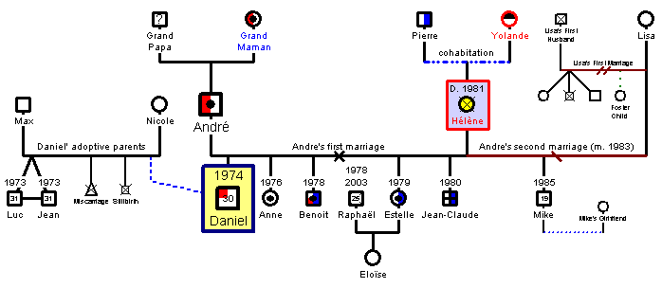
Family emotional intelligence
Capacity for recognizing our own feelings and those of others and the ability to manage our emotions and our relationships with others.
- Self-awareness
- Social Awareness
- Self-Management
- Relationship Management
Balshaw and Goldberg
- Self-awareness
- Emotional resilience
- Motivation
- Interpersonal sensitivity
- Influence
- Conscientiousness and integrity
The family business interaction factor
Family unity:
- Planning Activity
- Performance feedback
- Succession planning disclosure
- Advisory boards
- Family meetings

Family health and harmony are ensured via:
- Guidelines on the employment of family members
- Clears standards for succession and ownership transfer processes
- Promotion of cooperation and positive relationships between family members
The unique interaction between family and the business is a resource that provides an opportunity for gaining competitive advantages.
Benefits of family meetings (Beating the odds of having to deal with zero-sum dynamics)
Family unity and continuity
Stakeholders could mean:
- Owner only
- Owner-manager
- Family member with no share ownership
- Member of the current or next generation
- A key non family member
Family member have to develop policy and set direction.
Planning and policy making
Family meetings must address three critical issues:
- Educating uninformed members
- Communication the necessary information to the uninformed members through open and safe processes by experts.
- Developing effective planning and policy making bodies
What policies are useful?
- Family employment policy. Education and experience.
- Subcontractor policy. Guidelines for arm-length transaction.
- Board service policy. Link between family strategy and business strategy
- Family council service policy. Group coordinator or family council and other committees
- Dividend Policy. Family need vs. reinvestment.
- Liquidity policy. Cash flow
- Family constitution. Older and larger multigenerational families
Guidelines for policy making
- Involve as many family members as are relevant to a particular policy
  - Relevance is defined by expertise on the subject
- Understand the big picture and formulate a mission statement
  - What is best for extended family and business
  - Don’t include nepotism in the policy making
- Focus and current state and let go of the past
  - Stay away from ‘Well ya’ll remember that day ….’
- Use experience facilitators
  - Who can play a significant role in helping family business focus on the future
- Agree on the process you will follow to develop, review, edit, redraft, approve and ultimately enact policies.
Conflict management
Some conflict:
- Frustration over alienation or lack of inclusion
- Anger over unfairness in employment practices and promotions
- Dissatisfaction with dividend policies and lack of liquidity
Root: Perceptions

Steps to resolve conflict
- Avoidance. Conflicting parties withdraw. Rarely effective.
- Face-to-Face problem solving meeting.
- Formulate a share goal. Avoid zero-sum dynamic. Both parties need for win-win
- Expand resources to create win-win solution
- Play down differences and emphasize common interest
- Management might use authoritative command
- Change to formal organizational structure
- Negotiation.

Study Unit 3
Shareholders play a critical role in a family business and they can preserve a competitive advantage by allowing the family business to be managed by a long term horizon.
Ownership:
- Return on Invested Capital, Family Unity, Shareholder Value and Continuity
Management:
- Competitiveness, Growth, Career Opportunity, Profit
Shareholders Priorities
Shareholder wants risk-adjusted economies return captured in shareholder value and dividends or distractions
Manager more concerned with market with market share, competitors, growth and their own compensation and career opportunities.
Responsibilities of shareholders to the company
- Define and demand what is reasonable return on shareholder equity or invested assets.
- Provide the values and principles of doing business and ensure they remain instilled in the company
- Define the owning family’s strategy and communicate owning-family priorities

Effective Governance of the shareholder-firm relationship
Owner-family-business interaction is positive, it is a source of competitive advantage.
Major challenge, effective governance of the shareholder-firm relationship, two issues:
- The role of the board. Independent directors should balance the family board membership.
- Role of shareholder meetings, family meetings or family council.
Information, Communication and Education of the shareholders
Owners need to understand financial statements and be financial literate. Owners must attend shareholder meetings and interact/communicate with top management and board members.
Ownership Structure: Design and execute it
Ownership should be structured in a way that entrepreneurial speed, agility and competitiveness are maintained and that the next generation owner-manager ability to lead is not eroded.
To achieve this goal, different classes of stock can be issued, e.g., voting and non-voting for family members and phantom stock for nonfamily management. Also require buy-sell agreements.
TOPIC 1 Summary
Order to achieve competitive advantage:
- Jointly optimizing the ownership, management and family subsystem
- Controlling agency cost
- Ultimately exploiting the unique availability to family business.

TOPIC 2
Study Unit 4
Next generation good enough to run the business
- Evidence of readiness of the next-generation members to lead can be found
- When a successor is held accountable for profit/loss, the result determine his or her capability and readiness to be a successor
- Next generation members can earn respect through solid performance and interpersonal skills
- Education helps successors to gain both the skills and confidence to advance from middle to top management
- Coaches and mentors, both inside and outside the family, contribute to the development of successors
- Independent assessment of the S, W of a potential successor followed by feedback contribute to preparation of successor
- Through final review of successor performance and company-strategy fit, board of directors or independent outsides can advise on the timing of the succession
Profile of Successful successor
- Know business and love the nature of the business
- They experience and outside experience they know themselves well
- Want to lead and serve
- Guided responsibility by previous generation, advisors and board members
- Good relationships and ability to communicate
- Rely on non-family senior management to complement their work
- Lead thru aliases or controlling ownership
- Earn respect of non0familiy employees, suppliers, customers
- Skill and ability fit the strategic need of the business
- Respect the past and focus their energy on the feature

Reward and challenges for latter-generation family members
Junior generation members experience the following rewards:
- Employment
- Financial security
- Job security
- Company and product knowledge
- Favorable time-compression diseconomies
- Social and economic benefits
Junior generation face the following challenges
- Primogeniture Eldest son expected to take over business, where do that leave the other members of the family
- Coparcenary. CEO job divided among all siblings
- Incongruent hierarchies. Difference between family members position in the business and their perceived seniority levels in the business
- Shadow of the entrepreneurial founder. Has to deal with founder high need for autonomy, independence and achievement
- The rule are pre-established. Junior have to find their mark and gain legitimacy
- Professionalism of the junior family member. Junior have to proof he has the talents, ability, interest and commitment
- Resistance to change/commitment to status quo. Junior may appreciate the need for change but the natural human tendency is to resist change.
- Endowment effect. Tendency to value current possessions more than feature acquisitions.
Next-generation attributes, interest and ability. Ingredient for responsible leadership. Go Junior Go.
Require high financial and emotional capital for a sustainable business.
Desirable next-generation attributes
- Integrity and commitment most important
- Get the respect of employees
- Decision making and Interpersonal sills
- Technical skills moderate important
- Demographic factors and related family norms considerate of minimal importance
Next generation interest in join the family business can go about in the follow ways:
- Affective commitment. Junior wishes to pursue a career
- Normative commitment. Junior feels obligated to join
- Calculative commitment. Junior feels that a career is a must in the family business based on his calculation of the opportunity cost
- Desperate/dependent commitment. Junior is not confident he can cut it on the outside so the family business is his only choice.
Crafting the next generation career plan
Junior-generation family members to perform effectively, two dimensions have to be addresses, namely:
- Smart money management Junior require financial savvy
- Managerial worthiness. Junior must be well prepared for managerial responsibilities. Junior must be treated in the same way as non-family members. Must be measured, and feedback must be provided.
Family Relations
- Parent relationship will reflect on the actions of their children.
- Siblings close but not enmeshed, separate and differentiated but not isolated
- Intellectual and emotional stimulation without destructive rivalry
- Also important is the caliber of talent attracted in marriage
Sibling and cousin teams
Mom/Dad loves al children; one should be chosen to lead family business.
Next generation personalities
Fulfill different roles.
Interdependence of Team members
Central problem and difficult to manage. Design good organizational structure to accommodate these relationships.
A vision for the company: Taking it to the next level.
Younger members change agent role to play. Welcome next generation ideas. Junior’s complementary skills and perspectives are precisely what a family business often needs.
Disagreement: Having the difficult conversations
Controlling parents where differences are not solved in a generation, next generation render powerless.
Respecting the past and focus on the feature
Tension between generation around issues of growth and innovation is neither new nor exclusive a product or new technology.
Some final rules of the road for next generation leaders
Most harmonious relationship exists between father in 50’s and children between 23 and 33.

Study Unit 5

Secession and the transition of power
- CEO of family business must build intuitions of governance and manage to transfer power.
- CEO architect of governance and also one of successive continuity.
- CEO spouses also central to leadership in family-controlled companies
CEO builds institutions of governance, namely:
- Board of directors/advisory board
- Family council
- Family assembly
- Annual shareholder meeting
- Management team, including non-family manager
The transfer of power
Transfer of power can only be successful design for the unique family business and simultaneously incorporates a threefold transfer:
- Family leadership
- Ownership control
- Company management
In family business, transfer power id further complicated by the demands of the family relationship and the sheer potency of ownership.
CEO as an architect of succession and continuity
Right people + implement strategies that ensure both sustainability and continuity.
CEO EXIST Styles and the transfer of power
- The monarch
  - Monarch in business does not talk about succession, nor do they set a date for departure or a deadline for change in responsibility.
- The general
  - Chief executives leave office reluctantly and plot a return. General lives for the day when they will be called back into service to right the wrongs, real or not, committed by next-generation managers.
- The ambassador
  - Fewer owners become ambassadors. Ambassadors exit the business by delegating most of the operating responsibilities to next-generation members and/or key nonfamily managers but hold on to their diplomatic or representational duties on behalf of the cooperation.
- The Governor
  - Governors set a exit date and announce it publicly, thus committing themselves to the goal of transferring power within an established time frame.
- The inventor
  - The inventor designation is really a metaphor for an existing CEO who takes on a satisfying key position in another enterprise
- Transition Czar
  - Consult during manager and political process
  - Skilled architect he would craft the business in such a way that the siblings in the next generation would remain united in friendship.
  - CEO Spouse help
  - Transition czars realize the risk posed by a power vacuum and provide active leadership of the entire succession process with family members, key nonfamily managers, customers and suppliers.
Promoting trust among family members in the process of transferring power
Unique roles of the CEO spouse
CEO spouse’ unique roles are:
- Steward of the family
- Facilitator of communication
- Touchstone of emotional intelligence in family relationships
Spouses assume different leadership roles, depending on
- Relationship with CEO
- Knowledge and interest in the business
- Commitment and vision
- Their perception of need
- CEO and next-generation members
- Spouse ability to perform the leadership required
- The availability of others to perform communication-promoting and trust-enabling functions
Role type of CEO Spouse
- Business Partner
  - Critical to business, whether through their financial investment in it or because of their professional, technical or administrative skills.
  - May be large shareholders
  - May enable a culture of secrecy to persist in the family business
- Chief Trust Officer
  - Proving the glue that keeps everyone united through the predictable challenges faced by family businesses.
  - Act as healer, mediators and Facilitators.
  - Effective at putting succession planning and transition to retirement on the CEO’s agenda.
- Senior Advisor/Keeper of family values
  - More than a problem solver, raise kids with business savvy
  - No visible role in the business
  - Anti-isolation agent
- Free Agent
  - Aware of both family and business matters
  - Choose to develop identity separate from CEO
  - Are available for consultation and advice during tricky times
- Jealous Spouse
  - Jealous spouse provide the motivation for greater delegation and professionalization of the business so that its success and survival depends less on the superhuman efforts of the CEO
- ‘Interim CEO’ spouse
  - Interim or full leadership
  - CEO spouse might be needed because:
    - Successors are too young
    - No successors are qualified
    - Key nonfamily members not capable
    - Owning family recognize leadership needed.
Implications of CEO exit style and CEO spouse roles for succession and the transfer of power.
CEO spouse co-architect of family unity.

TOPIC 3
Study Unit 6
Creating the strategy
- Porter’s five forces
- Family business strategic planning, 3 levels. Between family members, between family and management and between management and the board.
Zero-sum family dynamic and strategic planning
- Strategic planning promotes communication and counter secrecy and “me-ism”.
- No growth exist, a zero-sum dynamic exist
- Zero-sum precursor to business failure and disharmony in family business

Creating value with unique business models
Seven primary sources of value on which family companies can build competitive advantage are:
- Financial resources – Cash and Securities
  - Address financial disadvantage by going public
  - Financial constraints a barrier to healthy growth
- Physical assets – Plants and Equipment
  - Seldom a major contributor to health creation
  - Family business are better served by explicating choosing not to base value creation on physical assets
- Product , its price and performance
  - Sometimes protected by patents
- Brand equity
  - Well know source for equity for family-controlled companies
- Organizational Capability
  - Having unique organization capabilities are capable of differentiating themselves and creating value in ways that others find it difficult to replicate
- Customer-Supplier integration
  - Need digital services in the mix
- Nature of family-business relationship
  - Family unity correlate positive with positive management
Life Cycle of the firm and the family, and the need for parallel strategic planning
Parallel strategy: Both shareholders (family owners) and the management (often a team of owner-manager and nonfamily managers) to think about, plan and execute strategy.
Stages of business development
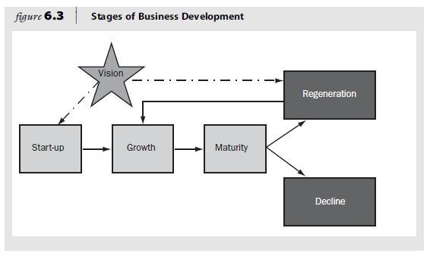
- Maturity after start-up, growth.
- Mature phase complex set of stakeholders
- Each stakeholder different perspective
- May loose vision, this will set the stage for decline
Life cycle stages influencing family business strategy
- In a safe environment candid conversation take place between family business stakeholders. Safe environment: Family Council
  - Shareholders develop a family vision that includes the desired relationship, going forward, between the family and its business.
- Shareholders discuss and formulate policies:
  - Hire requirements (Employment and Education)
  - Desired to have a continual of professional family business
  - Expectation on returns on family capital
  - Willingness to reinvest in the business for continued growth
- More formal strategic planning processes occur in the management ranks, they analyse
  - Competition
  - S, W in relationship with competitors
  - Changes and trends in the industry
Above results in a summary strategy statement
This will flag unique challenges and opportunities. The culmination of the work is a set of strategic actions that require human, organizational and financial resources.
- Dual-trajectory of the parallel strategic planning process then interacts.
- In parallel strategic process, CEO, Family business leaders and board members are the advocates the customers changing interest.
The customer-oriented company
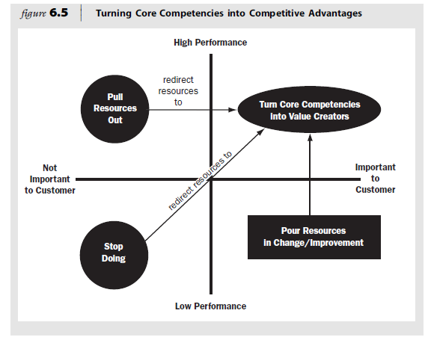
- Customer-oriented companies are the outcome from the perspective of what the customer who’s is using their product or service.
Strategic planning and disciplined execution
- Strategy making is guided by the owner’s vision for the future and a legacy derived from the firm’s competencies.
- Essential aspects of preparedness is succession and continuity planning
- Succession is not an event, but a series of new and unpredictable experiences
Unique vision of family-controlled companies
- Unique vision and business models are needed to lead an enterprise to competitive fitness
- Strategy is about making choices, and choosing to be different
- Family-owned business competencies for value creation
  - Rapid speed to market
  - Flexibility and nimbleness
  - Strategic focus
  - Concentrated ownership structure
  - Lower total cost derived from reduced agency cost
  - High quality of product / service
  - Capacity for customization

Life Cycle Stages Influencing Family-Business strategy

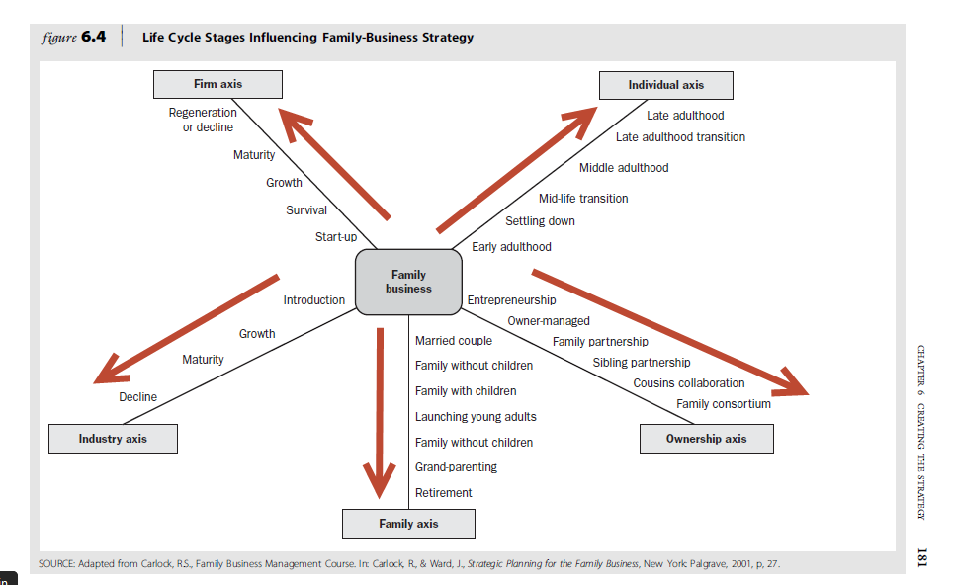

Study Unit 7
Planning the estate
Minimize estate tax and allow for continuity
- Estate is a collective term for everything a person owns
- Estate planning involves all the activities leading to the accumulation and management of assets or possessions and involve three processes
  - Building up an estate
  - Preserving the estate
  - Transferring the estate
Financial objectives when transferring the estate
- Minimization of transfer cost
- Protection of assets
- Provision of sufficient funds to make the transfer possible
Family business owners can adopt any of the three approaches
- No estate planning – No will entry for how the estate should be transferred
- Elementary estate planning – Relative small estate, details on owners will
- Comprehensive estate planning – Large estate, detail plan
Estate planning consist of the following 5 steps
- Set objectives
- Take Stock
- Establish the estate liabilities
- Choose estate planning techniques
- Implement estate plan
The estate plan
- Main focus minimize tax
- Not done at the cost of general transition
Family business’s estate plan should address the appropriate allocation of income source to the following:
- Founder
- Spouse
- Non active family shareholders
- The heirs
It must also address:
- Financial control of the corporation though buy-sell agreements
- Transfer of voting and non-voting stock
- The allocation of stock to appropriately qualified heirs
Approach the estate planning from a number of different points of view
- Parent – father or mother
- Spouse
- CEO
- Chairperson of the board
- Principal shareholder
- Philanthropist
Additional Issues
- Preserving speed and agility
- Giving successors the capacity to lead
- Corporate structure and classes of stock
- Trusts
- Equity and non-family members

Pitfalls to avoid estate and ownership transfer planning
Mistakes to avoid in estate and ownership transfer:
- Procrastinating in planning the estate and ignoring the inevitability
- Single-mindedly pursuing tax minimization
- Failing to use estate planning as an opportunity to teach the next generation
- Failure to make business continuity the cornerstone of the planning
- Confusing fairness with love and a desire to treat all heirs equally
- Failing to consult and communicate with heirs
- Insufficiently preparing the successors and/or failing to acknowledge the specific strengths and weaknesses of next generation members
- Failing to submit the estate and ownership transfer plan to professional
The roles of the board of directors
- Board of director can make owner accountable for progress in the leadership and development of the next generation
- Can address the issue of estate planning and ownership transfer
- Can invite spouse and co-owners to attend board meeting held with tax and estate planning consultants
- Facilitate discussion with potential successor

Study Unit 8
Financial considerations and valuation of the family business
Strong contributor to the economy of the country and add value to the stakeholders
Overcoming the accounting language barrier
Integration of financial management and the business:
- Link with strategy
- Link with accounting
- Link with line management
- Link with economic environment
- Link with law
- Link with investment decisions
- Link with financing decisions
Financial measure that matters
Balance Sheet
Stock. Picture moment in time for business
- Assets of Business
- Liability of business
- Equity of business
- Short-term assets
- Fix assets
- Capital equipment
- Depreciation
- Accumulated Depreciation
- Current liability
- Retain earning
- Total equity
- Net working capital (NWC) total current assets – total current liability
- Capital Expenditure (CAPEX) Additional investment in lo9ng term fixed assets
Income Statement
Flow. Net income or Net loss.
- Expenses (SG&A)
- Gross Profit – SG&A we get EBITDA
- EBITDA used to measure operating performance. Can company pay debt.
- EBIT = Operating Income, income after deducting all operating expenses from sales
- EBT, Earning before tax
Financial statement analysis
. Need to understand the financial by calculating ratios
Ratios:
- Day’s sales outstanding AR/average sales per day. Indicate the average number of days after the sales was made getting the money.
- Fixed asset turnover Sales / Net Fix Assets. How well fixed assets are used to generate sales.
- Total asset turnover Sales / Total Assets. How effective all assets are used
- Inventory turnover Sales/Inventory. What is the inventory flow?
- Debt ratio total liability / total assets
- Gross margin Gross profit/sales
- Profit margin net income / sales
The DUPOINT approach
Use to calculate Return On Equity
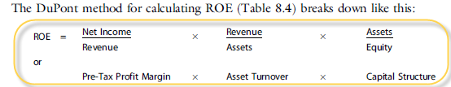

Focus on:
- Expense control through the profit margin
- Asset utilization through the total asset turnover
- Debt utilization through the equity multiplier
ROE does not explicitly consider risk
Family business accounting: is it really different?
NO
What is your business worth?
Must know how much is business worth? Must understand the valuation process.
Business Valuation
- Art of estimating the owners’ interest in a business.
- Ultimately, the value is an opinion guided by sound judgment
Underlying factors impacting on value (six factors):
- Fair market value. Based valuation on free-market decision
- Going-concern perspective. Evaluate company as ongoing operating business.
- Highest and best use. Focus on use of assets of the business
- Future Prospects. Determine the future prospects of the business
- Substitution. Assess the likelihood of substitutes of alternative products
- Objectivity. Use sound valuation.
Other factors impacting on the valuation
Analyst reviews the follow four additional key factors in determine an appropriate valuation of the business:
- Growth. Overall economic and market outlook and the specific industry
- Profitability. Net income and cash flow
- Management. Strength of management team
- Risk. Size and position of business
- Competition. Market positioning
- Market. Market position.
- Future community development. Impact on business
- Legal commitments.
- Union contracts.
- Buildings.
- Product prices
Adjustment for family accounting
Salary distortion and Perks
Valuation Methods
Three common valuation approaches
- The discounted cash-flow approach. Converting the company’s estimate future cash flow into a value for the business by applying a discount rate. The discounted rate project the risk that the project cash flow might not be realized. Requires estimate future cash flow of the business, timing of the future cash flows, and appropriate returns that covers the risk.
- The guideline public company method. Select value from specific publically traded companies compares to privately hold. Challenge is to find comparable companies.
- The guideline transaction method. Also called merger and acquisition method. Compare past sale of companies to determine appropriate valuation.
Must distinguish between business value and owner value. Business value is the value for the entire business, regardless of how it is financed. Equity value however is the total value of the firm less the amount of debt.
Firm value – outstanding debt = equity value
Must know value of business. Indicator of well the business is doing.
Estimate of enterprise value, consider of value:
- Economies situation
- Market situation
- Industry situation
- Company specific situation
Discount for lack of control and minority positions
- Acquisition value
- Controlling value
- Minority marketable values
- Minority nonmarket value
Nonfinancial return and costs not captured by business valuation
Nonfinancial private benefits, namely:
- Investments in brands or ventures that convey a high reputation
- Long-range internationalization project
- Investment that diversify the family’s wealth
- Emotional returns
- Total-value formula = financial value + emotional value or TV (Total Value) = DCF (Discounted Cash Flow) + DFPB (Discounted financial private benefits) + (ER (emotional returns)-EC (emotional cost))

Study Unit 9
Key non-family management
Perspectives of non-family managers
Three concerns:
- Balancing the competing demands of the family and business is a challenge.
- Management and governance practices are inadequate.
- There are concerns about succession.
Career opportunities for non-family managers
Need to understand future career opportunities, is possible in a merit-based professional run family business that promotes business growth.
Compensation and Benefits
Paid less, les flexibility and have less flexible job description.
Clear separation between payments to family members, owners and family. Family members should be rewarded according to sound business practices.
- Decide on a compensation philosophy.
- Benchmark levels of remuneration and determine and adopt market-related salaries.
- Adjust pay to reflect the qualitative characteristics of the job.
- Decide on an annual incentive plan.
- Establish criteria for assessing performance.
- Clearly communicate the plan and update regularly.
Performance feedback
Nonfamily members more satisfied with feedback than owner-managers. Non-family members given feedback to the younger family members must bear in mind they will work for them in the future.
Extending the family culture to non-family managers
- Have talk with top managers

Motivating and retaining non-family managers
Reasons not to appoint non-family member as bridging president or CEO
- Culture of independence and deep sense of personal/family identity

A non-family manager as a bridging president or CEO
Reason to appoint non-family CEO
- Outgoing CEO is not capable of leading a succession process
- No successors are qualified to carry out the chosen strategy
- Potential successors are too young and are not quite ready for the job
- Owing family recognize that business needs leadership
- The business needs dramatic change
- The owning family sees the need for change.
CEO is contingent on three factors:
- The particular needs and opportunities the business face
- Family’s preference
- Family’s skills or lack thereof
For outside CEO to be successful he/she should:
- Build credibility with multiple stakeholder groups
- Effect change by balancing a sense of urgency with speed required to incorporate traditional values
- Obtain consensus on the board
- Provide all stakeholders with timely financial and operating information
- Groom his/her own successor
Outside advisors: The family-business consultant
Study Unit 10
Governance definition: Optimally discipline and control the nature of the relationship between family members, shareholders and managers in such a way that the enterprise prospers and the family promotes and protects it unity.
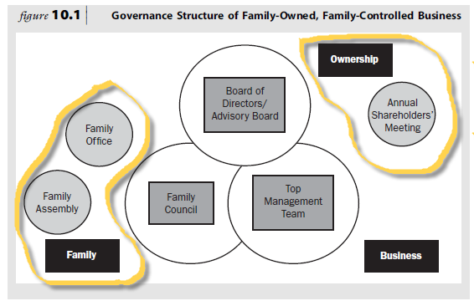
The board of directors
- Review financial status
- Deliberate on strategy
- Look out for interest of stakeholders
- Promote and protect the unity and long term commitment
- Mitigate potential conflicts between shareholders
- Ensure the ethical management of the business
- Be a respectful critic of management
- Review the performance of and hold CXEO and top management responsible
- Provide advice to the CEO on acquisition
- Bring a fresh outside perspective
- Assist in the recruitment and selection of new board members
- Assist in the objective planning and management of the multiyear succession and continuity process.
- Legal entity

King III report on Corporate Governance
- Fairness
- Accountability
- Responsibility
- Transparency
The board of directors and the financial performance of the firm
The family-business advisory board
Family business should have two boards, namely:
- Board of directors with family members and outsiders
- Advisory board with just outsiders
Advisory board advice and counsel. Not common in South Africa, Family business in South Africa still very secretive. Reasons:
- Link to society and culture
- Bankruptcy is a learning experience
- RSA lack of knowledge and experience managing a family business
Board versus independent advisory/consultants
Two differences between advisors and independent board members:
- The issue of independence. Independent thinking and respectful disagreement are more likely to be found among independent board members.
- The issue of commitment and continuity over the long term. Board members are committed to a longer-term relationship with the organization.
Members of the family-business board
When constituting a board of directors for a family business, the following should be taken into account:
- Mission: Work with and Advice CEO
- Size of the board: 5 – 9 members
- Composition of board membership: CEO, independent outsiders, managers (also successor if in process)
- Presentation to the board: Other family members, managers, invited guests
Recruitment and Selection
Specific consideration:
- If family on board (Other than CEO) selection according to acceptable board policy. Most qualifies. Could be function of Family Council.
- Successful peers, key functional heads, business unit managers
- Referral of candidates
- Board duty requires kb, leadership, competencies and experience
- Term of board members should be staggered
- Potential board members should have complementary skills.
Read Below if you can (paste rather small):
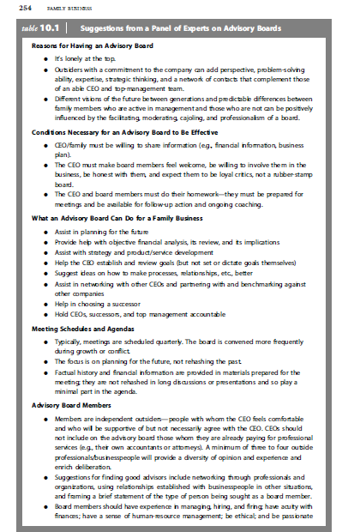
Compensation and motivation of board members
- Offer per diem fee for attendance
- Continued motivation will depend on the ability to install change
Major roles of the board of directors
- Setting company strategy. And to do so they need:
  - Share and understand CEO dream
  - Access to data, e.g. financial records
  - Access to people
- Adapting over generations (between the old and the new). Reconcile:
  - The wisdom o know what made the business successful in the past
  - The passion to make a difference, seize today’s opportunities and thrive in a decade ahead
- Succession and continuity planning:
  - Relieve CEO parent of the daunting task choosing one of his children
The family council
- The family council is a governance body that focuses on family matters.
- Discuss on a regular basis family related business issues.
- They are family members
- Family members and spouses of all generations participate
- Must meet on regular basis, have mission statement and a family creed
- Deliberate on:
  - Dividend policy
  - Liquidity arrangement
  - Transfer of ownership and control
  - Estate planning
  - Decide on non-economic goals and values
Boundary between board of Directors and a family council
Family councils can contribute to family-controlled companies by:
- Helping families draw the line between family membership and board duty
- Establishing a system of governance that both differentiates and integrated family and business goals

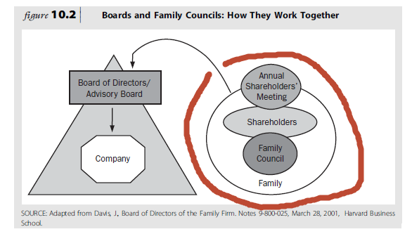
Family assembly
Arrange by large multigenerational families where all family members cannot serve on a family council. Help to inform family members of development in the family business.
Annual Shareholder’s meeting
- Legal requirement
- At least one meeting per year
- Must report on performance, returns on shareholder equity and dividend to be distributed.
- Shareholders during meeting elect the board of directors and attend to other matters on the agenda.
Family Office
Assist shareholders with duties and responsibilities arising from their ownership relationship with the company.
Top management team
- Must consist of family and non-family members
CEO can take the following steps to enhance the effectiveness of the board
- Recruit and select board members
- Prepare a board book to prepare new board members
- Share critical business information
- Do pre-meeting preparation
- Hold quarterly meetings
- Ensure board-members are available for follow-up

Study Unit 11
Family communication
Family meetings
- Address issues to balance family-owner-management system

- Update family members not active in the business about the business
- Opportunity for good communication
- Educate family about the three systems
- Engage family members in responsible ownership
- Update family members on the estate plan
- Allow for policy
- Good time for problem solving and conflict resolution
- Forum for introspective and celebration
- Safe harbor for planning the family’s future involvement in the business
Family Council
- Family council help to reduce family’s propensity to become a zero-sum entity
- Governance body
- More formal
- Promote communication
- Safe harbor for conflict
- Support education
Ownership and family policy making
- Employment policy
- Subcontractor policy
- Board service policy
- Family strategy, dividend policy, liquidity policy
- Family constitution
Family Constitution
- Governs the relationship between shareholders, family members and managers
- Also called family charter
- Make explicit principles and guidelines that shareholders will follow
- No legal bearing
- Contain
  - Vision
  - Family values
  - Desired behavior of family to firm
  - Employment policy
  - Next-generation family member development
  - Ownership policy
  - Family band/venture policy
  - Dividends and family benefit policy
  - Liquidity policy
  - Board of directors
  - Family meeting
  - Shareholder meeting

Study Unit 12
Change, adaptation and innovation: the future of family business
Continuity and Culture
High on performance over a long period of time have a strong culture that fits strategy.
Changing the Culture
- Strong culture not enough, must be flexible and adaptive
- Owners who hold themselves and manager accountable for continuity will be instrumental in companies that last
- Style of leadership required for continuity:
  - Leader challenge the status quo
  - External perspective
  - Ability to forge new direction
  - Ability to generate a sense of urgency
New leader of the evolution
- Must demonstrate self-awareness and self-management
- Word and actions consistent
- Ownership transferred, authority earned slowly
- Must demonstrate competence, caring and consistency
- Must maintain contact and communication
Difference between founder and successor:
- Successor does not inherit the authority to lead
- Transfer of power not implicit
Traps for new leaders:
- Authority is earned not inherited
- Staying in contact, even during conflict
- Don’t be distracted by key managers. Don’t lose focus.
- You can’t always answer to all problems
- Attempting to much to fast or too little too slowly
- Being over cautious.

Raw material of new culture
Culture of an organization change when:
- Leader change the information that employees and family (active/inactive) receive
- Alters the way employees are paid and paid for what.
- Job responsibilities and reporting relationships
- Adapts a mechanism for coordination and accountability.
Change is the function of the following:
- Dissatisfaction with the status quo
- Vision of the desired future
- Practical first steps for achieving the goal of change
Need all three for change to gain momentum
The three states of evolution
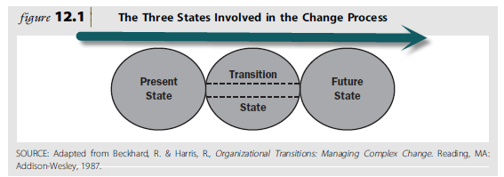
- Present State. Need for change triggered externally or internally.
- Transition State. Forming action plans and temporarily structures. Add system to control the change. Must understand where to start:
  - Top management
  - Family
  - Ownership
  - Systems that are most ready
  - New teams, units or governance bodies
  - Temporary project teams
  - Best practices for family-business continuity.
- Future State. Define precisely. Must be presented to the board of directors.
Continuity and family-management-ownership structures
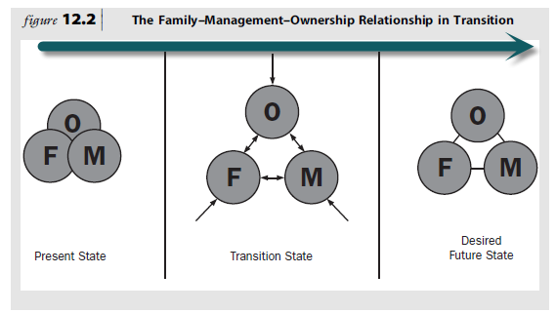
Success planning
Barriers to succession planning in family organizations
Founder/Owner | Family
Death anxiety | Death as taboo, discussion a hostile act, fear of loss/abandonment
Company as symbol, loss of identity, concern about legacy | Fear of sibling rivalry
Dilemma of choice, fiction of equality | Change of spouse position
Generational envy, loss of power

Key factors in succession planning
- Pressure inside and outside the family business
Inside the business | Inside the Family | Outside the Family
Inside the business | The family managers | The employees
Inside the business | Hanging on or getting company control | Rewards or loyalty
Inside the business | Selection of family members as managers | Sharing of equity growth and success
Inside the business | Continuity of family investment | Professionalism
Inside the business | Building a dynasty | Bridging family transitions
Inside the business | Rivalry | Stake in the company
Outside the business | The relatives | The outsiders
Outside the business | Income and inheritance | Competition
Outside the business | Family conflict and alliance | Market, product, supply and technology influence
Outside the business | Degree of involvement in the business | Tax Laws
Outside the business |  | Regulatory Agencies

- Forcing events
Indecent that results in replacement of the owner-manager
- Death of the owner
- Illness of some form
- Mental or psychological breakdown
- Abrupt departure
- Legal problems
- Severe decline in business
- Financial difficulties

- Source of Succession
Following type of successors:
- Entrepreneurial successor
- Managerial successor
Owner-manager considers the following successor:
- Family insider.
  - Gradually delegate operations to successor
  - Founder should switch roles from founder to coach
  - Experience management team should coach the successor
- Family outsider.
  - Family who gained exceptional experience outside the company
- Non-family insider.
- Non-family outsider
  - Only for interim successor.
  - Also happen when company need specialist when there is difficult times for company.
  - No eligible family members.
Entry strategies
Can choose either an early or delayed entry strategy.
Early entry strategy | Advantages | Disadvantages
Early entry strategy | Intimate familiarity with the nature of the business and employees is acquired | Conflict result when the owner has difficulty with teaching or relinquishing control to the successor.
Early entry strategy | Skills specifically required by the business are developed | Normal mistake tend to be viewed as incompetence in the successor.
Early entry strategy | Exposure to others in the business facilitates acceptance and the achievement of credibility.  Strong relationships with continents are readily established. | Knowledge of the environment is limited and risks of inbreeding are incurred.
Delayed entry strategy | The successor’s skill is judged with greater objectivity. | Set patters of outside activity mat conflict with those prevailing in the family organization.
Delayed entry strategy | The development of self-confidence and growth in depended of family influence are achieved | Resentment may result when successor are advanced ahead of long-term exmployees.
Delayed entry strategy | Outside success established credibility and serves as a basis for accepting the successor as a competent executive.
Delayed entry strategy | Perspective of the business environment is broadened.

Stages in the process of succession
- Pre- business stage. Young child is exposed to business. Part of growing up.
- Introductory stage. Child too young to work is exposed to elements of the business and people associated with.
- Introductory functional stage. Works as part time employee. During completion of formal education. This includes the formal education and experience in the business.
- Functional Stage. Potential successor enters full time employment, after completion of formal education.
- Advantage functional stage. Potential successor is promoted to management position, but does not yet manage the entire organization.
- Early succession stage. Given supervisory position. Exercise control by giving overall direction. Parents still final decision.
- Mature succession stage. Leadership transition stage is complete and successor is now the leader in fact and name.
Model of succession in the family business
See page 123 in the study guide.
Developing a succession strategy
Family business owner should address the following steps to ensure the transition happen without problems (5 aspects of effective succession):
- Understanding the contextual aspects
  - Time. Start early
  - Type of venture.
  - Capabilities of managers.
  - Entrepreneur/owner’s vision.
  - Environmental factors.
- Identify successor qualities
  - Adequate knowledge
  - Fundamental honesty and capability
  - Good health
  - Energy, alertness, perception
  - Enthusiasm about organization
  - Personality compatibility with the business
  - High degree of perseverance
  - Stability and maturity
  - Reasonable amount of aggression
  - Thoroughness and a proper respect for detail
  - Ability to solve problems
  - Resourcefulness
  - Ability to plan
  - Talent for developing people
  - Personality of a starter
  - Appropriate agreement with the owners philosophy
- Developing a written succession strategy (plan)
  - Owner control the management continuity strategy
  - Owner consults with selected family members
  - Owner works with professional advisors
  - Owner works with family involvement

If owner is still healthy and the business is viable, consider:
- Owner formulate buy/sell agreement
- ESOPs
- Sell or liquidate business
- Sell or liquidate after discovering illness
Organization development approaches to change
Six organization development approaches, namely:
- Individual consultation by family- business advisor with CEO and the successor candidate(s)
- Twofold consultation with CEO and successor or successors
- Group consultation with family or stakeholders
- Intergroup consulting with family and non-family management
- Development of interpersonal skills in the next generation
- Designing and facilitating whole-family forums and appreciative inquire processes
Commitment planning
Whop is the stakeholders, where are they at, where should they be.
Institutionalizing the change
BBBEE
The future: Can family business compete and thrive?
Ask:
- What are the social and business imperatives of providing goods and services in South Africa
- Who are our potential customers
- Who will be our customers in the next 10 years
- Do we want to transform into a truly representative South Africa business
Agility in the face of change
Appreciate the competitive strengths that led the business to the family’s success.
Family business has the follow strengths that are not easy replicated:
- Speed and flexibility
- Long-term strategies
- Strategic focus on protected niches
- Customer orientation
- Patient capital in the presence of practices that safeguard trust and family unity
Competition and Value creation
Family businesses can create competitive advantages by adopting a unique combination of the resources of value.
Family-business qualities:
- Stable capital structure
- Take long-term view of staffing and investment
- More labor intensive and less capital intensive
- Innovation can be achieve at relative low cost
- Can make strong contribution to the triple-bottom line
- Foster entrepreneurial instinct
- Active as mentors into the next generations
Tapping the next generation
Revive the supply chain
Organic competencies and the business future
Organic competencies by family-owned businesses:
- Unique and idiosyncratic organizational capability
- Customer-supplier integration
- Product/Service price
- Brand equity
- Concentrated ownership
- Family unity
Global opportunities
RSA need to grow
Positive-Sum Dynamics through family and enterprise leadership
7 strategies to avoid zero-sum dynamics

Study Unit 13

Continuing the spirit of enterprise: lessons from centennial family companies.
Family Culture and Cultural blur as positive advantage:
- Love in the family
- Strong ownership
- Social capital
- Family value of independence
- Strong work ethic
- Creativity in the founder
- Caring attitude

