ASSIGNMENT 02

MODULE CODE: PST131

SUBMITION DATE 13-04-2018

UNIQUE NUMBER: 723108

SECTINON: HOME LANGUAGE
Question1.
  - The behaviourist theory of language acquisition shares a common claim compared to nativist theoty of language acquisition on two grounds. Firstly they both claim that the new born baby is born with the ability to learn a language. The proof is as follows the behaviourists claim that “each new born infant has a potential for learning.” On the other hand the nativists basically holds that “ humans are endowed with ability for learning language”. Secondly both insist that learning is promoted by the positive environment. The nativsts emphasise the interaction between the child and the adults whereas the behaviourists believe that all learning results from positive reinforcement of the desired behaviour.
Finally the only ground on which the two differ prevails when nativist theory holds that humans endowed with specific ability for learning whereas the behaviourist theory states that no specific capacity for language learning.

  - The role of the teacher in communicative approach is to firstly have the thorough knowledge of how the language, intended to teach, works. This will help him/her to meaningfully support the learners to develop their communicative skills appropriately. The next the teacher must also be aware of the fact that learners are not at the same level of development as a results the teacher must organise the knowledge activities according to the individuals` needs and also guide and advise rather than prescribing. The teacher serves as co communicator encourages learners to share their ideas and be an exemplary as a proficient communicator.

  - As the starting point is the reading in the class to establish and emphasise meaningful experience and at times individual reading considered to challenge more competent readers. Secondly directed reading must be well planned and provided to support those who have same reading abilities which maybe poor and requires scaffolding. Thirdly if the progress prevails reading logs can be introduced in which learners take full responsibility with minor support from the whenever necessary. The fourth and fifth reading conferences can be held on regular basis when silent reading conducted then the teacher and the discuss what was read, reading periods considered with varying times incorporates reading aloud and sharing times.

Question 2
2.1. Description of story
Title: A very clever girl
Author: Roald Dahl.
Type of story: Descriptive story
Concise summary of story: The story is about negligent parents who can see how clever and wonderful their daughter is, they do not support in her development.
Main characters: Matilda and parents.
Which character did you like best? : Matilda
Why? : Matilda is very clever and try some means to enhance her development when her parents resist to buy her books. She goes to the nearest library for the quest of reading.
Where and when do events take place? : The events take place in Matilda`s home over unspecified period.
Is there conflict between the characters? : Yes, the conflict is that Matilda has read every reading material in the house and therefore asked her father to buy a book for her hence her father resists claiming that she is getting spoiled. The reason for the conflict is that her parents are so ignorant and do not care of their children. I think their children more especially when it comes to education.
One striking incident: It is when Matilda visits the local library and asks to sit a while and read a book.
The four unfamiliar words in the story:1. scab means a dry, rough protective crust that forms over a wound during healing.
2. extra ordinary means very unusual or remarkable,
3. Telly means informal term for television
4. librarian the person who works in the library.

2.2. Combrink`s integration model.
Selected Poem: The balloon written by Karla Kuskin.
Phase 1: Preparation for the reading of a text.
I would ask the learners to tell about the parks and activities normally take place in parks. The next step is to ask them to name non-living things that are easily blown away by even light wind. Then we choose one like a feather then they are instructed to imagine themselves being a feather taken away up by the wind gliding very high like an eagle. They must tell how would they feel gliding in the sky.
Phase 2: First reading of the text
I will use tape recorder in which the poem is taped and sound loud such that it is easy to detect the feeling of the speaker. Then distribute the copies of the poem for them to read for themselves
Phase 3:
After reading the poem they are instructed to write down what the poem means to them and how do they feel about the poem. They will be made aware of the element of confidentiality and about the possibility that their responses may not be final they are likely to change as we move along with the poem.
Phase 4 and 5: Sharing, developing and structuring responses.
I will let them in pairs voluntarily share their responses and those feel confident enough to report to the class. If necessary explanation of unknown words shall be explained. Then the best reader reads aloud while the class clapping to the reading. In the second time of reading the class listen careful and identify the rhyming words and personification. Rhyming words like “:trees and breeze” personification “ it Flattered”. Finally learners will compare the text with newspaper report to highlight differences between the two and get encouraged to read other texts written by the same author.
2.3. The importance of using the drama by the language teacher in the class.
1. The dramatisation promotes active participation in learning from the side of learners.
2. It arouses interest and ownership to the activity.
3. Active participation enhances insight into the subject matter that develops desired attitude from the learners.
4. It also allows learners to develop speaking and listening skills as they enjoy themselves.
5. Finally it affords the opportunities fir the learners to exposed to cultural diversity and develop respect, tolerance and appreciation of multicultural societies.
2.4. Activities to develop creative writing skills.
Study the picture below and answer the following questions.
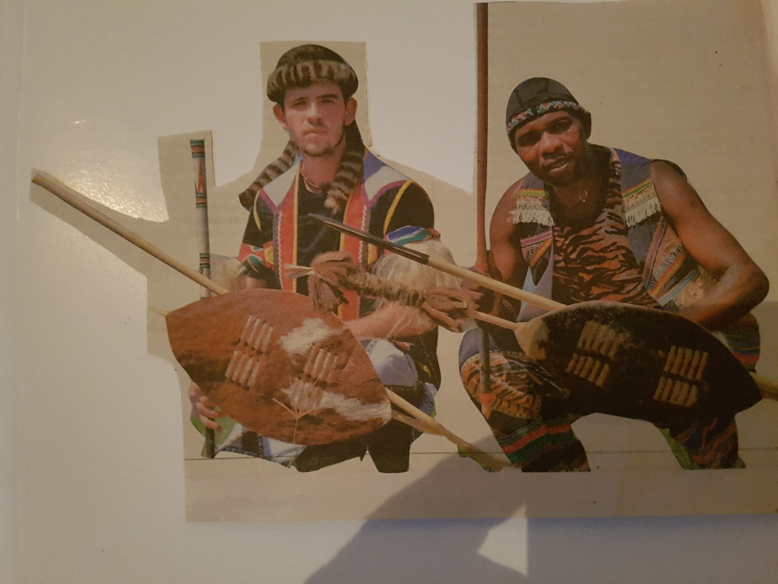
Step 1.
The learners will be shown the picture. Then they will be asked to use their feelings and imaginations then in pairs discuss the pictures by using the following guiding questions:
- What occasion these men dressed for?
- Do you think they are going to be special in that occasion? (support your answer).
Step 2.
Then few brave learners will be encouraged to share their responses with the class. Then all responses will be appreciated and clarity be given that the interpretation of the situation is not about impressing the teacher but rather is about individual`s feeling and imaginations. More emphasis will be put on establishing and maintaining logic when it comes to self expression.
Step 3. Individual work
They write a story about the picture following the instructions below:
Instructions.
- Each learner imagines him/herself as one of the men in the picture
- Then write a story with a topic and consists of tree paragraphs each consists of 4-6 lines.
- In a paragraph there must be one idea, the first one explains the occasion and it`s atmosphere.
- The second paragraph tells about tells about the feeling of the main character in terms of preparations before performing.
- The last paragraph tells about the performance and the response of the audience as well as the feeling of the main character after performing.
Question 3.
Lesson plan: First additional language.
Grade: 5
Duration: 45min
Theme: Friends
Learning outcomes:
Learners by the end of the lesson should be able to:
- Write a description of a person
- Write a short message.
Resources: pluck cards with characters names and short description of characters respectively.
: Short story of three characters.
: tape recorder to play the short story.
: chalk board (metal) and small magnets to hang pluck cards.
Introduction: 5 min.
I will play the tape recorder 2 two times for them. They will listen careful and take some notes.
After listening they use pluck cards of names to match with the descriptions attached on the board.
Presentation/ body
I will firstly ensure that everybody understands the concept of description.
There after take them step by step through the writing processes.
To name the few steps brainstorming , organising, drafting, sifting and checking of grammar and spelling.
Assessment:
They will do the following tasks:
Write the description of someone you know.
Follow the frame below:

My ________ is _____________ and_______________. She/He likes ___________________.
She/He often____________. He/She is probably_______________ now.
Write a short message
Read the short message below. Rewrite it in full sentences.( Use the frame below to help you.)
Dear ___________________________________________
Please __________________________________________
Love___________________________________________
Assessment method: Peer assessment.
Marking rubric.
Judgement based on grammar, punctuation and tense.

Question 4
4.1. Positive attitude when teaching additional language is important based on the following points.
Firstly the teacher of first additional language is likely to face with the group of learners from diverse cultural backgrounds which is the very important element for consideration during planning and teaching to be accommodated.
Secondly the teacher must understand the socioeconomic background of the learners in order to provide appropriate support to learners.
Thirdly it is also vital for the teacher to know the learners` level of development that goes with screening assessing which is driven by dedication emanate from positive attitude as a results the able to select meaningful activities that match learners` needs.
Lastly it allows teacher to be an agent of transformation that involves all stake holders in his or her planning and consider to even develop the community if necessary.
The teacher with positive attitude go as far as to have a broader picture of a problem and convert a school into be center of development.
4.2. The principles of integrated approach.
- Prior knowledge
-Differentiation
-learning strategies
-Cultural relevance
-Active engagement.

Question 5
  - The importance of using ICT tools emanates from its ability to bring real life situation into the class when internet is used.
Secondly teacher is able to use accurate drawings and real statistics that allows learners to observe reality and get better understanding of subject matter taught.
It also encourages independence from the side of learners when researching on their own and also speeds up language learning as giving opportunities outside the classroom. However the disadvantages it goes with expanses and if the teacher cannot set up the device its a problem.
  - Pre writing activities help a child to develop skills on how to hold and use a pen to write.
As the learners required to draw sometimes to copy the information and use colours all these develop from pre writing activities. So to help learners with pre writing activities I will let them trace complicated drawings and put colours on simple drawings.
  - The importance of songs, rhymes and word games prevails when through these learners improve in correct pronunciation of words. Learners develop and become fluent when expressing themselves in different social contexts. Word games increase their vocabulary and ferry them to become competent communicators in different situations as they grow up.
  - When reading the poem aloud clap to the poem. Secondly they read selected lines from the poem and identify the sounds they hear the most. They match rhyming words like trees and breeze. They tell what a poem is about and indicate how do they feel about the poem`s content.

