Name: _________________________________ Date: _____________

1 | Explain the term “desertification”. | 2
2. | Classify and explain the three accepted causes of desertification.  ____________________________________________________________
 |  | 12

3 |  | Look the picture below and explain all the visible signs that the veld has been overgrazed.  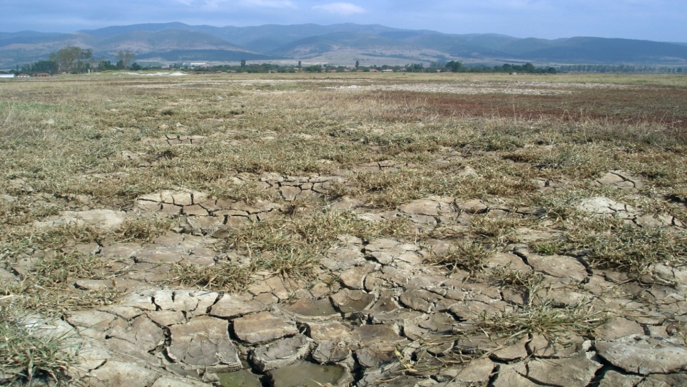  Picture from e-ecodb.bas.bg | 6
4. | Outline ways salinizations occurs in the dry lands and problems it poses to human society.  ___________________________________________________________
12

