MNG2601: GENERAL MANAGEMENT

TOPIC 1: THE NATURE OF MANAGEMENT

(STUDY UNIT 1) CHAPTER 1: INTRODUCTION TO MANAGEMENT

INTRODUCTION P4

All organisations utilise societies’ scarce resources, namely:
# | Scarce Resource | Academic Name
1 | People | Human resources
2 | Money | Capital
3 | Raw materials | Physical resources
4 | Knowledge | Information resources

Managers – plan and implement (organise, lead & control)

BUSINESS ORGANISATIONS AND MANAGERS P5

The ways in which organisations serve society: they bring together the resources of a nation to produce the goods and services it needs.

THE NATURE OF MANAGEMENT P6

The 4 fundamental management functions:
# | Management Function
1 | Planning (P) – where the organisation wants to be (the vision, mission and goals)
2 | Organising(O) – deals with task, roles & responsibilities
3 | Leading (L) - redirecting the human resources & motivating them to be more productive.
4 | Controlling – managers should constantly make sure that the organisation is on the right course to reach its goals
EXTERNAL ENVIRONMENT
FIGURE 1.2 – THE INTERACTIVE NATURE OF THE MANAGEMENT PROCESS
PLANNING (PART II)
Managers determine the organisations vision, mission & goals and device on a strategy to achieve them
CONTROLLING (PART V)
Managers monitor progress and take corrective steps to reach the mission and goals
ORGANISING (PART III)
Managers group activities to establish authority, allocate resources and delegate
LEADING (PART IV)
Managers/Directors motivates members of the organisation to achieve the mission and goals
The differences between vision, mission, goals strategy

Vision | What the company wants to become – it should be future-oriented. It’s the image of the company, what the company wants to create. Its what the company is and what it wants to become. Vision statement should be motivating and inspiring and should drive decision-making. Eg. “Be the safest, most customer-focused & successful transportation company in the world (Norfolk)”
Mission | This is what the company does. It should be short and easy to memorize but shouldn’t be generic should have the words To….in it. Eg. “To promote & develop growth of tennis (US Tennis Association)”
Goals | Are dreams with deadlines, they are quantifiable and you should clearly know if you hit them or not.
Strategy | Its something everyone can contribute to, that will advance the organisation. They are usually designed to overcome constraints.

Learn Table 1.1: The basic resources of an organisation p7

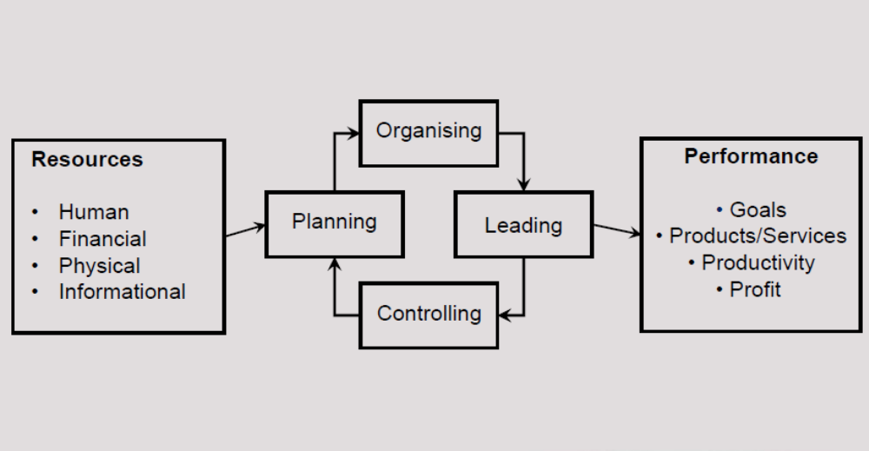

The interactive nature of the management process: the external environment:

MANAGEMENT FUNCTIONS (ALSO MANAGEMENT PROCESSES)
# | Function | Description
1 | Planning | Managers determine the organisation’s vision, mission and goals and decide on a strategy to achieve them
2 | Organising | Managers group activities together, establish authority, allocate resources, and delegate
3 | Leading | Managers direct and motivate members of the organisation to achieve the mission and goals
4 | Controlling | Managers monitor progress and take corrective steps to reach the mission and goals

A DEFINITION OF MANAGEMENT P8

Management is the process of planning, organising, leading, and controlling the scarce resources of the organisation to achieve the organisation’s mission and goals as productively as possible.

# | Function | Description
1 | Planning | - The management function that determines where the organisation wants to be in the future: vision, mission, goals  - Strategic plans: made by top management, 5-10 years  - Tactical plans: made by functional managers  - Operational plans: made by lower management, shorter term plans i.e. daily, weekly, monthly
2 | Organising | - Allocation of human resources  - Tasks, roles and responsibilities are defined  - Development of a framework or organisational structure  - Organisational design: management must match the organisation’s structure to its strategies

3 | Leading | - Directing the human resources of the organisation and motivating them in such a way that they will be willing to work productively to reach the organisation’s mission and goals  - Managers are responsible for getting things done through other people  - Leading the organisation means making use of influence and power to motivate employees to achieve organisational goals
4 | Controlling | - Managers should constantly make sure that the organisation is on the right course to reach its goals  - The aim of control is to monitor actual results against planned results

DIFFERENT LEVELS AND KINDS OF MANAGEMENT IN THE ORGANISATION P10

Managers are usually classified into 2 categories p10:

# | Category | Description
1 | According to their level in the organisation | Top, middle, lower or first-line
2 | By the functional or specialist area of management for which they are responsible | The functional managers i.e. marketing manager, finance manager, operations, human resources, research and development etc.

FIG 1.4 – CLASSIFICATION ACCORDING TO LEVELS & FUNCTIONAL AREA

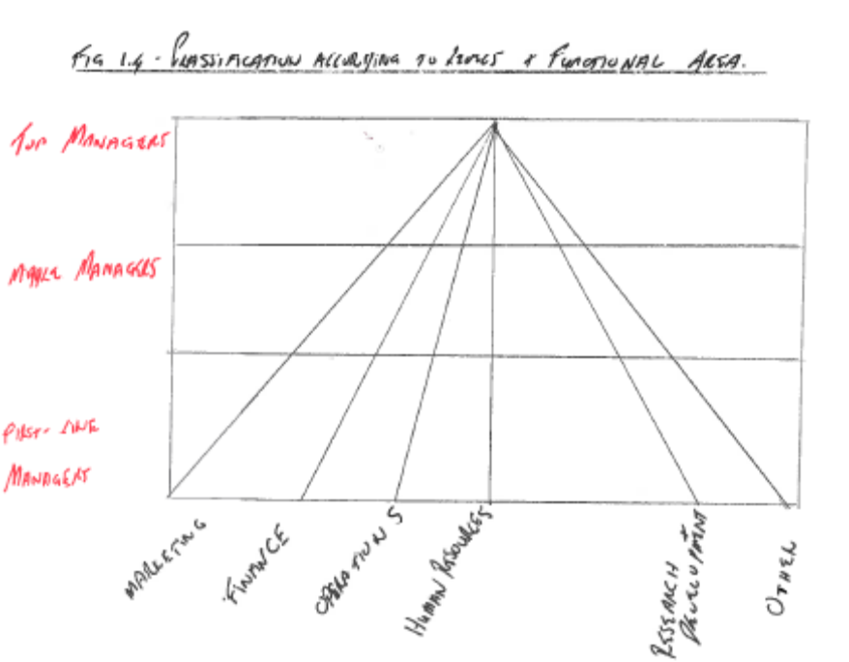

1.. Top management p10:

# | Responsibility
1 | Responsible for the organisation as a whole
2 | Includes board of directors, partners, managing director, chief executives
3 | Responsible for determining the mission, vision, goals and overall strategies of the entire organisation
4 | Concerned with long-term planning, designing the organisation’s broad organisation structure, leading the organisation, and monitoring (controlling) its overall performance

2. Middle management p11:

# | Responsibility
1 | Responsible for specific departments of the organisation
2 | Includes functional heads such as financial manager, marketing manager etc.
3 | Primarily concerned with implementing the strategic plan formulated by top management
4 | Responsible for medium-term planning (the near future) and leads by means of the department heads
5 | Continually monitor environmental influences that may affect their own departments

3. Lower/first-line management p11:

# | Responsibility
1 | Responsible for smaller segments of the organisation e.g.: the different sections
2 | Includes supervisors or foremen
3 | Deal with the monthly, weekly and daily management of their sections
4 | Ensure the plans made my middle management are implemented
5 | The primary concern of a supervisor is to apply policies, procedures and rules to achieve a high level of productivity in his/her section, to provide technical assistance, to motivate subordinates, and to ensure that the section’s goals are reached

MANAGEMENT ACTIVITIES

Areas of management include:
- general management – focuses on the entire organisation
- marketing – marketing of new product/services and improving old
- finances – deals with all financial matters
- production/operations – physical production of goods/services
- human resources – training, development, remuneration etc
- public relations – create favourable, objective image of the organisation
- research & development – developing new products/services and improving the old products/services

Learn the areas of management p12

- Interpersonal Role
- Information Role
- Decision Making Role

The Role Distribution of Managers p14
FIGURE 1.6 – OVERLAPPING THE DISTRIBUTION OF MANAGERS (MINTZBERG)
INTERPERSONAL
Figure head
Leader
Relationship builder

INFORMATION ROLE

Monitor
Analyser
spokesperson
DECISION MAKING

Entrepreneur
Problem solver
Allocator of resources
Negotiator

Henry Mintzberg, a famous theorist, came to the conclusion that managers play about 10 different roles i.e. the overlapping role distribution of managers:

# | Category | Description
1 | Interpersonal role | Figurehead
2 | Interpersonal role | Leader
3 | Interpersonal role | Relationship builder
4 | Information role | Monitor
5 | Information role | Analyser
6 | Information role | Spokesperson
7 | Decision-making role | Entrepreneur
8 | Decision-making role | Problem solver
9 | Decision-making role | Allocator of resources
10 | Decision-making role | Negotiator

MANAGERIAL SKILLS AND COMPETENCIES AT VARIOUS MANAGERIAL LEVELS P15

MANAGEMENT SKILLS
# | Skill | Description
1 | Conceptual | The mental ability to view the organisation and its parts holistically. Involves the manager’s thinking and planning abilities
2 | Interpersonal | The ability to work with people
3 | Technical | The ability to use the knowledge or techniques of a specific discipline to reach specific goals

A competency in managerial skills refers to the necessary:
# | Competency
1 | Knowledge
2 | Skills
3 | Value orientation

The 3 major skills needed by managers at all levels and in all departments and sections of the organisation are:
FIGURE 1.7 – MANAGERIAL SKILLS NEEDED AT VARIOUS MANAGERIAL LEVELS
TOP MANAGEMENT | MIDDLE MANAGEMENT | LOWER MANAGEMENT | NON-MAN (WORKERS
CONCEPTUAL | CONCEPTUAL | CONCEPTUAL | CONCEPTUAL
CONCEPTUAL | CONCEPTUAL | CONCEPTUAL | INTERPERSONAL
CONCEPTUAL | CONCEPTUAL | INTERPERSONAL | INTERPERSONAL
CONCEPTUAL | CONCEPTUAL | INTERPERSONAL | TECHNICAL
CONCEPTUAL | INTERPERSONAL | INTERPERSONAL | TECHNICAL
CONCEPTUAL | INTERPERSONAL | TECHNICAL | TECHNICAL
INTERPERSONAL | INTERPERSONAL | TECHNICAL | TECHNICAL
INTERPERSONAL | TECHNICAL | TECHNICAL | TECHNICAL
TECHNICAL | TECHNICAL | TECHNICAL | TECHNICAL

MANAGEMENT AND ORGANISATIONAL PERFORMANCE P18

# | Theory | Description
1 | The fundamental economic principle | Achieving the highest possible satisfaction of needs with scarce resources
2 | The task of management in a free-market economy | To manage in such a way that the organisation makes a sustainable profit, that is, earns the highest possible income with the lowest possible costs
3 | The triple bottom line | Run the organisation as profitably as possible with due responsibility of the organisation towards the community, as well as the environment for which it needs to care

MANAGEMENT AND ORGANISATIONAL PERFORMANCE

The task of management in a free-market economy is to manage in such a way that the organisation earns the highest possible income with the lowest possible costs, with profit as the favourable difference between the two.

Efficiency means doing something right, whereas effectiveness means that the right thing is done.

THE SCOPE OF MANAGEMENT

Effective and efficient management practice is equally important in smaller business organisations as well as non-profit organisations such as government departments and organisations, municipalities, universities and schools, sports clubs, and even political parties.

- Large Business organisations eg. (PWC) – competes globally
- Small business organisations (SMEs)
- Non-profit organisations

END OF STUDY UNIT 1

(STUDY UNIT 2) CHAPTER 2 : THE EVOLUTION OF THE MANAGEMENT THEORY p27

UNDERSTANDING THE DIFFERENT MANAGEMENT THEORIES P30
The environmental forces that shape management thought:
# | Environmental Force
1 | Social
2 | Political
3 | Economic
4 | Technological
5 | International
6 | Ecological

Significant developments that have an effect on managers & organisations:

1. | Advances in information technology | - the internet & other forms of globally connected networks which provide the ability to share info on a worldwide basis.  - Electronic commerce including EDI (electronic data interchange) enabling managers to reshape their business processes to improve response time & efficiency.  - Mobile computing: enables individuals to have access to information technology, irrespective of their physical location.
2. | Globalisation of the marketplace | Used to be associated only with large, mature organisations, with the availability of the internet and the trend toward e-commerce even the smallest business can reach global marketplace with ease.
3. | Increasing predominance of entrepreneurial firms | Entrepeneurs provides opportunities for minorities & others who may face barriers in traditional corporate environments & provides many job opportunities for others.
4. | The growing importance of intellectual capitals | Many employees will work in knowledge companies, and the value of their knowledge, as both input & output will determine their value to the organisation.

The key elements of productivity are:
# | Element of Productivity
1 | The outcome is continuous improvement of performance
2 | The improvement must be measurable
3 | The key drivers of productivity are:  - Effectiveness  - Efficiency  - Utilisation  - Elimination of all forms of waste | Doing the right things  Doing things the right way  Optimum use of human capital and physical resources
4 | The benefits of productivity must be:  - The environment  - The economy  - Society

THE THEORIES OF MANAGEMENT P30
There are 2 main schools of thought:
# | School of Thought | Description
1 | Classical approaches
2 | Contemporary approaches
3 | The eclectic approach | Borrowing management principles from different theories as dictated by circumstance

Learn Figure 2.2: The evolution of management theory p32

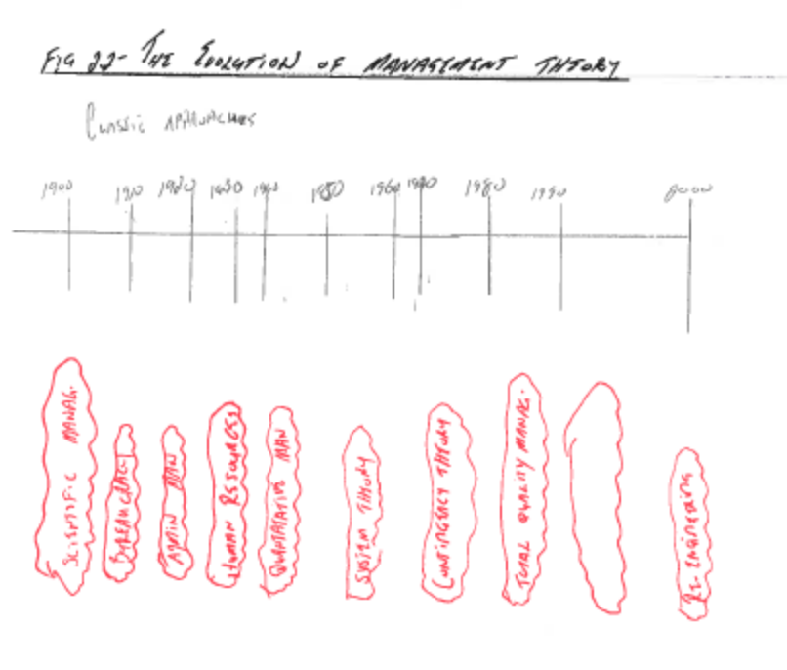

THE CLASSICAL APPROACHES P32
The main limitations of the classical approaches:
# | Limitation
1 | They ignored the relationship between the organisation and its external environment
2 | They focused on specific aspects of the organisation at the expense of other considerations

1. Scientific Management School p34
# | Fact | Description
1 | Founded by | Frederick W. Taylor
2 | What he studied | Studied individual workers to see exactly how they performed their tasks
3 | Premise | There is 1 best way to perform any task and measure everything that is measurable - known as time-motion-study
4 | Problem he addressed | How to judge whether an employee had put in a fair day’s work
5 | Limitations | - Workers cannot be viewed simply as parts of a smoothly running machine  - Money is not the only motivator of employees  - Creates the potential for exploitation of labour i.e. possible strikes by workers  - Can lead to ignorance of the relationship between the organisation and its changing external environment as the focus remains on internal issues i.e. the workers and their productivity
6 | Belief | Money motivates workers
7. | Other researchers who helped establish these principles of efficiency:  - Frank & Lillian Gilbreth who focused on work simplification and  - Henry L Gantt whose main concern was productivity on shop floor level

The 3 fundamental things he taught:
# | Fundamental Lesson
1 | Find the best practice wherever it exists – today we call it “benchmarking”
2 | Decompose the task into its constituent elements – we call it “business process redesign”
3 | Get rid of things that don’t add value

# | Summary
1 | Summary: scientific management focused on the issue of managing work – not on managing people
2 | Focus: ways to improve the individual worker

2. The Process or Administrative Approach p34
# | Fact | Description
1 | Founded by | Henri Fayol
2 | What he studied | Administrative side of operations
3 | Premise | There are 5 basic functions of administration: planning, organising, commanding, coordinating, and controlling
4 | Limitation | Postulates that formal authority should be maintained by managers
5 | Belief | Management is a skill – something that one can learn once its underlying principles are understood
6 | Focus | Focuses on managing the total organisation

3. The Bureaucratic Approach p35
# | Fact | Description
1 | Founded by | Max Weber
2 | What he studied | The fundamental issue of how organisations are structured
3 | Premise | Any goal-oriented organisation comprising thousands of individuals would require the carefully controlled regulation of its activities
4 | Problem he addressed | He developed a theory of bureaucratic management that stressed the need for a strictly defined hierarchy, governed by clearly defined regulations and authority
5 | Limitations | - Bureaucratic results in managers being compensated for doing what they are told to do – not for thinking  - Managers are often rewarded for complying with old, outdated rules  - Limited organisational flexibility and slow decision-making
6 | Belief | - Weber’s ideal bureaucracy is based on legal authority  - Legal authority stems from rules and other controls that govern an organisation in its pursuit of specific goals  - Managers are given authority to enforce the rules by virtue of their position  - Obedience is not owed to an individual person but to a specific position in the hierarchy of the organisation

4. Human Relations Movement p36
- Grew out of a famous series of studies called the ‘Hawthorne Studies’.
- The studies following the ‘Hawthorne Effect’ concluded that group pressure, rather than management demands, had the strongest influence on worker productivity.
- In short, workers were more motivated by social needs than economic needs.
# | Fact | Description
1 | Founded by | Mayo
2 | What he studied | Hawthorne Studies (see above)
3 | Premise | Management’s concern for the well-being of their subordinates and sympathetic supervision enhances workers’ performance
4 | Problem he addressed | Viewed workers as human beings and not as machines
5 | Limitations | - The belief that a happy worker is a productive worker is too simplistic  - Economic aspects of work remain important to workers  - The human aspect of work is even more complex than originally suggested by the results of the Hawthorne Studies  - Many factors play a role in the productivity of workers: their values, attitudes, perceptions, learning, motivation
6 | Belief | The importance of paying attention to people to improve their productivity.

5. The Quantitative Management Theory p38
# | Fact | Description
1 | Founded by | Not any
2 | What he studied | Management science or operations research
3 | Premise | Management is primarily about crunching the numbers
4 | Problem he addressed | The greatest contribution of the techniques (linear programming, PERT/CPM, regression analysis) are in planning and control activities
5 | Limitations | Many aspects of management decisions cannot be quantified and expressed by means of mathematical symbols and formulae
6 | Belief | Not addressed in text book
7 | Focus | Deals with mathematical models, statistics, and other models, and their use in management decision-making

CONTEMPORARY APPROACHES P39

1. The Systems Approach p39
# | Fact | Description
1 | Founded by | Ludwig von Bertalanffy
2 | What he studied | Not any
3 | Premise | He noted characteristics common to all sciences:  - The study of a whole, or organism  - The tendency of a system to strive for a steady state of equilibrium  - An organism is affected by and affects its environment and can thus be seen as an open system
4 | Problem he addressed | Viewed an organisation as a group of interrelated parts with a single purpose: to remain in balance (equilibrium)
5 | Limitations
6 | Belief | From a systems point-of-view, management should maintain a balance between the various parts of the organisation, as well as between the organisation and its environment
7 | Focus | The open system perspective of an organisation is a system that comprises 4 elements:  - Input – resources  - Transformation processes – managerial processes, systems etc.  - Outputs – products or services  - Feedback – reaction from the environment

2. The Contingency Approach p40
Based on the systems approach to management:
# | Fact | Description
1 | Founded by | Not listed in text book
2 | What he studied | Using the right management approach for the situation in which managers find themselves.
3 | Premise | - The application of management principles depends on the particular situation that management faces at a given point in time  - Emphasises a situational approach (dependent on a specific situation) but not all management situations are unique, so;  - The characteristics of a situation are called ‘contingencies’:  - The organisation’s external environment - its rate of change and degree of complexity  - The organisation’s own capabilities – its strengths and weaknesses  - Managers and workers – their values, goals, skills, and attitudes  - The technology used by the organisation
4 | Problem he addressed | - Recognises that every organisation, even every department or unit within an organisation is unique  - Every organisation exists in a unique environment with unique employees and unique goals
5 | Limitations | Not listed in text book
6 | Belief | - There is no single best way to manage  - Management has to decide whether to use principles of the: scientific, bureaucratic, administrative, behavioural, or quantitative approaches or a combination of these
7 | Focus | - Tries to direct the available techniques and principles of the various approaches to management towards a specific situation in order to realise the goals of the organisation as productively as possible  - The manager must learn multiple ways to compete, innovate, and lead

3. Total Quality Management p42
# | Fact | Description
1 | Founded by | W. Edwards Deming
2 | What he studied | Total: quality involves everyone and all activities in the organisation;  Quality: meeting customers’ agreed requirements, formal and informal, at the lowest cost, first time every time;  Management: quality must be managed
3 | Premise | - A well-organised organisation was one in which statistical control reduced variability and resulted in uniform quality and a predictable quantity if output  - It is a philosophy of management that is driven by competition and customer needs and expectations  - Customer: everyone who interacts with the organisation’s products or services, internally or externally i.e. employees, suppliers and the people who buy the products or services
4 | Problem he addressed | - Countered the belief that low costs were the only way to increase productivity
5 | Limitations | - Should not be confused with quality control: quality control identifies mistakes that may already have occurred where;  - TQM emphasizes actions to prevent mistakes
6 | Belief | - A profound knowledge, including an understanding of a system, statistics, and psychology, is required for the achievement of quality
7 | Focus | - Create an organisation that is committed to continuous improvement

It was inspired by a small group of quality experts, the most prominent of them being W Edwards Deming.

Total quality management

Total: Quality involves everyone and all activities in the organisation
Quality: Meeting customers’ agreed requirements, formal and informal, at the lowest cost, first time every time.
Management: Quality must be managed.

TQM encompasses employees and suppliers, as well as the people who buy the organisation’s products or services. The goal is to create an organisation committed to continuous improvement.
TQM emphasizes actions to prevent mistakes; quality control consists of identifying mistakes that may already have occurred.

4. Six Sigma p44
# | Fact | Description
1 | Founded by | Motorola in the 1980s
2 | What he studied
3 | Premise | - Six Sigma is a quality initiative that focuses on defects per million  - The difference between potential and actual quality is waste
4 | Problem he addressed | Designed to improve manufacturing processes
5 | Limitations
6 | Belief | Defined at 3 different levels at Motorola University:  - As a metric – 3.4 defects per million opportunities (DPMO)  - As a methodology – business improvement methodology that focuses on:  - Understanding and managing customer requirements  - Aligning key business processes to achieve those requirements  - Utilising rigorous data analysis to minimise variation in those processes  - Driving rapid and sustainable improvement to business processes  - As a management system
7 | Focus | - Focus on improving quality (reducing waste) by helping organisation to produce products and services better, faster and more cheaply  - Focuses on defect prevention, cycle-time reduction, and cost savings  - Identifies and eliminates costs that provide no value to customers i.e. wasted costs

Learn: the South African excellence model p45

Six Sigma Management System p46
Six Sigma is a high performance system for implementing business strategy. It is a top-down solution to help organisations to:
# | Description
1 | Align their business strategy to critical improvement efforts
2 | Mobilise teams to attack high-impact projects
3 | Accelerate improved business results
4 | Govern efforts to ensure improvements are sustained

DMAIC p46:
# | Legend | Description
D | Define | Define the goals of the improvement activity
M | Measure | Measure the existing system
A | Analyse | Analyse the system to identify ways to eliminate the gap between the current performance of the system or process and the desired goal. Statistical tools should be used.
I | Improve | Improve the system. Use statistical methods to validate the improvement
C | Control | Control the new system

Six Sigma Roles and Responsibilities p46:
# | Legend | Description
1 | Champions | High-level individuals who understand Six Sigma and are committed to its success
2 | Sponsors | Owners of processes and systems who help initiate and coordinate Six Sigma improvement activities in their areas of responsibility
3 | Master Black Belt | Highest level of technical and organisational proficiency: provides the technical leadership of the Six Sigma programme
4 | Black Belt | Technically oriented individuals held in high regard by their peers. Actively involved in the process of organisational change and development.
5 | Green Belt | Six Sigma project leaders capable of forming and facilitating Six Sigma teams and managing Six Sigma projects from concept to completion

Senge’s 7 Organisational Learning Disabilities p47:
# | Disability
1 | The delusion of learning from experience
2 | Generative learning cannot be sustained in an organisation if employees’ thinking is dominated by short-term events. A short-term inclination prohibits creative learning
3 | The myth of teamwork
4 | “I am my position”: when people in organisations focus only on their jobs, they have little understanding of and sense of responsibility towards the results produced when all jobs interact
5 | The enemy is out there
6 | The illusion of taking charge: often proactiveness is reactiveness in disguise. True proactiveness comes from seeing how we contribute to our own problems
7 | The parable of the boiled frog

6. Senge’s 5 disciplines that enable us to overcome these disabilities and create new futures for the organisation:
A process that enables an organisation to adapt to change and move forward by acquiring new knowledge, skills and behaviours and therefore transform itself.
# | Discipline
1 | Becoming committed to lifelong learning
2 | Challenging one’s own assumptions and generalisations about the organisation and the world around it: this is essential to becoming a learning individual and a learning organisation
3 | Sharing a vision for the organisation
4 | Encouraging active dialogue in the organisation
5 | Promoting systems thinking: it is vital that these disciplines develop as a unit

7. Re-engineering p48
# | Fact | Description
1 | Founded by | Hammer and Champy
2 | What he studied
3 | Premise | - Re-engineering considers the entire organisation, including its suppliers and customers  - It involves a significant reassessment of what a particular organisation is all about  - It entails a fundamental reappraisal of the way that organisations operate
4 | Problem he addressed
5 | Limitations
6 | Belief | The following 6 conditions are vital for successful re-engineering:  - Powerful external forces for change should make change inevitable  - Vigorous backing from top management  - Focus on the process improvements that customers really care about and are willing to pay for  - Thorough knowledge of the needs for customers is essential  - All major departments effected by the process(es) should be represented on the team  - Changes in HR programmes and IT should be closely coordinated with the re-engineering effort
7 | Focus | Re-engineering is constant and relentless in its focus on integrating 4 key drivers:  - People  - Process  - Technology  - Infrastructure

CURRENT AND NEAR FUTURE MANAGEMENT REALITIES P49

- The new source of sustainable competitive advantage available to organisations has people at its centre- their knowledge, creativity, and talent
- Capital and technological advantages can be emulated by competitors, but the human asset is intangible and very difficult to imitate

The fact that the new competitive advantage lies in the human assets of organisations poses unprecedented challenges to the modern manager. Managing this source of competitive advantage requires that managers thoroughly grasp:

# | Grasp
1 | How the current and near-future environments differ from previous ones
2 | How today’s organisations differ from previous ones
3 | The impact of both of the above on management

Corruption is a major problem in Africa, it undermines development by:
# | Corruption
1 | Raising transaction costs
2 | Increasing uncertainty
3 | Promoting bribery
4 | Often results in capital outflows as this money is forwarded to foreign bank accounts

The types of environments p50:
# | Environment | Description
1 | Evolutionary | - Predictable  - Change gradually which makes it possible to predict trends
2 | Revolutionary | - Unpredictable  - Drastic change aka discontinuous change  - Forecasting becomes impossible in these types of environments
Scenario development is the visualisation of alternative futures.
Other types of management:
# | Type of Management | Description
1 | Cross-boundary management | Managers need to be able to assess the implications of their decisions on different people, processes, systems, and so on that make up the organisation
2 | Interim management | - Ensuring that the best manager manages specific projects  - This means that the workforce of organisations will be in constant flux (it is also known as transient or journey management)

END OF STUDY UNIT 2/CHAPTER 2

(STUDY UNIT 3) CHAPTER 3 MANAGING IN A CHANGING ENVIRONMENT P57

INTRODUCTION P58
Managers cannot manage their organisations effectively if they do not p60:
- Understand the relationship between the organisation and its environment
- The threats and opportunities that exist in the environment
- The trends that appear and disappear
- How all of these form part of a broad environmental system

CONCEPTS OF SYSTEMS THEORY P61

The Organisation as a Sub-System of its Environment p61
# | Study Note
1 | A system can be defined as a set of interrelated elements (sub-systems) functioning as a whole
2 | A business organisation is a system that operates in a specific environment
3 | Business organisations are not self-sufficient, nor are they self-contained
4 | They exchange resources with and are dependent upon the external environment in which they operate
5 | The organisation and its environment depend on each other for survival

Learn Figure 3.2: A systems perspective of an organisation p61
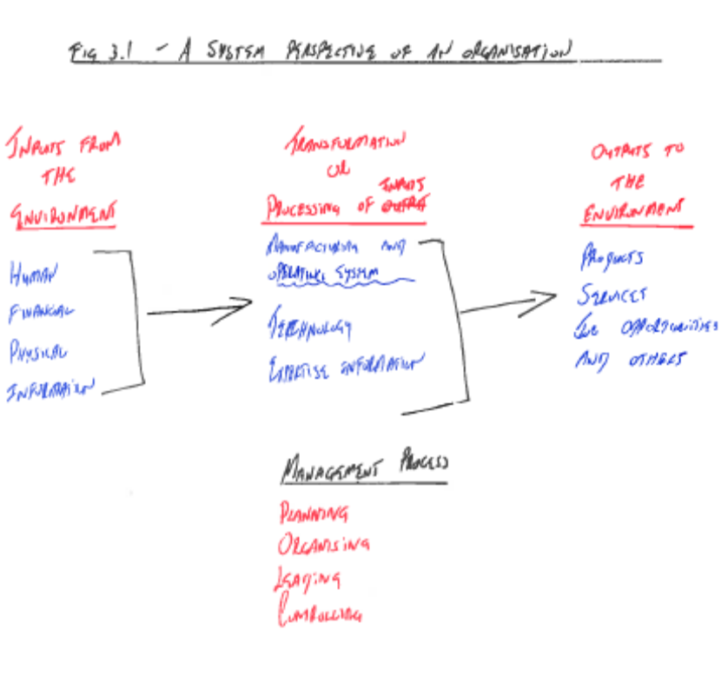
A business organisation obtains resources or inputs from the environment in the form of:
# | Resource or Input
1 | People (labour)
2 | Physical resources (raw materials)
3 | Capital (financial resources)
4 | Information (knowledge and expertise)

The transformation process – the activity of processing inputs from the environment into products and services for the environment – constitutes the field of study of management. This transformation process is carried out by the organisation as a specific sub-system of its environment.

The Systems Approach in Management p61
There are 4 basic concepts that must be understood when explaining systems theory and presenting the business organisation as an interdependent system:
# | Concept
1 | An open system (as opposed to a closed system)
2 | Sub-systems
3 | Synergy
4 | Entropy – the process of systems disintegration

More about systems:
# | Concept
1 | A system is closed when it is self-supporting and can exist independently of a particular environment
2 | A system is open if:  - It is dependent on the environment in which it operates  - The environment is dependent on the system  - There is a specific interaction between system and environment
3 | A sub-system is a system within a system e.g. the marketing, operations, human resources and finance functions in an organisation
4. | Synergy: The whole is greater than the sum of its parts – the individual sub-systems are simultaneously applied in such a way that the result of their simultaneous application is greater than the sum of their individual efforts

THE COMPOSITION OF THE MANAGEMENT/BUSINESS ENVIRONMENT P63

Learn Figure 3.3: The composition of the management environment p64
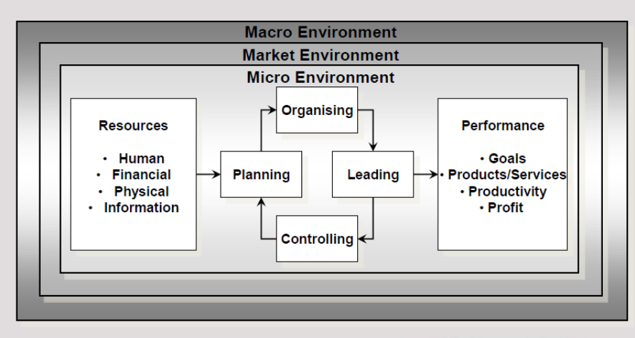

# | Study Note
1 | The management environment is defined as all those factors or variables, both inside and outside the organisation, that may influence the continued and successful existence of the organisation
2 | The business environment comprises the:  - Macro-environment (external environment)  - Market environment (external environment)  - Micro-environment (internal environment)

The micro-environment p63:
# | Study Note
1 | The key variables in this environment include:  - The vision, mission, and goals  - Organisation strategies  - Various management functions  - The organisation’s resources  - The organisation’s employees and organisational culture
2 | Management primary task in this environment:  - To identify the strengths and weaknesses of the business organisation

The market-environment (or task environment) p63:
# | Study Note
1 | Surrounds the organisation
2 | The key variables in this environment include:  - Consumers – needs, preferences, purchasing power, behaviour  - Suppliers – supply of products, raw materials, services and even finance  - Intermediaries – compete to distribute an organisation’s product or its competitors  - Competitors – established (as well as new and potential) and wish to maintain or improve their position  - Labour unions – deal with the supply of labour
3 | Management primary task in this environment:  - Identify, evaluate, and utilise opportunities in the market  - Minimise threats  - Develop its strategy in such a way that it can deal with competition in that industry

The macro-environment p65:
# | Study Note
1 | Exists outside of the organisation and the market environment
2 | It comprises 6 distinct sub-environments (aka the PESTIE environment):  - The political environment – the government, political involvement, and legislation  - The economic environment – inflation, recession, exchange rates, monetary and fiscal policy  - The social environment – lifestyles, urbanisation, habits, values, culture  - The technological environment – responsible for the pace of innovation of change (includes infrastructure)  - The international environment  - The ecological environment – natural resources, flaura and fauna, mineral resources, access to water, quality of air etc.

Main Characteristics of the Management/Business Environment p65
# | Characteristic
1 | The interrelatedness of environmental factors or variables
2 | Increasing instability
3 | Environmental uncertainty – this is a function of the amount of info available as well as the confidence that management has in that info
4 | The complexity of the environment – relates to the number of external variables to which the organisation must react as well as fluctuations in the variables themselves
5 | The environment is becoming unpredictable

THE INTERNAL OR MICRO-ENVIRONMENT P66
# | Study Note
Consists of four variables:
- the mission, goals & objectives & strategies of the organisation
- the organisation & its management
- the resources of the organisation
- the organisational culture.
1 | Internal environment: main environment in which management operates i.e. plan, organise, lead, control
2 | The internal environment can be described in terms of the organisation’s:  - Functional departments (finance, operations etc.)  - Resources (human, financial, physical, information)  - Value-chain (primary and secondary activities)
3 | The 2 different ways of looking at the internal environment:  - A structure that comprises functional departments  - An environment that comprises the resources
4 | The value-chain approach – a chain of activities that must be performed to create a product or service, according to this approach an organisation comprises:  - Primary activities  - Secondary activities

THE MARKET OR TASK ENVIRONMENT P67
# | Study Note
1 | This is the environment that immediately surrounds the organisation, it comprises the:  - Consumers – their needs, purchasing powers & behaviour  - Suppliers of materials of capital and labour  - Intermediaries – wholesalers & retailers, commercial agents & brokers, financial intermediaries such as banks  - Competitors – new entrants, existing competitors, availability of substitute products/services & the bargaining power of clients, consumers & suppliers.  - Substitute products  - Possible new entrants  - Labour unions

The Market p68
Changes in in markets are influenced directly by the variables in the macro-environment:
# | Environment | Description
1 | Demographic trends | Affect the number of consumers
2 | Economic factors | Determine the purchasing power
3 | Cultural values | Exert particular influences on the purchasing behaviour of consumers

Intermediaries p69
# | Study Note
1 | Creates the utilities of: place, time and ownership
2 | Wholesalers, retailers, commercial agents, brokers, spaza shops
3 | Financial intermediaries

Competitors p70
# | Study Note
1 | Competition can be defined as a situation in the market environment in which different organisations with more or less the same product or service compete for the business patronage of the same consumers
2 | Competition ensures:  - Excessive profits are kept in check  - Incentives are provided for higher productivity  - Technological innovation is encouraged
3 | The nature and intensity of competition in a particular market are determined by 5 forces:  - The threat of new entrants (competitors) or competitors departing  - The bargaining power of clients and consumers  - The bargaining power of suppliers  - The threat of substitute products or services  - The number of existing competitors
4 | Management must be sensitive to trends in the market environment to enable it to make the most of opportunities and to avoid possible threats timeously – the tools that management should use for this purpose are:  - Environmental scanning  - Information management

Learn Figure 3.6: Competitive forces in an industry p71

THE MACRO-ENVIRONMENT P71

The Composition of the Macro-Environment p71
# | Study Note
1 | Represent the uncontrollable environmental force, or “megatrends”
2 | The 6 variables, called “PESTIE”:  - Political  - Economic  - Social  - Technological (includes infrastructure i.e. roads, bridges etc.)  - International  - Ecological

1. The Technological Environment P72
# | Study Note
1 | Refers to the knowledge of how to do something
2 | The most basic effect of technological innovation is productivity which results in keener competition
3 | Superior management of technology and innovation within the organisation can be an important source of competitive advantage
4 | The technological environment should be assessed continuously, this includes:  - Identification of important technologies and technological trends both inside and outside the industry  - Analysis of potential change in important current and future technologies  - Analysis of the competitive impact of important technologies  - Analysis of the organisation’s technological strengths and weaknesses  - A list of priorities which should be included in a technology strategy for the organisation

2. The Economic Environment P73
# | Study Note
1 | The economy is influenced by changes in:  - Technology  - Politics  - Ecology  - Social  - International environment
2 | These cross influences constantly cause changes in:  - Economic growth rate  - Levels of employment  - Consumer income  - Rate of inflation  - Exchange rate  - The general state of the economy

3. The Socio-Cultural Environment P74
# | Study Note
1 | This is the environmental variable that is most sensitive to cross-influences by other variables, especially technology and economy
2 | Culture - the same total of the way of life of a group of people – influences an individual’s lifestyle
3 | Culture is not homogeneous, there are numerous sub-cultures based on:  - Nationality  - Religion  - Population group  - Geographical area
4 | An organisation is at the centre of social change

4. The Ecological/Natural Environment p76
# | Study Note
1 | The ecological or physical environment contains the limited natural resources from which an organisation obtains its raw materials
2 | Threats include:  - A shortage of resources  - The rising cost of energy  - The cost of pollution  - Damage to a country’s natural resources

5. The Political (politico-governmental) Environment p76
# | Study Note
1 | It influences the organisation primarily as a regulating force
2 | Other influences include:  - Annual budget  - Taxation  - Import control (or lack of it)  - Promotion of exports  - Import tariffs to protect certain industries against excessive foreign intervention  - Price control in respect of certain goods and services  - The marketing of agricultural products  - Health regulations and incentives

6. International government – comprising the unique environmental factors of the countries with which the organisation has business relations.

INTERFACES BETWEEN THE ORGANISATION AND THE ENVIRONMENT P78

- Environmental changes influences the organisation because its strategies, structures & systems in equilibrium with the environment.
- Uncertainty in the environment is determined by 1) Extent of change (refers to the degree of stability/instability in the environment; 2) level of complexity (refers to the relative number of variables in the environment.
- Crises in the environment can occur at any time & influence the organisation (eg. Political upheavals, the weakening of a country’s currency or an environmental disaster.

(NB: See Figure 3.6 - Environmental change and uncertainty.

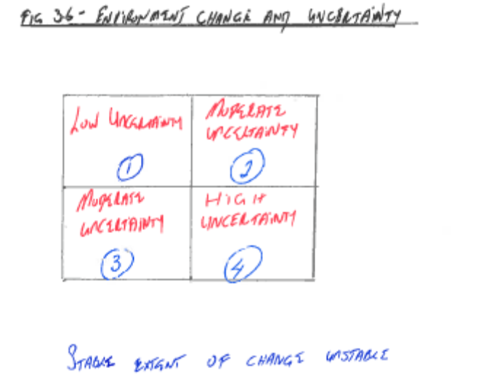

Uncertainty in the Environment p79
# | Study Note
1 | An organisation’s environment can be studies from 2 perspectives:  - The extent of change – the degree of stability or instability  - The level of complexity – depends on the number of variables

HOW MANAGEMENT CAN PREPARE FOR ENVIRONMENTAL CHANGE

# | Study Note
1 | The response to environmental change revolves mainly around:  - Environmental scanning  - Information management
2 | Responses to change:  - Managing information  - Strategic responses  - Structural change

Information management p81:
# | Study Note
1 | An organisation’s information management system should make adequate provision for environmental scanning
2 | The importance of environmental scanning:  - The environment is changing constantly  - Determine whether factors in the environment constitute a threat to the organisation’s mission, goals, and strategy  - Determine if the factors in the environment offer opportunities
3 | The extent of environmental scanning is determined by:  - The nature of the environment in which an organisation operates and the demands the environment makes on it  - The basic relationship that an organisation has with its environment  - The source and extent of change will influence the degree of meaningful scanning

END OF STUDY UNIT 2

END OF TOPIC 1

TOPIC 2: PLANNING

(STUDY UNIT 4) – CHAPTER 5 – PLANNING p129

INTRODUCTION
# | Study Note
1 | Strategic plan (including strategic goals) (long-term)
2 | Tactical plan (medium-term)
3 | Operational plan (short-term)

THE NATURE AND IMPORTANCE OF PLANNING P131

During the planning process, goals are formulated.
Planning (as the primary management function) is necessary for p132:
- Structuring the organisation
- Determining what kind of people the organisation needs
- Determining how people should be led
- Furnishing standards of control

The effectiveness of a plan includes values such as p132:

- Input/output
- Individual and group satisfaction
- Customer satisfaction
- Productive use of the organisation’s scarce resources
- Concern for the environment

Attributes and benefits of planning p133:

- Planning forces an organisation to be proactive – it forces management to consider possible changes that may occur and then prepare timeously for these changes
- Labour legislation forces SA organisations to plan their workforce according to the relevant laws
- Planning ensures that managers and workers focus their efforts on the attainment of the same goals
- Sound plans are essential when monitoring the progress of an organisation – actual results can be measured against clearly stated goals
- Increasing complexity of organisations makes planning essential

KINDS OF ORGANISATIONAL PLAN P134
The types of plans made by top, middle, and lower management differ in many respects:

- Top management: strategic plans – for the entire organisation
- Middle management: tactical plans for specific functional areas e.g. finance or marketing department
- Lower management: operational plans for their smaller sections
Learn Figure 5.2: The types of organisational plan p135

1. Strategic Plans p134:
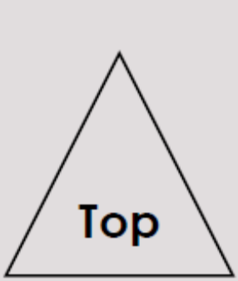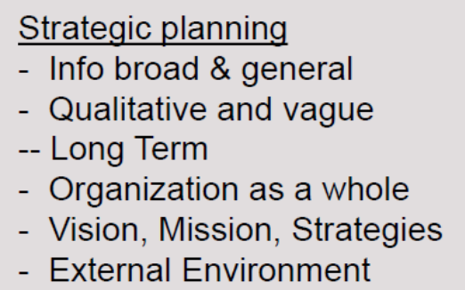
Strategic plans are plans designed to ensure that the organisation as a whole is aligned with the changing external environment.
- Planning at this strategic level includes p134:

- Creating a vision of the future for the entire organisation
- Translating the vision into a realistic mission statement
- Translating the mission statement into measurable long-term goals
- Choose a strategy/strategies to attain the above

- The strategic plan reflects the following characteristics p134:
- Strategic plans have an extended time frame, usually more than 5 years
- Focus on the entire organisation – not just certain departments
- Look at reconciling the organisation’s resources with threats and opportunities in the external environment
- Focus on creating and maintaining a competitive advantage for the organisation
- These plans also take synergy into consideration

- The Balanced Scorecard (BSC) is a tool that can be used at strategic, tactical and operational level to ensure that all divisions and individuals focus on the same key performance areas.

2. Tactical/FUnctional Plans p135:

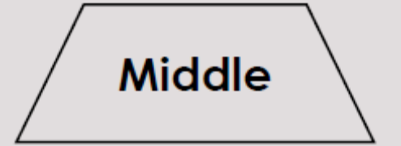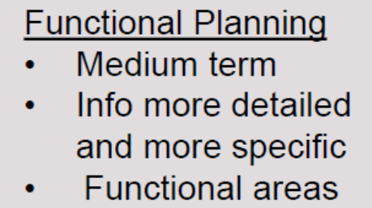
Tactical plans deal mainly with people and action to implement the strategic plans. Synergy is important in tactical planning p136.

STUDY TABLE 7.1 IN THE PRESCRIBED BOOK THAT ILLUSTRATES THE DIFFERENCES BETWEEN STRATEGIC & TACTICAL PLANS

3. Operational Plans p136:
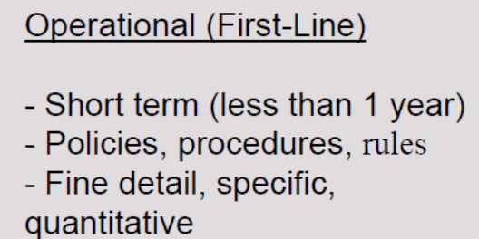
Operational goals focus on carrying out tactical plans to achieve operational goals:

- Narrowly focused
- Short time horizons (monthly, weekly, day-to-day)

There are 2 basic forms of operational plan p136:

- Single-use plans: used for non-recurring activities – programmes, projects, budgets
- Standing plans: remain roughly the same for long periods of time – policies, standard procedures, rules

Learn Figure 5.3: Types of operational plan p137

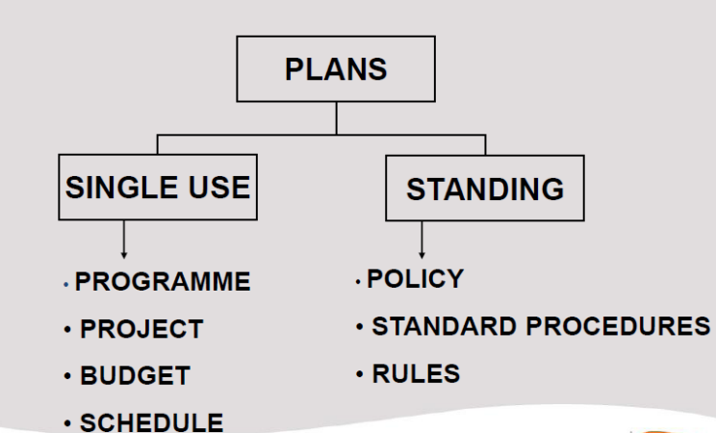

A project goes through the following phases:

- Initiating
- Planning
- Executing
- Controlling
- Closing

THE TIME FRAME FOR PLANNING P138:

1. Long-Term Plans p138:

The time-frame for strategic planning should take into account variables such as:

- The stability of the relevant industry
- The turbulence in the business environment

2. Intermediate Plans (Tactical Plans) p138:

Intermediate plans refer to the medium-term planning carried out by middle management for the various functional departments to realise tactical goals derived from the strategic goals.

Intermediate plans are components of long-term goals and plans.

3. Short-term goals (operational plans)

Are concerned with periods of no longer than a year. They are developed by lower management to achieve the operational goals. Short-term plans are concerned with the day-to-day activities of an organisation and the allocation of resources to particular individuals

STEPS IN THE PLANNING PROCESS P139:

Learn Figure 5.5: Steps in the Planning Process p141
The 8 steps for all planning situations are as follows:

Step 1. Identifying changes that necessitate planning

Identify any changes that necessitate planning. These changes can occur either outside or inside the organisation.

Step 2. Establishing goals

Goals need to be formulated to give direction to all major plans. These goals form a hierarchy, starting with the vision at the top of the hierarchy.

Step 3. Drawing up premises

Consistent premises should therefore be agreed upon by top management to ensure that subordinate managers base their plans upon the same premises.

Step 4. Developing various courses of action

To search for and examine various courses of action.

Step 5. Evaluating various courses of action

To evaluate the options by weighing up the various factors in the light of the premises and goals. One option may appear to be extremely profitable but may require the retrenchment of many employees; another option may seem less profitable but may not lead to job losses.

Step 6. Selecting a course of action

The manager may even decide to follow several courses rather than a single one.

Step 7. Formulating derivative plans

Planning is seldom complete when a decision is made.

Step 8. Budgeting

Managers ensure that they have the resources available to carry out the plans to achieve the organisation’s goals.

BARRIERS TO EFFECTIVE PLANNING P142:

The barriers to effective planning are p143:

- Ignoring the constantly changing external environment (a complex environment)
- New Technology
- New Legislation
- Scarce resources
- managers need to understand the strategy, goals & plans of the organisation
- reluctance of managers to establish goals
- resistance to change
- planning is time-consuming & expensive

Guidelines that managers can use to overcome barriers to planning p144:

- Effective planning should start at the top of an organisation
- Management should realise the limitations of planning
- The role that line and functional managers play in the planning process cannot be overemphasized
- Plans should constantly be revised and updated
- Contingency planning may be very useful in a turbulent environment

PLANNING TOOLS P144:

- Forecasting
- Budgeting
- Scheduling
- Monitoring tools

1. Forecasting p144:

- A forecast is a projection of conditions expected to prevail in the future based on both past and present information
- Forecasting starts with the identification of factors that might provide opportunities or pose threats to an organisation in the future

2. Budgeting p146

- A budget is a financial plan that deals with the future allocation and utilisation of resources over a given period
- A budget is a tool that managers use to translate future plans into quantitative terms (rands and cents)
- It also serves as a control mechanism for evaluating organisational activities i.e.:
  - It sets limites to the amount of resources that can be used by a department
  - It establishes standards of performance against which future events will be compared
- Characteristics of budgets p146:
  - They most frequently stated in monetary terms
  - They cover a specific period (usually 1 year)
  - They contain an element of management commitment
  - They are reviewed and approved by an authority higher than the one that prepared them
  - Once approved, they can be changed only under previously specified conditions
  - They are periodically compared with actual performance, and variances are analysed and explained
- Zero-based budgeting (ZBB) p147:
  - Important in organisations going through change
  - No reference is made to the previous level of expenditure

3. Scheduling and Monitoring p147:

- The Gantt chart p147:

  - Graphic planning and control method

- PERT (Programme Evaluation and Review Technique) p148:

  - Planning tool that uses a network to plan projects involving numerous activities and their interrelationships

  - The key components of PERT are:

    - Activities
    - Events
    - Time
    - Critical path – longest or most time-consuming sequence of events and activities
    - Cost

  - The 4 steps that can be followed to develop a PERT network p149:

    - List all activities and events
    - Determine completion times
    - Arrange tasks chronologically
    - Determine the critical path

GOAL FORMULATION P149

1. The Focus Areas p151:

- A well-written mission statement will provide clear guidelines in terms of the key focus areas when its long-term goals are formulated
- These focus areas are called key performance areas – critical to the attainment of the organisation’s mission
- Often includes areas such as (these are focus areas suggested in the BSC):
  - Finance
  - Customers
  - Internal processes
  - Learning and innovation

2. Properties of Well-Formulated Goals p151:

Goals need to meet certain specifications in order to fulfil their managerial purpose:

- Specific
- Flexible
- Measurable
- Attainable
- Congruent
- Acceptable

1. Specify
Goals should be specific and should indicate what they are related to, the time frame for accomplishing them, and the desired results.

2. Flexibility
Organisations are often “guilty” of not changing their goals when the conditions on which the goals were based subsequently change.

(NB: See Figure 5.9 – The Balanced Scorecard)

3. Measurability
Measurability means that goals should be stated I terms that can be evaluated or quantified objectively.

4. Attainability
Goals should be realistic and attainable, but should also provide a challenge for management and personnel.

5. Congruency
Goals should be congruent with one another. Incongruent goals may lead to friction and conflict.

6. Acceptability
The collaboration of managers at all levels in the goal-formulation process is therefore important.

3. The degree of openness p153:
We can distinguish between official and operative goals:

- Official goals: those that society expects – derived from the vision and mission
- Operative goals: private, unpublished goals

THE PROCESS OF GOAL SETTING P153

Types of goal-setting:

- Centralised goal-setting – has a disadvantage in that top level managers may not know the issues and problems faced by lower level managers
- Decentralised goal-setting:
  - Top-to-bottom approach – the board of directors or corporate level managers set the corporate goals & the head of each division or business unit sets the goals for his/her division inline with the corporate goals.
  - Bottom-up approach – the lower level set their goals & higher level managers set their goals to be in line with the lower level goals.
  - A combination of the above

TECHNIQUES FOR GOAL SETTING P154
- The BSC as a goal-setting tool ensures that all departments, sections and individuals focus on the same KPAs
- Management by Objectives (MBO):
  - Based on the belief that the joint participation of subordinates and superiors in translating or converting broad organisational goals into more specific individual goals has an impact on employee motivation
  - You are motivated to perform more efficiently in an organisation if you participate in selecting your own personal goals
  - Learn Figure 5.10: The Process of MBO p155
- The process of MBO:

The goal hierarchy
It is necessary for each subordinate involved in the MBO process to have a clear understanding of the hierarchy of plans and goals in the organisation.

Job output
The key performance areas as well as the key performance indicators of the subordinate should be discussed to ensure that both parties are familiar with the subordinate’s job output.

Performance targets
The subordinate formulates performance targets in predetermined areas of responsibility for a forthcoming period.

Discussion of goals
The subordinate meets with his or her superior to discuss potential performance targets. The discussion between subordinate and superior should also spell out the resources that a subordinate needs in order to work effectively towards goal attainment.

Determination of checkpoints
These periodic reviews not only monitor the subordinate’s progress, but also provide an opportunity to adjust goals that have become unrealistic in the light of changing conditions or uncontrollable events.

Evaluation and feedback
The superior should meet with the subordinate to review the degree of goal attainment. Some of the major benefits that organizations experience when they implement MBO are:

- Improved employee morale through participate in goal setting;
- Increased clarity of the outputs that have to be delivered;
- Improved communication resulting from the process of discussion of goals.

MBO has limitations, one of them being the overburdening of manager and subordinate with the administration of the process.

- Some of the major benefits of MBO:
  - Improved employee morale through participation in goal setting
  - Increased clarity of the outputs that have to be delivered
  - Improved communication resulting from the process of discussing goals

END OF CHAPTER 5/STUDY UNIT 4

(STUDY UNIT 5) CHAPTER 6: MANAGERIAL DECISION MAKING P163

INTRODUCTION P164

Successful managers “out decide” their competitors in at least 3 ways:
- They make better decisions
- They make decisions faster
- They implement decisions more
A decision implies that managers are faced with 1 of 3 things:
- A threat
- A problem
- An opportunity

THE RELATIONSHIP BETWEEN PROBLEMS, PROBLEM SOLVING, AND DECISION MAKING P166

- Problem solving: the process of taking corrective action that will solve the problem and that will realign the organisation with its goals
- Decision making: the process of selecting an alternative course of action that will solve a problem – managers need to make a decision whenever they are faced with a problem

TYPES OF MANAGERIAL DECISIONS P166
- Programmed decisions – repetitive and routine:
- Decisions are programmed to the extent that they are repetitive and routine. Examples of programmed decisions include the processing of payroll vouchers, the processing of graduation candidates at a university.
- Managers can usually handle programmed decisions by means of policies, standard operating procedures, and rules.

- Non-programmed decisions – novel and ill-structured:
- Decisions are non-programmed to the extent that they are novel and unstructured.
- Non-programmed decisions have never occurred before, they are complex and elusive, and there is no established method for dealing with them.

DECISION-MAKING CONDITIONS P167
The conditions under which decisions are made are:

- Certainty
- Risk
- Uncertainty

1. Certainty
A decision is made under conditions of certainty when the available options and the benefits or costs associated with each are known in advance.

2. Risk
Decisions under conditions of risk are perhaps most common.
Probability falls into two categories:

1. Objective and
2. Subjective

Objective probability is based on historical evidence. Historical evidence is not available, so a manager must rely on a personal estimate and belief, or subjective probability, of the situation outcome.

3. Uncertainty
A decision is made under conditions of uncertainty when there is a lack of information – the outcome of each alternative is unpredictable and managers cannot determine probabilities.

What are the possible crises that may be sources of uncertainty and high risk for organisations? These crises may fall into seven categories, namely:-

- Economic recessions, stock market crashes, hostile takeovers
- Physical industrial accidents supply breakdowns,
- Personnel strikes, workplace violence
- Criminal theft of money and goods, product tampering
- Information theft of information, tampering with company records
- Reputation rumour mongering, slander
- Natural disasters fires, floods, earthquakes

DECISION-MAKING MODELS P169

The 2 primary decision-making models p169:
- The rational model: the decision-maker should select the best possible solution aka optimising
- The bounded-rationality model: decision-maker uses satisficing – selecting the first option that meets the minimal criteria

Managers need to know which model to use when:
- Rational model (optimise): non-programmed, high-risk, in conditions of uncertainty
- Bounded-rationality model (satisfice): programmed, low-risk, or certain conditions

THE DECISION-MAKING PROCESS P170

Learn Figure 6.2: Model of the Decision-Making Process p171 (stage 2-5 are not generally follows in programmed decisions – criteria is already set in policies etc.)

Describes a set of phases that individual decision makers or decision-making teams should follow in order to increase the probability that their decisions will be optimal.

Stage 1: Recognise, classify, and define the problem or opportunity
The problem or opportunity may be classified in terms of the type of decision that needs to be made, the decision-making condition and the decision-making model making model used.
(NB: See Figure 6.2 Model of the decision-making process)

Stage 2: Set goals and criteria
The manager will be responsible for this task. He or she can make an individual decision or involve a group in decision making.

Stage 3: Generate creative alternative courses of action
Innovation and creativity play a major part in generating various courses of action.

Stage 4: Evaluate alternative courses of action.
Each option should be evaluated in terms of its strengths and weaknesses, advantages and disadvantages, benefits and costs.

Stage 5: Select the best option
This step requires a manager to evaluate each option carefully against the goals and criteria set during the second state, with a view to ranking the options in order of priority.

Stage 6: Implement the chosen option
It is possible for a good decision to be damaged by poor implementation, while a poor decision may be helped by good implementation.
Stage 7: Conduct follow-up evaluation
Evaluation is necessary to provide feedback on its outcome. Adjustments are invariably need to ensure that actual results compare favourably with planned results.

GROUP DECISION MAKING P174
Groups are subject to social factors when making decisions:
- Social conformity
- Levels of communication skill
- Dominance by a specific group member
The advantages of group decision-making are as follows: p174
- Variety of skills and specialised knowledge – this will lead to better quality decisions
- Multiple and conflicting views can be taken into account
- Beliefs and values can be transmitted and aligned
- More commitment to decisions because more members participate
- Participation in problem solving will improve the morale and motivation of employees
- Allowing participation trains people to work in groups
The disadvantages of group decision-making are as follows: p174
- More time consuming and slower decisions
- More likely to satisfice than an individual
- One group member, or a sub-group, may dominate and nullify the group decision
- It may inhibit creativity and lead to conformity and ‘groupthink’

TECHNIQUES FOR IMPROVING GROUP DECISION MAKING P175
The 4 popular techniques p175:
- Brainstorming p175
  - Criticism is prohibited
  - No “yes, but…” comments allowed
  - Imaginative solutions are welcome
  - Quantity is important
  - Combination and improvement of suggested solutions is encouraged
- Nominal group technique p176
  - 7-10 members meet as a group
  - Each member independently writes down his/her ideas
  - Each member presents one idea to the group – no discussion takes place until all ideas have been recorded
  - The ideas are clarified through a guided decision
  - The group leader instructs participants to vote on their preferred solutions
  - Each member silently and independently ranks the ideas
  - The process may conclude with an acceptable solution
  - Appropriate when there is a: dominant person, conformity, or groupthink
- The Delphi technique p176
  - Does not require the physical presence of participants
  - Involves using a series of confidential questionnaires to refine a solution
  - Characterised by the following steps:
    - Problem identified and members asked to provide solutions using a questionnaire
    - Each member anonymously and independently completes the first questionnaire
    - Results compiled at a central location, transcribed, and reproduced
    - Each member then receives a copy of the results
    - Process repeats (last 2 steps)
- Group decision support system (GDSS) p177
  - Computer-supported group decision-making systems
  - In an electronic brainstorming sessions, the participants simply type in their suggestions. These ideas are disseminated to the other group members without an identifying mark. Thus anonymity is preserved and the group members can respond more freely than in a conventional brainstorming session.
  - (NB: See Figure 6.4 Typical GDSS configuration for a face-to-face meeting). Top management commonly uses the Delphi technique for a specific decision. Brainstorming and the nominal group techniques are frequently used at middle and lower management level where work groups are involved.

TOOLS FOR DECISION MAKING P178

1. Quantitative tools for decision making

Decision-making tools in conditions of certainty

Linear programming
The most frequently and extensively used. It is a quantitative tool for optimally allocating scarce resources among competing uses to maximize benefits or minimize losses.

Queuing theory
Queuing theory is a quantitative tool for analyzing the costs of waiting in queues. The objective of queuing theory is to achieve an optimal balance between the cost of increasing service and the amount of time individuals, machines, or materials must wait for service.

Decision-making tools in conditions of risk and uncertainty
(NB: See Figure 6.5 – Conditions of decision making and quantitative decision-making tools)

Probability analysis
The term “probability’ refers to the estimated likelihood, expressed as a percentage, than an outcome will occur. There are two complementary approaches to using probability analysis, namely pay-off matrices and decision trees.

Pay-off matrix
The pay-off matrix is a technique for indicating possible pay-offs, or returns, from pursuing different courses of action.
(NB: See Table 6.2 Pay-off matrix showing alternative pay-offs)

Decision tree
A decision tree is a graphic illustration of the various solutions available to solve a problem.

Break-even analysis
This technique involves the calculation of the volume of sales that will result in a profit. The break-even point is then calculated as the level of sales where no profit or loss results.

Capital budgeting
Capital budgeting is a technique that can be used to evaluate alternative investments. A process by which each alternative investment is analysed in financial terms and

(NB: See Figure 6.6 - A decision tree)

Simulation
Simulation is a quantitative tool for imitating a set of real conditions so that the likely outcomes of various courses of action can be compared. This enables managers to save time and money and keeps them better informed.

2. The Kepner-Fourie method

The Kepner-Fourie method combines the objective quantitative approach with some subjectivity. The subjectivity comes from determining “must” and “want” criteria and assigning value weights to them. Table 6.3 on the next page shows the use of the method to decide which house to buy.

Step 1 Compare each alternative to the “must” criteria listed in column 1.
Step 2 Rate each “want” criterion (column 1) on the scale of 1 to 10.
Step 3 Assign a value of 1 to 10 to how well each alternative meets all the “want” criteria.
Step 4 Compute the weighted scores (WS) for each alternative by multiplying the importance
value by the “meets criteria” value for each house.
Step 5 Select the alternative with the highest total weighted score as the solution the problem.
3. Cost-benefit analysis

- Compares the costs & benefits of each alternative course of action using subjective intuition & judgment.
- Makes the minimum use of mathematics to make the decision.
- Advantages – can be considered the benefits
- Disadvantages – can be considered the costs.

END OF STUDY CHAPTER 6/STUDY UNIT 5

(STUDY UNIT 6) CHAPTER 7: INFORMATION MANAGEMENT P191

INTRODUCTION P192
- In the late 1940s, Herbert A Simon popularised the notion that management was primarily a decision-making process
- The main elements of an information system – the quality of a decision is related to the quality of the information, the quality of the information depends on the accuracy with which data is:
  - Gathered
  - Coded
  - Processed
  - Stored; and
  - Presented

THE LINK BETWEEN DECISION MAKING AND INFORMATION P193
An information system transforms data from an organisation’s external and internal environments into information that can be used by managers in the decision-making process.
See Figure 7.1: The Relationship Between an Organisation’s Information System and Decision Making p193

WHAT IS AN INFORMATION SYSTEM P195

A Definition of an Information System p195
Data refers to raw, unanalysed numbers and facts about events or conditions from which information is drawn. Information, on the other hand, is processed data that is relevant to a manager. Management information is information that is timely, accurate, and relevant to a particular situation. An “information system” can now be defined as the people, procedures, and other resources used to collect, transform, and disseminate information in an organisation. An information system accepts data resources as input and processes them into information products as output.

The difference between data and information:
- Data – raw, unanalysed numbers and facts about events or conditions from which information is drawn
- Information – Processed data that is relevant to a manager
Management information is information that is:
- Timely
- Accurate
- Relevant to a particular situation
Definition of an information system:
- The people, procedures, and other resources used to collect, transform, and disseminate information in an organisation
- An information system accepts data resources as input and processes them into information products as output

THE BASIC COMPONENTS OF AN INFORMATION SYSTEM P195
An information system utilizes hardware, software, and human resources to perform the basic activities of input, processing, output, feedback, control, and storage. (NB: See Figure 7.2 – An information system model)

“Hardware resources” is a broad term that denotes the physical components of a computer system. The four main categories of computer system components are:-

- Input devices, such as keyboards, optical scanning devices.
- A central processing unit (CPU), which consists of electronic components. The CPU can be seen as the “brain” of the computer.
- Output devices, printers, audio devices and display screens.
- Auxiliary storage, magnetic disks and tapes.

Software resources are the programs or detailed instructions that operate computers.

These include:
- System software, which manages the operations of a computer.
- Application software, which performs specific data-processing.
- Procedures that entail the operating instructions for users of an information system.

The human resources required to operate an information system include specialists and end-users. Specialists are people who develop and operate information systems, such as systems analysts, programmers, and computer operators.
While end-users are people who use the information produced by a system. Managers are end-users of information.

An information system utilised:
- Hardware
- Software
- Human resources/procedures
To perform the basic activities of:
- Input
- Processing
- Output
- Feedback
- Control
- Storage
Learn Figure 7.2: An Information Systems Model p196
The 4 main categories of computer system components (hardware resources) are p196:
- Input devices
- Central processing unit (CPU)
- Output devices
- Auxiliary storage
Software resources are the programs or detailed instructions that operate computers. They include:
- System software
- Application software
- Procedures that entail the operating instructions for users of an information system
The human resources required to operate an information system include:
- Specialists
- End-users

CHARACTERISTICS OF USEFUL INFORMATION P197
- Quality (accuracy). The more accurate the information, the higher its quality.
- Relevance. Information is relevant only when it can be used directly in problem-solving and decision-making processes.
- Quantity (sufficiency). Quantity is the sufficient amount of information available when users need it – more is not always better.
- Timeliness (currency). Timeliness means the receipt of the needed information while it is current and before it ceases to be useful for problem-solving and decision-making processes.

ORGANISING INFORMATION SYSTEMS (IS) P197
An organisation’s corporate or grand strategy feeds down, through divisional or business unit strategies, into a number of functional strategies, such as marketing strategy, the financial strategy and the information systems (IS) strategy p197.

IS strategy, as one of an organisation’s functional strategies, may have various sub-strategies.

1. IT strategy can be developed into a hardware and software strategy:
2. The manual systems strategy can be developed into a planning and staffing strategy.
3. The communications strategy can be developed into a data strategy and voice strategy.

Learn Figure 7.3: Hierarchy of an Organisation’s Strategy p198

CLASSIFICATION OF INFORMATION SYSTEMS P198
Information systems perform operational and managerial support roles in organisations p199:
1. Operations information systems – make routine decisions that control physical processes
  - Transaction-processing systems (TPS) – record and process data resulting from business transactions such as sales, purchases and inventory changes
  - Process control systems (PCS) – an IS in which decisions adjusting a physical production process are automatically made by computers
  - Office automation systems (OAS) – support office communication and productivity such as word processors, email, desktop publishing, teleconferencing
2. Management information systems – Provide information on and support for decision-making managers – it supports the decision-making needs at the operational, tactical and strategic levels of management
  - Information-reporting systems (IRS) p200 – information reports
  - Decision support systems (DSS) p201:
    - Computer based information systems that provide interactive information support to managers during the decision-making process Use:
      - Analytical models
      - Specialised databases
      - The decision-maker’s own insights and judgements
      - Interactive computer-based modelling process
  - Executive information systems (EIS) p201:
    - Tailored to the strategic information needs of top management
    - Access to information on the organisation’s critical success factors
3. Other classifications
  - Expert systems (ES) p201: branch of applied IA
    - An attempt to mimic human experts
    - Decision-making and/or problem-solving package
  - Business function information systems p202
Information systems directly support the business functions of accounting, finance, human resource management, administration, purchasing, marketing, and operations management.
  - The internet p202:
The Internet makes use of thousands of computers linked by thousand of different paths. Each message sent bears an address code that speeds it towards its destination. It offers almost unlimited communication opportunities. One drawback is the limited privacy of information sent over it.

Internet access usually provides four primary capabilities:
1. Electronic mail (e-mail) enables users to send, receive, and forward messages from people
all over the world.
2. Telnet enables users to log in to remote computers and to interact with them.
3. File transfer protocol (FTP) enable users to move files and data from one computer to another. Users can download magazines, books, documents, software, music, graphics, and much more.
4. World Wide Web ( or “the Web”) is a set of standards and protocols that enable users to access and input text, documents, images, video, and sound on the Internet.
  - The extranet p203 – WAN
The extranet is a wide area network that links an organisation’s employees, suppliers, customers, and other key stakeholders electronically. The general public does not have access to an extranet.
  - The intranet
The intranet is a semi-private internal network where access is limited to an organisation’s employees. It enables managers and employees to communicate with each other and to access internal information and databases for which they have been cleared, through their desktop or laptop computers.
  - E-commerce p203 – B2C, B2B, C2C
Electronic commerce (e-commerce) can be defined as “the process of buying and selling goods and services electronically by means of computerized business transactions. Three types of e-commerce exist, namely business-to-consumer, business-to-business and consumer-to-consumer:
1. Business-to-consumer (B2C) e-commerce involves selling products and services to customers over the Internet. Amazon.com is an example.
2. Business-to-business (B2B) e-commerce, which refers to electronic transactions between organisations.
3. Consumer-to-consumer (C2C) e-commerce is made possible when an Internet-based business acts as an intermediary between and among consumers e.g.. Web-based auctions.

DEVELOPING AN INFORMATION SYSTEM P204

1. Systems Investigation p204:
Learn Figure 7.5: The Relationship Between MIS and Levels of Management p205
Systems development life cycle (SDLC):
- Systems investigation
- Systems analysis
- Systems design
- Systems implementation, maintenance, and security

2. Systems Analysis p205:
Involves many of the activities used when a feasibility study is conducted, but is a more in-depth study of end-user information requirements. Steps:
- Study of the information requirements of an organisation and its end-users
- Understand the current system that is to be improved or replaced – determine the importance, complexity and scope of the problem at hand
- Determine the system requirements for a new or improved IS

3. Systems Design p206:
Specifies how a system will accomplish the goal from systems analysis -it involves logical and physical design activities.

4. Systems Implementation, Maintenance, and Security p206:
- Systems Implementation p206:
- Acquiring hardware and software
- Developing software
- Testing programs and procedures
- Developing documentation
- Carrying out installation activities
- Training of end-users and operating personnel

- Systems Maintenance p206:
- Monitoring
- Evaluating
- Modifying
- Enhancing a system once it is up and running
- Post audit
- Systems Security p206:
- Access rights

END OF STUDY UNIT 6/CHAPTER7

TOPIC 3: ORGANISING

(STUDY UNIT 7) CHAPTER 8: ORGANISING AND DELEGATING P215

INTRODUCTION P216
Organising is the process of creating a structure for the organisation that will enable its people to work effectively towards its vision, mission, and goals.

ORGANISING, ORGANISATION, AND ORGANISATIONAL STRUCTURE P217
The difference between organising, organisation, and organisational structure:
- Organising:
  - The process of creating a structure for the organisation that will enable its people to work effectively towards its vision, mission, and goals
  - The process of determining which tasks managers and workers should perform, who will perform them, and how these tasks will be managed and coordinated
  - Structure follows strategy
- Organisation:
  - The end result of the organising process
  - The process of assigning the tasks necessary to achieve the organisation’s goals to the relevant business units, departments, or sections, and then providing the necessary coordination to ensure that these business units, departments, or sections work synergistically
- Organisational structure:
  - The task of dividing up the work, allocating responsibility etc. is the design of the org. structure
  - The basic framework of formal relationships between responsibilities, tasks, and people in the organisation

REASONS FOR ORGANISING P218

Some of the reasons why organising is necessary include p218:

1. Allocation of responsibilities.
2. Accountability. The responsible employees will be expected to account for the outcomes, positive or negative, for that portion of the work directly under their control.
3. Establishing clear channels of communication
4. Resource deployment. Organising helps managers to deploy resources meaningfully.
- The principle of synergy enhances the effectiveness and quality of the work performed.
- Division of work.
7. Organising means systemicatically group in a variety of task, procedures, and resources.
8. Departmentalisation. The related tasks and activities of employees are grouped together meaningfully n specialized sections, departments, or business units.
9. Coordination. The organisation structure is responsible for creating a mechanism to coordinate the activities in the entire organisation.

THE ORGANISING PROCESS P219

The organising process (vision, mission, goals & strategies of the organisation) involves five phases namely :

- Outlining the tasks and activities to be completed in order to achieve the organisational goals
- Design jobs & assign to employees
- Define worker relationship.
- Developed organisational design– this entails:
  - Grouping the organisational members into work units
  - Developing an integrating mechanism to coordinate the efforts of diverse work groups
  - Determining the extent to which decision-making in the organisation is centralised or decentralised – the locus of decision making
- A control mechanism should be put in place

Learn Figure 8.1: Stages in the Organising Process p220
Precursor: vision, mission, goals, and strategies (strategic plan)
- Outline tasks and activities
- Design jobs and assign to employees
- Define worker relationships
- Develop organisational design
- Control mechanism

PRINCIPLES OF ORGANISATION P220:

- Unity of command and direction
“Unity of command” means that each employee should report to only one supervisor. Unity of direction means that all task and activities should be directed toward the same mission and goals.

- Chain of command
“Chain of command” states that a clear, unbroken chain of command should link every employee with someone at a higher level, all the way to the top of the organisation.

(NB: See Figure 8.2 - Stages in the organising process)
(NB: See Table 8.1 - Principles of organisation)

- Span of control
“Span of control” refers to the number of subordinates reporting to a manager. A flat organisation exists when there are few levels with wide spans of control, whereas a tall organisation exists when there are many levels with narrow spans of control.

- Division of work
With the division of work, employees have specialized jobs.

- Standardisation
Standardisation is the process of developing uniform practices that employees are to follow I doing their jobs. The purpose is to develop a certain level of conformity.

6. Coordination
Coordination means that all departments, sections, should work together to accomplish the strategic, tactical, and operational goals of the organisation. Coordination entails integrating all organisational tasks and resources to meet the organisation’s goals.

Thompson has identified three major forms of interdependence, namely pooled interdependence, sequential interdependence, and reciprocal interdependence.

1. In groups that exhibit pooled interdependence, the units operate with little interaction; the outputs of the units are pooled at organisational level.
2, In sequential interdependence, the output of one unit becomes the input for the next unit.
3. Reciprocal interdependence refers to a situation in which the outputs of one work unit become the inputs for the second work units, and vice versa.

7. Responsibility, authority, and accountability
Responsibility is the obligation to achieve goals by performing required activities. Authority is the right to make decisions, issue orders, and use resources. Accountability is the evaluation of how well individuals meet their responsibility. Managers can delegate responsibility and authority, but never their accountability.

8. Power

“Power” refers to the ability to influence the behaviou of others in an organisation.
The following kinds of power can be distinguished in organisations:

- Legitimate power is the authority that the organisation grants to a particular position.
- The power of reward is the power to give or withhold rewards, which can be of a financial or a non-financial nature.
- Coercive power is the power to enforce compliance through fear, wither psychological or physical.
- Referent power relates to personal power and is a somewhat abstract concept.
People follow a person with referent power simple because they like, respect, or identify with him or her.
- Expert power is based on knowledge and expertise, and a leader who possesses it has special power over those who need his or her knowledge.

9. Delegation
Delegation is the process of assigning responsibility and authority for attaining goals. Responsibility and authority are delegated down the chain of command.

10. Downsizing and delayering

- Downsizing is a managerial activity aimed at reducing the size of an organisation’s workforce.
- Delayering is the process of reducing the number of layers in the vertical management hierarchy.

AUTHORITY P224

Authority is the right to make decisions, issue orders and to use resources. It resides in positions rather than in people.

Different types of authority are:

- Formal authority
- informal authority
- Line authority
- Staff authority
- Centralised authority
- Decentralised authority

    - Formal authority
Formal authority refers to the specified relationships among employees. It is the sanctioned way of getting things done.

2. Informal authority
Informal authority refers to the patterns of relationship and communication that evolve as employees interact and communicate. It is the unsanctioned way of getting things done.

3. Line authority
Line authority entails the responsibility to make decisions and issue orders down the chain of command. Line authority originates at top management level, with the directors, and is delegated to the heads of the different units, departments, or sections.

4. Staff authority
Staff authority entails having the responsibility to advise and assist other personnel.

- Centralised authority.
In centralised authority, important decisions are made by top managers.

6. Decentralized authority
In decentralised authority, lower levels can decide on certain issues.

The following factors should be considered in deciding to centralize or decentralize authority:

- The external environment: The more complex the environment and the greater the uncertainty, the greater the tendency is to decentralise.
- The history of the organisation
- The nature of the decision: The riskier the decision and the higher the costs.
- The strategy of the organisation.
- Skills of lower-level managers.
- The size and growth of the organisation.

Advantages of decentralization

- The workload of top management is reduced.
- Decision making improves because decisions are closer to the core of action and time is not wasted.
- There should be improved morale and initiative at the lower levels of management.
- Decentralisation of decision making renders it faster and more flexible.
- Decentralisation authority also fosters a competitive climate in the organisation.

Disadvantages of decentralization

- There is the danger of loss of control.
- There is the danger of duplicating tasks.
- Decentralisation of authority requires more expensive and more intensive management training and development to enable managers to execute delegated tasks.
- Decentralisation also demands sophisticated planning and reporting methods.

Table 8.2: The Advantages and Disadvantages Associated with Decentralisation p228
Advantages | Disadvantages
Reduced workload for top managers | Defeats integration of sub-units
Improved decision making | Potential loss of control
Improved training, morale, initiative | Danger of duplication
Faster and more flexible decision making | More expensive and intensive training required
Fosters a competitive climate | Demands sophisticated planning and reporting methods

ORGANISATIONAL DESIGN P229
Organisational design refers to the arrangement of positions into work units or departments and the interrelationship among them within an organisation – the choice of an organisational structure should always be viewed against the strategy of the organisation.
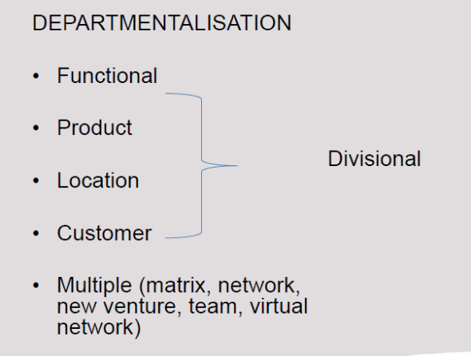

Organisational Chart p229
The graphic representation of the way in which an organisation is put together – it shows authority and communication relationships between jobs and units.

Departmentalisation p229
The grouping of related activities into units or departments:
- Functional departmentalisation p229:
  - Activities belonging to each management function are grouped together
  - Used by organisations with a single product focus
  - Poses challenges in terms of coordination of the specialist functions – specialists may view the organisation solely from their own perspective

- Product departmentalisation p230:
  - All activities concerned with the manufacturing of a product, or group of products, are grouped together in product sections
  - Logical structure for large organisations providing a wide range of products or services – see Figure 8.3: Product departmentalisation p230
  - The advantages are p230:
    - Specialised knowledge of employees regarding particular products is used to maximum effect
    - Decisions can be made quickly within a section
    - The performance of each group can easily be separately measured
  - The disadvantages are p230:
    - Managers in one particular section may concentrate their attention almost exclusively on their particular products and tend to lose sight of those of the rest of the organisation
    - Administrative costs could increase
- Location departmentalisation p230:
  - Suitable for multinational businesses
- Customer departmentalisation p230:
  - Appropriate when an organisation concentrates on a particular segment of the market or group of consumers, or a limited group of users
  - Same advantages and disadvantages as product departmentalisation
  - Structures based on product, location, or customers resembles in some respects a small privately owned business
  - Figure 8.5: Customer Departmentalisation p231
- Multiple departmentalisation p231: the hybrid, used by large or complex organisations:
  - Matrix departmentalisation p231:
    - Combines functional and product departmental structures
    - Employee works for finance dept. but is also assigned to one or more products or projects
    - Advantage - flexibility
    - Disadvantage – employee reports to 2 superiors – violates the unity of command principle
  - Divisional departmentalisation (divisional or M-form structure) p232:
    - Figure 8.7: Divisional Departmentalisation p233
    - Large, complex, and global organisations with related products and services
    - Departmentalised into semi-autonomous strategic business units
    - Any combination of the other forms of departmentalisation may be used by the organisation within its divisions
    - When the organisation has unrelated diversified business units = the conglomerate structure based on autonomous profit centres

  - Network structure p233:
    - Describes an interrelationship between different organisations
    - A network organisation usually performs the core activities itself but subcontracts non-core activities to other organisations
    - Disadvantage- must coordinate its network partners activities to ensure they contribute to the networked organisation’s mission and goals
    - Figure 8.8: Network Structures p233
  - New venture units p233:
    - Groups of employees who volunteer to develop new products or ventures
    - Uses a form of matrix structure and when complete can be adopted into:
      - The new products or ventures become part of the traditional departmentalisation
      - The products are developed into a totally new department
      - The new products grow into divisions
  - Team approach p233:
    - Gives managers a way to delegate authority, push responsibility to lower levels and be more flexible and responsive in the competitive global environment
    - Figure 8.9: The Team Approach p234
  - The virtual network approach p234:
    - Builds on the features of the network organisation
    - No longer necessary to have all employees, teams, departments in one office or facility
    - Advantage – provides flexibility because partnerships and relationships with other organisations can be formed or disbanded as needed
    - Disadvantage – higher levels of reciprocal and sequential interdependence than a network organisation

JOB DESIGN P235:

Job design refers to the process of combining the tasks that each employee is responsible for.

1. Job specialisation

Job specialisation, or job simplification, refers to the narrowing-down of activities to simple, repetitive routines.

The term “job” specialisation should not be confused with “person specialisation”, which refers to individuals with specialised training e.g. medical specialists, lawyers, etc etc

    - Job expansion

It is the process of making a job less specialized. Jobs can be expanded through job rotation, job enlargement, and job enrichment.

        - Job rotation involves performing different jobs for a set period of time.
        - Job enlargement stems from the thinking of industrial engineers. A job is enlarged when an employee carries out a wider range of activities of approximately the same level of skill.
        - Job enrichment is implemented by adding depth to the job. Job enrichment entails increasing both the number of tasks a worker does and the control the worker has over the job.

  - Based on Herzberg’s two-factor theory of motivation
  - Herzberg argued that job rotation and job enlargement do not enhance employee motivation - a worker should be provided with actual control over the task to be more motivated
  - Involves increasing the number of tasks a worker does and the control the worker has over the job
  - Two more forms: work teams and the job characteristics model

DELEGATION P236:

The process through which managers assign a portion of their total workload to others – authority is also passed on to an employee. Managers delegate for the following reasons:

- Promotes succession planning
- Enables manager to get more management work done
- Subordinates profit from delegation – learn to develop decision-making and problem-solving skill
- Managers remain accountable for their subordinates

The parity principle:
- Neither managers nor subordinates should be held responsible for things beyond their control or influence
- Authority and responsibility should be co-equal

1. Principles of effective delegation

Some principles that can be used as guidelines:

1. Explain the reason(s) for delegating.
2. Set clear standards and goals.
3. Ensure clarity of authority and responsibility.
4. Involve subordinates.
5. Request the completion of tasks.
6. Provide performance training.
7. Provide feedback to the subordinate.

2. The advantages of delegation

Important advantages when applied properly:-

- Managers who train their staff to accept more responsibility are in a good position themselves to accept more authority and responsibility from higher levels of management.
- Delegation encourages employees to exercise judgement and accept accountability.
- Better decisions are often taken by involving employees who are “closer to the action”.
- Quicker decision making takes place.

    - Obstacles to effective delegation

Barriers may be helpful to us, as managers:

- A manager may fear that his or her own performance evaluation will suffer if subordinates fail to do a job properly.
- The manager may also feel that the subordinate will not do the job as well as he or she can do it.
- Managers are often too inflexible or disorganised to delegate.
- Managers may also be reluctant to delegate because they fear their subordinates will do the job better then they can.

The following are examples of organisational impediments to delegation:-

- Delegation is not effective if authority and responsibility are not clearly defined.
- When a manager does not make subordinates accountable for task performance, there is a likelihood that this responsibility will be passed on to others.
- Individuals may not have a good understanding of what is expected of them

    - Overcoming obstacles to effective delegation

One way of overcoming obstacles is to create a culture of continuous learning. Improved communication between subordinates and managers removes obstacles to delegation.

    - The delegation process

The recommended steps in the delegation process:-

1. Decide on the tasks to be delegated.
2. Decide who should perform the tasks.
3. Provide sufficient resources for carrying out the delegated tasks.
4. Delegate the assignment.
5. Be prepared to step in, if necessary.
6. Establish a feedback system.

(NB: See Figure 8.10 - The delegation process)

SUMMARY
By following the steps in the delegation process, managers will

- Reduce their own workload to focus more on management challenges,
- Develop their subordinates.
- Increase productivity in the organisation.
Learn Figure 8.10: The Delegation Process p240

END OF STUDY UNIT 7/CHAPTER 8

TOPIC 4 : LEADING

(STUDY UNIT 8) CHAPTER 12: INDIVIDUALS IN THE ORGANISATION P334 (STUDY UNIT 8)

INTRODUCTION P335
The psychological contract refers to the overall set of expectations held by an individual in terms of what he or she will contribute to the organisation. Contributions refer to the following:

- The effort put into the job
- Competencies of the individual
- Ability, time, creativity etc.

The psychological contract also states what the organisation will provide in return for the individual’s contributions:

- Salary
- Job security
- Benefits
- Career opportunities
- Status
- Promotion opportunities

THE IMPORTANCE OF THE HUMAN DIMENSION IN MANAGEMENT P335
Reasons why managers should optimise their workforce p336:
- People spend a large part of their day at work – they work to satisfy their needs and wants
- People are the lifeblood of an organisation
- Knowledge workers are at the centre of success
- People are part of a social system

PEOPLE AS A SUB-SYSTEM P336
The individual in an organisation has the same characteristics as any other sub-system:

- A system is complex – each individual is unique
- A system can be either open or closed
- People, in turn, influence the environment in which they function
- A system strives for equilibrium

PEOPLE IN THE ORGANISATION P337
Learn Figure 12.1: Key Variables that Determine the Behaviour of Employees p338
There are certain key variables that influence the individual behaviour of employees:
- Values and attitudes p337 – basic beliefs that a certain way of doing things is preferable to another; an attitude is a collection of feelings and beliefs
- Personality p340
- Motivation p345
- Perception p345
- Learning p346
- Ability p344

VALUES AND ATTITUDES P337
To understand an employee’s work-related attitudes, managers should look at these 3 components p339:
- An affective component
- A behavioural component
- A cognitive component
Managers are interested in attitudes that are job related p339:
- Job satisfaction p339
- Job involvement p340 – psychological identification with the job
- Organisational commitment p340 – as above, but identification with the employer organisation
The 5 elements that contribute to worker’s negative attitudes towards their work (Gang & Gang) p340:
- Excessive workload
- Concerns about leadership effectiveness
- Anxiety about job and financial security
- Lack of challenging work, boredom, frustration
- Insufficient recognition
Managers can try to change an employee’s negative attitude by changing the following p340:
- Organisational factors – career opportunities, communication, remuneration, promotion, job, training
- Group factors – co-workers and managers
- Personal factors – needs and aspirations
Learn Figure 12.2: Factors that can Lead to a Change in Attitude p341

PERSONALITY P340

An individual’s personality determines how he or she perceives, evaluates, and reacts to the environment – factors that provide valuable insight into employee behaviour p341:

- Personality type (the MBTI; type A or type B personality)
- Locus of control – the extent to which a person believes behaviour directly influences his or her actions
- Authoritarianism – the extent to which an employee believes in power or status differences
- Self-monitoring – the extent to which an employee is able to mould behaviour according to co-workers
- Achievement orientation
- Self-esteem
- Risk profile

Learn Table 12.1: Traits of Persoanlity Types A and B p342
Type A | Type B
Unceasing struggle to achieve more in less time | Rarely try to complete an increasing number of tasks in a shorter period
Competitive | Do not exhibit their superiority
Impatient | Patient
Think or do two or more things simultaneously | Stay focused
Cannot cope with leisure time | Can relax without guilt
Emphasize quantity of work over quality of work | No need to display achievement
Rarely creative | Creative
Rely on past experiences when making decisions | Develop unique solutions to problems

Myers-Briggs Type Indicator (MBTI) classifies individuals as follows p342:
- Extrovert or introvert (E or I)
- Sensing or intuitive (S or N)
- Thinking or feeling (T or F)
- Perceiving or judging (P or J)

THE INDIVIDUAL’S ABILITY P344
Ability – a person’s capacity to do the different tasks in a job, it comprises 2 components p344:
- Intellectual capacity
- Physical ability

Competency – refers to 4 aspects p344:
- Knowledge
- Skills
- Value orientation
- Applied in context

MOTIVATION P345
n/a

PERCEPTION P345

The process in which individuals arrange and interpret sensory impressions in order to make sense of their environment.

Differences in perception depend on p345:
- Who is doing the perceiving
- The object being perceived
- The context in which perception occurs
The shortcuts that people take are known as ‘cognitive strategies’ p346:
- Heuristics – decision-making principles used to draw quick conclusions about other people
- Prejudices – the result of stereotyping
The halo effect – when a general impression is form based on certain characteristics such as intelligence, appearance.

LEARNING P346
Learning styles include p347:
- Reading
- Listening
- Observing
- Doing

EMOTIONAL INTELLIGENCE (EI) P347

EI – the ability to access, manage, make use of one’s own feelings in the workplace – as well as those of other people.

Goleman found that the emotional competencies that differentiate superior from average performers are p347:
- Self-awareness
- Self-management (managing one’s own emotions)
- Social awareness (empathy)
- Social skills (managing relationships)

MENTORING AND COACHING P348

        - Mentoring (about career) - addresses the whole person and his or her career and aims to boost capabilities and standing as well as inner self (how to behave, workplace values, personal dilemmas).
        - Coaching (about job) – focuses in improved performance and has a short-term focus on one aspect of the job only

TYPES OF WORKPLACE BEHAVIOUR P349

Important workplace behaviours include:

- Performance behaviours – derived from the psychological contract
- Withdrawal behaviours – absenteeism and turnover
- Organisational citizenship – behaviour that makes a positive overall contribution
- Dysfunctional behaviours – theft, withholding information, harassment, spreading rumours

END OF STUDY UNIT 8/CHAPTER 12

(STUDY UNIT 9) CHAPTER 11: LEADERSHIP P307

INTRODUCTION P308

Factors that play a major role in leading people p308:

- Understand the basic behaviour of followers and the relationship between followers and the organisation
- Understand how groups and teams behave, and why individuals join groups
- Know how to motivate followers

THE NATURE OF LEADERSHIP P309

INTRODUCTION P309

Without leadership, organisations stagnate, lose their way, and eventually become irrelevant.

A DEFINITION OF LEADERSHIP P310

Leadership is the process of influencing and directing the behaviour of individuals and groups towards reaching the organisation’s mission and goals.

Leadership entails p310:

- Formulating the organisation’s vision, mission, strategic goals, and strategies and communicating these
- Giving orders and instructions
- Deliberating with followers and supervising their work
- Taking steps to improve their (followers) performance
- Disciplining
- Dealing with conflict

THE COMPONENTS OF LEADERSHIP P311
The components of leadership:

- Authority – the right to give orders and to demand action from subordinates
- Power – the ability to influence the behaviour of others
- Influence – the ability to apply authority and power in such a way that followers take action
- Delegation – subdividing a task and passing a smaller part on to a subordinate with the authority to execute
- Responsibility
- Accountability

Kinds of power as per French and Raven p312:

The following kinds of power:-

Legitimate power
This refers to the authority that the organisation grants to a particular position.

The power of reward
The is the power to give or withhold rewards.

Coercive power
This is the power to enforce compliance through fear, either psychological or physical.

Referent power
This refers to personal power. Subordinates follow their leader simply because they like, respect, or identify with him or her. Such a leader is said to have “charisma”

Expert power
This is power based on knowledge and expertise.

Learn Table 11.1: The Sources of a Leader’s Influence p314

THE IMPORTANCE OF LEADERSHIP P313

(NB: See Table 11.1 - The sources of leaders’ influence)

LEADERSHIP AND MANAGEMENT P315
        - Management – about coping with the complexity of practices and procedures to make organisations work
        - Leadership – about setting the direction of the organisation and coping with change

Learn Table 11.2: The Distinction Between Management and Leadership p315

THE THEORETICAL FOUNDATIONS OF LEADERSHIP P316

LEADERSHIP CHARACTERISTICS OR TRAITS P316

Trait theories of leadership – isolate characteristics that differentiate leaders from non-leaders and effective leaders from ineffective leaders.

THE BEHAVIOURAL APPROACH TO LEADERSHIP P317

The 2 basic forms of leadership behaviour (Michigan University, by Lukert) p318:
- Task-orientated leader behaviour in which the leader is concerned primarily with careful supervision and control to ensure that subordinates to their work satisfactorily. Subordinates are merely instruments to get the work done.
- Employee-orientated leader behaviour in which the leader applies less control and more motivation and participative management to get the job done. Focuses on people and their needs and progress.
Learn Figure 11.4: The Leadership Grid p319

Situation models – Tannenbaum and Schmidt p318 – a series of leadership styles that can be used in certain situations, with varying degrees of authority and freedom.

Learn Figure 11.5: A Continuum of Leadership Behaviour p320
The first leadership style (task oriented) stresses the actual job; the second concerns the development of motivated groups. In Figure 11.5 the model depicted in this figure presents a series of leadership styles that can be used in certain situations. A continuum from left to right in the model also indicates a change from autocratic to democratic leadership.

THE CONTINGENCY OR SITUATIONAL APPROACHES TO LEADERSHIP P319

Leaders’ success is often determined by their ability to sum up a situation and adapt their style of leadership accordingly.

Situation models – Tannenbaum and Schmidt p318 – a series of leadership styles that can be used in certain situations, with varying degrees of authority and freedom.

FIEDLER’S CONTINGENCY (OR SITUATIONAL) THEORY OF LEADERSHIP P320

Based on the assumption that, for lack of a single best style, successful leadership depends on the match between the leader, the subordinate, and the situation i.e. how well the leader’s style fits the situation.
According to Fiedler, a manager can maintain this match by:
- Understanding his or her style of leadership (task or employee-oriented)
- Analysing the situation to determine if the style will be effective (whether to use autocratic or democratic)
- Matching the style and the situation by changing the latter to make it compatible with the style

HERSEY AND BLANCHARD’S LEADERSHIP CYCLE MODEL P321 (WELL-KNOWN SITUATIONAL MODEL)

- Postulates that the most effective management style for a particular situation is determined by the maturity of the subordinate(s) i.e. that person’s need for achievement, willingness to accept responsibility, and task-related ability and experience.
- The degree or level of maturity is represented by 4 quadrants:
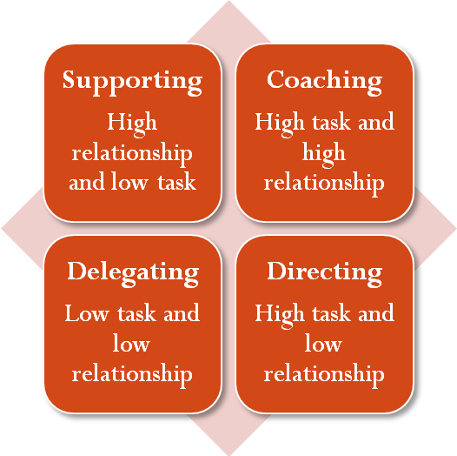
The leadership cycle model postulates that managerial style must change as a group of subordinates develops and reaches maturity. Leaders must thus analyse the situation, determine the degree of training required and adapt style.

The Vroom-Yetton-Jago Model p322

- Recognised that task structures have varying demands for routine and non-routine activities – leader behaviour must adjust to reflect the task structure.
- The model provided a sequential set of rules to be followed in determining the form and amount of participation in decision making in different types of situations. The model is a decision tree incorporating 5 alternative leadership styles and 12 contingencies. Refer Figure 11.5 p320

PATH-GOAL THEORY P322
Developed by Robert House – it is the leader’s job to assist his or her followers in attaining their goals and to provide the necessary direction and support to ensure that their goals are compatible with the overall mission and goals of the organisation.

The role of the leader – to make the journey along the path easier by reducing obstacles and pitfalls.

House identified 4 leadership behaviours p322:
- The directive leader – lets employees know what is expected of them and gives specific guidance as to how the work should be done
- The supportive leader – shows concern for the needs of employees
- The participative leader – consults with employees and uses their suggestions before making a decision
- The achievement-oriented leader – sets challenging goals and expects employees to perform at their highest level

SOME CONTEMPORARY PERSPECTIVES ON LEADERSHIP P323

- Transactional leadership p323 – traditional approach
- Charismatic leadership p323 – emotional impact on subordinates e.g.: Bill Gates
- Transformational leadership p323 – ability to bring about innovation and change e.g.: South Africa:
  - Leaders tune into their organisation’s environment
  - Leaders think in a kaleidoscopic way – challenge assumptions to find new solutions
  - Leaders form and communicate inspiring visions – help give meaning
  - Leaders build a coalition to support their change
  - Leaders turn dreams into reality by nurturing and supporting their coalitions
  - Leaders drive the change process by pushing and overcoming obstacles
  - Leaders make heroes
- Female leadership p325 – interactive, concerned with consensus building
- Dynamic engagement p325 – 5 categories and 10 behaviours Table 11.3 p326
- Attribution theory p325 – leaders seek proof or reasons why subordinates act in a certain way, and then modify their behaviour to guide the followers
- Substitutes for leadership p326 – internal factors that influence job satisfaction and performance

LEADERSHIP AND POLITICAL BEHAVIOUR IN ORGANISATIONS P327

TYPES OF POLITICAL BEHAVIOUR IN ORGANISATIONS P327
The 4 basic forms of political behaviour

- Inducement – manager offers or promises something in exchange for support
- Persuasion – plays on emotions
- Obligation – support for support, even if the manager does not agree with the cause
- Coercion – force

MANAGING POLITICAL BEHAVIOUR IN ORGANISATIONS P328

- Managers should be aware that people may regard actions as political, even if they’re not
- By granting adequate autonomy and responsibility to subordinates, managers reduce the risk of political behaviour
- Managers should limit the use of power
- Managers should clear the air by handling differences and conflict openly
- Managers should avoid covert behaviour
- Management systems and rewards systems linked directly to performance

END OF STUDY UNIT 9/CHAPTER 11

(STUDY UNIT 10) CHAPTER 14 MOTIVATION P383

INTRODUCTION P384

Motivation is the willingness of an employee to achieve organisational goals – people are motivated to do what is in their best interests.

THE MOTIVATION PROCESS P384

Learn Figure 14.1: The Motivation Process p385
The motivation process p385:
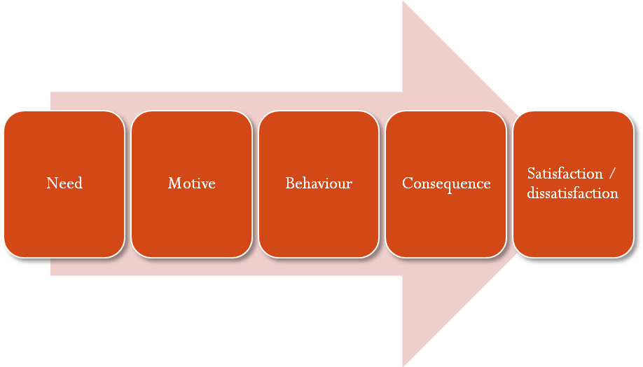
The variables that determine performance are p385:
- Motivation – goal or desire
- Ability – training, knowledge, skills
- Opportunity to perform
Motivation x Ability x Opportunity = Performance

THE CLASSIFICATION OF MOTIVATION THEORIES P386:

We classify motivation theories in terms of p387:

- Content (the what and the how) – Maslow hierarchy, Herzberg two-factor model, acquired need theory
- Process (the what and the how) – equity theory and expectancy theory
- Reinforcement theories (the ways in which desired behaviour can be encouraged) -reinforcement theory

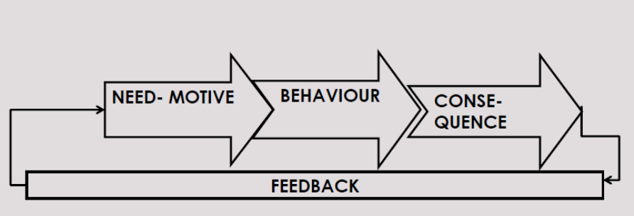

Learn Table 14.1: Classification of Motivation Theories p387

CONTENT THEORIES P387
Associated with Maslow, Herzberg, and McClelland and attempts to answer:

- What needs to people want to satisfy?
- What are the factors that influence individual behaviour?

Maslow’s Hierarchy of Needs p387

Based on 2 important assumptions p387:

- People always want more, and their needs depend on what they already have
- People’s needs arise in order of importance
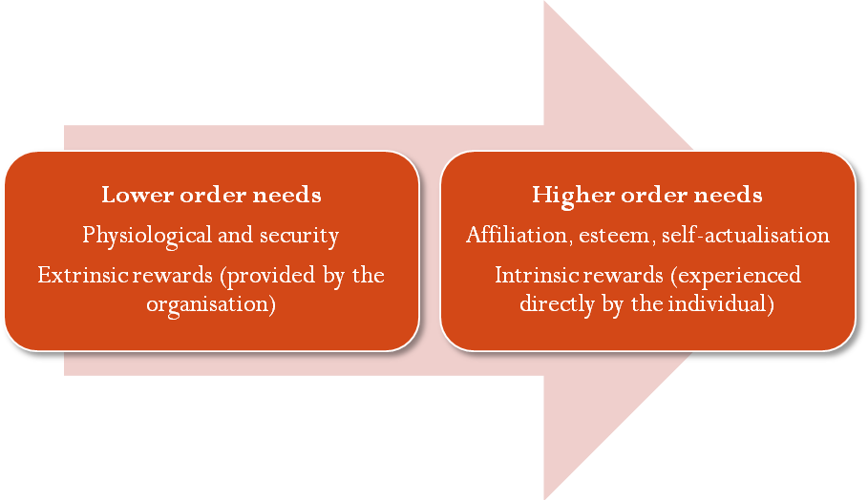

The 5 levels in Maslow’s hierarchy of needs model are p388:
- Physiological needs
- Security needs
- Social needs
- Esteem needs
- Self-actualisation needs

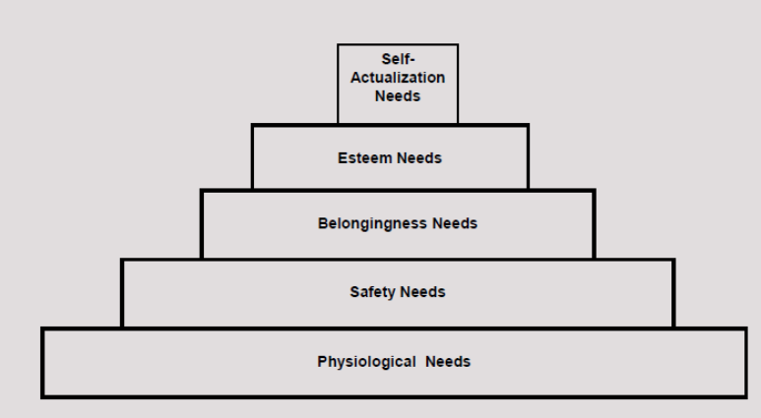
Criticisms of Maslow’s theory p388:
- During certain periods of their lives, people reorder the hierarchy
- Difficult to determine the level of needs at a certain point in time
- Managers work with many employees
- Individuals differ in the extent to which they feel a need has been sufficiently satisfied

The value of Maslow’s theory p389:

- It highlights important categories of needs
- It makes a distinction between higher order and lower order needs
- It stresses the importance of personal growth and self-actualisation in the workplace

Herzberg’s Two-Factor Motivation Theory p389

Studied the relationship between job satisfaction and productivity in the 1950s.
Learn Figure 14.3: Model of Herzberg’s Two-Factor Theory p390
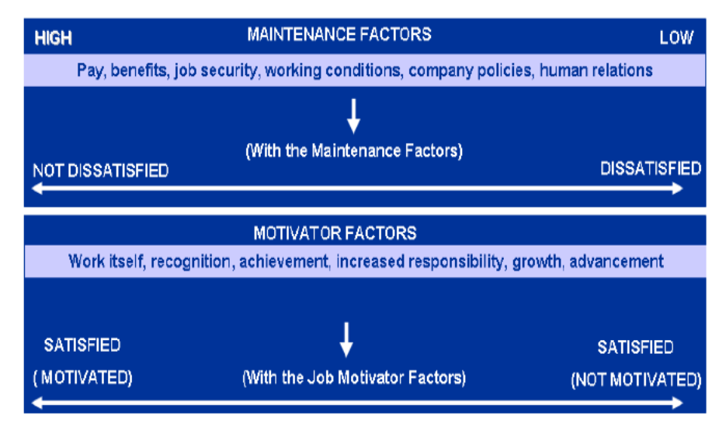

Motivator factors – relate to job content (what people actually do in their work):
- Achievement
- Recognition
- Work itself
- Responsibility
- Advancement
Hygiene factors – relate to job context:
- Salary
- Interpersonal relations (supervisor and subordinates)
- Company policy and administration
- Status
- Job security
The value of Herzberg’s two-factor theory in the workplace p391:
- Extends Maslow’s ideas and makes them more applicable in the workplace
- Focuses attention on the importance of job-centred factors in the motivation of employees
- Offers an explanation for the limited influence on motivation of more money, fringe benefits, and better working conditions
- Only ‘motivators’ stimulate motivation – not hygiene factors

McClelland’s Achievement Motivation Theory (Acquired Needs Model) p392

Postulates that people acquire certain types of needs during a lifetime of interaction with the environment – when a need is strong, it will motivate the person to engage in behaviours to satisfy that need:

- The need for achievement (N Ach)
- The need for affiliation (N Aff)
- The need for power (N Pow)

PROCESS THEORIES P393

Focus is on how motivation actually occurs – focus on process of individual goal-setting and evaluation of satisfaction

- Equity theory
- Expectancy theory

The Equity Theory of Motivation p394

An individual must be able to perceive a relationship between:

- The reward he or she receives; and
- His or her performance
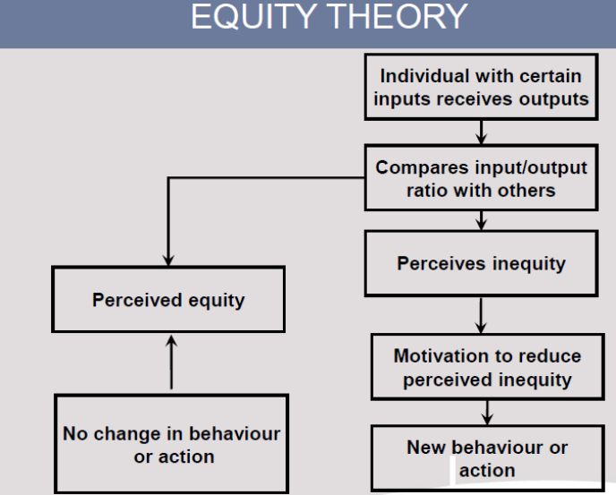

The Expectancy Theory of Motivation (Victor Vroom) p395

People will act according to:

- Their perceptions that their work efforts will lead to certain performances and outcomes; and
- How much they value the outcomes

Learn Figure 14.5: The Expectancy Theory Model p396
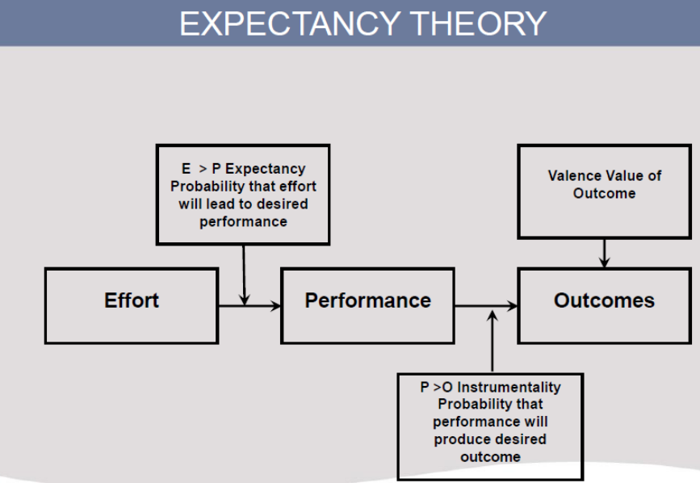

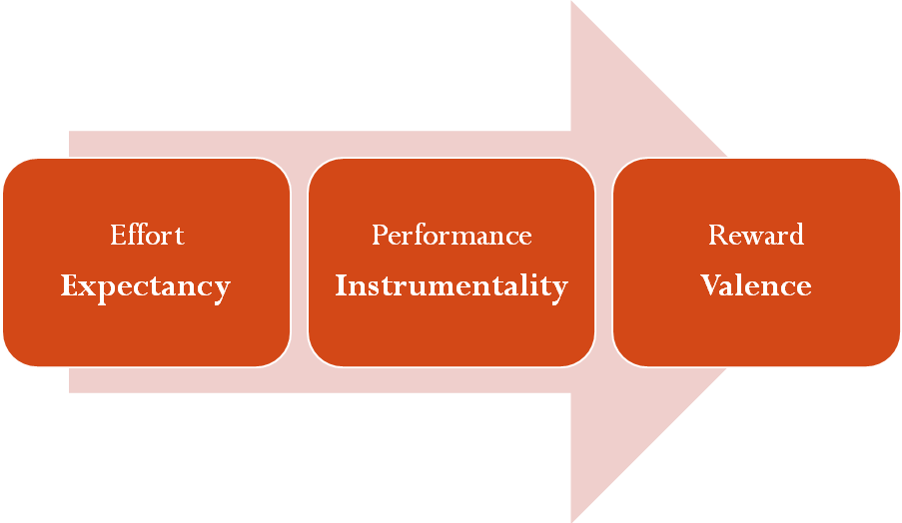
An individual’s work motivation is determined by the following elements p396:
- Expectancy (effort-performance relationship)
- Instrumentality (performance-reward relationship)
- Valence (rewards-personal goals relationship) – value attached to outcomes
Criticism p396 – rewards are not linked to performance.

The Reinforcement Theory of Motivation p397
Reinforcement theory is a behaviourist approach – behaviour is a function of its consequences, so: behaviours followed by positive consequences will occur more frequently and vice-versa.
Reinforcement can be positive or negative p397:
- Positive:
  - Positive reinforcement
  - Avoidance
- Negative:
  - Punishment
  - Extinction
Strategies for scheduling reinforcement p397:
- Continuous reinforcement – when managers reinforce all desired behaviours
- Fixed interval schedule – fixed times regardless of behaviour
- Variable interval schedule – used mainly for praise or rewards
- Fixed ratio schedule – provides reinforcement after a fixed number of performances
- Variable ratio schedule
Fred Luthans – US expert on management – studied effects of reinforcement theories. The 5 steps that managers should follow to enhance motivation in the workplace by using reinforcement theory p398:
- Identify critical, observable, performance-related behaviours that are NB to successful job performance
- Measure how often workers engage in these behaviours
- Analyse the causes and consequences of these behaviours
- Use positive and negative reinforcement to increase frequency of critical behaviours
- Evaluate extent to which reinforcement has changed workers’ behaviour
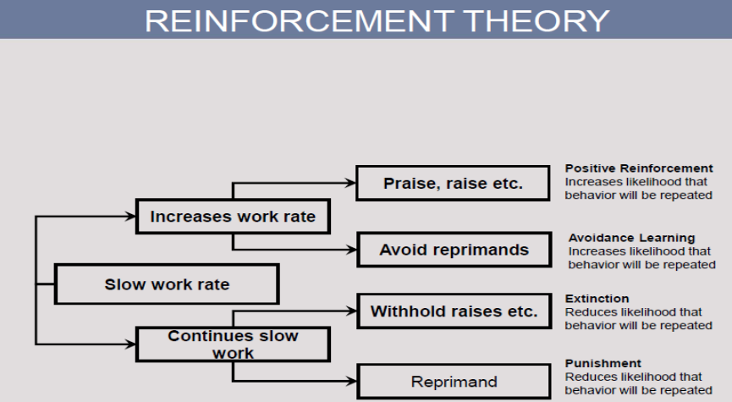

MONEY AS A MOTIVATOR P399
- Maslow – money satisfies the lower order needs
- Herzberg’s theories – a monetary reward linked to good performance - such as a merit bonus – acts as a motivator
- Equity theory – we use pay as a measurement of fair treatment by comparing it to our outputs
- Expectancy theory – money is a motivator if employees perceive that good performance results in a monetary reward that they value highly
- Reinforcement theory – money is a reward to reinforce behaviour that leads to positive job performance

DESIGNING JOBS THAT MOTIVATE P399
Job enlargement, job enrichment, and the job characteristics model:

Job Enlargement p399
- Job enlargement involves horizontal workloading – adding a greater variety of tasks to an existing job
- Disadvantage – increases variety of tasks, does not alter the challenge that the work offers

Job Enrichment p400
- The concept of vertical workloading – attributed largely to Herzberg’s findings re: the two-factor model
- Job enrichment implies the addition of the following to worker’s activity:
  - Measurable goals
  - Decision-making responsibility
  - Control and feedback
- Two-factor theory and job enrichment p401 – job enrichment is required for intrinsic motivation:
  - The job should have sufficient challenge to utilise the full ability of the employee
  - Employees who demonstrate increasing levels of ability should be given increasing levels of responsibility
  - If a job cannot be designed to use an employee’s full abilities, then the organisation should consider automating the task or replace with employee with lower level of skill

The Job Characteristics Model p401
Developed by Hackman and Oldman – certain core job dimensions create critical psychological states which lead to certain beneficial personal and work outcomes – strongest in employees with a high need for personal growth and development.
This model recognises an important limitation of job enrichment – not all workers can or want to apply job enrichment to their work and not all types of work are suitable for job enrichment.
The 5 core dimensions of this model p402:
- Skill variety
- Task identity
- Task significance
- Autonomy – think management by objectives
- Feedback
The 3critical psychological states p402:
- Meaningfulness of work – is the task important, valuable, worthwhile?
- Responsibility for outcomes of the work
- Knowledge of the actual results of the work activities
The job diagnostic survey (JDS) – questionnaire that measures the degree to which various job characteristics are present in a particular job. The index used to predict the degree to which a job motivates a work = Motivating Potential Score (MPS):
MPS = Skill variety + Task identity + Task significance x Autonomy x Feedback
Learn Figure 14.8: The Job Characteristics Model p403
The job characteristics model can guide managers to redesign jobs with a view to enhancing their motivating potential by p403:
- Combing tasks, enabling workers to perform the entire job – skill variety and task identity
- Allow workers to be identified with the work they have done – task identity and task significance
- Establishing a client relationship – skill variety, autonomy, and feedback
- Loading jobs vertically – allowing greater responsibility and control over work – autonomy
- Feedback

END OF STUDY UNIT 10/CHAPTER 14

END OF TOPIC 4

TOPIC 5: CONTROL

(STUDY UNIT 11) CHAPTER 16: CONTROL

INTRODUCTION

The term “Control” has a specific meaning, namely the process by which management ensures that the actual activities fit in with the predetermined goals and planned activities.

The nature of control

The aim of control is to keep deviations to a minimum. In a sense control is supervisory – it supervises and measures the progress made towards attaining a particular goal. Control is a continuous process and is interwoven with planning, organizing, and leading.

The control system informs management of the following:

A control process is necessary in an organisation for the following reasons.
- Activities are proceeding according to plan.
- Things are not proceeding according to plan.
- The situation has changed.

THE IMPORTANCE OF CONTROL

A control process is necessary in an organisation for the following reasons:

1. Control is exercised to ensure that all activities at all levels of the organisation are in accordance with the organisation’s goals. (NB: See Figure 16.1 - The link between planning and controlling)
- Control is applied to ensure that the organisation’s resources are deployed in such a way that it attains its goals.
- Control usually results in better quality.
- An organisation is to reach its goals according to plan, control is necessary.
- The complexity of organisations is another factor. Larger organisation – the greater the number of people the greater is the need for control.
- Competition is a significant factor.
- Control can also help to minimize costs and limit the accumulation of errors.
- Control facilitates delegation and treamwork.

THE CONTROL PROCESS

Control is the process in which management ensures resources are meaningfully deployed so that the mission and goals of the organisation can be attained. (NB: See Figure 16.2 – The control process).
The process includes setting standards, measuring actual performance, evaluating any deviations and taking steps to rectify deviations.

Step 1. Establishing standards of performance

A performance standard is a projection of expected or planned performance. Suitable performance standards can therefore be developed and they include the following:-

- Profit standards
- Market share standard
- Productivity standards
- Staff development standards

Performance standards enable management to distinguish between acceptable and unacceptable performance and to keep abreast of the strategy and plans. The Balanced Scorecard (BSC) is a popular control tool that ensures clear standards. Standards are set in areas such as finance, customer satisfaction, internal processes and learning and innovation. The Six Sigma method tries to eliminate mistakes. “Sigma” refers to a deviation.

Step 2: Measuring actual performance
Collecting data and reporting on actual performance are ongoing activities.

Step 3: Evaluation deviations
Determining whether performance matches standards entails evaluating differences between actual performance and the predetermined standards.

Step 4: Taking corrective action
Aimed at achieving or bettering the performance standard and ensuring that differences does not recur in the future. If actual performance does not match the performance standard, management has three options:

- Actual performance can be improved to attain the standard.
- The strategy can be revised to attain the performance standards set.
- The performance standards can be lowered or raised.

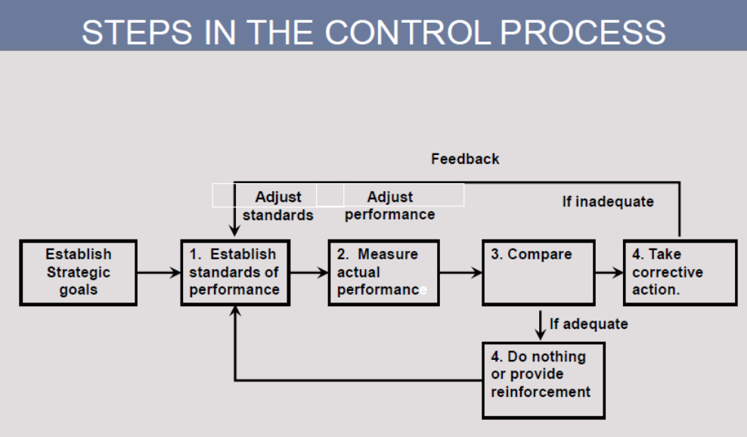

FOCUS OF CONTROL

Figure 16.3 illustrates the focal points, or the key areas of control. (NB: See Figure 16.3)

- The control of physical resources entails factors such as inventory control, quality control, and control of equipment.
- Financial resources are situated in the center of the other resources because most control measures or techniques are quantified in financial terms.
- The control of information sources concerns accurate market forecasting, adequate environmental scanning, and economic forecasting.
- Control of human sources involves orderly selection and placement, control over training and personnel development.

1. The control of physical resources

An organisation’s physical resources are its tangible assets, such as buildings, office equipment and furniture. Control systems for these resources involve usage procedures, periodic inspections, and stocktaking.

Inventory control

“Inventory” refers to the reserves of resources held in readiness to produce products and services as well as the end-products that are kept in stock to satisfy consumers’ needs. Inventory refers to four basic kinds of reserves such as raw materials, work in process, components, and finished products. Organisations keep inventories mainly for the following purposes:-

- To satisfy the needs of customers and consumers;
- In the case of raw materials and components, to keep uncertainties in delivery and availability to a minimum.
- As a hedge during times of high inflation.

In keeping inventories, the most expensive costs in the price of money, or interest, to finance inventories, followed by storage costs, insurance, and risk. (NB: See Table 16.1 Types of inventory, purpose, and sources of control)

The following three control systems are relevant here:

1. The concept of economic ordering quantity (EOQ) is based on replenishing inventory levels by ordering the most economical quantity.
2. The materials requirements planning (MRP) system was develop in the 1960’s to eliminate the shortcomings of the EOQ. Inventories are ordered only when they are needed.
3. The just-in-time (JIT) system is a refinement of the MRP system that originated in Japan. JIT is based on the premise that actual orders for finished products are converted into orders for raw materials and components, which arrive just in time for the manufacturing process.

The success of this complex inventory control system depends largely on reliable deliveries of flawless components, stable relationships and a reliable labour force.

Operational Control

- The ability of purchasing of raw materials management to ensure that the required quantity & quality of raw materials components/services are available at the lowest possible cost,
- It also establishes how well the organisation’s transformation process works.

Total Quality control (TQM)

The management approach that emphasizes the management of quality is known as total quality management (TQM). (NB: See Figure 16.4 - Managing quality).
Quality control refers to the activities that management performs to ensure a level of quality that will satisfy the consumer, on the one hand, and have certain benefits for the organisation, on the other. The following steps:

1. The first step in quality control is the definition of quality goals or standards.
2. The second step in quality control is measuring quality. The use of benchmarking. Statistical control methods to analyse product data with a view to quality.
3. Third, quality control entails rectifying deviations and solving quality problems in an effort to keep the cost of quality as low as possible.

2. The control of financial resources

Financial control concerns the control of resources as they flow into the organisation,financial resources that are held by the organisation and financial resources flowing out of the organisation. We examine two instruments of financial control: namely budgetary control and financial analysis.

The budget

This allocation of financial resources is done by means of the budget. A budget is a formal plan, expressed in financial terms, that indicates how resources are to be allocated to different activities, departments or sub-departments. A budget’s contribution to financial control is as follows:-

- It supports management in coordinating resources.
- It provides guidelines on the application of the organisation’s resources.
- It defines or sets standards that are vital to the control process.
- It makes possible the evaluation of resource allocation, departments, or units.

(NB: See Table 16.2 – Types of budget)

The most important advantage of a budget is that it facilitates effective control by placing a money value on operations and in doing so enables managers to pinpoint problems. Budgets also facilitate coordination between departments and maintain records of organisational performance.

Financial analysis

Management can use financial analyses as an instrument of control. Certain financial ratio analyses enable management to control the organisation’s financial resources. (NB: See table 16.3 – A few financial ratio analyses)

3. The control of information resources

Relevant and timely information is vital in monitoring the progress of goal attainment.

4. The control of human resources

The main instrument used to control an organisation’s human resources is performance management. This entails evaluating employees and managers in the performance of the organisation. (NB: See Figure 16.5 The performance management process for human resources)

LEVELS OF CONTROL

The two basic levels of control within an organisation are strategic control and operations control.

Strategic control

Strategic control is exercised at top management level and entails a close study of the organisations:

- Total effectiveness
- Productivity, and
- Management effectiveness

Productivity can be defined as an economic measure of efficiency that summarises what is produced (output) relative to resources used (input) to produce it.

Productivity can be increased in the following ways:

- Improving operations by spending more on research and development.
- Increasing employee involvement.

Different reasons for low productivity in South Africa, here are some of these reasons:-

- Insufficient education and training of the workforce,
- Obsolete technology and systems,
- A lack of awareness and knowledge of productivity
- And cultural and socio-political factors.

The third dimension is measuring management effectiveness, which is in fact a management audit of an organisation’s main success factors.

Operations control

Operations control is therefore concerned with the organisation’s processes that entail transforming resources into products and services. (NB: See Figure 16.6 - Three forms of operations control)

Preliminary control

The purpose of preliminary control is to anticipate and prevent possible problems regarding any of the resources. – Financial, physical, human, or information.

Screening control

Screening control is action taken as resources are transformed into products and services in order to ensure that standards for product or service quality are met.

Post-action control

Post-action control focuses on the outputs of the transformation process and involves actions taken to fix a faulty output. Another form of post-action control is when an organisation takes action to minimize negative impact on customers due to faulty outputs.

CHARACTERISTICS OF AN EFFECTIVE CONTROL SYSTEM

Integration

A control system is effective when it is integrated with planning, and when it is flexible, accurate, goal-oriented, timely, and not too complex. (NB: See Figure 16.7 - Integration of planning and control)

Flexibility

The second characteristic of a control system is flexibility. This means that it should be able to accommodate change.

Accuracy

A control system should be designed in such a way that it provides a goal-oriented and accurate picture of the situation.

Timeliness
Timely control data is not obtained by means of hasty, makeshift measurement; control data should be supplied regularly.

Unnecessary complexity

Unnecessarily complex control systems are often an obstacle because they can have a negative influence on the sound judgement of competent managers.

A control system should be:

1. Integrated with the planning system
2. Flexible
3. Accurate
4. Timely
5. Simple

END OF STUDY UNIT 11/CHAPTER 16

END OF TOPIC 5

